|  |  |
| --- | --- |
|  | **MINISTRY OF EDUCATION AND TRAINING** |

|  |
| --- |
| **FPT UNIVERSITY** |
| Capstone Project Document |
| Spa Service Providing System |

|  |  |
| --- | --- |
| **SWP490_G51** | |
| **Group Members** | Hoàng Mạnh Hà – HE140295  Nguyên Như Chương – HE140285  Phạm Kiều Trinh – HE140643  Trần Nam Long – HE140955  Nguyễn Trung Dũng – HE140858 |
| **Supervisor** | Lê Thanh Hải |
| **Ext Supervisor** |  |
| **Capstone Project code** | SSDS |

- Hanoi, September 2022 -

Table of Contents

Acknowledgement 1

Definition and Acronyms 1

I. Project Introduction 2

1. Overview 2

1.1 Project Information 2

1.2 Project Team 2

2. Product Background 2

3. Existing Systems 2

3.1 herskincare.vn 2

3.2 Thu Cuc Clinic 4

4. Business Opportunity 6

5. Software Product Vision 6

6. Project Scope & Limitations 6

6.1 Major Features 6

6.2 Limitations & Exclusions 7

II. Project Management Plan 8

1. Overview 8

1.1 Scope & Estimation 8

1.2 Project Objectives 10

1.3 Project Risks 10

2. Management Approach 11

2.1 Project Process 11

2.2 Quality Management 11

2.3 Training Plan 12

3. Project Deliverables 13

4. Responsibility Assignments 14

5. Project Communications 14

6. Configuration Management 14

6.1 Project Management 14

6.2 Document Management 15

6.3 Source Code Management 18

6.4 Tools & Infrastructures 19

III. Software Requirement Specification 19

1. Overall description 19

1.1 Product Overview 19

1.2 Bussiness Rules 20

2. User Requirements 22

2.1 Actors 22

2.2 Use Cases 22

3. Functional Requirements 55

3.1 System Functional Overview 55

3.2 Feature 63

4. Non-Functional Requirements 77

4.1 External Interfaces 77

4.2 Quality Attributes 78

5. Requirement Appendix 79

5.1 Application Messages List 79

IV. Software Design Description 81

1. System Design 81

1.1 System Architecture 81

1.2 Package Diagram 85

2. Database Design 86

2.1 Database Diagram 86

2.2 Table Descriptions 88

3. Detailed Design 104

3.1 Manage Category 104

3.2 Manage Service 108

3.3 Manage Branch 112

3.4 Manage Data Config 115

3.5 Manage equipment 118

3.6 Manage Appointment 122

3.7 Manage SCA Form 128

3.8 Manage User 133

3.9 Administrator 137

3.10 Authentication 140

V. Software Testing Documentation 142

1. Scope of Testing 142

2. Test Strategy 143

2.1 Testing Types 144

2.2 Test Levels 144

2.3 Supporting Tools 144

3. Test Plan 145

3.1 Human Resources 145

3.2 Test Environment 145

3.3 Test Milestones 145

4. Test Cases 146

5. Test Reports 146

VI. Release Package & User Guides 146

1. Deliverable Package 146

2. Installation Guides 147

2.1 System Requirements 147

3. User Manual 147

3.1 Overview 147

3.2 Guest/Customer 147

3.3 Receptionist/Manager 160

# Acknowledgement

First, the team would like to express their deepest gratitude to all the team members who completed this capstone project together and contributed a small part to the development of the training system for FPT University.

The team would like to extend our special gratitude to our beloved teacher Mr. Le Thanh Hai who has accompanied and taught the team during the past four months and the person who gave us the golden opportunity to implement this wonderful project.

Finally, the team would like to thank all the Teachers in the college for the past four years who have not stopped working to pass on the knowledge that has helped the group mature and complete the project.

# Definition and Acronyms

|  |  |
| --- | --- |
| **Acronym** | **Definition** |
| PWM | Psychology website |
| AWS | Amazon Web Services |
| BA | Business Analysis |
| BR | Business Rule |
| ERD | Entity Relationship Diagram |
| GUI | Graphical User Interface |
| PM | Project Manager |
| SDD | Software Design Description |
| SPMP | Software Project Management Plan |
| SRS | Software Requirement Specification |
| UC | Use Case |
| API | Application Program Interface |
| SCA | Spa consulting advice |

# I. Project Introduction

## 1. Overview

### 1.1 Project Information

* Project name: Spa Service Providing System
* Project code: SSDS
* Group name: SWP490_G51
* Software type: Web application

### 1.2 Project Team

|  |  |  |  |
| --- | --- | --- | --- |
| **Full Name** | **Role** | **Email** | **Mobile** |
| Lê Thanh Hải | Lecturer | Hailt10@fe.edu.vn | 0912656836 |
| Hoàng Mạnh Hà | Leader | HaHMHE140295@fpt.edu.vn | 0963093432 |
| Nguyên Như Chương | Member | ChuongNNHE140285@fpt.edu.vn | 0989099821 |
| Phạm Kiều Trinh | Member | TrinhPKHE140643@fpt.edu.vn | 0983436245 |
| Trần Nam Long | Member | LongTNHE140955@fpt.edu.vn | 0336769294 |
| Nguyễn Trung Dũng | Member | DungNTHE140858@fpt.edu.vn | 0983325543 |

## 2. Product Background

Currently, people have more and more health care need and people's use of spa and beauty care services been increasing. More and more spa service establishments are springing up all over the country. Famous brands such as Beauty Beyond Spa, Thu Cuc Clinic, [herskincare.vn](http://herskincare.vn/), etc. have affirmed their reputation and prestige over the past many years. Although they have built a brand, the above spas still do not have a website that provides good enough services to customers. Their website at first glance is quite full of functions to serve customer needs, but if you go into details, those functions are still only at a basic level. In addition, there are some spas that still use the method of contacting and replying to customers via chat box on Facebook, Instagram. This can take up too much of the customer's time and still not meet their actual needs.

## 3. Existing Systems

### 3.1 herskincare.vn

- Link web: herskincare.vn

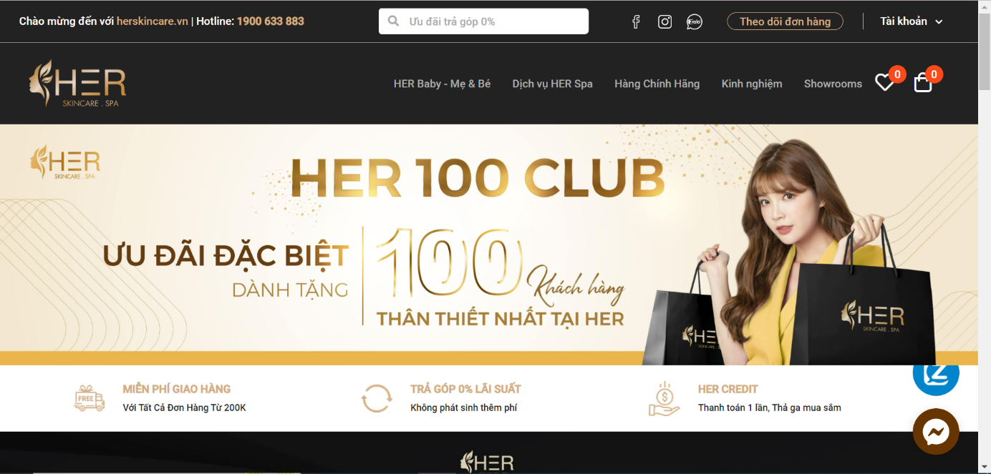

*Figure 1.1: herskincare Home Page*

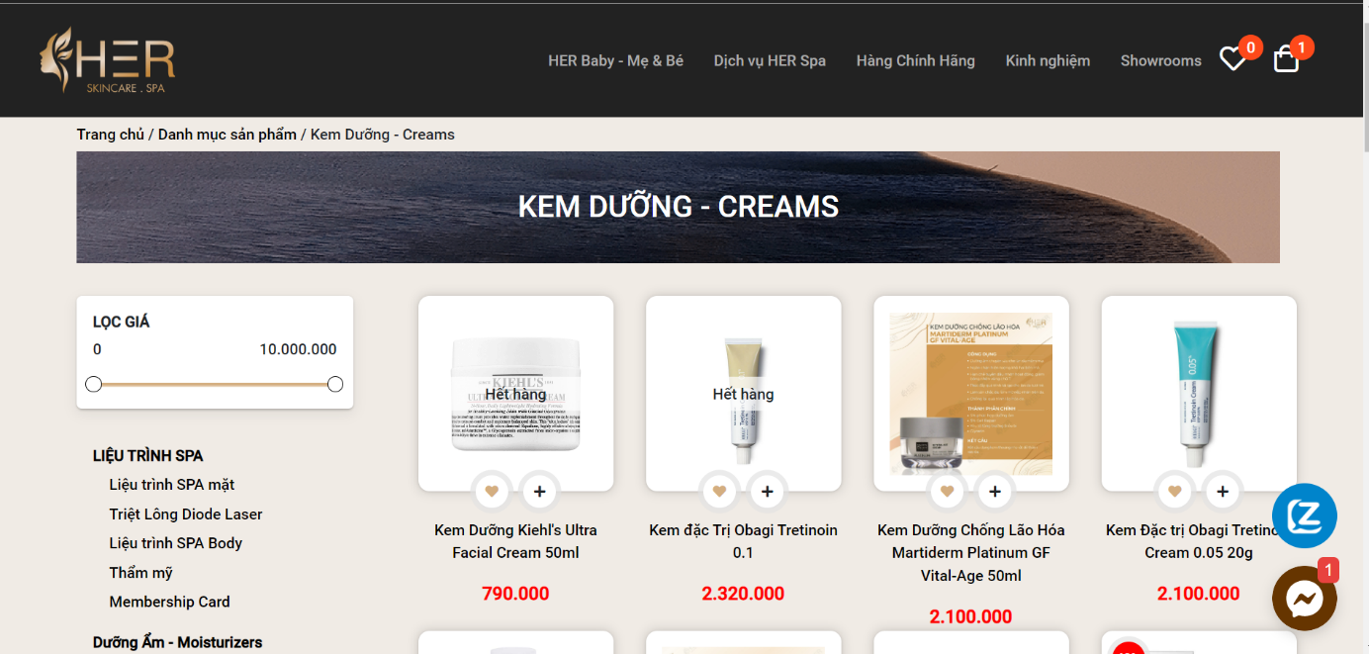

*Figure 1.2: Product Selling Page*

Customers can visit the website to view information about the spa services that Her provides as well as the products that Her sells. In addition, customers can also buy spa treatments and products right on the website.

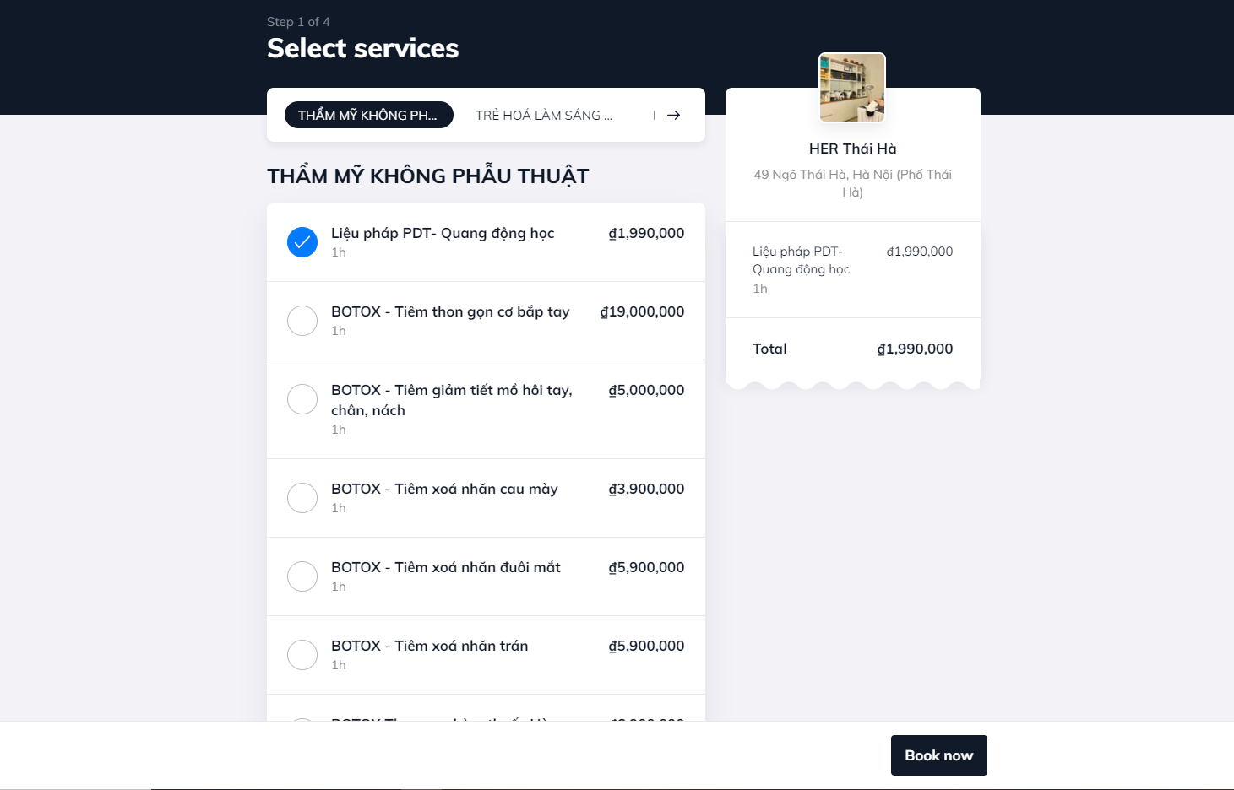

*Figure 1.3: Booking Page*

Customers can select services and choose time base on calendar.

|  |  |
| --- | --- |
| **Advantages** | **Disadvantages** |
| * Have full basic functions * Succinct, beauty layout * Wide range of services, products for customer to choose * Fast reload, forward page | * Customer cannot cancel booked appointment schedule |

### 3.2 Thu Cuc Clinic

- Link web: thucucclinics.com

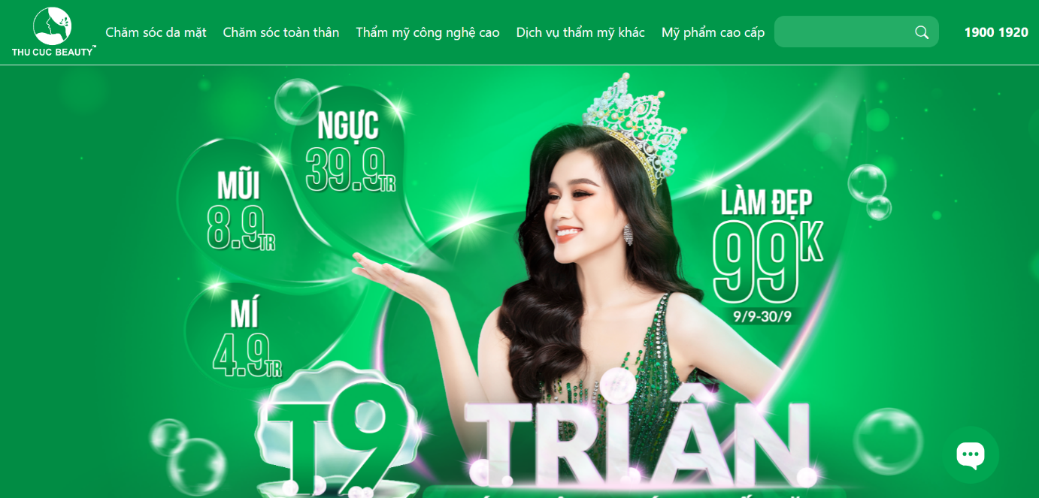

*Figure 1.4: Thu Cuc Clinic Home Page*

thucucclinics.com is a website that provides information about services, products, and technologies that Beauty Thu Cuc provides.

Customers can access the website to see detailed information of each service such as: Introduction, process, time, cost, …

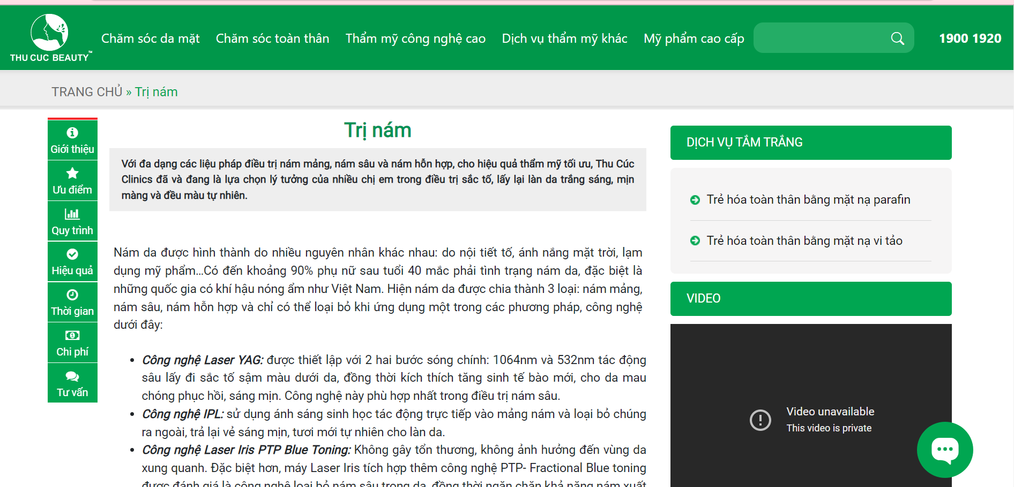

*Figure 1.5: Service detail page*

For consultation, customers need to leave their name, email address, question, phone number and wait for a response from the clinic.

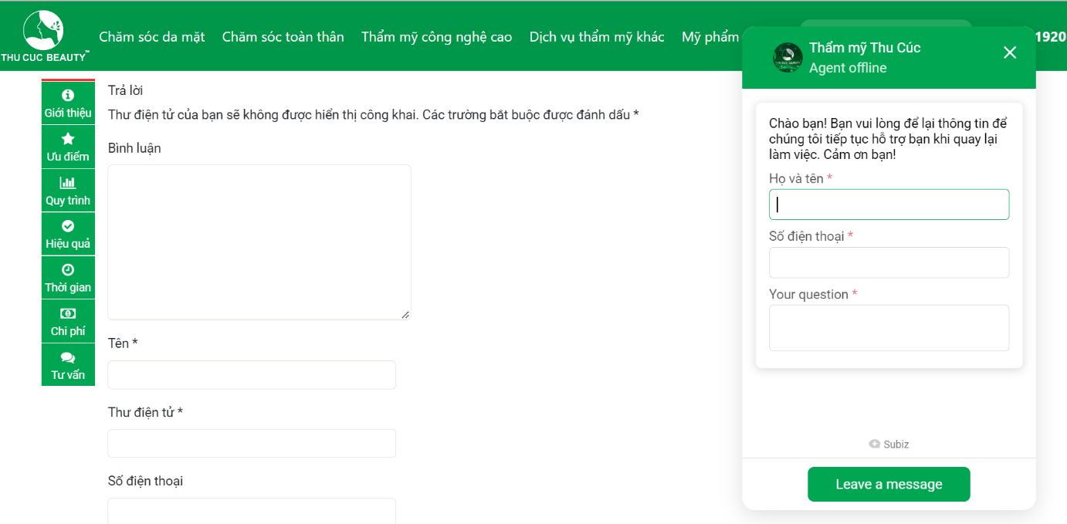

*Figure 1.6: Question and message form*

|  |  |
| --- | --- |
| **Advantages** | **Disadvantages** |
| * Provide very detail information about services * Succinct, beauty layout, user-friendly * Various services * Detailed categories | * Don’t have booking function * Some links cannot connect |

## 4. Business Opportunity

There are many big spa brands but there are very few of them establish a convenient website for customer. Through the shortcomings in the current market, we want to develop a website providing spa services. We see this as a great potential that we can compete with existing brands on the market based on our superior technology. We guarantee that: On the customer side, it can be easily used, shorten the service selection time, provide real needs. Customers' needs while still ensuring the best efficiency. On the spa owner's side, it is easy and quick to grasp the actual needs of customers to manage the store appropriately, helping customers and store owners communicate with each other conveniently.

## 5. Software Product Vision

For healthcare clients looking to book an appointment, the Spa Execution System is an internet-based and smartphone-enabled application that will accept individual and group appointments, process payments and distributing appointments to each spa facility. Unlike the process of booking appointments by phone, Facebook, Instagram... takes time and effort. Customers of Spa Execution System will not have to spend time waiting for answer from the shop owner which will help them be proactive in arranging and saving their own time.

## 6. Project Scope & Limitations

### 6.1 Major Features

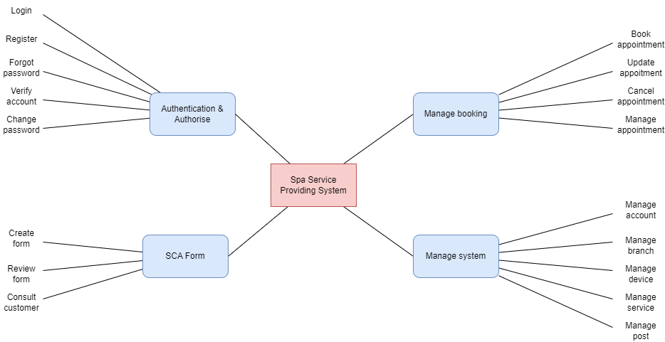

*Figure 1.7: Major Features of Spa Service Providing System*

|  |  |  |
| --- | --- | --- |
| **ID** | **Major Features** | **Description** |
| FE-01 | Authentication & authorise | User uses account to access the system, different roles access different features of this system. |
| FE-02 | Manage booking | This is our main feature. This feature includes different roles:   * Customer role: User can choose services and book an appointment. * Receptionist role: User can manage all appointments of customer. * Manager role: User can view all appointments and their status. |
| FE-03 | SCA form | The website has a set of questions about health status for customer. Customer enters their information and problems they are facing. Based on the answers, the website will return a best result for them and recommend services which should be used. |
| FE-04 | Manage system | This feature is designed only for Manager role. Manager will have permission to manage the whole system includes create, update, delete, deactivate branch, equipment, service, category, data config. |

### 6.2 Limitations & Exclusions

**6.2.1 Limitations**

|  |  |
| --- | --- |
| **ID** | **Description** |
| LI-01 | New customers still cannot check the details of health assessment such as body, facial skin, stress, … to be able to advise the best service for customers. |
| LI-02 | There is no direct communication method with customers on the website |

**6.2.2 Exclusions**

|  |  |
| --- | --- |
| **ID** | **Description** |
| EX-01 | There is currently no actual payment function |

# II. Project Management Plan

## 1. Overview

### 1.1 Scope & Estimation

|  |  |  |  |
| --- | --- | --- | --- |
| **#** | **WBS Item** | **Complexity** | **Est. Effort**  **(man-days)** |
| **1** | **Pre-Initiation Phase** |  | **5** |
| 1.1 | Come up with ideas | Complex | 2.5 |
| 1.2 | Determine the role of team members | Simple | 1 |
| 1.3 | Choose topic | Medium | 1 |
| 1.4 | Register Capstone Project | Simple | 0.5 |
| **2** | **Initiation Phase** |  | **10** |
| 2.1 | Kick-offs meeting | Simple | 1 |
| 2.2 | Identify stakeholders | Medium | 4 |
| 2.3 | Meet Instructor | Simple | 1 |
| 2.4 | Project introduction | Medium | 4 |
| **3** | **Planning Phase** |  | **23** |
| 3.1 | Define project scope | Simple | 3 |
| 3.2 | Choose working model process | Simple | 2 |
| 3.3 | Select tools and techniques | Simple | 1 |
| 3.4 | Project schedule planning | Complex | 7 |
| 3.5 | Risk management plan | Medium | 5 |
| 3.6 | Project organization | Simple | 3 |
| 3.7 | Software project management planning | Medium | 3 |
| **4** | **Execution Phase** |  | **225** |
| 4.1 | **Requirements Analysis** |  | **20** |
| 4.1.1 | User Requirements | Medium | 8 |
| 4.1.2 | Functional Requirements | Medium | 8 |
| 4.1.3 | Non-Functional Requirements | Simple | 4 |
| 4.2 | **Design** |  | **25** |
| 4.2.1 | Basic architecture design | Medium | 5 |
| 4.2.2 | Detail design | Medium | 10 |
| 4.2.3 | Data & Database Diagram design | Complex | 10 |
| 4.3 | **Coding** |  | **160** |
| 4.3.1 | Back-end | Complex | 65 |
| 4.3.2 | Front-end | Complex | 65 |
| 4.3.3 | Fix bugs | Medium | 30 |
| 4.4 | **Testing** |  | **40** |
| 4.4.1 | Unit test | Medium | 14 |
| 4.4.2 | Integration test | Medium | 14 |
| 4.4.3 | System test | Medium | 8 |
| **5** | **Monitoring and Controlling Phase** |  | **23** |
| 5.1 | Meet instructor | Simple | 3 |
| 5.2 | Control risk scope | Medium | 5 |
| 5.3 | Control cost | Medium | 5 |
| 5.4 | Process report | Medium | 10 |
| **6** | **Closing Phase** |  | **25** |
| 6.1 | Complete final report | Complex | 10 |
| 6.2 | Prepare for final project presentation | Medium | 9 |
| 6.3 | Present final report | Complex | 5 |
| 6.4 | Project closed | Simple | 1 |
| **Total Estimated Effort (man-days)** | | | **307** |

### 1.2 Project Objectives

|  |  |  |
| --- | --- | --- |
| **No.** | **Milestones** | **Completion Date** |
| 1 | Initiating Phase | 22/09/2022 |
| 2 | Planning Phase | 29/09/2022 |
| 3 | Executing Phase | 04/01/2022 |
| 4 | Monitoring and controlling | 28/01/2022 |
| 5 | Project Closed | 30/01/2022 |
| 6 | Project defence | 04/02/2022 |

Project must be finished before 30/01/2022 with three main deliverables:

* Web App (Cover 100% requirement)
* Project documentation
* Project presentation slides

|  |  |  |  |  |  |
| --- | --- | --- | --- | --- | --- |
| **#** | **Testing Stage** | **Test Coverage** | **No. of Defects** | **% of Defect** | **Notes** |
| 1 | Unit Test | 100% | 6 | 3% | Reviewing and tests |
| 2 | Integration Test | 100% | 70 | 6% | Tester creates and tests |
| 3 | System Test | 100% | 4 | 2% | Tester creates and tests |

### 1.3 Project Risks

|  |  |  |  |  |
| --- | --- | --- | --- | --- |
| **#** | **Risk Description** | **Impact** | **Possibility** | **Response Plans** |
| 1 | Absence of team members, especially by mental and physical illness | High | Low | Members must notify the team about the absence period, personal schedule, and the plan of how to keep up with the work process.  Ensure that the absence of a member won’t affect others and always have plans to deal with this problem. The PM reminds team members about task deadlines. |
| 2 | Broken devices during working on project | High | Low | Carefully prepare personal device.  Borrowed friends while the laptop was being repaired. |
| 3 | Lack of skill and technology knowledge | Normar | High | Members must learn new skills or technology to develop the app. Members can discuss to decide which feature needs to be out of scope. |
| 4 | Requirement changes | High | High | All members discuss carefully at the beginning of each iteration to define the scope and requirements.  Ensure resource allocation is modified correctly to adapt to new requirements. |
| 5 | Conflict among team members: Team members disagree with others and refuse to work or work below their ability | Medium | Low | Define clear tasks and unify the opinion before starting tasks.  All members discuss resolving the conflict. Voting. |
| 6 | Hosting the website for the first time | Medium | High | Ask someone who has experience in deployment.  Look for information about hosting the website on Google and technology websites.  Learn from tutorial video on YouTube. |

## 2. Management Approach

### 2.1 Project Process

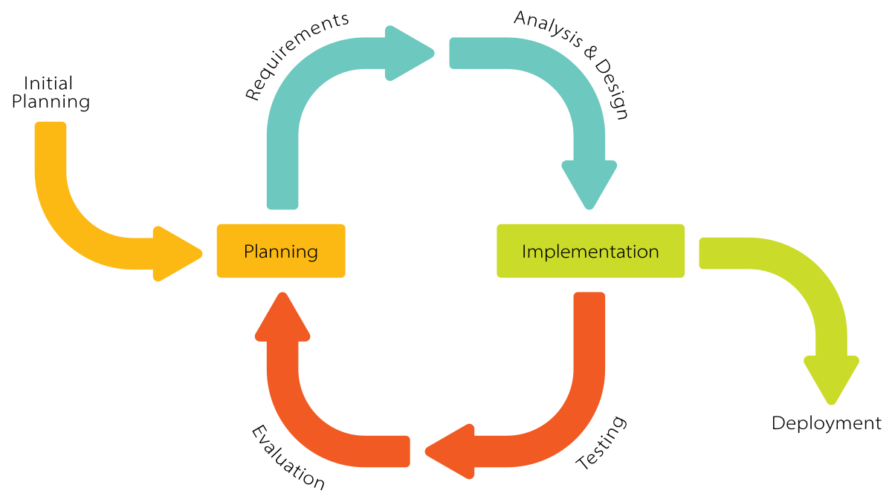

*Figure 2.1: Iterative and Incremental Software Process Model*

After researching the software development model carefully, the project will use the Iterative and Incremental Software Process Model. In an Iterative & Incremental model, initially, a partial implementation of a total system is constructed so that it will be in a deliverable state. The Iterative & Incremental model is mostly used when the scope of the project is big, the major requirements are defined clearly, some more details will be added later in software development. By using this software process model, we break down the developing system task into a series of smaller tasks which will be completed separately, allowing us to take advantage of what was learned during the development of earlier parts of the system. The reasons for the project to choose this model are:

* You can develop some main functions that prioritize requirements first.
* Requirements changes can be easily accommodated.
* Testing and debugging during smaller iterations are easy.
* Easier to manage risk easier because risk segments are identified and dealt with during its iteration.
* Customers can provide feedback to each product increment, thus avoiding surprises at the end of development.
* Customers get important functionality early

### 2.2 Quality Management

**2.2.1 Defect Prevention:**

* If any defect is found, the related person must be notified immediately at that time.
* Defects must be carefully evaluated such as "How bad is the defect and can it damage the system?", "How long is the time to fix that defect?".
* The deadline for fixing the defect must be specified clearly.
* There is always a plan to prepare for what could happen at any time.

**2.2.2 Reviewing:**

* The curator must be honest and not biased towards any of the project members. If there is an error, the person must immediately notify the person responsible for the defect.
* Defects should be recorded on the Bug Tracking software with details such as priority.
* The person responsible for defects found must-have solutions to fix the defect as quickly as possible.

**2.2.3 Unit Testing:**

* The curator must prepare the test cases carefully and accurately and must not ignore any cases. Test cases should be appropriate for the functionality of the system.
* Defects should be recorded on the Bug Tracking software with details such as priority.
* The person responsible for defects found must-have solutions to fix the defect as quickly as possible.

**2.2.4 Integration Testing:**

* The curator must prepare the test cases carefully and accurately and must not ignore any cases. Test cases should be appropriate for the functionality of the system.
* Defects should be recorded on the Bug Tracking software with details such as priority.
* The person responsible for defects found must-have solutions to fix the defect as quickly as possible.
* Internal modules within the system work smoothly.

**2.2.5 System Testing:**

* The curator must prepare test cases carefully and accurately. The test cases must match well with the system and system and architecture design.
* Defects should be recorded on the Bug Tracking software with details such as priority.
* The person responsible for defects found must-have solutions to fix the defect as quickly as possible.
* System testing test cases cover the entire system functionality and the communication under development with external systems.

### 2.3 Training Plan

|  |  |  |  |
| --- | --- | --- | --- |
| Training Area | Participants | When, Duration | Waiver Criteria |
| Java Spring Boot | Backend Members | 22/09/2022 to 29/09/2022 | Mandatory |
| React JS | Frontend Members | 22/09/2022 to 06/10/2022 | Mandatory |
| Gitlab | All Team members | 22/09/2022 to 25/09/2022 | Mandatory |

## 3. Project Deliverables

|  |  |  |  |
| --- | --- | --- | --- |
| **#** | **Deliverable** | **Due Date** | **Notes** |
| 1 | Project Introduction | 22/09/2022 | Prepare project ideals/ Intro |
| 2 | Project Management Plan | 29/09/2022 | Prepare Project Plan, Create Technical Prototype |
| 3 | Software Requirement Specification (SRS) | 06/10/2022 | Write SRS Document and Create Test Plan |
| 4 | Software Design Specification (SDS) | 16/10/2022 | Architecture Design, Detailed Design, Database |
| 5 | Code and Implement Iteration 1 | 06/11/2022 | Code & Unit test, Integration test and System test |
| 6 | Code and Implement Iteration 2 | 27/11/2022 | Code & Unit test, Integration test and System test |
| 7 | Code and Implement Iteration 3 | 18/12/2022 | Code & Unit test, Integration test and System test |
| 8 | Code and Implement Iteration 4 | 04/01/2023 | Code & Unit test, Integration test and System test |
| 9 | Test Documentation | 28/01/2023 | Write test documents and synthesize test cases |
| 10 | Software User Guides | 29/01/2023 | Write user manuals document |
| 11 | Final code and report | 30/01/2023 | Final Code, final report |

## 4. Responsibility Assignments

*D~Do; R~Review; S~Support; I~Informed; <blank>- Omitted*

|  |  |  |  |  |  |
| --- | --- | --- | --- | --- | --- |
| **Responsibility** | **ChuongNNHE14028** | **DungNTHE140858** | **TrinhPKHE140643** | **LongTNHE140955** | **HaHMHE140295** |
| Project Planning | S | S | R | R | D |
| Project Tracking | I | I | I | S | D |
| Project Introduction Document | S | D | R | R | D |
| Prepare SRS Document | S | I | I | S | D |
| Prepare SDD Document | S | I | I | S | D |
| Code Backend | I | I | D | D | I |
| Code Fronted App | D | D | I | S | I |
| Test Document and Report | S | S | S | D | R |

## 5. Project Communications

|  |  |  |  |  |
| --- | --- | --- | --- | --- |
| **Communication Item** | **Who/ Target** | **Purpose** | **When, Frequency** | **Type, Tool, Method(s)** |
| Weekly Meeting with Supervisor | Team members and supervisor | Report project progress.  Seek advice.  Submit documentation | Thursday | Offline |
| Weekly Meeting | Team members | Reports Review, tracking progress | Sunday, Tuesday | Google Meet |
| Daily Meeting | Team members | Task Review | Daily | Google Meet |
| Additional Meeting | Team members | Solving Issues | Unspecified | Google Meet |

## 6. Configuration Management

### 6.1 Project Management

Our project uses Jira to manage project task, schedule.



*Figure 2.2: Jira Software*

Jira is a [proprietary](https://en.wikipedia.org/wiki/Proprietary_software) [issue tracking](https://en.wikipedia.org/wiki/Issue_tracking_system) product developed by [Atlassian](https://en.wikipedia.org/wiki/Atlassian) that allows [bug tracking](https://en.wikipedia.org/wiki/Bug_tracking_system) and [agile](https://en.wikipedia.org/wiki/Agile_software_development) [project management](https://en.wikipedia.org/wiki/Project_management). Plan, track, and manage your agile and software development projects in Jira. Customize your workflow, collaborate, and release great software.

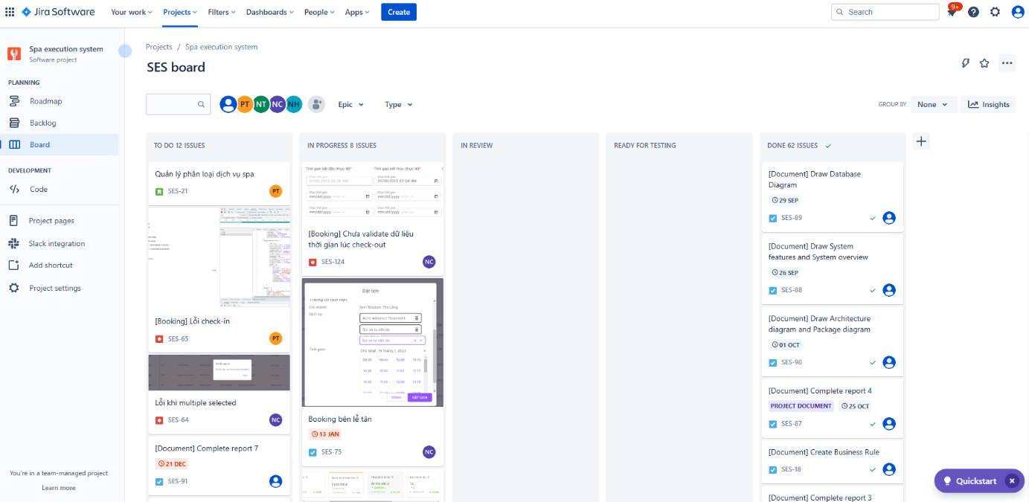

*Figure 2.3: Project’s board in Jira*

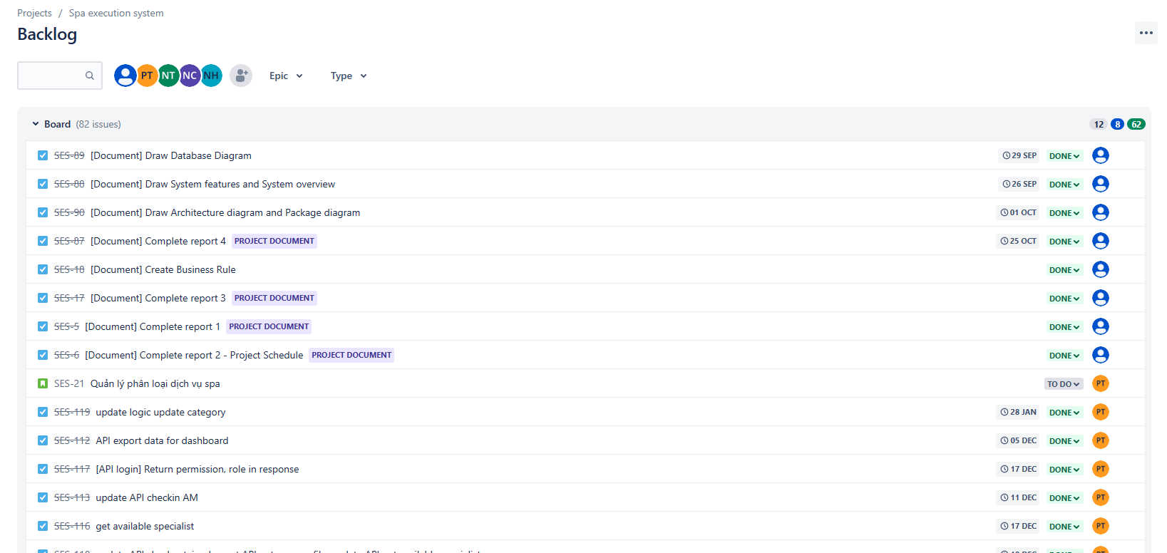

*Figure 2.4: Project’s backlog in Jira*

### 6.2 Document Management

Our project uses Confluence and Google Drive to manage project documents.

**- Confluence:**



*Figure 2.5: Confluence*

Confluence is a web-based corporate [wiki](https://en.wikipedia.org/wiki/Wiki) ([collaboration software](https://en.wikipedia.org/wiki/Collaboration_software)) developed by Australian software company [Atlassian](https://en.wikipedia.org/wiki/Atlassian). Atlassian wrote Confluence in the [Java](https://en.wikipedia.org/wiki/Java_(programming_language)) programming language and first published it in 2004. Confluence Standalone comes with a built-in Tomcat web server and [hsql](https://en.wikipedia.org/wiki/Hsql) database, and also supports other databases.

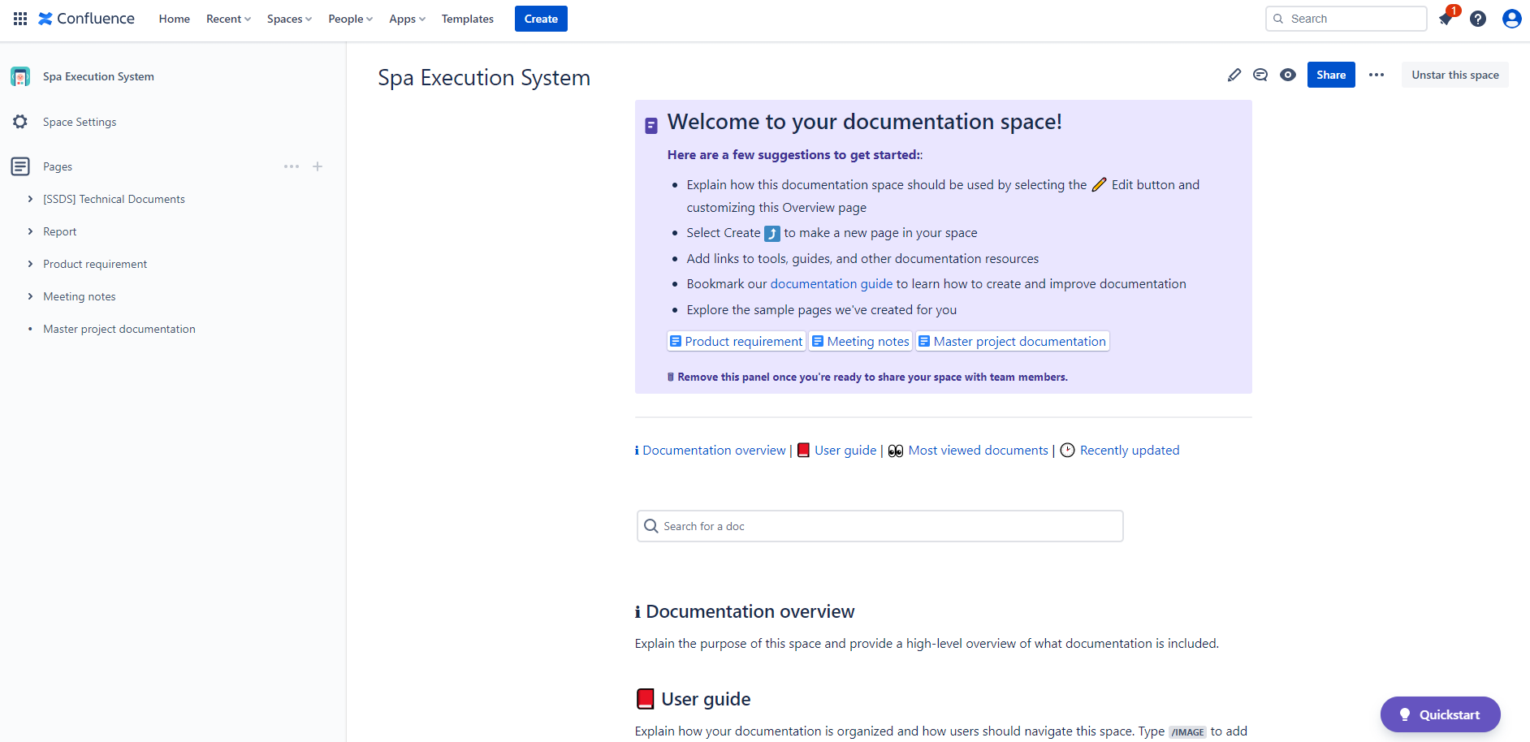

*Figure 2.6: Confluence Overview*

This is an example about APIs management in Confluence

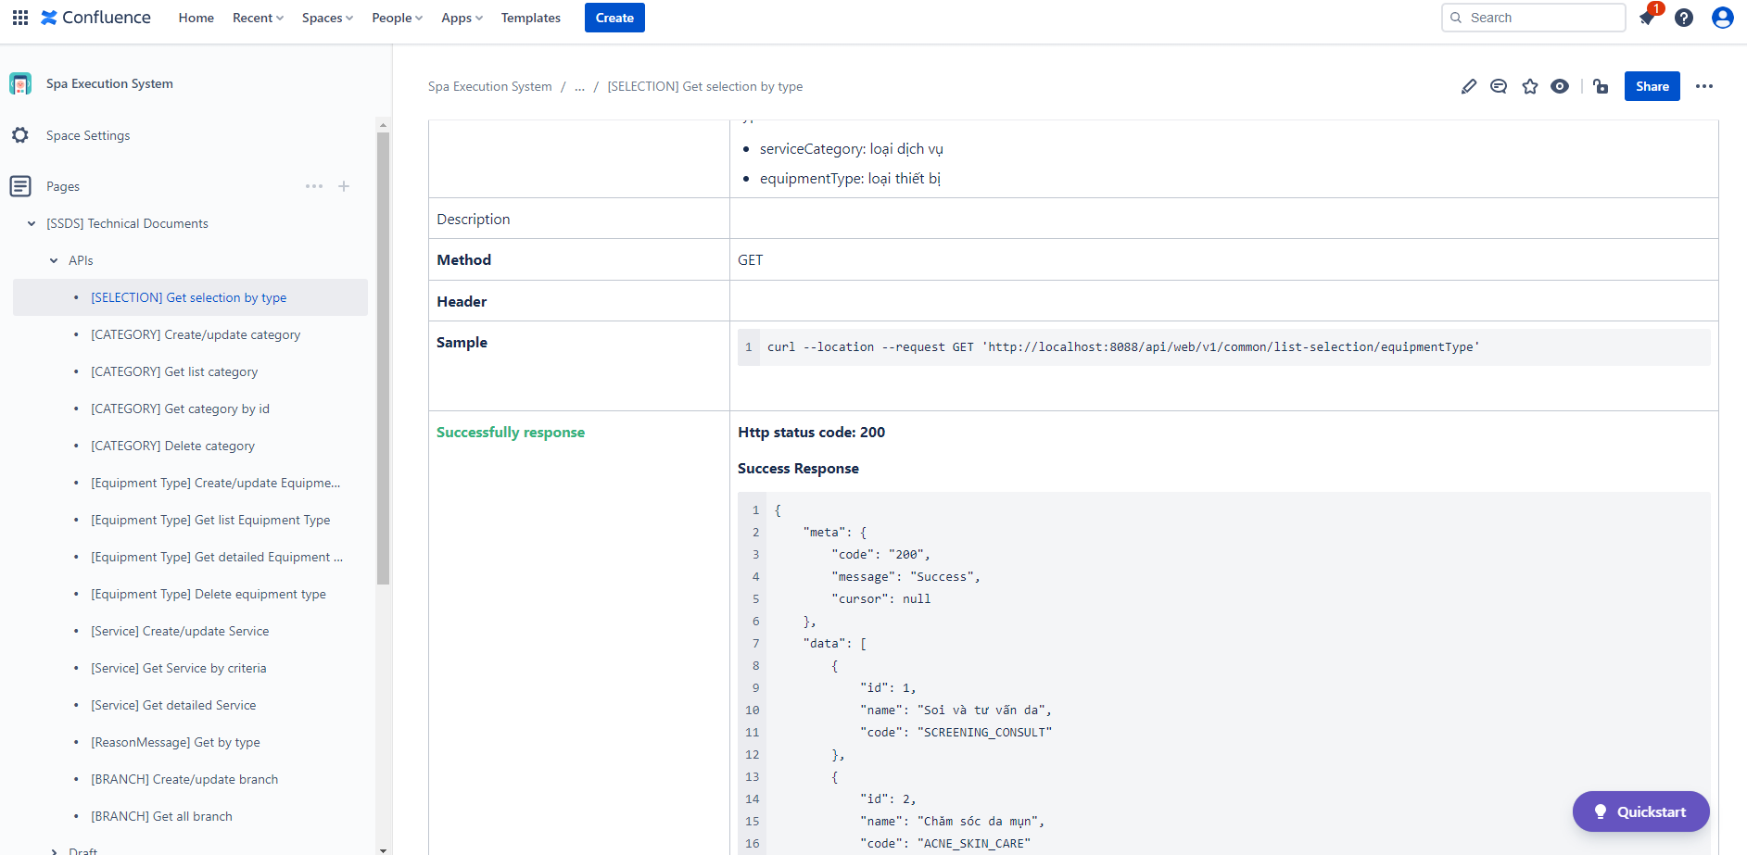

*Figure 2.7: APIs management in Confluence*

**- Google Drive:**



*Figure 2.8: Google Drive*

Google Drive is a [file storage](https://en.wikipedia.org/wiki/File_hosting_service) and [synchronization service](https://en.wikipedia.org/wiki/File_synchronization) developed by [Google](https://en.wikipedia.org/wiki/Google). Launched on April 24, 2012, Google Drive allows users to store files in the [cloud](https://en.wikipedia.org/wiki/Cloud_storage) (on Google's servers), synchronize files across devices, and [share files](https://en.wikipedia.org/wiki/File_sharing). In addition to a [web interface](https://en.wikipedia.org/wiki/Web_application), Google Drive offers apps with offline capabilities for [Windows](https://en.wikipedia.org/wiki/Microsoft_Windows) and [macOS](https://en.wikipedia.org/wiki/MacOS) computers, and [Android](https://en.wikipedia.org/wiki/Android_(operating_system)) and [iOS](https://en.wikipedia.org/wiki/IOS) smartphones and tablets. Google Drive encompasses [Google Docs](https://en.wikipedia.org/wiki/Google_Docs), [Google Sheets](https://en.wikipedia.org/wiki/Google_Sheets), and [Google Slides](https://en.wikipedia.org/wiki/Google_Slides), which are a part of the [Google Docs Editors](https://en.wikipedia.org/wiki/Google_Docs_Editors) [office suite](https://en.wikipedia.org/wiki/Office_suite) that permits collaborative editing of documents, spreadsheets, presentations, drawings, forms, and more. Files created and edited through the Google Docs suite are saved in Google Drive.

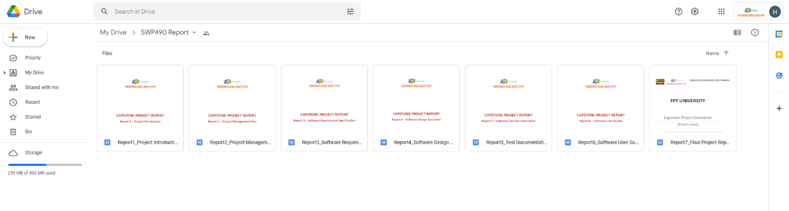

*Figure 2.9: Google Drive Overview*

### 6.3 Source Code Management

Our project uses GitLab to manage source code.

**- Gitlab**



*Figure 2.10: Gitlab*

GitLab helps you automate the builds, integration, and verification of your code. With SAST, DAST, code quality analysis, plus pipelines that enable concurrent testing and parallel execution, your teams get quick insights about every commit so they can deliver higher quality code faster.

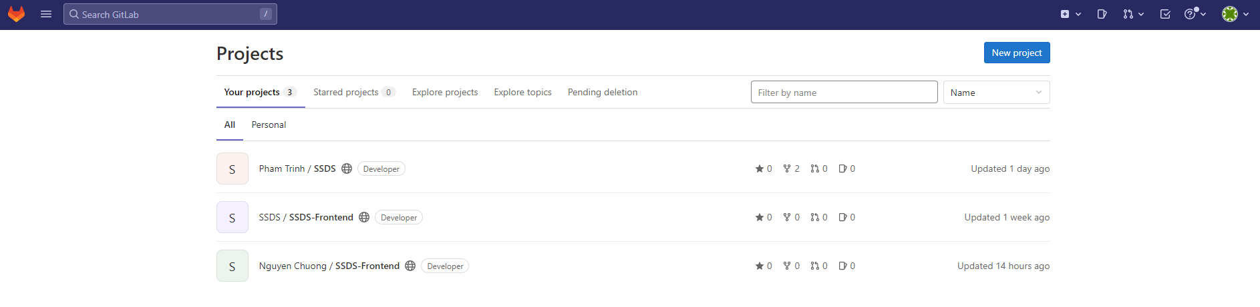

*Figure 2.11: Project management in GitLab*

This is a code management in GitLab.

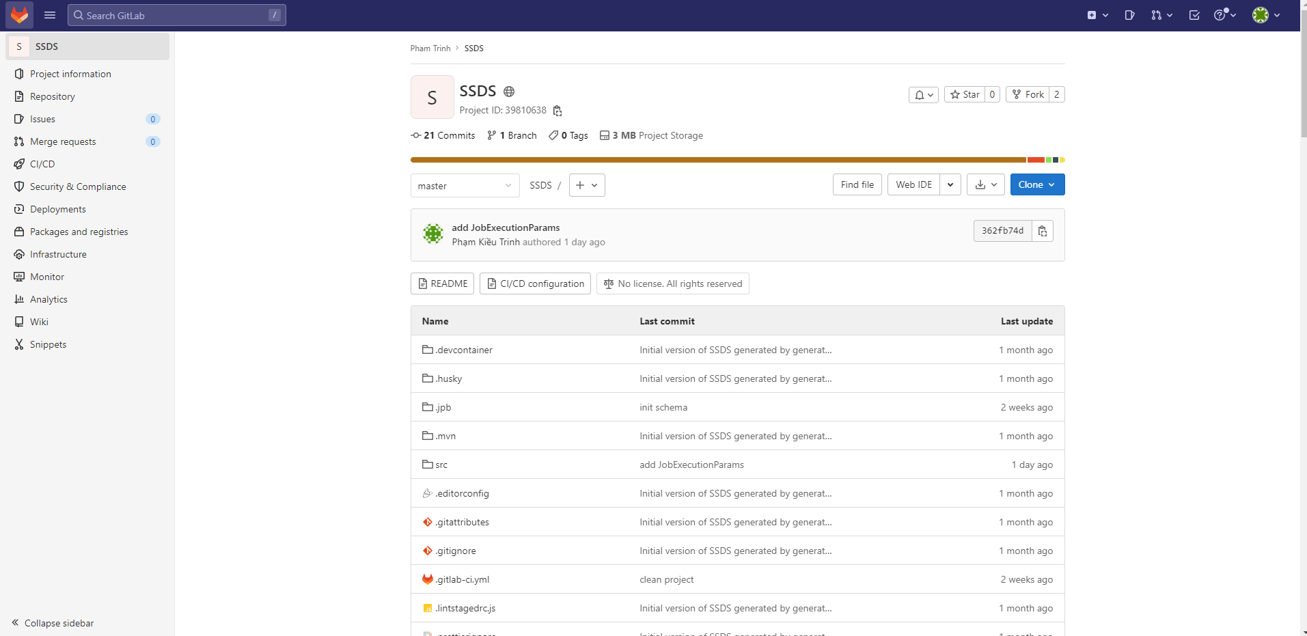

*Figure 2.12: Code management in GitLab*

### 6.4 Tools & Infrastructures

|  |  |
| --- | --- |
| **Category** | **Tools / Infrastructure** |
| **Technology** | ReactJS (FrontEnd), Java/SpringBoot (BackEnd), Kafka |
| **Database** | MySQL |
| **IDEs/Editors** | Visual Studio Code, IntelliJ, WebStorm |
| **Diagramming** | Figma, DrawIO |
| **Documentation** | Ms Office, Google Docs/Sheets/Slides |
| **Version Control** | GitLab (Source Codes), Confluence (Documents) |
| **Deployment server** | Amazon Web Services |
| **Third part** | Google Map Platform |
| **Project management** | Jira (Schedule, Tasks, Defects) |
| **Communication** | Messenger, Google Meet |

# III. Software Requirement Specification

## 1. Overall description

### 1.1 Product Overview

The Spa Service Providing System is a system that provide spa service for customer and system management for manager. This system is almost fully automatic, integrates many functions help users easy to use. Friendly Graphic User Interface, provide many details information about service, working order is handled smooth and reasonable. We commit that our system will overcome shorthrought of the other systems on current market and get the best performance.

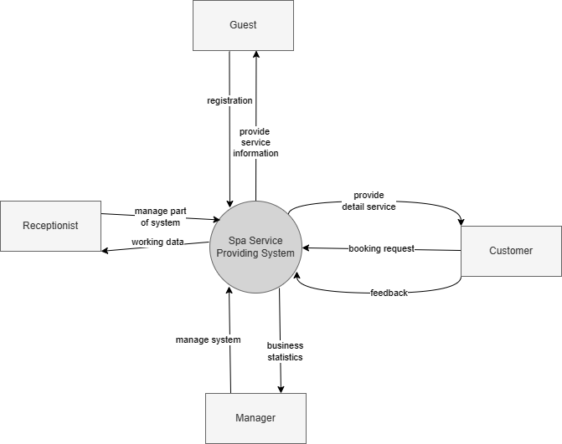

*Figure 3.1: Product Overview*

### 1.2 Bussiness Rules

|  |  |
| --- | --- |
| ID | Rule Definition |
| BR-01 | The website only active when it has been connected to the internet and server |
| BR-02 | Email must be valid |
| BR-03 | Phone number must be valid |
| BR-04 | Fullname must be at least 8 characters and contain no special characters and number |
| BR-05 | Password must be at least 8 characters, contains 1 uppercase letter, 1 number and 1 special character |
| BR-06 | Can’t register email, phone number that already registered |
| BR-07 | Can’t change registered email, phone number |
| BR-08 | User must use registered email to login |
| BR-09 | User can be only one of three roles: Customer, Receptionist, Manager |
| BR-10 | The default role after register on the website is Customer |
| BR-11 | Only Manager can change role of account |
| BR-12 | Each role has different permission to access the system |
| BR-13 | After register on the website, user must validate through email |
| BR-14 | Forgot password field must contain registered email |
| BR-15 | Date of birth must be from 1-1-1922 to current day |
| BR-16 | User can select many categories |
| BR-17 | Title of the post must contain less than 255 characters |
| BR-18 | Description of the post must contain less than 1000 characters |
| BR-19 | Image size should not exceed 5mb |
| BR-20 | Deactivated function will make relative object do not display on the website |
| BR-21 | Imported file must be excel file and in the right format |
| BR-22 | Text field must not empty |
| BR-23 | Address must contain less than 500 characters |
| BR-24 | Code must contain less than 255 characters |
| BR-25 | Name must contain less than 255 characters |
| BR-26 | Post list sorted by the latest time |
| BR-27 | Latitude and longitude must be float number |
| BR-28 | Booking appointment must follow step by step |
| BR-29 | SCA form can only be submitted if user answers all questions |

## 2. User Requirements

### 2.1 Actors

|  |  |  |
| --- | --- | --- |
| **#** | **Actor** | **Description** |
| 1 | Guest | Visitor who hasn’t registered |
| 2 | Customer | Has already registered an account with user role and experience the features for users on the website |
| 3 | Receptionist | Has already registered an account with receptionist role and manages appointments, spa specialists. |
| 4 | Manager | Has an account in the system with manager role and responsible for managing the whole system |

### 2.2 Use Cases

#### 2.2.1 Diagram(s)

- Overview

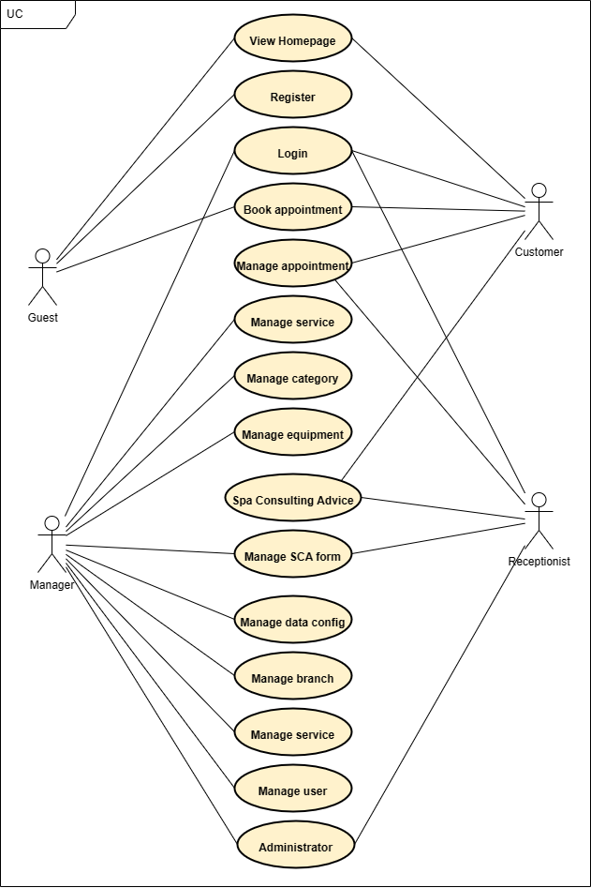

*Figure 3.2: Overview Use Case Diagram*

- Guest

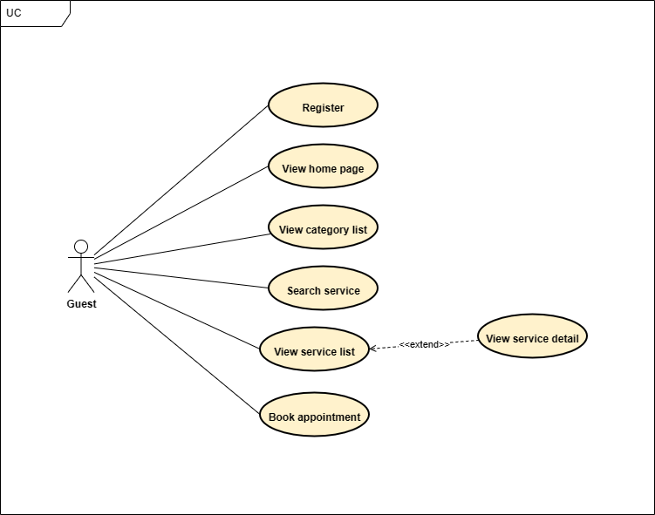

*Figure 3.3: Guest Use Case Diagram*

- Customer

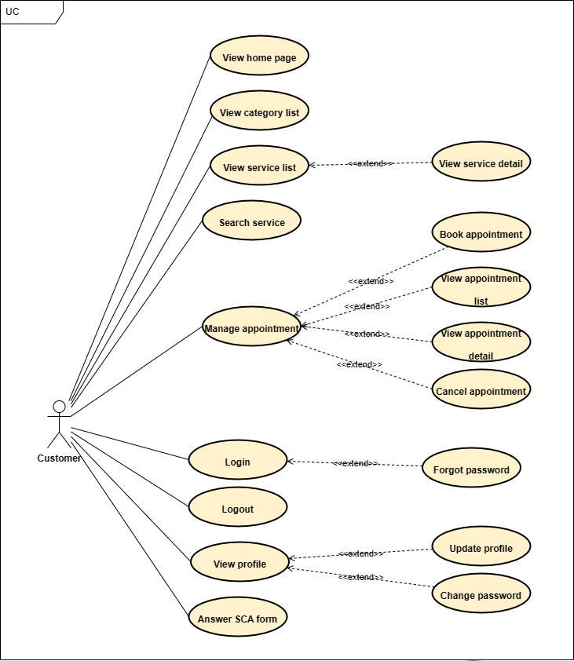

*Figure 3.4: Customer Use Case Diagram*

- Receptionist

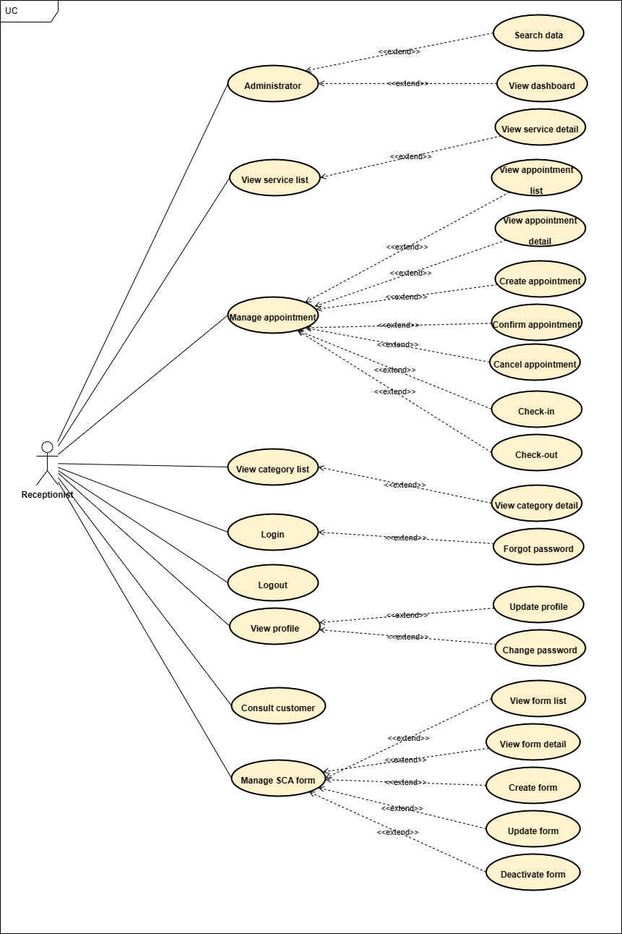

*Figure 3.5: Receptionist Use Case Diagram*

- Manager

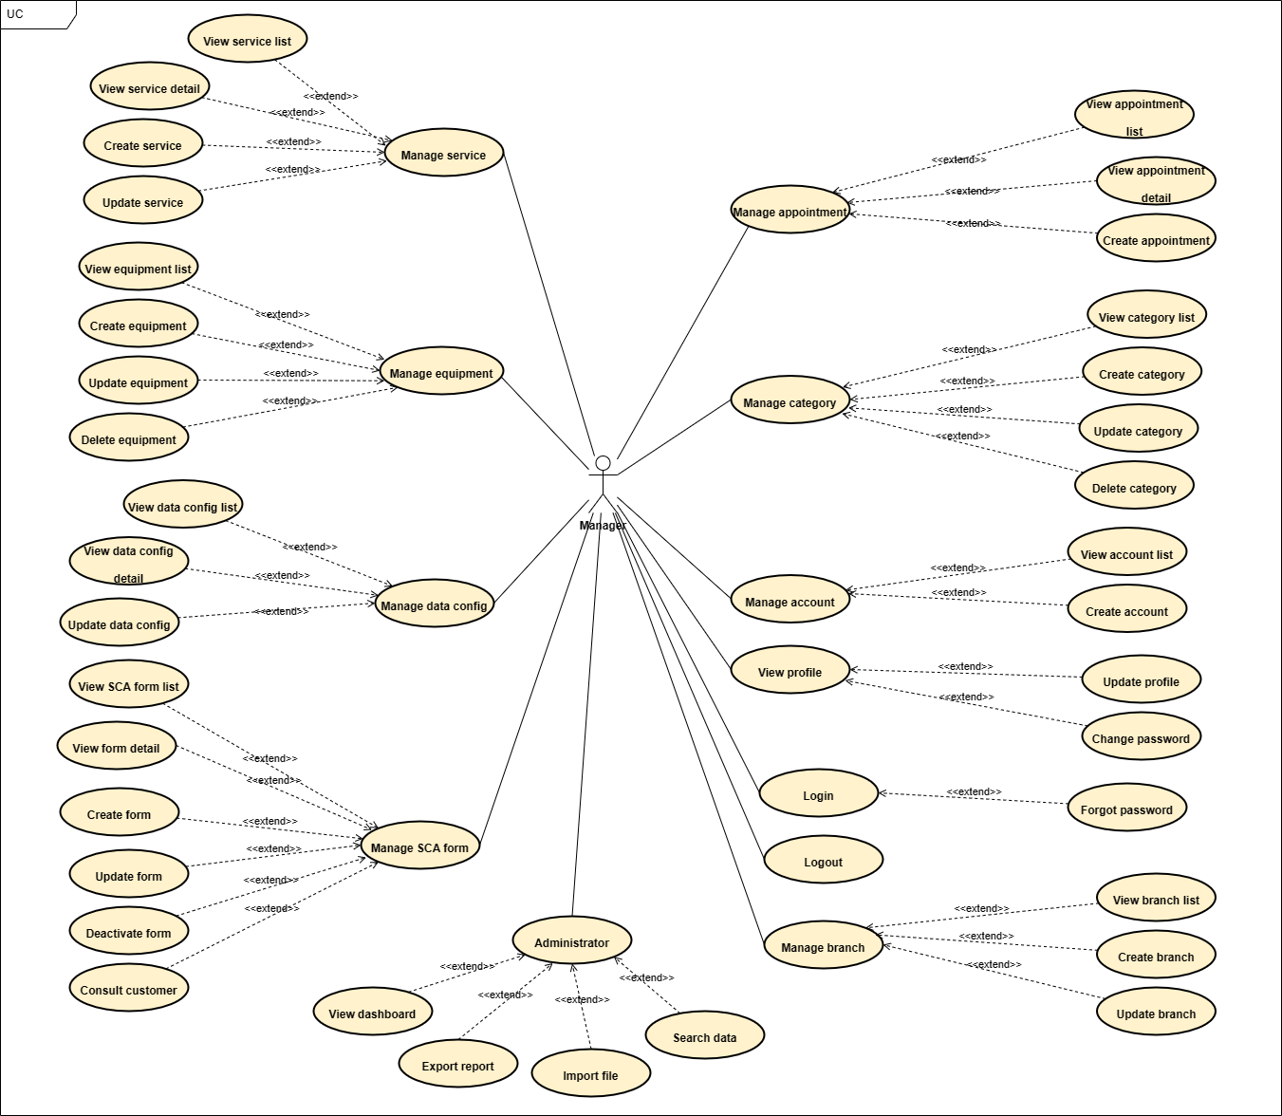

*Figure 3.6: Manager Use Case Diagram*

#### 2.2.2 Descriptions

|  |  |  |  |
| --- | --- | --- | --- |
| **Module** | **ID** | **Use Case** | **Actor** |
| Homepage | UC-01 | View homepage | Guest, Customer |
| Authentication | UC-02 | Register | Guest |
| UC-03 | Login | Customer, Receptionist, Manager |
| UC-04 | Forgot password | Customer, Receptionist, Manager |
| UC-05 | Logout | Customer, Receptionist, Manager |
| Manage profile | UC-06 | View profile | Customer, Receptionist, Manager |
| UC-07 | Update profile | Customer, Receptionist, Manager |
| UC-08 | Change password | Customer, Receptionist, Manager |
| Manage service | UC-09 | Search service | Guest, Customer |
| UC-10 | View service list | Guest, Customer, Receptionist, Manager |
| UC-11 | View service detail | Guest, Customer, Receptionist, Manager |
| UC-12 | Create service | Manager |
| UC-13 | Update service | Manager |
| Manage appointment | UC-14 | Book appointment | Guest, Customer |
| UC-15 | View appointment list | Customer, Receptionist, Manager |
| UC-16 | View appointment detail | Customer, Receptionist, Manager |
| UC-17 | Create appointment | Receptionist, Manager |
| UC-18 | Confirm appointment | Receptionist |
| UC-19 | Check-in | Receptionist |
| UC-20 | Check-out | Receptionist |
| UC-21 | Cancel appointment | Customer, Receptionist |
| Manage branch | UC-22 | View branch list | Receptionist, Manager |
| UC-23 | View branch detail | Receptionist, Manager |
| UC-24 | Create branch | Manager |
| UC-25 | Update branch | Manager |
| Manage category | UC-26 | View category list | Guest, Customer, Receptionist, Manager |
| UC-27 | View category detail | Receptionist, Manager |
| UC-28 | Create category | Manager |
| UC-29 | Update category | Manager |
| UC-30 | Delete category | Manager |
| Manage user | UC-31 | View user list | Receptionist, Manager |
| UC-32 | Create user | Receptionist, Manager |
| Manage equipment | UC-33 | View equipment list | Receptionist, Manager |
| UC-34 | View equipment detail | Receptionist, Manager |
| UC-35 | Create equipment | Manager |
| UC-36 | Update equipment | Manager |
| UC-37 | Delete equipment | Manager |
| Manage data config | UC-38 | View data config list | Receptionist, Manager |
| UC-39 | View data config detail | Receptionist, Manager |
| UC-40 | Update data config | Manager |
| Manage SCA form | UC-41 | View SCA form list | Receptionist, Manager |
| UC-42 | View SCA form detail | Receptionist, Manager |
| UC-43 | Create SCA form | Receptionist, Manager |
| UC-44 | Update SCA form | Receptionist, Manager |
| UC-45 | Deactivate SCA form | Receptionist, Manager |
| UC-46 | Answer SCA form | Customer |
| UC-47 | Consult customer | Receptionist, Manager |
| Administrator | UC-48 | View dashboard | Receptionist, Manager |
| UC-49 | Export report | Manager |
| UC-50 | Search data | Receptionist, Manager |
| UC-51 | Import file | Manager |

#### 2.2.3 Use case specification

**UC-01. View homepage**

|  |  |  |  |
| --- | --- | --- | --- |
| **Use Case ID** | UC-01 | **Use Case Name** | View homepage |
| **Create By** | HaHM | **Created Date** | 01/10/2022 |
| **Primary Actor** | Guest, Customer | **Secondary Actor** | N/A |
| **Description** | User wants to view homepage | | |
| **Pre-conditions** | N/A | | |
| **Post-conditions** | N/A | | |
| **Normal Flow** | 1. User goes to link “https://widen.dev/” | | |
| **Alternative Flow** | N/A | | |
| **Exceptions** | 1. The system cannot communicate with API server  2. Network error. | | |
| **Priority** | High | | |
| **Frequency of Use** | High | | |
| **Business Rules** | BR-01 | | |

**UC-02. Register**

|  |  |  |  |
| --- | --- | --- | --- |
| **Use Case ID** | UC-02 | **Use Case Name** | Register |
| **Create By** | HaHM | **Created Date** | 01/10/2022 |
| **Primary Actor** | Guest | **Secondary Actor** | N/A |
| **Description** | User wants to have an account on website | | |
| **Pre-conditions** | N/A | | |
| **Post-conditions** | N/A | | |
| **Normal Flow** | 1. User goes homepage.  2. User clicks on “Đăng ký” button.  3. The website displays the register screen.  4. User inputs all information needed.  5. User clicks on “Xác nhận” button. | | |
| **Alternative Flow** | User goes to link “https://widen.dev/signup” | | |
| **Exceptions** | E-1: The system cannot communicate with API server  E-2: Network error. | | |
| **Priority** | High | | |
| **Frequency of Use** | High | | |
| **Business Rules** | BR-01, BR-02, BR-03, BR-04, BR-05, BR-06, BR-10, BR-13 | | |

**UC-03. Login**

|  |  |  |  |
| --- | --- | --- | --- |
| **Use Case ID** | UC-03 | **Use Case Name** | Login |
| **Create By** | HaHM | **Created Date** | 01/10/2022 |
| **Primary Actor** | Customer, Receptionist, Manager | **Secondary Actor** | N/A |
| **Description** | User wants to login to website | | |
| **Pre-conditions** | PRE-1: User already has an account. | | |
| **Post-conditions** | POST-1: User is logged in to the system.  POST-2: User is redirected to the homepage. | | |
| **Normal Flow** | 1. User goes homepage  2. User clicks on “Đăng nhập” button.  3. The website displays the login screen.  4. User inputs all information needed.  5. User clicks on “Đăng nhập” button. | | |
| **Alternative Flow** | User goes to link “https://widen.dev/login” | | |
| **Exceptions** | E-1: The system cannot communicate with API server  E-2: Network error.  E-3: Not input all fields. | | |
| **Priority** | Low | | |
| **Frequency of Use** | Low | | |
| **Business Rules** | BR-01, BR-08, BR-09, BR-12 | | |

**UC-04. Forgot password**

|  |  |  |  |
| --- | --- | --- | --- |
| **Use Case ID** | UC-04 | **Use Case Name** | Forgot password |
| **Create By** | HaHM | **Created Date** | 01/10/2022 |
| **Primary Actor** | Customer, Receptionist, Manager | **Secondary Actor** | N/A |
| **Description** | User forgets password and want to take it back | | |
| **Pre-conditions** | PRE-1: User already has an account. | | |
| **Post-conditions** | POST-1: User gets new password by email. | | |
| **Normal Flow** | 1. User clicks on “Đăng nhập” button.  2. The website displays Login screen.  3. User clicks on “Quên mật khẩu” button.  4. The website displays Forgot password screen.  5. User inputs email or account name into field.  6. User clicks on “Gửi” button.  7. The system will send a new password to email linked to user’s account. | | |
| **Alternative Flow** | User goes to link “…” | | |
| **Exceptions** | E-1: The system cannot communicate with API server.  E-2: Network error.  E-3: User doesn’t have an account.  E-4: User inputs email or account that doesn’t exist in the system.  E-5: Not input all fields. | | |
| **Priority** | Low | | |
| **Frequency of Use** | Low | | |
| **Business Rules** | BR-01, BR-14 | | |

**UC-05. Logout**

|  |  |  |  |
| --- | --- | --- | --- |
| **Use Case ID** | UC-05 | **Use Case Name** | Logout |
| **Create By** | HaHM | **Created Date** | 01/10/2022 |
| **Primary Actor** | Customer, Receptionist, Manager | **Secondary Actor** | N/A |
| **Description** | User forgets password and want to take it back | | |
| **Pre-conditions** | PRE-1: User already has an account.  PRE-2: User has logged into the system. | | |
| **Post-conditions** | POST-1: User is logout of the system.  POST-2: User is redirected to the homepage. | | |
| **Normal Flow** | 1. User clicks on Avatar.  2. The website displays a drop-down list.  3. User clicks on “Logout” button. | | |
| **Alternative Flow** | N/A | | |
| **Exceptions** | E-1: The system cannot communicate with API server  E-2: Network error. | | |
| **Priority** | High | | |
| **Frequency of Use** | High | | |
| **Business Rules** | BR-01 | | |

**UC-06. View profile**

|  |  |  |  |
| --- | --- | --- | --- |
| **Use Case ID** | UC-06 | **Use Case Name** | View profile |
| **Create By** | HaHM | **Created Date** | 01/10/2022 |
| **Primary Actor** | Customer, Receptionist, Manager | **Secondary Actor** | N/A |
| **Description** | User wants to view detail information of his account | | |
| **Pre-conditions** | PRE-1: User already has an account.  PRE-2: User has logged into the system. | | |
| **Post-conditions** | N/A | | |
| **Normal Flow** | 1. User clicks on Avatar.  2. The website displays a drop-down list.  3. User clicks on “Tài khoản” button.  4. The website displays Profile screen. | | |
| **Alternative Flow** | N/A | | |
| **Exceptions** | E-1: The system cannot communicate with API server  E-2: Network error. | | |
| **Priority** | Medium | | |
| **Frequency of Use** | Medium | | |
| **Business Rules** | BR-01 | | |

**UC-07. Update profile**

|  |  |  |  |
| --- | --- | --- | --- |
| **Use Case ID** | UC-07 | **Use Case Name** | Update profile |
| **Create By** | HaHM | **Created Date** | 01/10/2022 |
| **Primary Actor** | Customer, Receptionist, Manager | **Secondary Actor** | N/A |
| **Description** | User wants to edit detail information of his account | | |
| **Pre-conditions** | PRE-1: User already has an account.  PRE-2: User has logged into the system. | | |
| **Post-conditions** | POST-1: User’s profile is update with new information. | | |
| **Normal Flow** | 1. User clicks on Avatar.  2. The website displays a drop-down list.  3. User clicks on “Tài khoản” button.  4. The website displays “Thông tin tài khoản” page.  5. User clicks on “Cập nhật thông tin” button.  6. User inputs all information needed.  7. User clicks on “Lưu thay đổi” button. | | |
| **Alternative Flow** | N/A | | |
| **Exceptions** | E-1: The system cannot communicate with API server  E-2: Network error.  E-3: Not input all fields. | | |
| **Priority** | Low | | |
| **Frequency of Use** | Low | | |
| **Business Rules** | BR-01, BR-07, BR-15, BR-22 | | |

**UC-08. Change password**

|  |  |  |  |
| --- | --- | --- | --- |
| **Use Case ID** | UC-08 | **Use Case Name** | Change password |
| **Create By** | HaHM | **Created Date** | 01/10/2022 |
| **Primary Actor** | Customer, Receptionist, Manager | **Secondary Actor** | N/A |
| **Description** | User wants to change password | | |
| **Pre-conditions** | PRE-1: User already has an account.  PRE-2: User has logged into the system. | | |
| **Post-conditions** | POST-1: User’s account is update with new password.  POST-2: User is redirected to View profile page. | | |
| **Normal Flow** | 1. User clicks on Avatar.  2. The website displays a drop-down list.  3. User clicks on “Tài khoản” button.  4. The website displays “Thông tin tài khoản” page.  5. User clicks on “Cập nhật thông tin” button.  6. The website displays “Cập nhật thông tin” screen.  7. User clicks on “Đổi mật khẩu” button.  8. The website displays “Đổi mật khẩu” screen.  9. User inputs all information needed.  10. User clicks on “Xác nhận” button. | | |
| **Alternative Flow** | N/A | | |
| **Exceptions** | E-1: The system cannot communicate with API server  E-2: Network error.  E-3: Not input all fields.  E-4: Wrong old password.  E-5: New password and Confirm new password is different. | | |
| **Priority** | Medium | | |
| **Frequency of Use** | Low | | |
| **Business Rules** | BR-01, BR-05 | | |

**UC-09. Search service**

|  |  |  |  |
| --- | --- | --- | --- |
| **Use Case ID** | UC-09 | **Use Case Name** | Search service |
| **Create By** | HaHM | **Created Date** | 01/10/2022 |
| **Primary Actor** | Guest, Customer | **Secondary Actor** | N/A |
| **Description** | User wants to find services that he looks for. | | |
| **Pre-conditions** | N/A | | |
| **Post-conditions** | N/A | | |
| **Normal Flow** | 1. User goes to “Dịch vụ” screen.  2. User inputs into search field.  3. User clicks on “Tìm kiếm” button.  4. The website displays result that user searchs for. | | |
| **Alternative Flow** | N/A | | |
| **Exceptions** | E-1: The system cannot communicate with API server  E-2: Network error. | | |
| **Priority** | Medium | | |
| **Frequency of Use** | High | | |
| **Business Rules** | BR-01, BR-22 | | |

**UC-10. View service list**

|  |  |  |  |
| --- | --- | --- | --- |
| **Use Case ID** | UC-10 | **Use Case Name** | View service list |
| **Create By** | HaHM | **Created Date** | 01/10/2022 |
| **Primary Actor** | Guest, Customer, Receptionist, Manager | **Secondary Actor** | N/A |
| **Description** | User wants to view all services | | |
| **Pre-conditions** | N/A | | |
| **Post-conditions** | N/A | | |
| **Normal Flow** | 1. User goes to homepage.  2. User clicks on “Dịch vụ” button.  3. The website displays “Dịch vụ” page. | | |
| **Alternative Flow** | User goes to link “…” | | |
| **Exceptions** | E-1: The system cannot communicate with API server  E-2: Network error. | | |
| **Priority** | High | | |
| **Frequency of Use** | High | | |
| **Business Rules** | BR-01 | | |

**UC-11. View service detail**

|  |  |  |  |
| --- | --- | --- | --- |
| **Use Case ID** | UC-11 | **Use Case Name** | View service detail |
| **Create By** | HaHM | **Created Date** | 01/10/2022 |
| **Primary Actor** | Guest, Customer, Receptionist, Manager | **Secondary Actor** | N/A |
| **Description** | User wants to view detail information of service | | |
| **Pre-conditions** | N/A | | |
| **Post-conditions** | POST-1: The website displays | | |
| **Normal Flow** | 1. User goes to “Dịch vụ” screen.  2. User clicks on service which user wants to view detail information. | | |
| **Alternative Flow** | User goes to link “…” | | |
| **Exceptions** | E-1: The system cannot communicate with API server  E-2: Network error. | | |
| **Priority** | High | | |
| **Frequency of Use** | High | | |
| **Business Rules** | BR-01 | | |

**UC-12. Create service**

|  |  |  |  |
| --- | --- | --- | --- |
| **Use Case ID** | UC-12 | **Use Case Name** | Create service |
| **Create By** | HaHM | **Created Date** | 01/10/2022 |
| **Primary Actor** | Manager | **Secondary Actor** | N/A |
| **Description** | User wants to create new service | | |
| **Pre-conditions** | PRE-1: User already has an account.  PRE-2: User has logged into the system by receptionist/manager role. | | |
| **Post-conditions** | POST-1: New service is created and displayed in service list. | | |
| **Normal Flow** | 1. User goes to “Quản lý” page.  2. User clicks on “Dịch vụ” button.  3. The website displays “Quản lý dịch vụ” screen.  4. User clicks on “Thêm dịch vụ” button.  5. User inputs all information needed into fields.  6. User clicks on “Thêm” button. | | |
| **Alternative Flow** | N/A | | |
| **Exceptions** | E-1: The system cannot communicate with API server  E-2: Network error.  E-3: Not input all fields. | | |
| **Priority** | Medium | | |
| **Frequency of Use** | Medium | | |
| **Business Rules** | BR-01, BR-22 | | |

**UC-13. Update service**

|  |  |  |  |
| --- | --- | --- | --- |
| **Use Case ID** | UC-13 | **Use Case Name** | Update service |
| **Create By** | HaHM | **Created Date** | 01/10/2022 |
| **Primary Actor** | Manager | **Secondary Actor** | N/A |
| **Description** | User wants to edit detail information of service | | |
| **Pre-conditions** | PRE-1: User already has an account.  PRE-2: User has logged into the system by receptionist/manager role. | | |
| **Post-conditions** | POST-1: New detail information is updated for service | | |
| **Normal Flow** | 1. User goes to “Quản lý” page.  2. User clicks on “Dịch vụ” button.  3. The website displays “Quản lý dịch vụ” screen.  4. User clicks on “Chỉnh sửa” button.  5. User inputs all information needed into fields.  6. User clicks on “Cập nhật” button. | | |
| **Alternative Flow** | N/A | | |
| **Exceptions** | E-1: The system cannot communicate with API server  E-2: Network error.  E-3: Not input all fields. | | |
| **Priority** | Medium | | |
| **Frequency of Use** | Medium | | |
| **Business Rules** | BR-01, BR-22 | | |

**UC-14. Book appointment**

|  |  |  |  |
| --- | --- | --- | --- |
| **Use Case ID** | UC-14 | **Use Case Name** | Book appointment |
| **Create By** | HaHM | **Created Date** | 01/10/2022 |
| **Primary Actor** | Guest, Customer | **Secondary Actor** | N/A |
| **Description** | User wants to book an appointment. | | |
| **Pre-conditions** | N/A | | |
| **Post-conditions** | POST-1: User has an appointment on the system. | | |
| **Normal Flow** | 1. User goes to homepage.  2. User clicks on “Đặt lịch” button.  3. The website displays “Đặt lịch” screen.  4. User inputs personal information then selects branch, service, datetime.  5. User clicks on “Đặt lịch” button.  6. The website displays a notification screen. | | |
| **Alternative Flow** | N/A | | |
| **Exceptions** | E-1: The system cannot communicate with API server  E-2: Network error.  E-3: User doesn’t select all information needed. | | |
| **Priority** | High | | |
| **Frequency of Use** | High | | |
| **Business Rules** | BR-01, BR-28 | | |

**UC-15. View appointment list**

|  |  |  |  |
| --- | --- | --- | --- |
| **Use Case ID** | UC-15 | **Use Case Name** | View appointment list |
| **Create By** | HaHM | **Created Date** | 01/10/2022 |
| **Primary Actor** | Customer, Receptionist, Manager | **Secondary Actor** | N/A |
| **Description** | User wants to view all appointment that he can manage. | | |
| **Pre-conditions** | PRE-1: User already has an account.  PRE-2: User has logged into the system. | | |
| **Post-conditions** | POST-1: The website displays all appointment. | | |
| **Normal Flow** | 1. User goes to “Quản lý” page.  2. User clicks on “Lịch hẹn” button.  3. The website displays “Quản lý lịch hẹn” screen. | | |
| **Alternative Flow** | N/A | | |
| **Exceptions** | E-1: The system cannot communicate with API server  E-2: Network error. | | |
| **Priority** | Medium | | |
| **Frequency of Use** | High | | |
| **Business Rules** | BR-01 | | |

**UC-16. View appointment detail**

|  |  |  |  |
| --- | --- | --- | --- |
| **Use Case ID** | UC-16 | **Use Case Name** | View appointment detail |
| **Create By** | HaHM | **Created Date** | 01/10/2022 |
| **Primary Actor** | Customer, Receptionist, Manager | **Secondary Actor** | N/A |
| **Description** | User wants to view detail information of an appointment. | | |
| **Pre-conditions** | PRE-1: User already has an account.  PRE-2: User has logged into the system. | | |
| **Post-conditions** | N/A | | |
| **Normal Flow** | 1. User goes to “Quản lý” page.  2. User clicks on “Lịch hẹn” button.  3. The website displays “Quản lý lịch hẹn” page.  4. User clicks on an appointment that user wants to view detail.  5. The website displays detail information of an appointment. | | |
| **Alternative Flow** | N/A | | |
| **Exceptions** | E-1: The system cannot communicate with API server  E-2: Network error. | | |
| **Priority** | Medium | | |
| **Frequency of Use** | High | | |
| **Business Rules** | BR-01 | | |

**UC-17. Create appointment**

|  |  |  |  |
| --- | --- | --- | --- |
| **Use Case ID** | UC-17 | **Use Case Name** | Create appointment |
| **Create By** | HaHM | **Created Date** | 01/10/2022 |
| **Primary Actor** | Receptionist, Manager | **Secondary Actor** | N/A |
| **Description** | User wants to create an appointment for customer when customer doesn’t have an account to book appointment. | | |
| **Pre-conditions** | PRE-1: User already has an account.  PRE-2: User has logged into the system by Receptionist, Manager role. | | |
| **Post-conditions** | POST-1: New appointment is created in the system. | | |
| **Normal Flow** | 1. User goes to “Quản lý” page.  2. User clicks on “Lịch hẹn” button.  3. The website displays “Quản lý lịch hẹn” screen.  4. User clicks on “Đặt lịch” button.  5. User inputs customer’s name, phone number, service, datetime into fields.  6. User clicks on “Đặt lịch” button. | | |
| **Alternative Flow** | N/A | | |
| **Exceptions** | E-1: The system cannot communicate with API server  E-2: Network error.  E-3: Not inputs all fields. | | |
| **Priority** | Medium | | |
| **Frequency of Use** | Medium | | |
| **Business Rules** | BR-01 | | |

**UC-18. Confirm appointment**

|  |  |  |  |
| --- | --- | --- | --- |
| **Use Case ID** | UC-18 | **Use Case Name** | Confirm appointment |
| **Create By** | HaHM | **Created Date** | 01/10/2022 |
| **Primary Actor** | Receptionist | **Secondary Actor** | N/A |
| **Description** | User wants to confirm an appointment which is booked. | | |
| **Pre-conditions** | PRE-1: User already has an account.  PRE-2: User has logged into the system. | | |
| **Post-conditions** | POST-1: An appointment is confirmed on the system. | | |
| **Normal Flow** | 1. User goes to “Quản lý” page.  2. User clicks on “Lịch hẹn” button.  3. The website displays “Quản lý lịch hẹn” page.  4. User clicks on “Xác nhận” button.  5. The website displays “Xác nhận lịch hẹn” screen.  6. User selects “Hành động” status.  7. User clicks on “Xác nhận” button. | | |
| **Alternative Flow** | N/A | | |
| **Exceptions** | E-1: The system cannot communicate with API server  E-2: Network error.  E-3: Not inputs all fields. | | |
| **Priority** | High | | |
| **Frequency of Use** | Medium | | |
| **Business Rules** | BR-01, BR-22 | | |

**UC-19. Check-in**

|  |  |  |  |
| --- | --- | --- | --- |
| **Use Case ID** | UC-19 | **Use Case Name** | Check-in |
| **Create By** | HaHM | **Created Date** | 01/10/2022 |
| **Primary Actor** | Receptionist | **Secondary Actor** | N/A |
| **Description** | User wants to check-in an appointment | | |
| **Pre-conditions** | PRE-1: User already has an account.  PRE-2: User has logged into the system by Receptionist role. | | |
| **Post-conditions** | POST-1: An appointment is checked in on the system. | | |
| **Normal Flow** | 1. User goes to “Quản lý” page.  2. User clicks on “Lịch hẹn” button.  3. The website displays “Quản lý lịch hẹn” page.  4. User clicks on “Check-in” button.  5. The website displays “Check-in” screen.  6. User selects started time, first service, specialist.  7. User clicks on “Check-in” button. | | |
| **Alternative Flow** | N/A | | |
| **Exceptions** | E-1: The system cannot communicate with API server  E-2: Network error.  E-3: Not inputs all fields. | | |
| **Priority** | High | | |
| **Frequency of Use** | Medium | | |
| **Business Rules** | BR-01, BR-22 | | |

**UC-20. Check-out**

|  |  |  |  |
| --- | --- | --- | --- |
| **Use Case ID** | UC-20 | **Use Case Name** | Check-out |
| **Create By** | HaHM | **Created Date** | 01/10/2022 |
| **Primary Actor** | Receptionist | **Secondary Actor** | N/A |
| **Description** | User wants to check-out an appointment | | |
| **Pre-conditions** | PRE-1: User already has an account.  PRE-2: User has logged into the system by Receptionist role. | | |
| **Post-conditions** | POST-1: An appointment is checked out on the system. | | |
| **Normal Flow** | 1. User goes to “Quản lý” page.  2. User clicks on “Lịch hẹn” button.  3. The website displays “Quản lý lịch hẹn” page.  4. User clicks on “Check-out” button.  5. The website displays “Check-out” screen.  6. User selects end time, uploads bill.  7. User clicks on “Check-out” button. | | |
| **Alternative Flow** | N/A | | |
| **Exceptions** | E-1: The system cannot communicate with API server  E-2: Network error.  E-3: Not inputs all fields. | | |
| **Priority** | High | | |
| **Frequency of Use** | Medium | | |
| **Business Rules** | BR-01, BR-22 | | |

**UC-21. Cancel appointment**

|  |  |  |  |
| --- | --- | --- | --- |
| **Use Case ID** | UC-21 | **Use Case Name** | Cancel appointment |
| **Create By** | HaHM | **Created Date** | 01/10/2022 |
| **Primary Actor** | Customer, Receptionist | **Secondary Actor** | N/A |
| **Description** | User wants to cancel appointment which is booked. | | |
| **Pre-conditions** | PRE-1: User already has an account.  PRE-2: User has logged into the system.  PRE-3: User has booked an appointment. | | |
| **Post-conditions** | POST-1: An appointment is updated on the system. | | |
| **Normal Flow** | 1. User goes to “Quản lý” page.  2. User clicks on “Lịch hẹn” button.  3. The website displays “Quản lý lịch hẹn” page.  4. User selects an appointment and clicks on “Hủy” button.  5. The website displays “Hủy lịch hẹn” screen.  6. User clicks on “Lý do hủy” button and selects status.  7. User clicks on “Xác nhận” button. | | |
| **Alternative Flow** | N/A | | |
| **Exceptions** | E-1: The system cannot communicate with API server  E-2: Network error.  E-3: Not inputs all fields. | | |
| **Priority** | High | | |
| **Frequency of Use** | Medium | | |
| **Business Rules** | BR-01 | | |

**UC-22. View branch list**

|  |  |  |  |
| --- | --- | --- | --- |
| **Use Case ID** | UC-22 | **Use Case Name** | View branch list |
| **Create By** | HaHM | **Created Date** | 01/10/2022 |
| **Primary Actor** | Receptionist, Manager | **Secondary Actor** | N/A |
| **Description** | User wants to view all branches in the system. | | |
| **Pre-conditions** | PRE-1: User already has an account.  PRE-2: User has logged into the system. | | |
| **Post-conditions** | N/A | | |
| **Normal Flow** | 1. User goes to “Quản lý” page.  2. User clicks on “Chi nhánh” button.  3. The website displays “Quản lý chi nhánh” page. | | |
| **Alternative Flow** | N/A | | |
| **Exceptions** | E-1: The system cannot communicate with API server  E-2: Network error. | | |
| **Priority** | High | | |
| **Frequency of Use** | Low | | |
| **Business Rules** | BR-01 | | |

**UC-23. View branch detail**

|  |  |  |  |
| --- | --- | --- | --- |
| **Use Case ID** | UC-23 | **Use Case Name** | View branch detail |
| **Create By** | HaHM | **Created Date** | 01/10/2022 |
| **Primary Actor** | Receptionist, Manager | **Secondary Actor** | N/A |
| **Description** | User wants to view detail information of a branch | | |
| **Pre-conditions** | PRE-1: User already has an account.  PRE-2: User has logged into the system by Manager role. | | |
| **Post-conditions** | POST-1: A new branch is created in the system. | | |
| **Normal Flow** | 1. User goes to “Quản lý” page.  2. User clicks on “Chi nhánh” button.  3. The website displays “Quản lý chi nhánh” page.  4. User clicks on “Xem chi tiết” button. | | |
| **Alternative Flow** | N/A | | |
| **Exceptions** | E-1: The system cannot communicate with API server  E-2: Network error.  E-3: Not input all fields. | | |
| **Priority** | High | | |
| **Frequency of Use** | Low | | |
| **Business Rules** | BR-01, BR-22, BR-23, BR-24, BR-25 | | |

**UC-24. Create branch**

|  |  |  |  |
| --- | --- | --- | --- |
| **Use Case ID** | UC-24 | **Use Case Name** | Create branch |
| **Create By** | HaHM | **Created Date** | 01/10/2022 |
| **Primary Actor** | Manager | **Secondary Actor** | N/A |
| **Description** | User wants to create new branch in the system. | | |
| **Pre-conditions** | PRE-1: User already has an account.  PRE-2: User has logged into the system by Manager role. | | |
| **Post-conditions** | POST-1: A new branch is created in the system. | | |
| **Normal Flow** | 1. User goes to “Quản lý” page.  2. User clicks on “Chi nhánh” button.  3. The website displays “Quản lý chi nhánh” page.  4. User clicks on “Thêm chi nhánh” button.  5. The website displays “Thêm chi nhánh” screen.  6. User inputs branch’s name, address, phone number into fields.  7. User clicks on “Thêm” button. | | |
| **Alternative Flow** | N/A | | |
| **Exceptions** | E-1: The system cannot communicate with API server  E-2: Network error.  E-3: Not input all fields. | | |
| **Priority** | High | | |
| **Frequency of Use** | Low | | |
| **Business Rules** | BR-01, BR-22, BR-23, BR-24, BR-25 | | |

**UC-25. Update branch**

|  |  |  |  |
| --- | --- | --- | --- |
| **Use Case ID** | UC-25 | **Use Case Name** | Update branch |
| **Create By** | HaHM | **Created Date** | 01/10/2022 |
| **Primary Actor** | Manager | **Secondary Actor** | N/A |
| **Description** | User wants to edit detail information of a branch | | |
| **Pre-conditions** | PRE-1: User already has an account.  PRE-2: User has logged into the system by Manager role. | | |
| **Post-conditions** | POST-1: A branch is updated in the system. | | |
| **Normal Flow** | 1. User goes to “Quản lý” page.  2. User clicks on “Chi nhánh” button.  3. The website displays “Quản lý chi nhánh” page.  4. User clicks on “Chỉnh sửa” button.  5. The website displays “Chỉnh sửa chi nhánh” screen.  6. User inputs branch’s name, address, phone number into fields.  7. User clicks on “Cập nhật” button. | | |
| **Alternative Flow** | N/A | | |
| **Exceptions** | E-1: The system cannot communicate with API server  E-2: Network error.  E-3: Not input all fields. | | |
| **Priority** | High | | |
| **Frequency of Use** | Low | | |
| **Business Rules** | BR-01, BR-22, BR-23, BR-24, BR-25 | | |

**UC-26: View category list**

|  |  |  |  |
| --- | --- | --- | --- |
| **Use Case ID** | UC-26 | **Use Case Name** | View category list |
| **Create By** | HaHM | **Created Date** | 01/10/2022 |
| **Primary Actor** | Guest, Customer, Receptionist, Manager | **Secondary Actor** | N/A |
| **Description** | User wants to view all categories | | |
| **Pre-conditions** | *\*Guest, Customer role has no pre-conditions*  PRE-1: User already has an account.  PRE-2: User has logged into the system by Receptionist/Manager role. | | |
| **Post-conditions** | N/A | | |
| **Normal Flow** | - On Guest, Customer role:  1. User goes to “Dịch vụ” page.  2. The website displays categories on the left side of “Dịch vụ” page.  - On Receptionist/Manager role:  1. User goes to “Quản lý” page.  2. User clicks on “Danh mục” button.  3. The website displays “Quản lý danh mục” page. | | |
| **Alternative Flow** | N/A | | |
| **Exceptions** | E-1: The system cannot communicate with API server  E-2: Network error.  E-3: User selects malformed file. | | |
| **Priority** | High | | |
| **Frequency of Use** | Low | | |
| **Business Rules** | BR-01, BR-16 | | |

**UC-27: View category detail**

|  |  |  |  |
| --- | --- | --- | --- |
| **Use Case ID** | UC-27 | **Use Case Name** | View category detail |
| **Create By** | HaHM | **Created Date** | 01/10/2022 |
| **Primary Actor** | Receptionist, Manager | **Secondary Actor** | N/A |
| **Description** | User wants to create a new category | | |
| **Pre-conditions** | PRE-1: User already has an account.  PRE-2: User has logged into the system by Manager role. | | |
| **Post-conditions** | POST-1: A new category is created in the system. | | |
| **Normal Flow** | 1. User goes to “Quản lý” page.  2. User clicks on “Danh mục” button.  3. The website displays “Quản lý danh mục” page.  4. User clicks on “Thêm chi tiết” button. | | |
| **Alternative Flow** | N/A | | |
| **Exceptions** | E-1: The system cannot communicate with API server  E-2: Network error.  E-3: Not input all fields. | | |
| **Priority** | High | | |
| **Frequency of Use** | Low | | |
| **Business Rules** | BR-01, BR-22 | | |

**UC-28: Create category**

|  |  |  |  |
| --- | --- | --- | --- |
| **Use Case ID** | UC-28 | **Use Case Name** | Create category |
| **Create By** | HaHM | **Created Date** | 01/10/2022 |
| **Primary Actor** | Manager | **Secondary Actor** | N/A |
| **Description** | User wants to create a new category | | |
| **Pre-conditions** | PRE-1: User already has an account.  PRE-2: User has logged into the system by Manager role. | | |
| **Post-conditions** | POST-1: A new category is created in the system. | | |
| **Normal Flow** | 1. User goes to “Quản lý” page.  2. User clicks on “Danh mục” button.  3. The website displays “Quản lý danh mục” page.  4. User clicks on “Thêm danh mục” button.  5. User inputs name, description and selects service.  6. User clicks on “Thêm” button. | | |
| **Alternative Flow** | N/A | | |
| **Exceptions** | E-1: The system cannot communicate with API server  E-2: Network error.  E-3: Not input all fields. | | |
| **Priority** | High | | |
| **Frequency of Use** | Low | | |
| **Business Rules** | BR-01, BR-22 | | |

**UC-29: Update category**

|  |  |  |  |
| --- | --- | --- | --- |
| **Use Case ID** | UC-29 | **Use Case Name** | Update category |
| **Create By** | HaHM | **Created Date** | 01/10/2022 |
| **Primary Actor** | Manager | **Secondary Actor** | N/A |
| **Description** | User wants to edit detail information of a category | | |
| **Pre-conditions** | PRE-1: User already has an account.  PRE-2: User has logged into the system by Manager role. | | |
| **Post-conditions** | POST-1: A category is updated in the system. | | |
| **Normal Flow** | 1. User goes to “Quản lý” page.  2. User clicks on “Danh mục” button.  3. The website displays “Quản lý danh mục” page.  4. User clicks on “Chỉnh sửa” button.  5. The website displays “Chỉnh sửa danh mục” screen.  6. User inputs name, description and selects service.  7. User clicks on “Cập nhật” button. | | |
| **Alternative Flow** | N/A | | |
| **Exceptions** | E-1: The system cannot communicate with API server  E-2: Network error.  E-3: Not input all fields. | | |
| **Priority** | High | | |
| **Frequency of Use** | Low | | |
| **Business Rules** | BR-01, BR-22 | | |

**UC-30: Delete category**

|  |  |  |  |
| --- | --- | --- | --- |
| **Use Case ID** | UC-30 | **Use Case Name** | Delete category |
| **Create By** | HaHM | **Created Date** | 01/10/2022 |
| **Primary Actor** | Manager | **Secondary Actor** | N/A |
| **Description** | User wants to deactivate a category | | |
| **Pre-conditions** | PRE-1: User already has an account.  PRE-2: User has logged into the system by Manager role. | | |
| **Post-conditions** | POST-1: A category is deleted | | |
| **Normal Flow** | 1. User goes to “Quản lý” page.  2. User clicks on “Danh mục” button.  3. The website displays “Quản lý danh mục” page.  4. User clicks on “Xóa” button. | | |
| **Alternative Flow** | N/A | | |
| **Exceptions** | E-1: The system cannot communicate with API server  E-2: Network error. | | |
| **Priority** | High | | |
| **Frequency of Use** | Low | | |
| **Business Rules** | BR-01 | | |

**UC-31. View user list**

|  |  |  |  |
| --- | --- | --- | --- |
| **Use Case ID** | UC-31 | **Use Case Name** | View user list |
| **Create By** | HaHM | **Created Date** | 01/10/2022 |
| **Primary Actor** | Receptionist, Manager | **Secondary Actor** | N/A |
| **Description** | User wants to view all accounts | | |
| **Pre-conditions** | PRE-1: User already has an account.  PRE-2: User has logged into the system by Receptionist/Manager role. | | |
| **Post-conditions** | POST-1: A category is not displayed on the website | | |
| **Normal Flow** | 1. User goes to “Quản lý” page.  2. User clicks on “Người dùng” button.  3. The website displays “Quản lý người dùng” page. | | |
| **Alternative Flow** | N/A | | |
| **Exceptions** | E-1: The system cannot communicate with API server  E-2: Network error. | | |
| **Priority** | High | | |
| **Frequency of Use** | Low | | |
| **Business Rules** | BR-01, BR-22 | | |

**UC-32. Create user**

|  |  |  |  |
| --- | --- | --- | --- |
| **Use Case ID** | UC-32 | **Use Case Name** | Create user |
| **Create By** | HaHM | **Created Date** | 01/10/2022 |
| **Primary Actor** | Receptionist, Manager | **Secondary Actor** | N/A |
| **Description** | User wants to create a new account | | |
| **Pre-conditions** | PRE-1: User already has an account.  PRE-2: User has logged into the system by Manager role. | | |
| **Post-conditions** | POST-1: A new account is created in the system. | | |
| **Normal Flow** | 1. User goes to “Quản lý” page.  2. User clicks on “Người dùng” button.  3. The website displays “Quản lý người dùng” page.  4. User clicks on “Thêm người dùng” button.  5. The website displays “Thêm người dùng” screen.  6. User inputs name, account’s name, password, phone number, email, date of birth, gender and selects role.  7. User clicks on “Tạo” button. | | |
| **Alternative Flow** | N/A | | |
| **Exceptions** | E-1: The system cannot communicate with API server  E-2: Network error.  E-3: Not input all fields. | | |
| **Priority** | High | | |
| **Frequency of Use** | Low | | |
| **Business Rules** | BR-01, BR-22 | | |

**UC-33. View equipment list**

|  |  |  |  |
| --- | --- | --- | --- |
| **Use Case ID** | UC-33 | **Use Case Name** | View equipment list |
| **Create By** | HaHM | **Created Date** | 01/10/2022 |
| **Primary Actor** | Receptionist, Manager | **Secondary Actor** | N/A |
| **Description** | User wants to view all equipments in the system | | |
| **Pre-conditions** | PRE-1: User already has an account.  PRE-2: User has logged into the system by Receptionist, Manger role. | | |
| **Post-conditions** | N/A | | |
| **Normal Flow** | 1. User goes to “Quản lý” page.  2. User clicks on “Thiết bị” button.  3. The website displays “Quản lý thiết bị” page. | | |
| **Alternative Flow** | N/A | | |
| **Exceptions** | E-1: The system cannot communicate with API server  E-2: Network error. | | |
| **Priority** | High | | |
| **Frequency of Use** | Medium | | |
| **Business Rules** | BR-01 | | |

**UC-34. View equipment detail**

|  |  |  |  |
| --- | --- | --- | --- |
| **Use Case ID** | UC-34 | **Use Case Name** | View equipment detail |
| **Create By** | HaHM | **Created Date** | 01/10/2022 |
| **Primary Actor** | Receptionist, Manager | **Secondary Actor** | N/A |
| **Description** | User wants to view detail information of an equipment | | |
| **Pre-conditions** | PRE-1: User already has an account.  PRE-2: User has logged into the system by Receptionist, Manger role. | | |
| **Post-conditions** | POST-1: A new equipment is created in the system | | |
| **Normal Flow** | 1. User goes to “Quản lý” page.  2. User clicks on “Thiết bị” button.  3. The website displays “Quản lý thiết bị” page.  4. User clicks on “Xem chi tiết” button. | | |
| **Alternative Flow** | N/A | | |
| **Exceptions** | E-1: The system cannot communicate with API server  E-2: Network error.  E-3: Not input all fields. | | |
| **Priority** | High | | |
| **Frequency of Use** | Medium | | |
| **Business Rules** | BR-01, BR-22, BR-24, BR-25 | | |

**UC-35. Create equipment**

|  |  |  |  |
| --- | --- | --- | --- |
| **Use Case ID** | UC-35 | **Use Case Name** | Create equipment |
| **Create By** | HaHM | **Created Date** | 01/10/2022 |
| **Primary Actor** | Manager | **Secondary Actor** | N/A |
| **Description** | User wants to create a new equipment | | |
| **Pre-conditions** | PRE-1: User already has an account.  PRE-2: User has logged into the system by Receptionist, Manager role. | | |
| **Post-conditions** | POST-1: A new equipment is created in the system | | |
| **Normal Flow** | 1. User goes to “Quản lý” page.  2. User clicks on “Thiết bị” button.  3. The website displays “Quản lý thiết bị” page.  4. User clicks on “Thêm thiết bị” button.  5. The website displays “Thêm thiết bị” screen.  6. User inputs name, description.  7. User clicks on “Thêm” button. | | |
| **Alternative Flow** | N/A | | |
| **Exceptions** | E-1: The system cannot communicate with API server  E-2: Network error.  E-3: Not input all fields. | | |
| **Priority** | High | | |
| **Frequency of Use** | Medium | | |
| **Business Rules** | BR-01, BR-22, BR-24, BR-25 | | |

**UC-36. Update equipment**

|  |  |  |  |
| --- | --- | --- | --- |
| **Use Case ID** | UC-36 | **Use Case Name** | Update equipment |
| **Create By** | HaHM | **Created Date** | 01/10/2022 |
| **Primary Actor** | Manager | **Secondary Actor** | N/A |
| **Description** | User wants to edit an equipment | | |
| **Pre-conditions** | PRE-1: User already has an account.  PRE-2: User has logged into the system by Receptionist, Manger role. | | |
| **Post-conditions** | N/A | | |
| **Normal Flow** | 1. User goes to “Quản lý” page.  2. User clicks on “Thiết bị” button.  3. The website displays “Quản lý thiết bị” page.  4. User clicks on “Chỉnh sửa” button.  5. The website displays “Chỉnh sửa thiết bị” screen.  6. User inputs name, description.  7. User clicks on “Cập nhật” button. | | |
| **Alternative Flow** | N/A | | |
| **Exceptions** | E-1: The system cannot communicate with API server  E-2: Network error.  E-3: Not input all fields. | | |
| **Priority** | High | | |
| **Frequency of Use** | Medium | | |
| **Business Rules** | BR-01, BR-22, BR-24, BR-25 | | |

**UC-37. Delete equipment**

|  |  |  |  |
| --- | --- | --- | --- |
| **Use Case ID** | UC-37 | **Use Case Name** | Delete equipment |
| **Create By** | HaHM | **Created Date** | 01/10/2022 |
| **Primary Actor** | Manager | **Secondary Actor** | N/A |
| **Description** | User wants to delete an equipment | | |
| **Pre-conditions** | PRE-1: User already has an account.  PRE-2: User has logged into the system by Receptionist, Manger role. | | |
| **Post-conditions** | POST-1: An equipment is deleted in the system | | |
| **Normal Flow** | 1. User goes to “Quản lý” page.  2. User clicks on “Thiết bị” button.  3. The website displays “Quản lý thiết bị” page.  4. User clicks on “Xóa” button. | | |
| **Alternative Flow** | N/A | | |
| **Exceptions** | E-1: The system cannot communicate with API server  E-2: Network error. | | |
| **Priority** | High | | |
| **Frequency of Use** | Medium | | |
| **Business Rules** | BR-01 | | |

**UC-38. View data config list**

|  |  |  |  |
| --- | --- | --- | --- |
| **Use Case ID** | UC-53 | **Use Case Name** | View data config list |
| **Create By** | HaHM | **Created Date** | 01/10/2022 |
| **Primary Actor** | Receptionist, Manager | **Secondary Actor** | N/A |
| **Description** | User wants to view all data configs | | |
| **Pre-conditions** | PRE-1: User already has an account.  PRE-2: User has logged into the system by Receptionist/Manger role. | | |
| **Post-conditions** | N/A | | |
| **Normal Flow** | 1. User goes to “Quản lý” page.  2. User clicks on “Cấu hình” button.  3. The website displays “Quản lý cấu hình” page.  4. User clicks on “Tạo mới” button.  5. User input all information needed into fields.  6. User clicks on “Xác nhận” button. | | |
| **Alternative Flow** | N/A | | |
| **Exceptions** | E-1: The system cannot communicate with API server  E-2: Network error. | | |
| **Priority** | High | | |
| **Frequency of Use** | Medium | | |
| **Business Rules** | BR-01 | | |

**UC-39. View data config detail**

|  |  |  |  |
| --- | --- | --- | --- |
| **Use Case ID** | UC-53 | **Use Case Name** | View data config detail |
| **Create By** | HaHM | **Created Date** | 01/10/2022 |
| **Primary Actor** | Receptionist, Manager | **Secondary Actor** | N/A |
| **Description** | User wants to view detail information of data config | | |
| **Pre-conditions** | PRE-1: User already has an account.  PRE-2: User has logged into the system by Receptionist/Manger role. | | |
| **Post-conditions** | N/A | | |
| **Normal Flow** | 1. User goes to “Quản lý” page.  2. User clicks on “Cấu hình” button.  3. The website displays “Quản lý cấu hình” page.  4. User clicks on “Xem chi tiết” button. | | |
| **Alternative Flow** | N/A | | |
| **Exceptions** | E-1: The system cannot communicate with API server  E-2: Network error. | | |
| **Priority** | High | | |
| **Frequency of Use** | Medium | | |
| **Business Rules** | BR-01 | | |

**UC-40. Update data config**

|  |  |  |  |
| --- | --- | --- | --- |
| **Use Case ID** | UC-40 | **Use Case Name** | Update data config |
| **Create By** | HaHM | **Created Date** | 01/10/2022 |
| **Primary Actor** | Manager | **Secondary Actor** | N/A |
| **Description** | User wants to update data config | | |
| **Pre-conditions** | PRE-1: User already has an account.  PRE-2: User has logged into the system by Manger role. | | |
| **Post-conditions** | POST-1: A data config is updated in the system | | |
| **Normal Flow** | 1. User goes to “Quản lý” page.  2. User clicks on “Cấu hình” button.  3. The website displays “Quản lý cấu hình” page.  4. User clicks on “Chỉnh sửa” button.  5. The website displays “Chỉnh sửa cấu hình” screen.  6. User input value of data config.  7. User clicks on “Chỉnh sửa” button. | | |
| **Alternative Flow** | N/A | | |
| **Exceptions** | E-1: The system cannot communicate with API server  E-2: Network error.  E-3: Not input all fields. | | |
| **Priority** | High | | |
| **Frequency of Use** | Medium | | |
| **Business Rules** | BR-01, BR-22 | | |

**UC-41. View SCA form list**

|  |  |  |  |
| --- | --- | --- | --- |
| **Use Case ID** | UC-41 | **Use Case Name** | View SCA form list |
| **Create By** | HaHM | **Created Date** | 01/10/2022 |
| **Primary Actor** | Receptionist, Manager | **Secondary Actor** | N/A |
| **Description** | User wants to view all SCA forms | | |
| **Pre-conditions** | PRE-1: User already has an account.  PRE-2: User has logged into the system by Receptionist, Manager role. | | |
| **Post-conditions** | N/A | | |
| **Normal Flow** | 1. User goes to “Quản lý” page.  2. User clicks on “Bộ câu hỏi tư vấn” button.  3. The website displays “Quản lý bộ câu hỏi tư vấn” page. | | |
| **Alternative Flow** | N/A | | |
| **Exceptions** | E-1: The system cannot communicate with API server  E-2: Network error. | | |
| **Priority** | High | | |
| **Frequency of Use** | Medium | | |
| **Business Rules** | BR-01 | | |

**UC-42. View SCA form detail**

|  |  |  |  |
| --- | --- | --- | --- |
| **Use Case ID** | UC-42 | **Use Case Name** | View SCA form detail |
| **Create By** | HaHM | **Created Date** | 01/10/2022 |
| **Primary Actor** | Receptionist, Manager | **Secondary Actor** | N/A |
| **Description** | User wants to view detail information of a SCA form | | |
| **Pre-conditions** | PRE-1: User already has an account.  PRE-2: User has logged into the system by Receptionist, Manager role. | | |
| **Post-conditions** | N/A | | |
| **Normal Flow** | 1. User goes to “Quản lý” page.  2. User clicks on “Quản lý bộ câu hỏi” button.  3. The website displays “Quản lý bộ câu hỏi” page.  4. User clicks on “Xem chi tiết” button.  5. The website displays detail information of SCA form. | | |
| **Alternative Flow** | N/A | | |
| **Exceptions** | E-1: The system cannot communicate with API server  E-2: Network error. | | |
| **Priority** | High | | |
| **Frequency of Use** | Medium | | |
| **Business Rules** | BR-01 | | |

**UC-43. Create SCA form**

|  |  |  |  |
| --- | --- | --- | --- |
| **Use Case ID** | UC-59 | **Use Case Name** | Create SCA form |
| **Create By** | HaHM | **Created Date** | 01/10/2022 |
| **Primary Actor** | Receptionist, Manager | **Secondary Actor** | N/A |
| **Description** | User wants to create a new SCA form | | |
| **Pre-conditions** | PRE-1: User already has an account.  PRE-2: User has logged into the system by Receptionist, Manager role. | | |
| **Post-conditions** | POST-1: A new SCA form is created in the system | | |
| **Normal Flow** | 1. User goes to “Quản lý” page.  2. User clicks on “Quản lý bộ câu hỏi” button.  3. The website displays “Quản lý bộ câu hỏi” page.  4. User clicks on “Thêm khảo sát mới” button.  5. The website displays “Thêm khảo sát mới” page.  6. User inputs all information needed into fields.  7. User clicks on “Thêm mới” button. | | |
| **Alternative Flow** | N/A | | |
| **Exceptions** | E-1: The system cannot communicate with API server  E-2: Network error.  E-3: Not input all fields. | | |
| **Priority** | High | | |
| **Frequency of Use** | Low | | |
| **Business Rules** | BR-01, BR-22 | | |

**UC-44. Update SCA form**

|  |  |  |  |
| --- | --- | --- | --- |
| **Use Case ID** | UC-44 | **Use Case Name** | Update SCA form |
| **Create By** | HaHM | **Created Date** | 01/10/2022 |
| **Primary Actor** | Receptionist, Manager | **Secondary Actor** | N/A |
| **Description** | User wants to update a SCA form | | |
| **Pre-conditions** | PRE-1: User already has an account.  PRE-2: User has logged into the system by Receptionist, Manager role. | | |
| **Post-conditions** | POST-1: A SCA form is updated in the system | | |
| **Normal Flow** | 1. User goes to “Quản lý” page.  2. User clicks on “Quản lý bộ câu hỏi” button.  3. The website displays “Quản lý bộ câu hỏi” page.  4. User clicks on “Chỉnh sửa” button.  5. The website displays “Chỉnh sửa khảo sát” screen.  6. User inputs all information needed into fields.  7. User clicks on “Cập nhật” button. | | |
| **Alternative Flow** | N/A | | |
| **Exceptions** | E-1: The system cannot communicate with API server  E-2: Network error.  E-3: Not input all fields. | | |
| **Priority** | High | | |
| **Frequency of Use** | Low | | |
| **Business Rules** | BR-01, BR-22 | | |

**UC-45. Deactivate SCA form**

|  |  |  |  |
| --- | --- | --- | --- |
| **Use Case ID** | UC-45 | **Use Case Name** | Deactivate SCA form |
| **Create By** | HaHM | **Created Date** | 01/10/2022 |
| **Primary Actor** | Receptionist, Manager | **Secondary Actor** | N/A |
| **Description** | User wants to deactivate a SCA form | | |
| **Pre-conditions** | PRE-1: User already has an account.  PRE-2: User has logged into the system by Receptionist, Manager role. | | |
| **Post-conditions** | POST-1: A SCA form is deleted from the system | | |
| **Normal Flow** | 1. User goes to “Quản lý” page.  2. User clicks on “Quản lý bộ câu hỏi” button.  3. The website displays “Quản lý bộ câu hỏi” page.  4. User clicks on “Vô hiệu hóa” button. | | |
| **Alternative Flow** | N/A | | |
| **Exceptions** | E-1: The system cannot communicate with API server  E-2: Network error. | | |
| **Priority** | High | | |
| **Frequency of Use** | Low | | |
| **Business Rules** | BR-01 | | |

**UC-46. Answer SCA form**

|  |  |  |  |
| --- | --- | --- | --- |
| **Use Case ID** | UC-62 | **Use Case Name** | Answer SCA form |
| **Create By** | HaHM | **Created Date** | 01/10/2022 |
| **Primary Actor** | Customer | **Secondary Actor** | N/A |
| **Description** | User wants to answer a SCA form | | |
| **Pre-conditions** | PRE-1: User already has an account.  PRE-2: User has logged into the system by Customer role. | | |
| **Post-conditions** | POST-1: An answered SCA form is created | | |
| **Normal Flow** | 1. User goes to homepage.  2. User clicks on “Câu hỏi đánh giá” button.  3. The website displays “Các bộ câu hỏi đánh giá” page.  4. User clicks on “Trả lời” button.  5. User answer all questions in a form and clicks on “Gửi câu trả lời” button. | | |
| **Alternative Flow** | N/A | | |
| **Exceptions** | E-1: The system cannot communicate with API server  E-2: Network error. | | |
| **Priority** | High | | |
| **Frequency of Use** | Low | | |
| **Business Rules** | BR-01, BR-22, BR-29 | | |

**UC-47. Consult customer**

|  |  |  |  |
| --- | --- | --- | --- |
| **Use Case ID** | UC-47 | **Use Case Name** | Consult customer |
| **Create By** | HaHM | **Created Date** | 01/10/2022 |
| **Primary Actor** | Receptionist, Manager | **Secondary Actor** | N/A |
| **Description** | User wants to consult customer after receiving a SCA form from them | | |
| **Pre-conditions** | PRE-1: User already has an account.  PRE-2: User has logged into the system by Receptionist, Manager role. | | |
| **Post-conditions** | POST-1: Customer receives a consulting. | | |
| **Normal Flow** | 1. User goes to “Quản lý” page.  2. User clicks on “Tư vấn khách hàng” button.  3. The website displays “Quản lý tư vấn khách hàng” page.  4. User clicks on “Tư vấn” button.  5. The website displays “Tư vấn khách hàng” screen.  6. User inputs all information needed into fields.  7. User clicks on “Comment” button. | | |
| **Alternative Flow** | N/A | | |
| **Exceptions** | E-1: The system cannot communicate with API server  E-2: Network error.  E-3: Not input all fields. | | |
| **Priority** | High | | |
| **Frequency of Use** | High | | |
| **Business Rules** | BR-01 | | |

**UC-48. View dashboard**

|  |  |  |  |
| --- | --- | --- | --- |
| **Use Case ID** | UC-48 | **Use Case Name** | View dashboard |
| **Create By** | HaHM | **Created Date** | 01/10/2022 |
| **Primary Actor** | Receptionist, Manager | **Secondary Actor** | N/A |
| **Description** | User wants to view dashboard | | |
| **Pre-conditions** | PRE-1: User already has an account.  PRE-2: User has logged into the system by Receptionist, Manager role. | | |
| **Post-conditions** | N/A | | |
| **Normal Flow** | 1. User goes to “Quản lý” page.  2. User clicks on “Dashboard” button.  3. The website displays “Dashboard” page. | | |
| **Alternative Flow** | N/A | | |
| **Exceptions** | E-1: The system cannot communicate with API server  E-2: Network error. | | |
| **Priority** | High | | |
| **Frequency of Use** | Low | | |
| **Business Rules** | BR-01 | | |

**UC-49. Export report**

|  |  |  |  |
| --- | --- | --- | --- |
| **Use Case ID** | UC-49 | **Use Case Name** | Export report |
| **Create By** | HaHM | **Created Date** | 01/10/2022 |
| **Primary Actor** | Manager | **Secondary Actor** | N/A |
| **Description** | User wants to export report from the system | | |
| **Pre-conditions** | PRE-1: User already has an account.  PRE-2: User has logged into the system by Manager role. | | |
| **Post-conditions** | POST-1: A report is exported from the system | | |
| **Normal Flow** | 1. User goes to “Quản lý” page.  2. User clicks on “Dashboard” button.  3. The website displays “Dashboard” page.  4. User clicks on “Xuất dữ liệu” button. | | |
| **Alternative Flow** | N/A | | |
| **Exceptions** | E-1: The system cannot communicate with API server  E-2: Network error. | | |
| **Priority** | High | | |
| **Frequency of Use** | Low | | |
| **Business Rules** | BR-01 | | |

**UC-50. Search data**

|  |  |  |  |
| --- | --- | --- | --- |
| **Use Case ID** | UC-50 | **Use Case Name** | Search data |
| **Create By** | HaHM | **Created Date** | 01/10/2022 |
| **Primary Actor** | Receptionist, Manager | **Secondary Actor** | N/A |
| **Description** | User wants to search data in the system | | |
| **Pre-conditions** | PRE-1: User already has an account.  PRE-2: User has logged into the system by Receptionist, Manager role. | | |
| **Post-conditions** | POST-1: A data is return by searched keyword | | |
| **Normal Flow** | 1. User goes to “Quản lý” page.  2. User inputs text in search field.  2. User clicks on “Search” button. | | |
| **Alternative Flow** | N/A | | |
| **Exceptions** | E-1: The system cannot communicate with API server  E-2: Network error. | | |
| **Priority** | High | | |
| **Frequency of Use** | High | | |
| **Business Rules** | BR-01 | | |

**UC-51. Import file**

|  |  |  |  |
| --- | --- | --- | --- |
| **Use Case ID** | UC-51 | **Use Case Name** | Import file |
| **Create By** | HaHM | **Created Date** | 01/10/2022 |
| **Primary Actor** | Manager | **Secondary Actor** | N/A |
| **Description** | User wants to import file into the system | | |
| **Pre-conditions** | PRE-1: User already has an account.  PRE-2: User has logged into the system by Receptionist, Manager role. | | |
| **Post-conditions** | POST-1: A data is return by searched keyword | | |
| **Normal Flow** | 1. User goes to “Quản lý” page.  2. User clicks on “Tải lên file” button.  3. User selects file to upload.  4. User clicks on “Xác nhận” button. | | |
| **Alternative Flow** | N/A | | |
| **Exceptions** | E-1: The system cannot communicate with API server  E-2: Network error. | | |
| **Priority** | High | | |
| **Frequency of Use** | Medium | | |
| **Business Rules** | BR-01 | | |

## 3. Functional Requirements

### 3.1 System Functional Overview

#### 3.1.1 Screens Flow

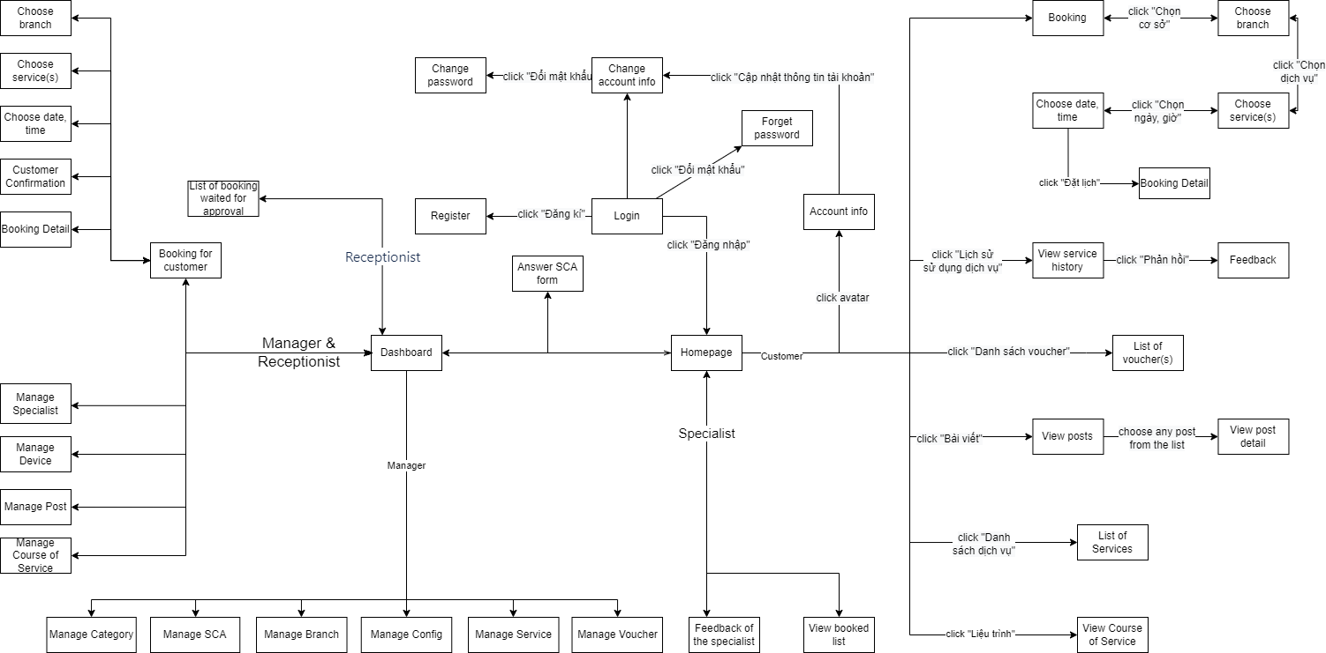

*Figure 3.7: Screens flow*

#### 3.1.2 Screen Descriptions

|  |  |  |  |
| --- | --- | --- | --- |
| **#** | **Feature** | **Screen** | **Description** |
| 1 | View homepage | Homepage | User goes to homepage |
| 2 | Login | Login | User already has an account and sign into the system |
| 3 | Register | Register | Users don’t have an account yet and create new accounts |
| 4 | Forgot password | Forgot password | User forgot password and want to reset password |
| 5 | Book appointment | Booking | User books an appointment |
| 6 | Choose branch | User selects a branch |
| 7 | Choose service | User selects a service |
| 8 | Choose datetime | User selects date and time |
| 9 | Booking detail | User views booking detail and confirms information after successfully booked |
| 10 | View service history | View service history | User views service history list that user has used |
| 11 | View service list | List of services | User views all service on the website |
| 12 | Manage profile | User info | User views account information |
| 13 | Change user info | User edits detail information of account |
| 14 | Change password | User changes new password |
| 15 | View appointment list | View booked list | User views booked appoitment list |
| 16 | Answer SCA form | Answer SCA form | User answers set of questions and sends it to the system |
| 17 | Dashboard Admin | Dashboard | User views statistics |
| 18 | Manage category | Manage category | User can create, update, delete category |
| 19 | Manage SCA form | Manage SCA | User can create, update, delete SCA form |
| 20 | Manage branch | Manage branch | User can create, update, deactivate branch |
| 21 | Manage config | Manage config | User can create, update, delete data config |
| 22 | Manage service | Manage service | User can create, update, deactivate service |
| 23 | Manage user | Manage user | User can create, update, deactivate account |
| 24 | Manage equipment | Manage equipment | User can create, update, deactivate equipment |
| 25 | Booking for customer | Booking for customer | User books an appointment for customer in case they don’t have account |
| 26 | List of booking waited for approval | List of booking waited for approval | User views list of booking waited for approval |

#### 3.1.3 Screen Authorization

|  |  |  |  |  |
| --- | --- | --- | --- | --- |
| **Screen** | **Guest** | **Customer** | **Receptionist** | **Manager** |
| Homepage | X | X | X | X |
| Login |  | X | X | X |
| Register | X |  |  |  |
| Forgot password |  | X | X | X |
| Booking |  | X |  |  |
| Choose branch |  | X | X | X |
| Choose service |  | X | X | X |
| Choose datetime |  | X | X | X |
| Booking detail |  | X | X | X |
| View service history |  | X |  |  |
| List of services | X | X | X | X |
| User information |  | X |  |  |
| Change user information |  | X |  |  |
| Change password |  | X |  |  |
| View booked list |  | X |  |  |
| Answer SCA form |  | X |  |  |
| Dashboard |  |  | X | X |
| Manage category |  |  |  | X |
| Manage SCA |  |  | X | X |
| Manage branch |  |  |  | X |
| Manage config |  |  |  | X |
| Manage service |  |  |  | X |
| Manage user |  |  | X | X |
| Manage equipment |  |  | X | X |
| Booking for customer |  |  | X | X |
| List of booking waited for approval |  |  | X | X |

#### 3.1.4 Non-Screen Functions

|  |  |  |  |
| --- | --- | --- | --- |
| **#** | **Feature** | **System Function** | **Description** |
| 1 | Send email | Confirm email | The system will send a confirmation mail to email linked to user’s account. |
| 2 | Forgot password | The system will send a new password to email linked to user’s account. |

#### 3.1.5 Entity Relationship Diagram

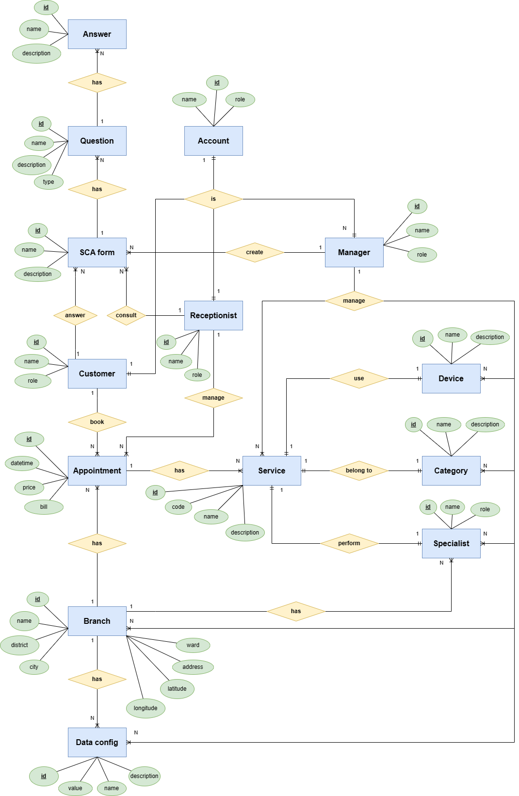

*Figure 3.8: Entity Relationship Diagram*

**Entities Description**

|  |  |  |
| --- | --- | --- |
| **#** | **Entity** | **Description** |
| 1 | Account | This account is used to login to the system. Each account has one role.  This entity has relationship with:  Customer**(“1-to-1”)**  Receptionist**(“1-to-1”)**  Manager**(“1-to-1”)**. |
| 2 | Customer | Thisis a Customer permissions account.  This entity has relationship with:  SCA form **(“1-to-Many”)**  Appointment**(“1-to-Many”)**  Account**(“1-to-1”).** |
| 3 | Manager | This is a Manager permissions account.  This entity has relationship with:  Account**(“1-to-1”)**  SCA form **(“1-to-Many”)**  Service**(“1-to-Many”)**  Equipment**(“1-to-Many”)**  Category**(“1-to-Many”)**  Specialist**(“1-to-Many”)**  Branch**(“1-to-Many”)**  Data config**(“1-to-Many”)** |
| 4 | Receptionist | This is a Receptionist permissions account.  This entity has relationship with  Account**(“1-to-1”)**  SCA form**(“1-to-Many”)**  Appointment**(“1-to-Many”)** |
| 5 | SCA form | This is set of consulting questions.  This entity has relationship with  Customer**(“Many-to-1”)**  Receptionist**(“Many-to-1”)**  Manager**(“Many-to-1”)**  Question**(“1-to-Many”)** |
| 6 | Question | This is question in form.  This entity has relationship with  SCA form**(“Many-to-1”)**  Asnwer**(“1-to-Many”)** |
| 7 | Answer | This is answer of question.  This entity has relationship with  Question **(“1-to-Many”)** |
| 8 | Appointment | An appointment is booked by Customer or created by Receptionist, Manager.  This entity has relationship with  Customer**(“Many-to-1”)**  Receptionist**(“Many-to-1”)**  Branch**(“Many-to-1”)** |
| 9 | Branch | This is a branch.  This entity has relationship with  Appointment**(“1-to-Many”)**  Data config**(“1-to-Many”)**  Specialist**(“1-to-Many”)**  Manage**(“Many-to-1”)** |
| 10 | Data config | Data config is set in each branch.  This entity has relationship with  Branch**(“Many-to-1”)**  Manage**(“Many-to-1”)** |
| 11 | Service | There are services in the system.  This entity has relationship with  Appointment**(“Many-to-1”)**  Manager**(“Many-to-1”)**  Equipment**(“1-to-1”)**  Category**(“1-to-1”)**  Specialist**(“1-to-1”)** |
| 12 | Equipment | There are equipments in the system.  This entity has relationship with  Service**(“1-to-1”)**  Manager**(“Many-to-1”)** |
| 13 | Category | Identify different type of service.  This entity has relationship with  Service**(“1-to-1”)**  Manager**(“Many-to-1”)** |
| 14 | Specialist | This is spa specialist.  This entity has relationship with  Service**(“1-to-1”)**  Manager**(“Many-to-1”)** |

### 3.2 Feature

#### 3.2.1 Guest and Customer

##### 3.2.1.1 Login

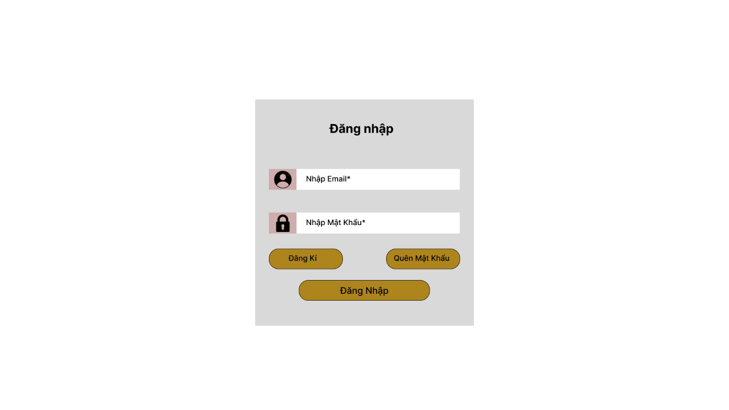

##### 3.2.1.2 Register

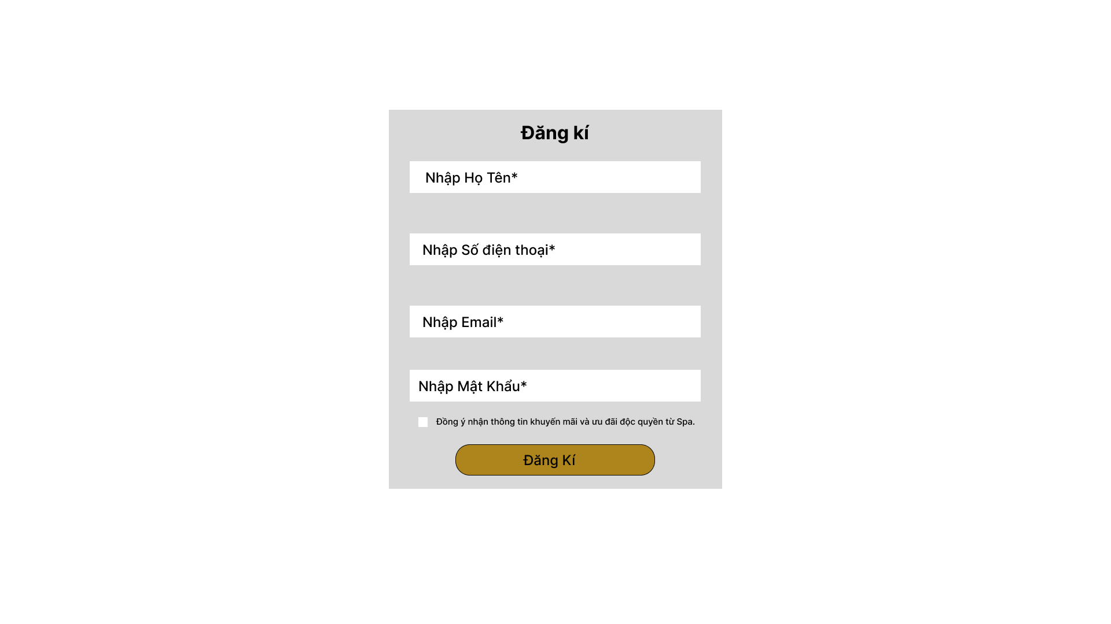

##### 3.2.1.3 Homepage

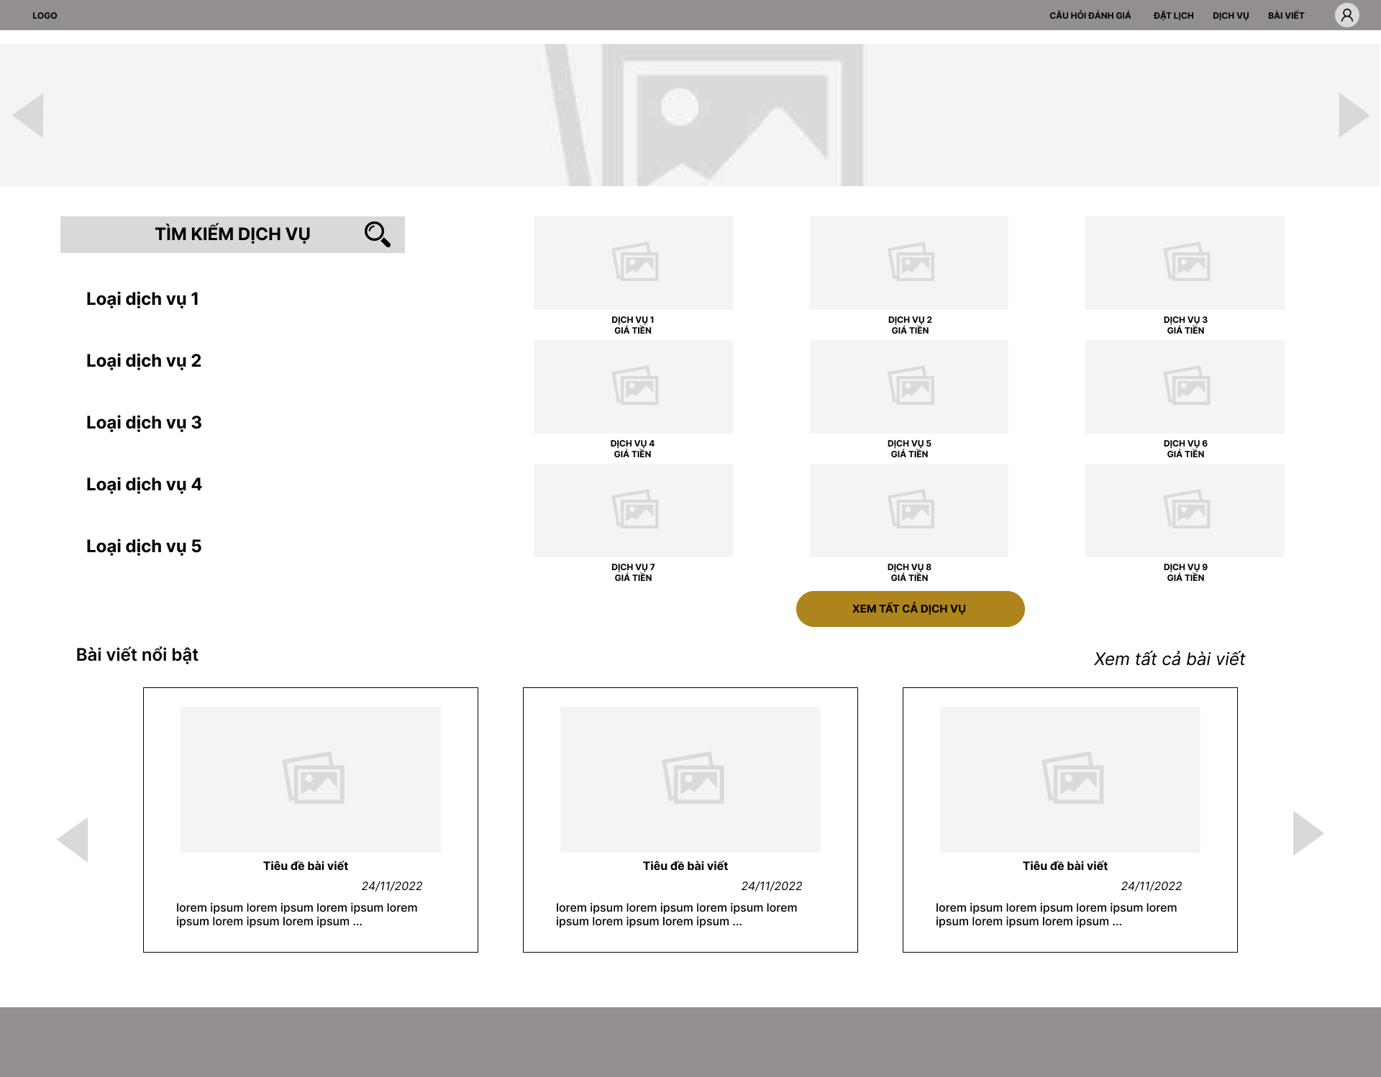

##### 3.2.1.4 Booking

**a. Select branch**

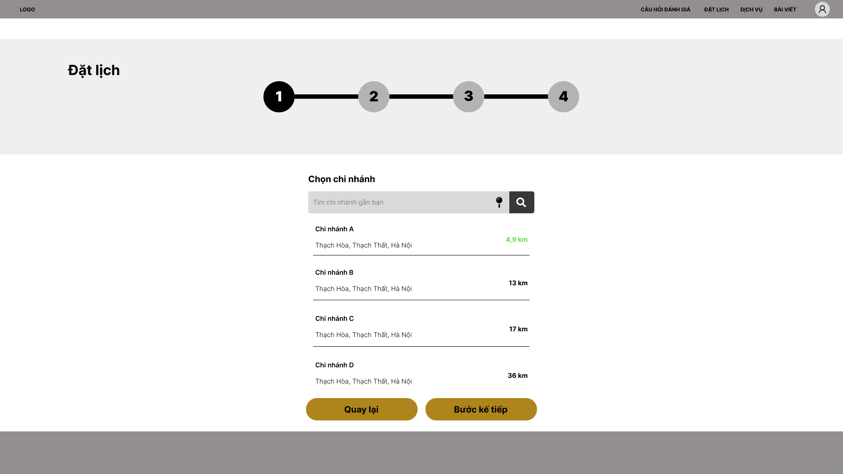

**b. Select service**

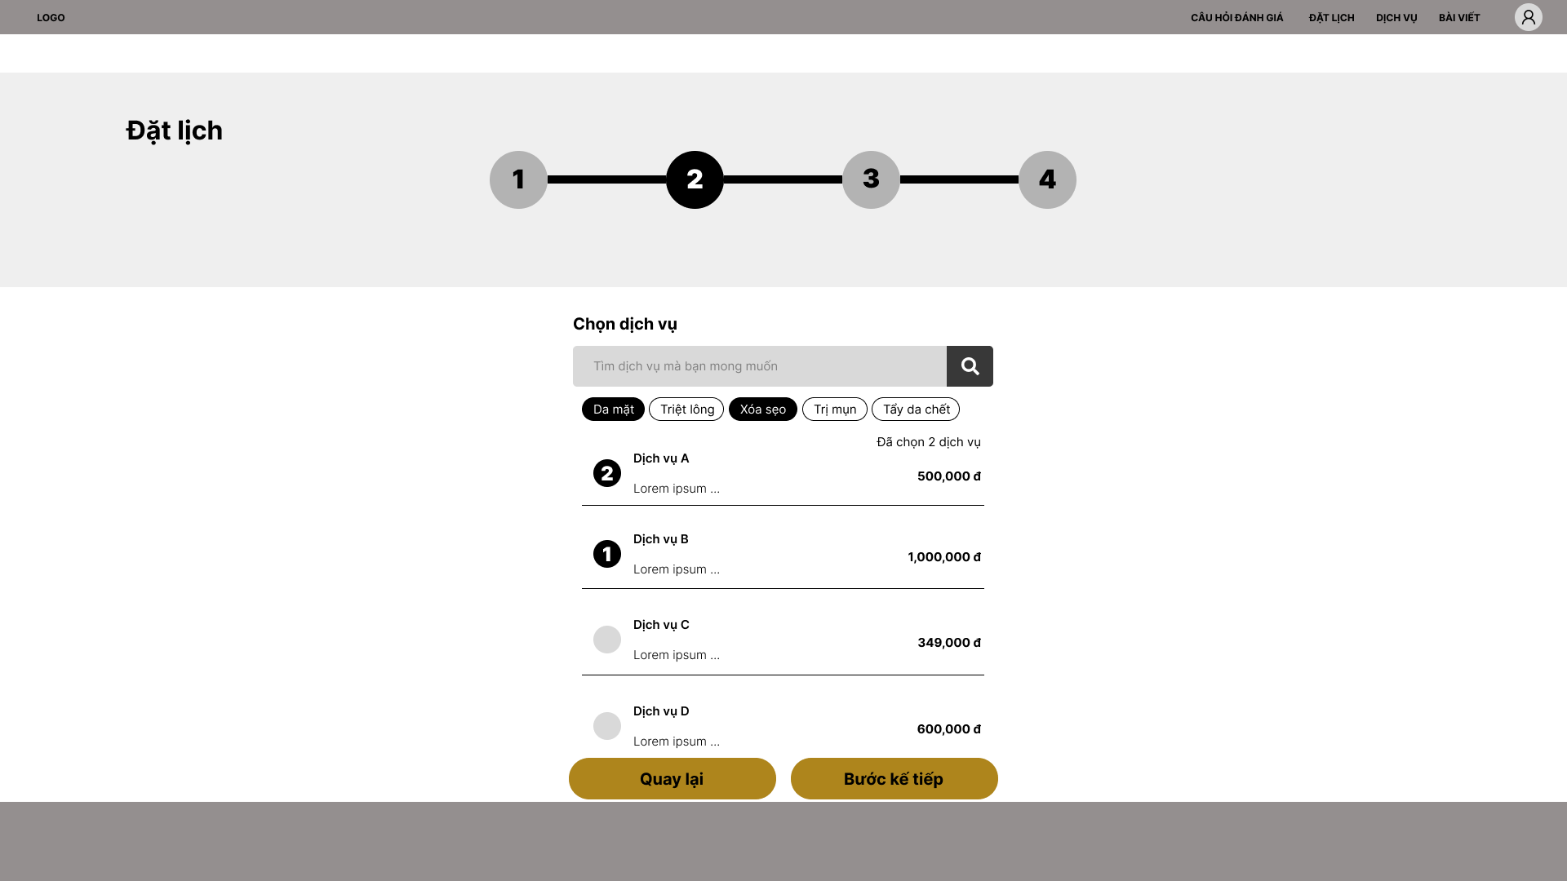

**c. Select time**

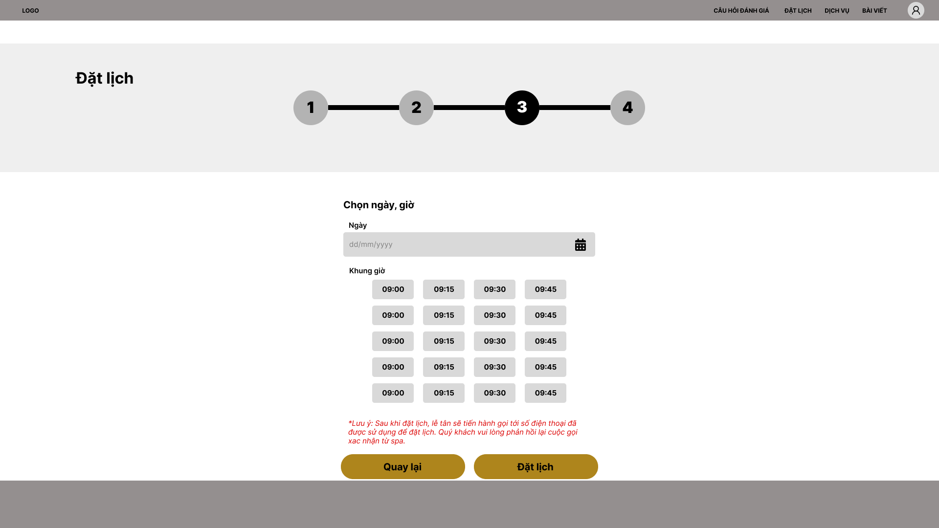

**d. Confirm**

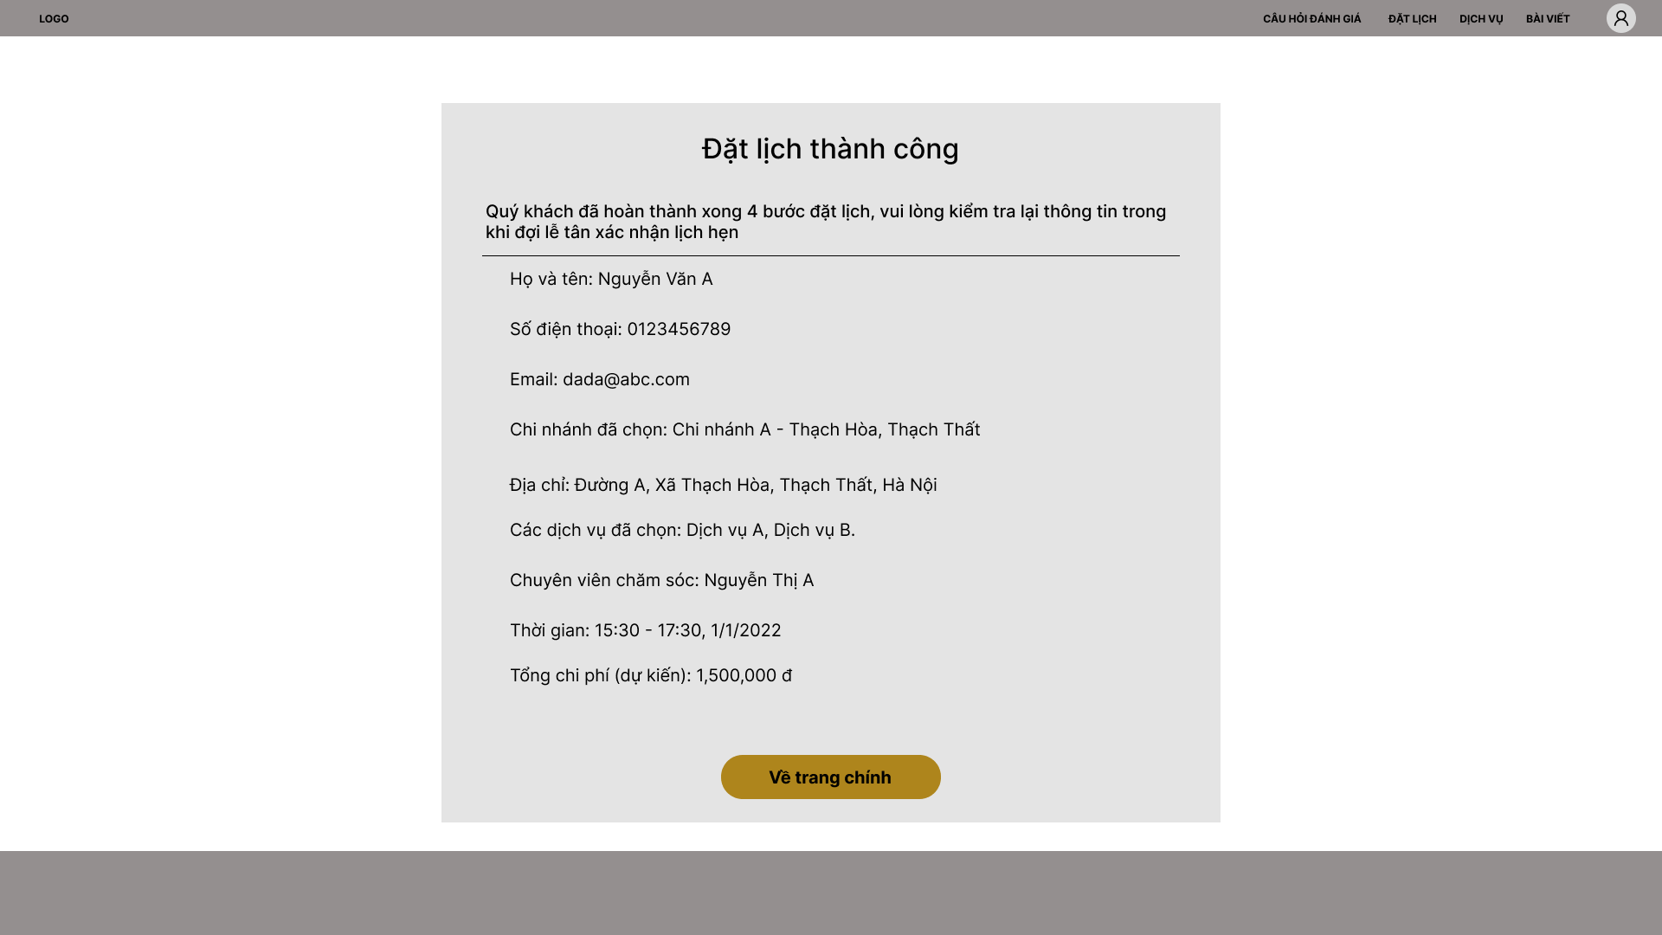

##### 3.2.1.5 SCA form

**a. SCA form list**

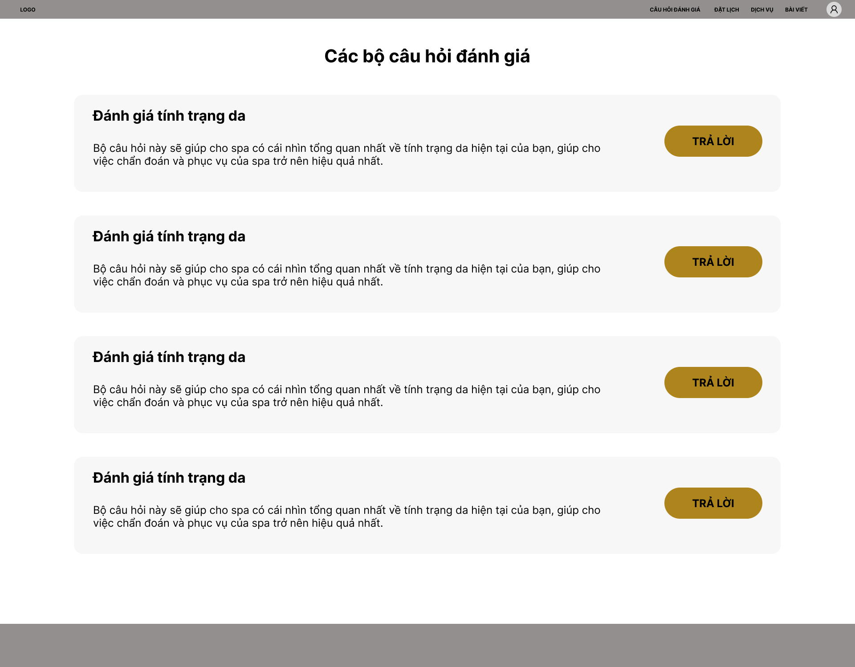

**b. SCA form detail**

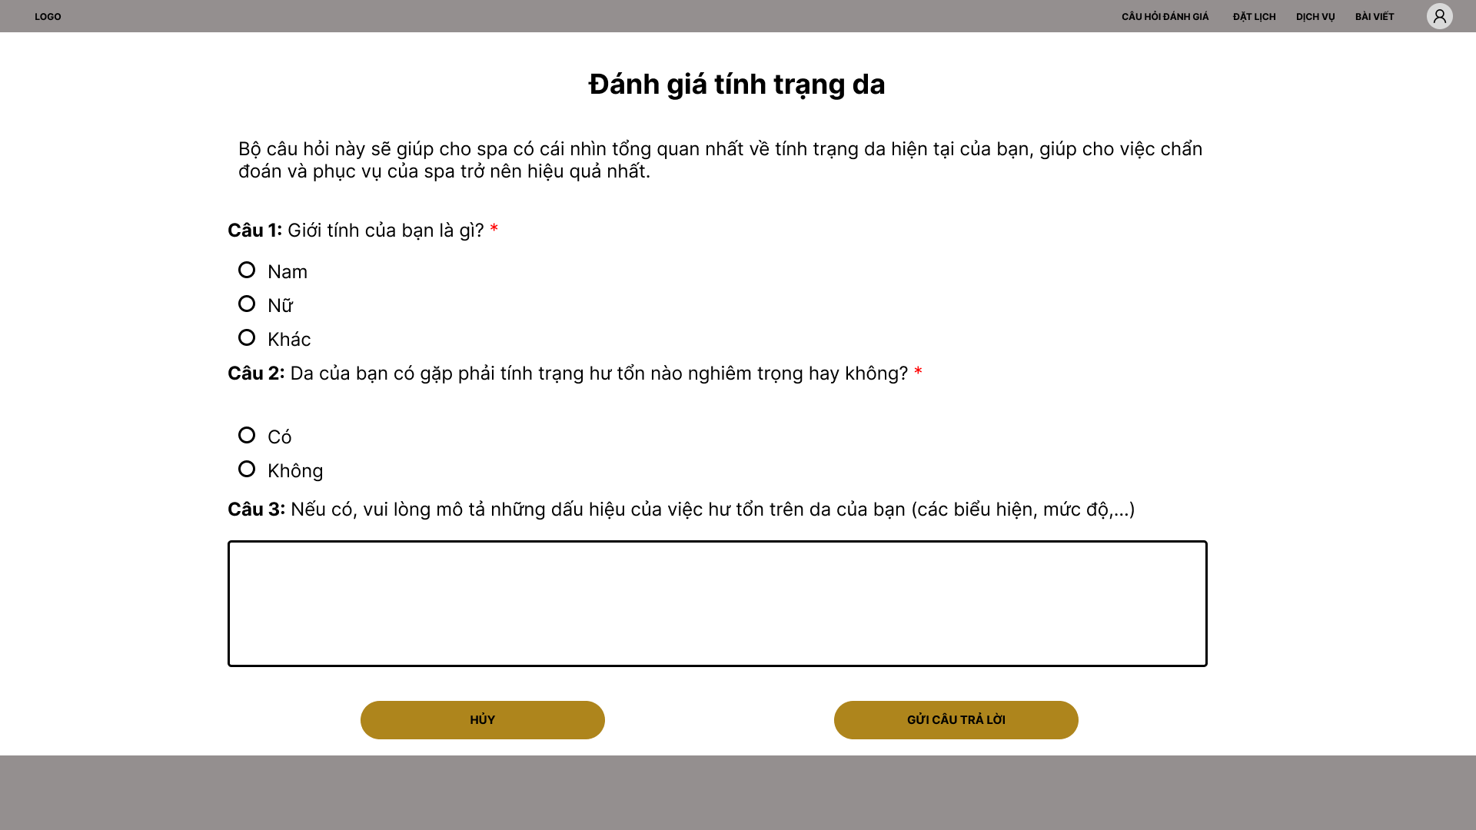

##### 3.2.1.6 Service

**a. Service list**

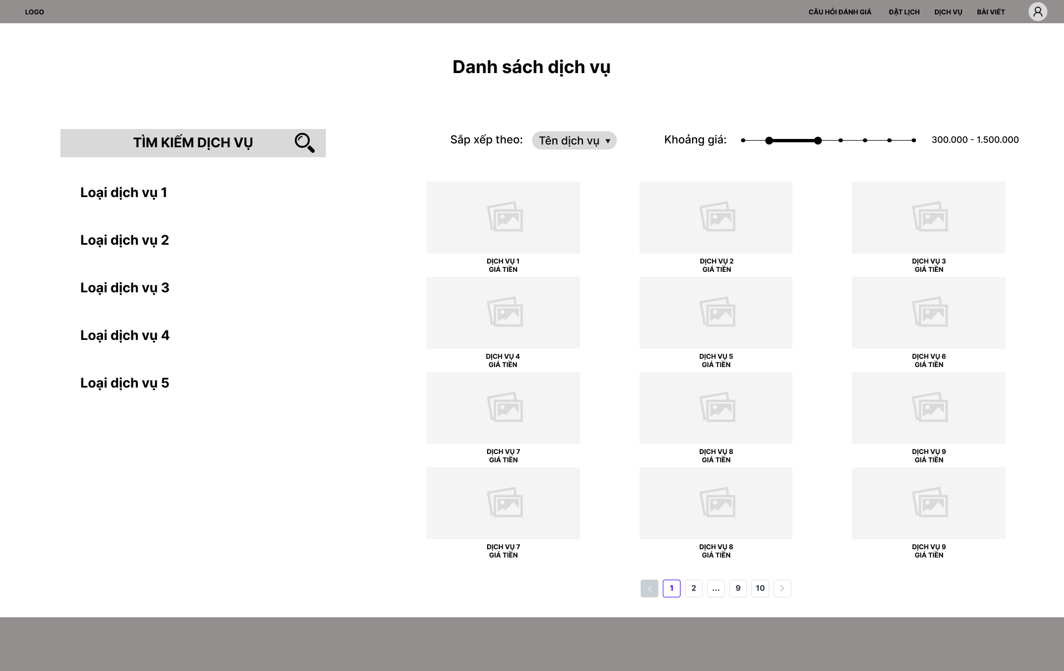

**b. Service detail**

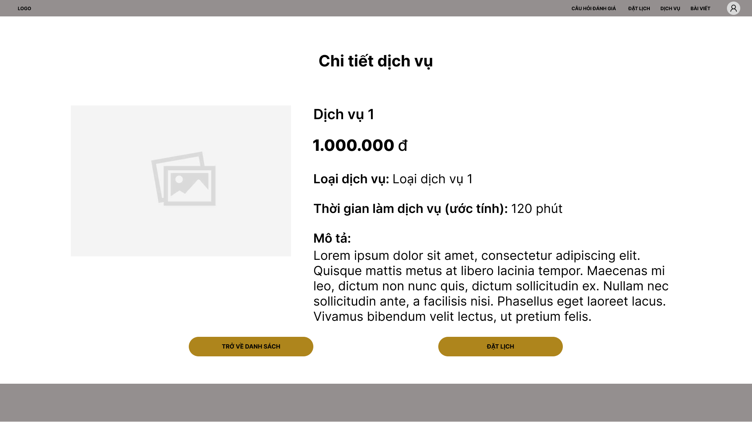

##### 3.2.1.7 User’s profile

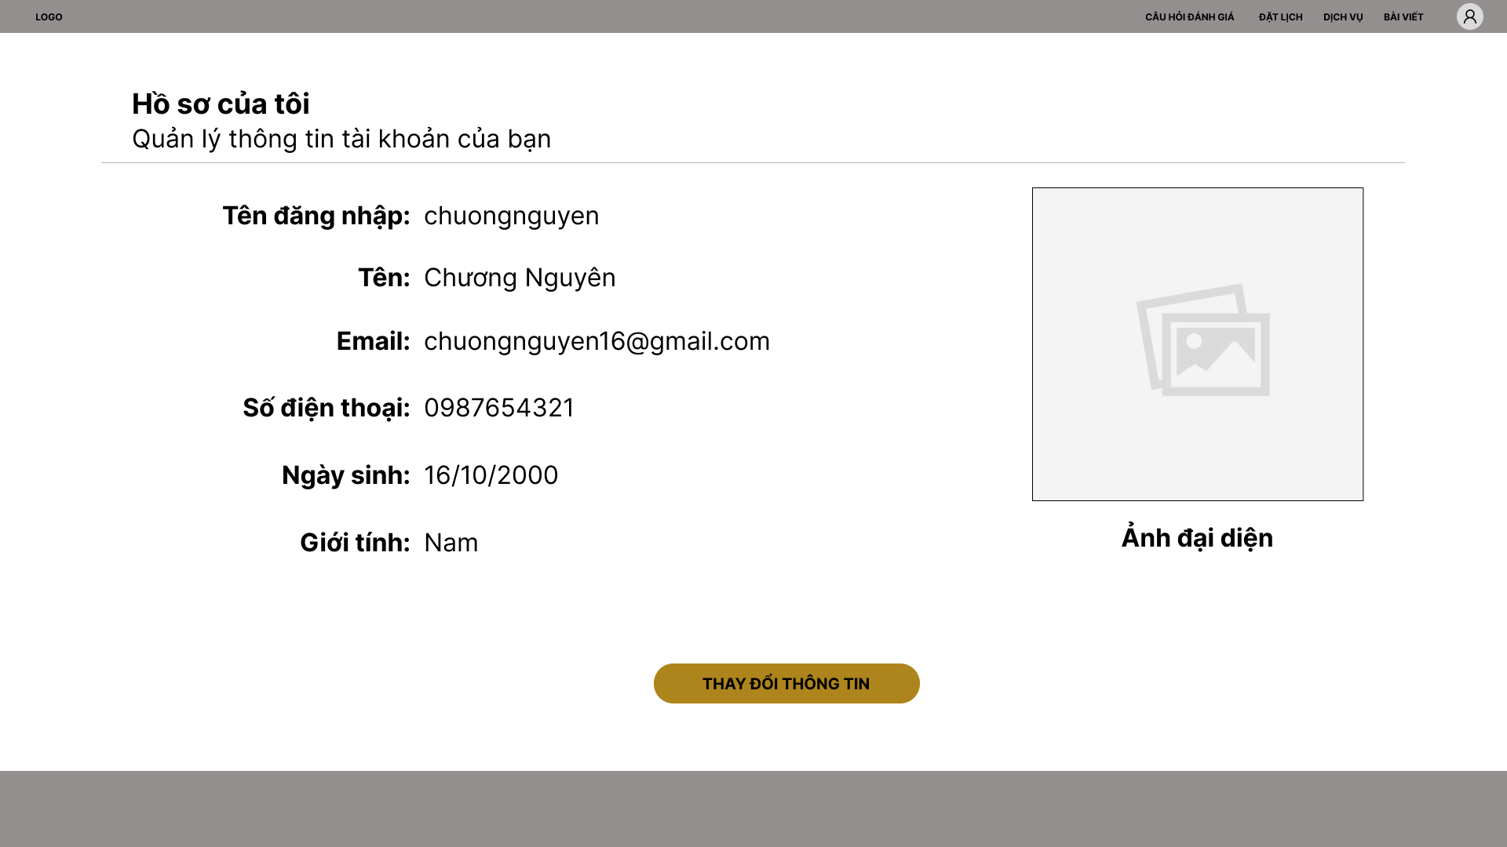

##### 3.2.1.8 Appointment

**a. Appointment list**

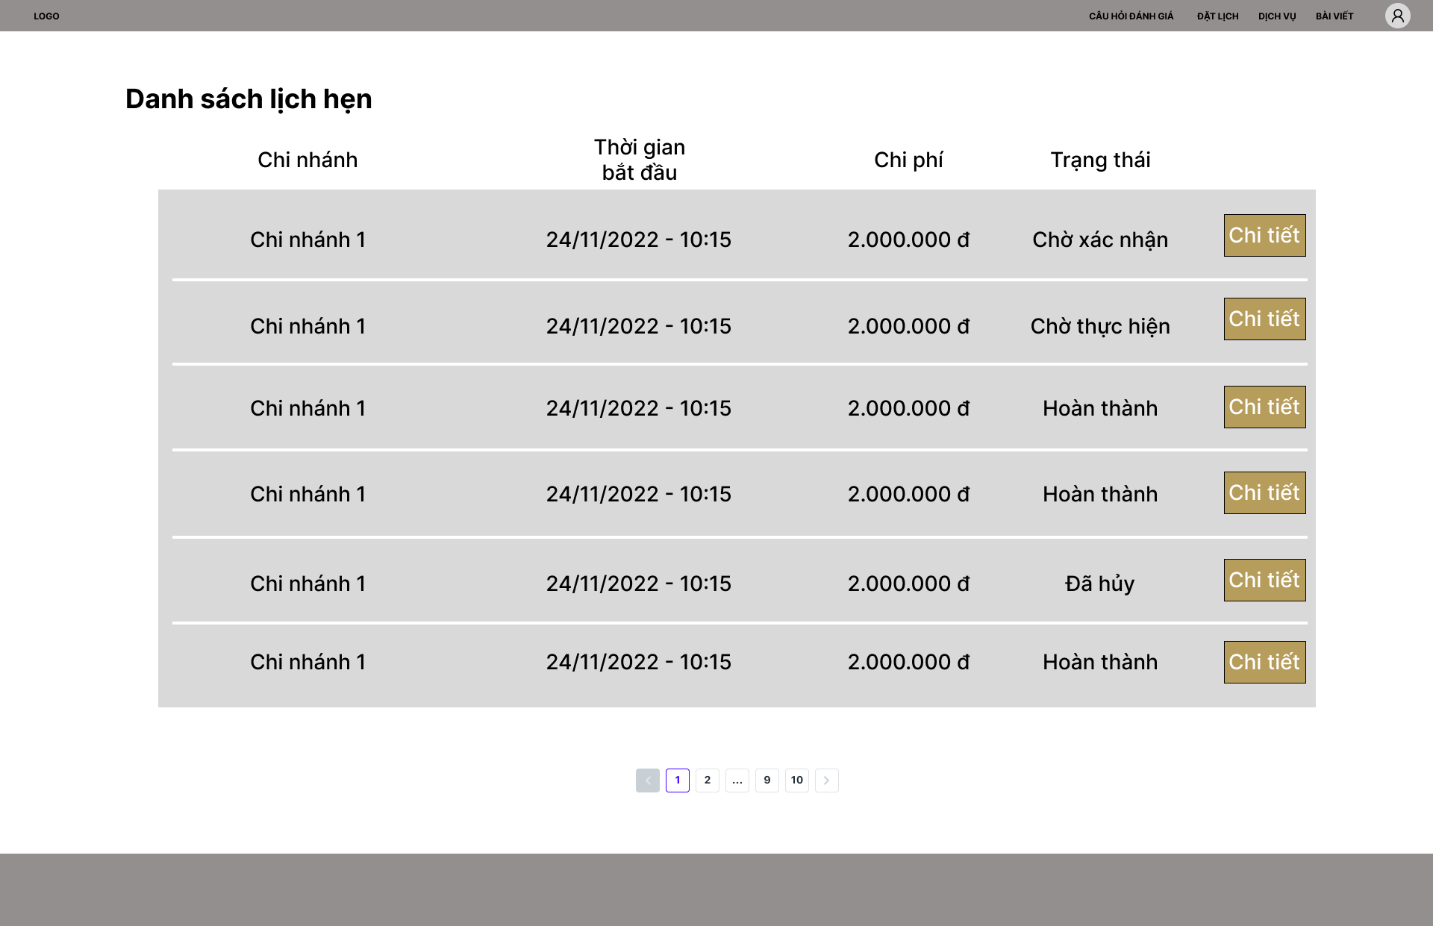

**b. Appointment detail**

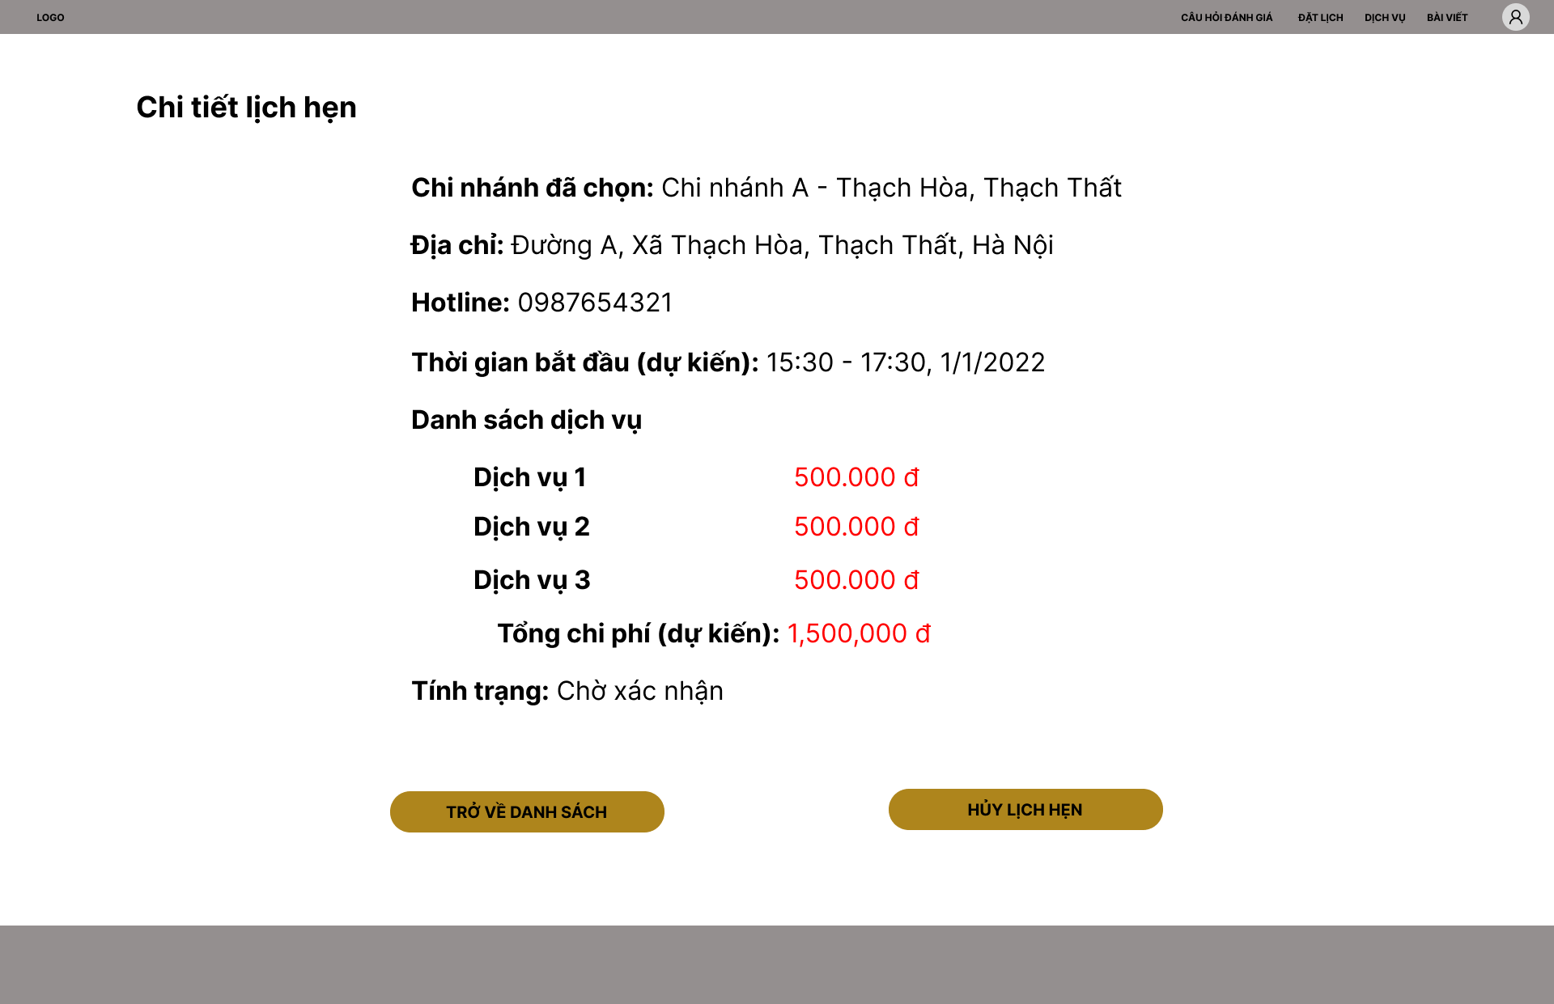

#### 3.2.2 Receptionist and Manager

##### 3.2.2.1 Dashboard

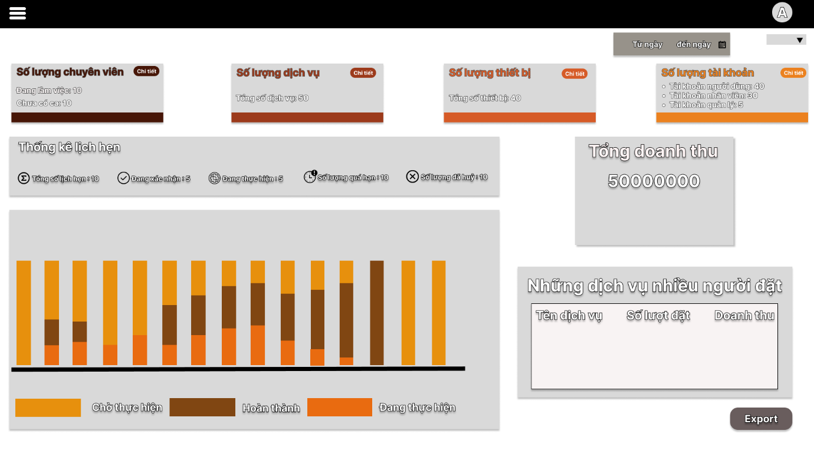

##### 3.2.2.2 Manage appointment

**a. Checkin**

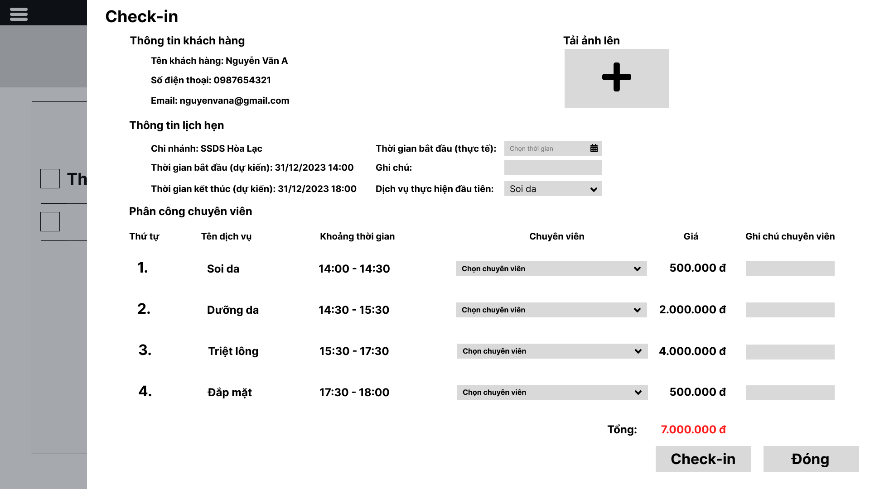

**b. Checkout**

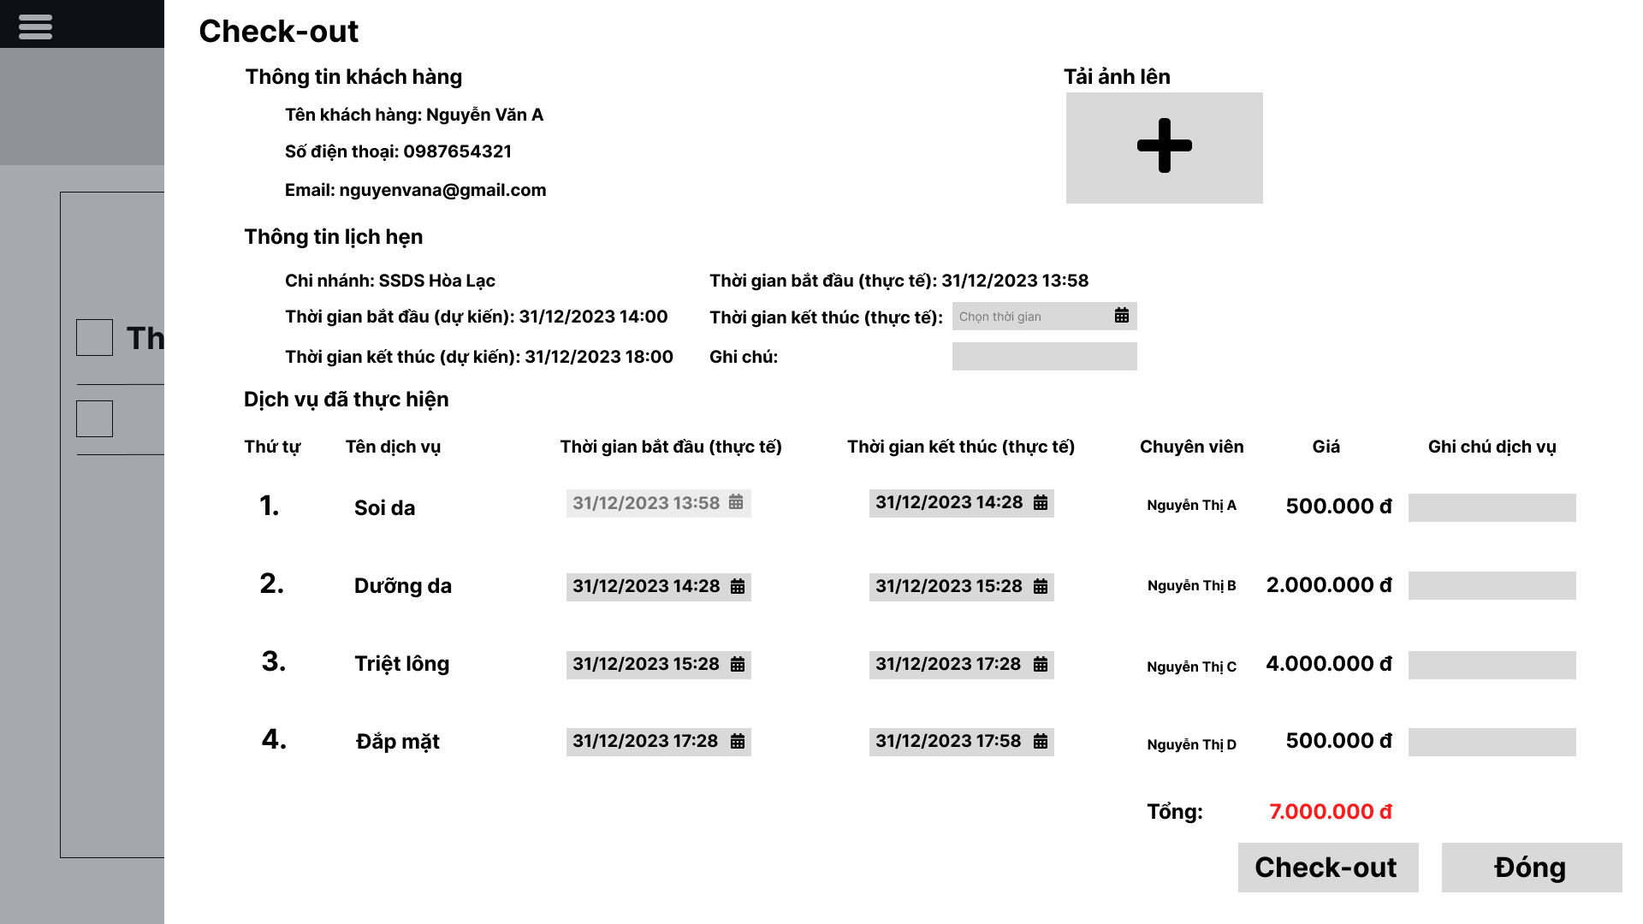

**3.2.2.3 Manage equipment**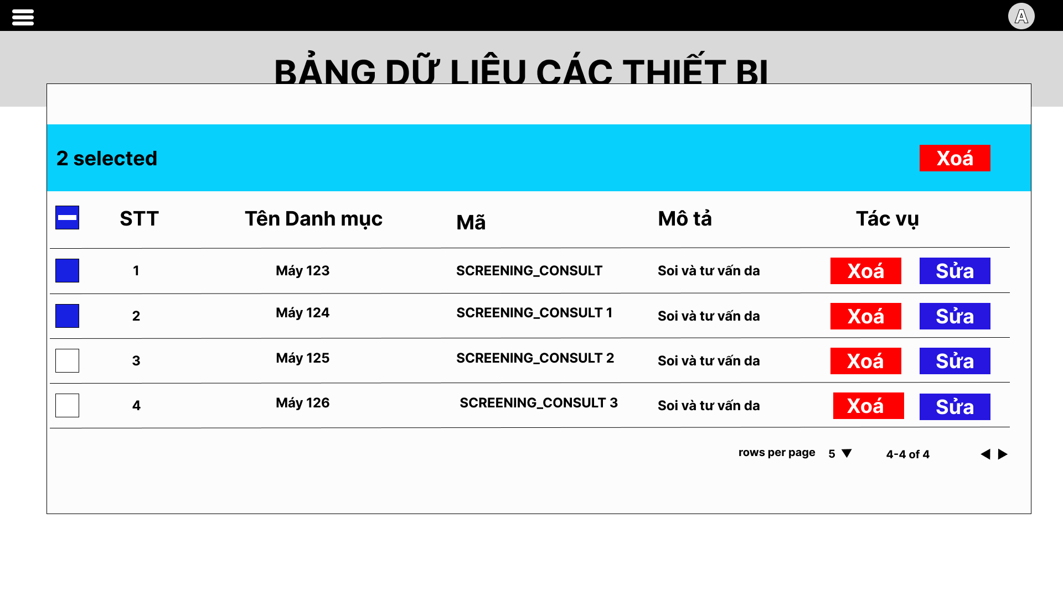

##### 3.2.2.4 Manage category

**a. Category list**

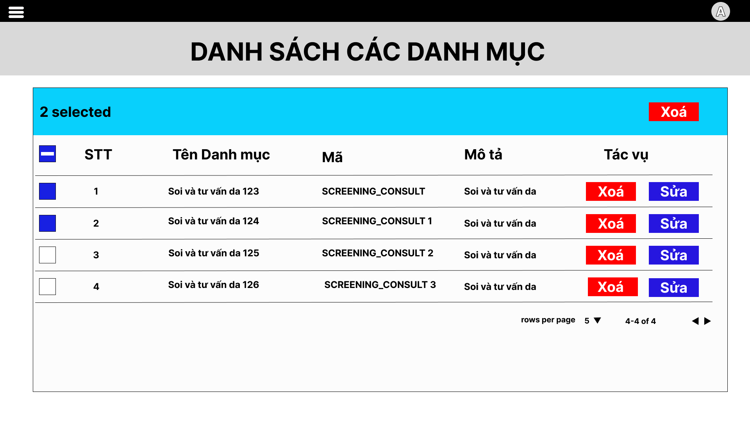

**b. Create category**

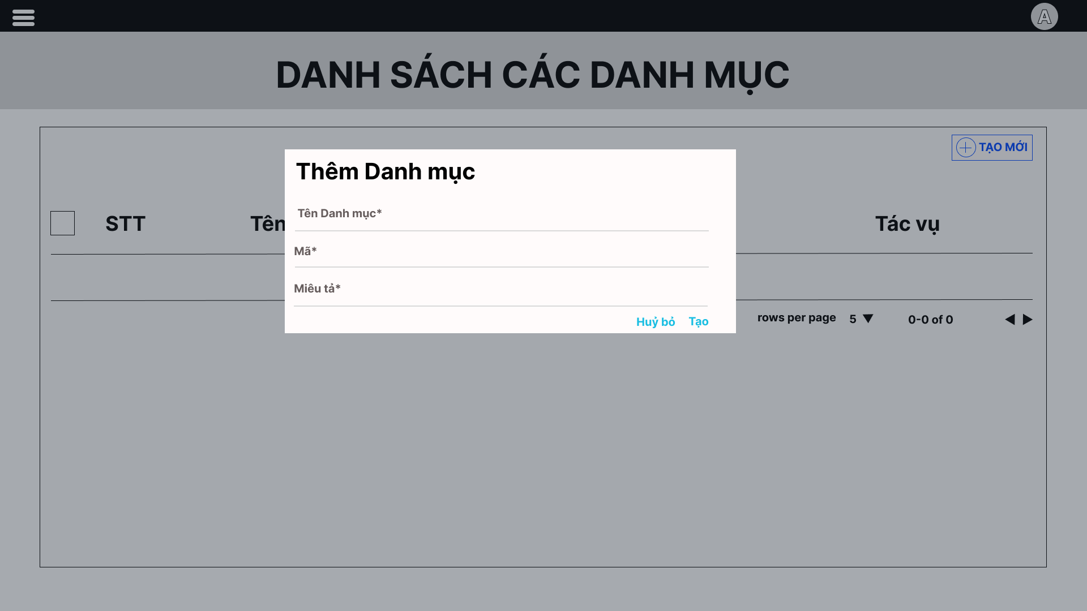

##### 3.2.2.5 Manage branch

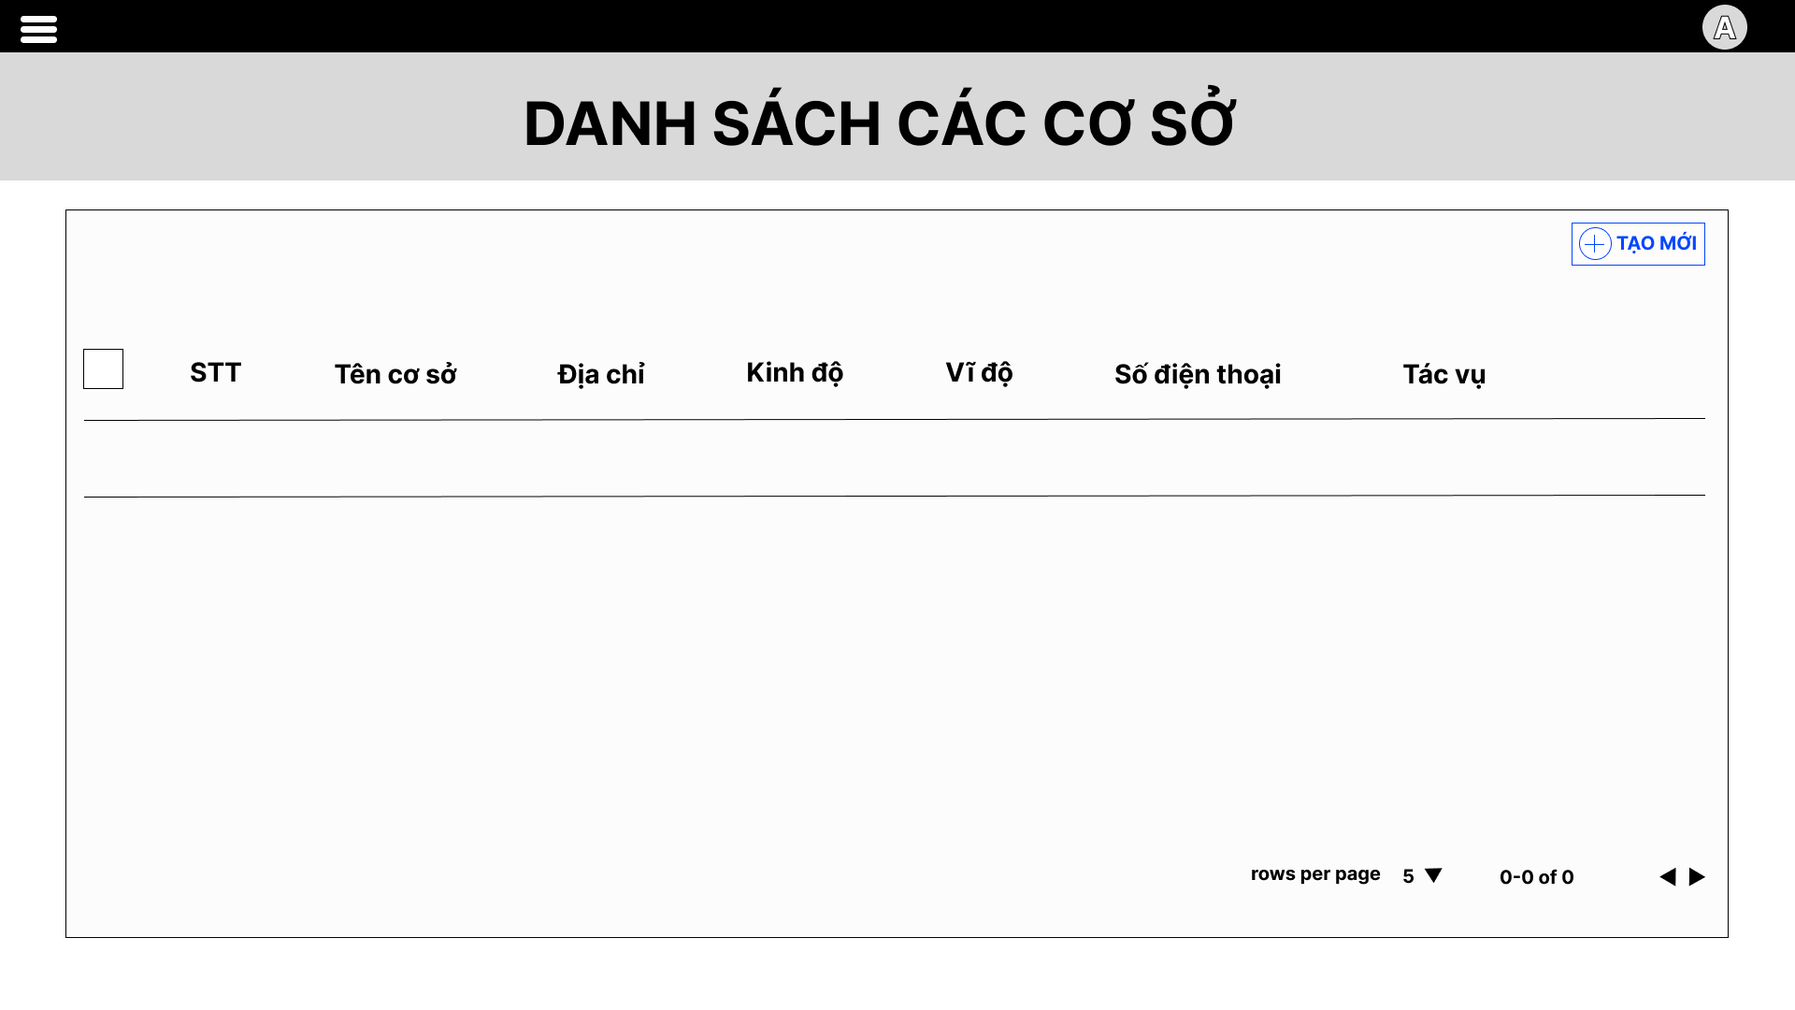

##### 3.2.2.6 Manage service

**a. Service list**

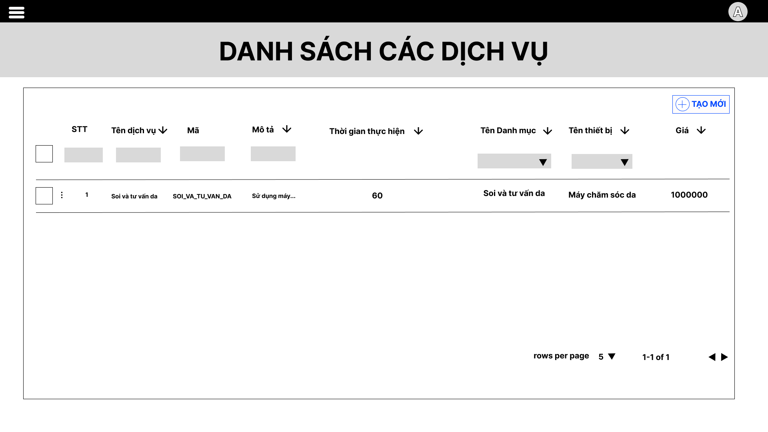

**b. Create service**

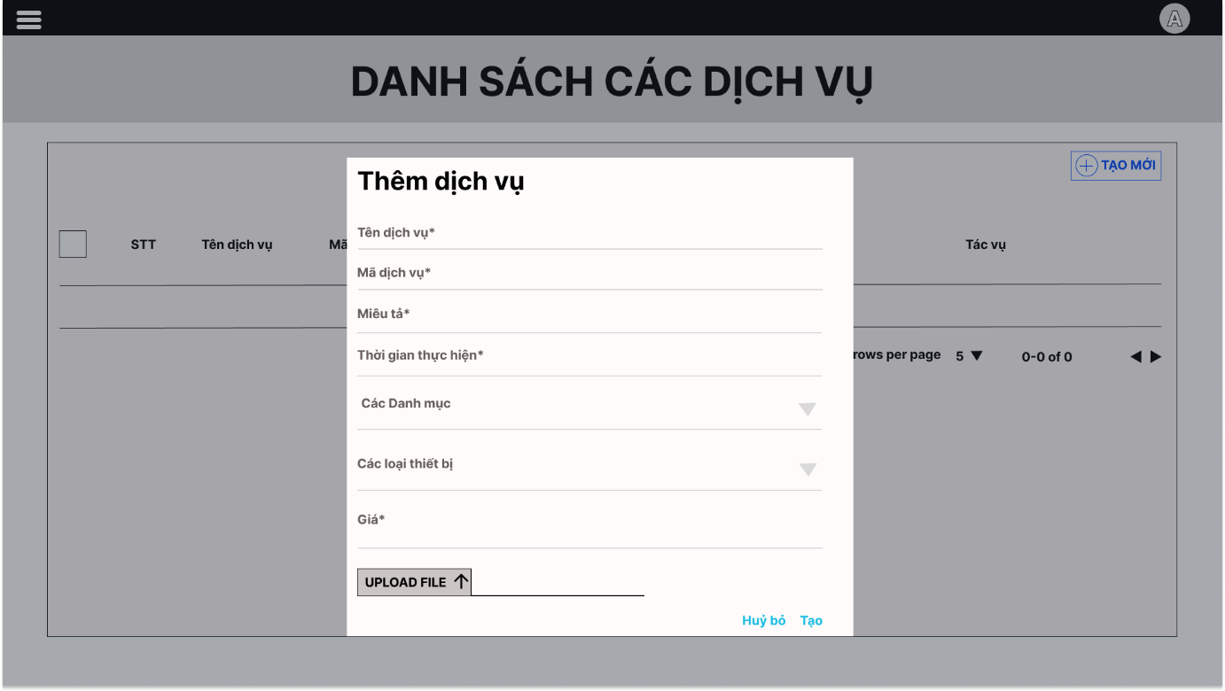

**c. Update service**

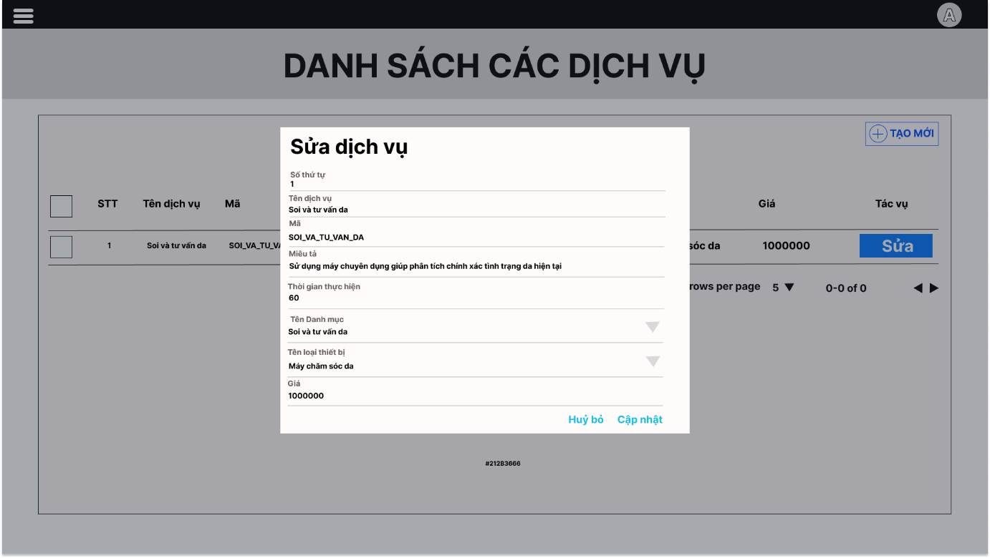

##### 3.2.2.7 Manage SCA form

**a. SCA form list**

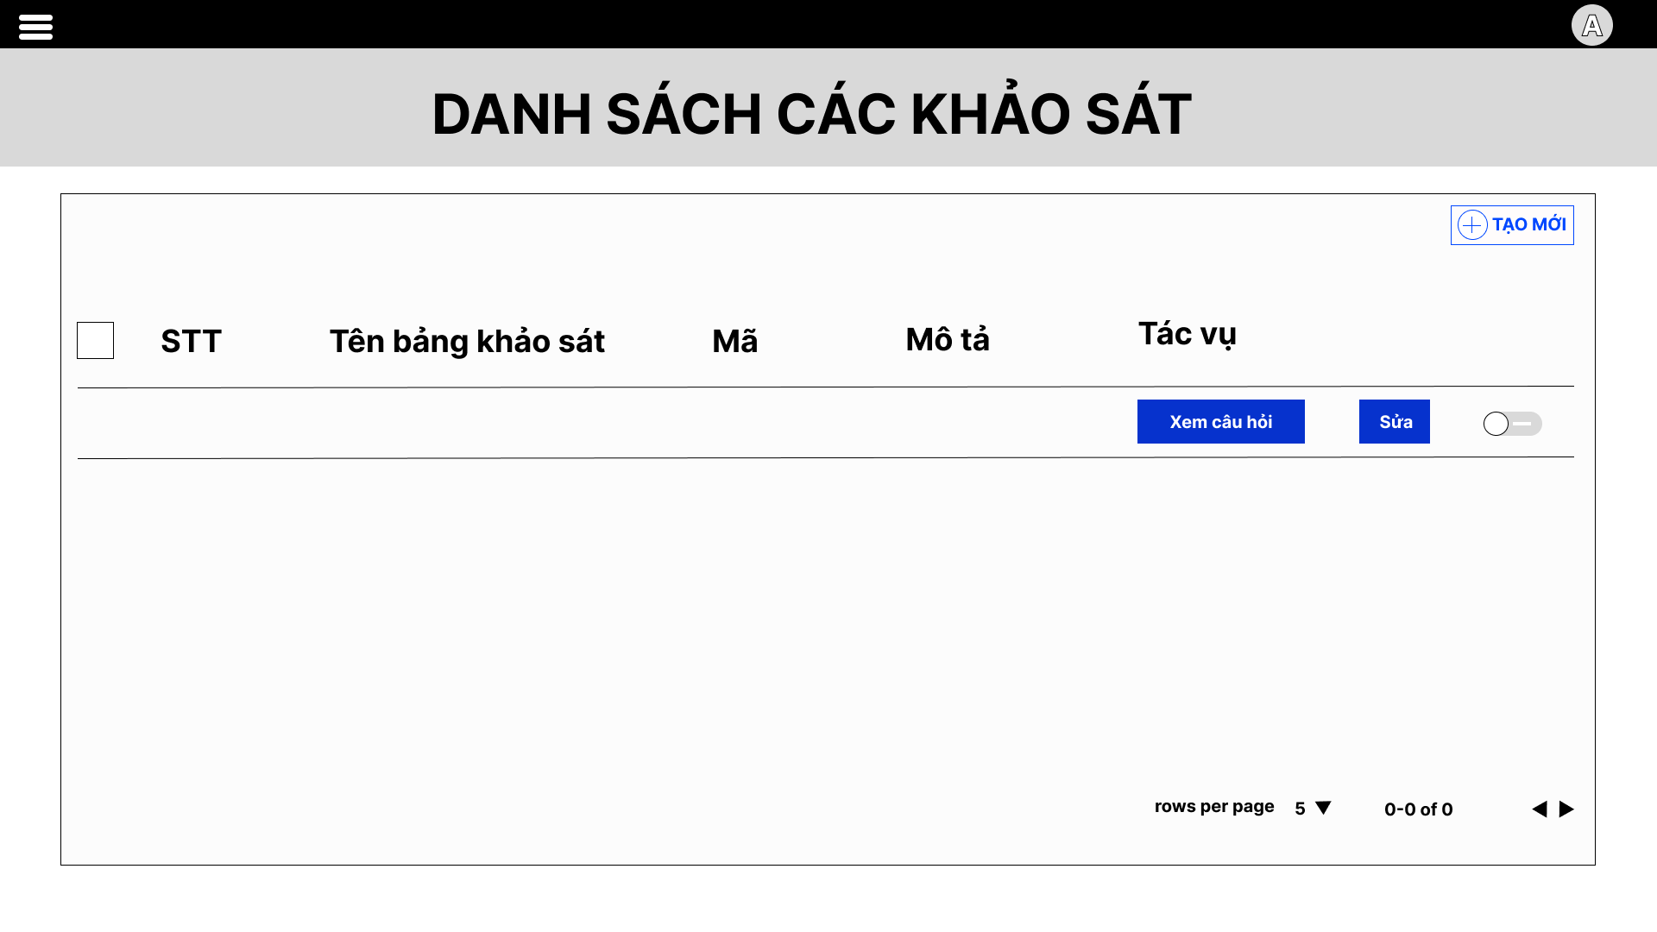

**b. SCA form detail**

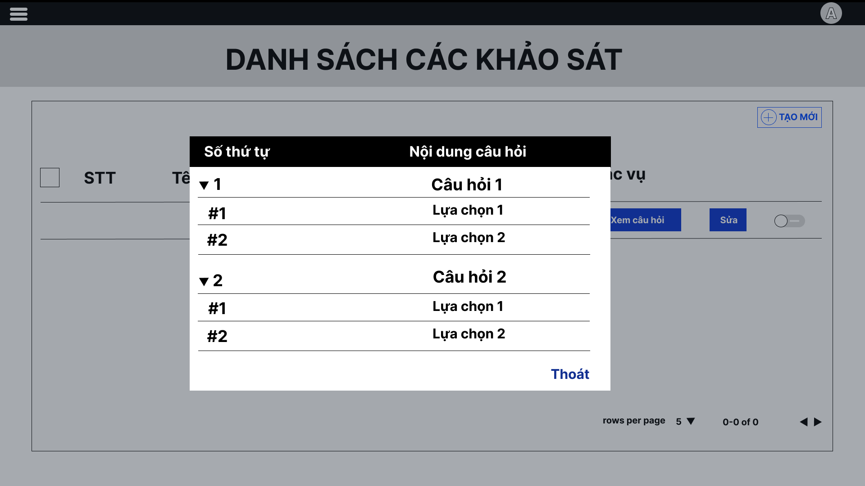

**c. Create SCA form**

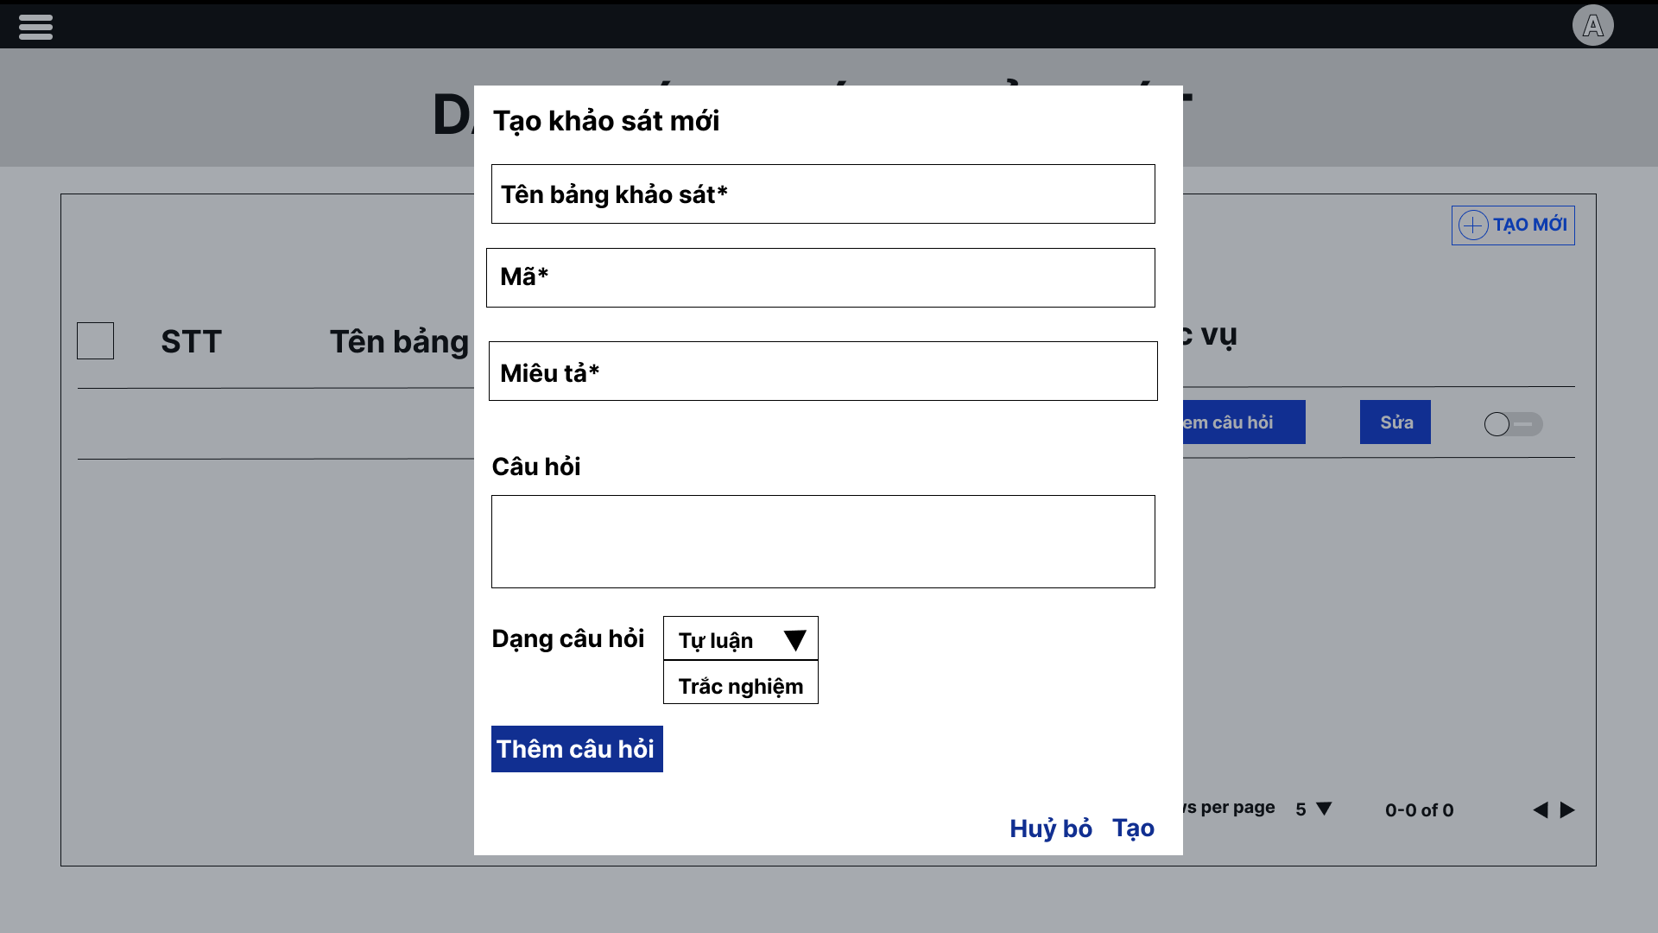

**d. Update SCA form**

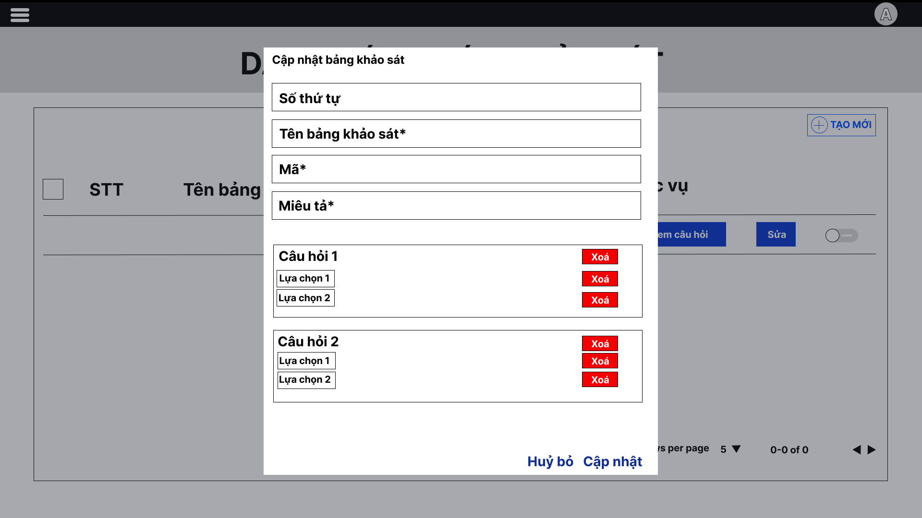

##### 3.2.2.8 Manage data config

**a. Data config list**

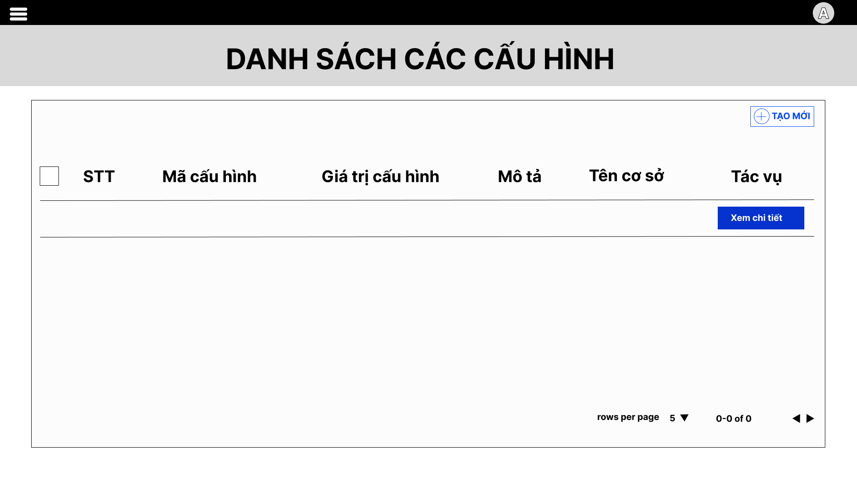

**b. Data config detail**

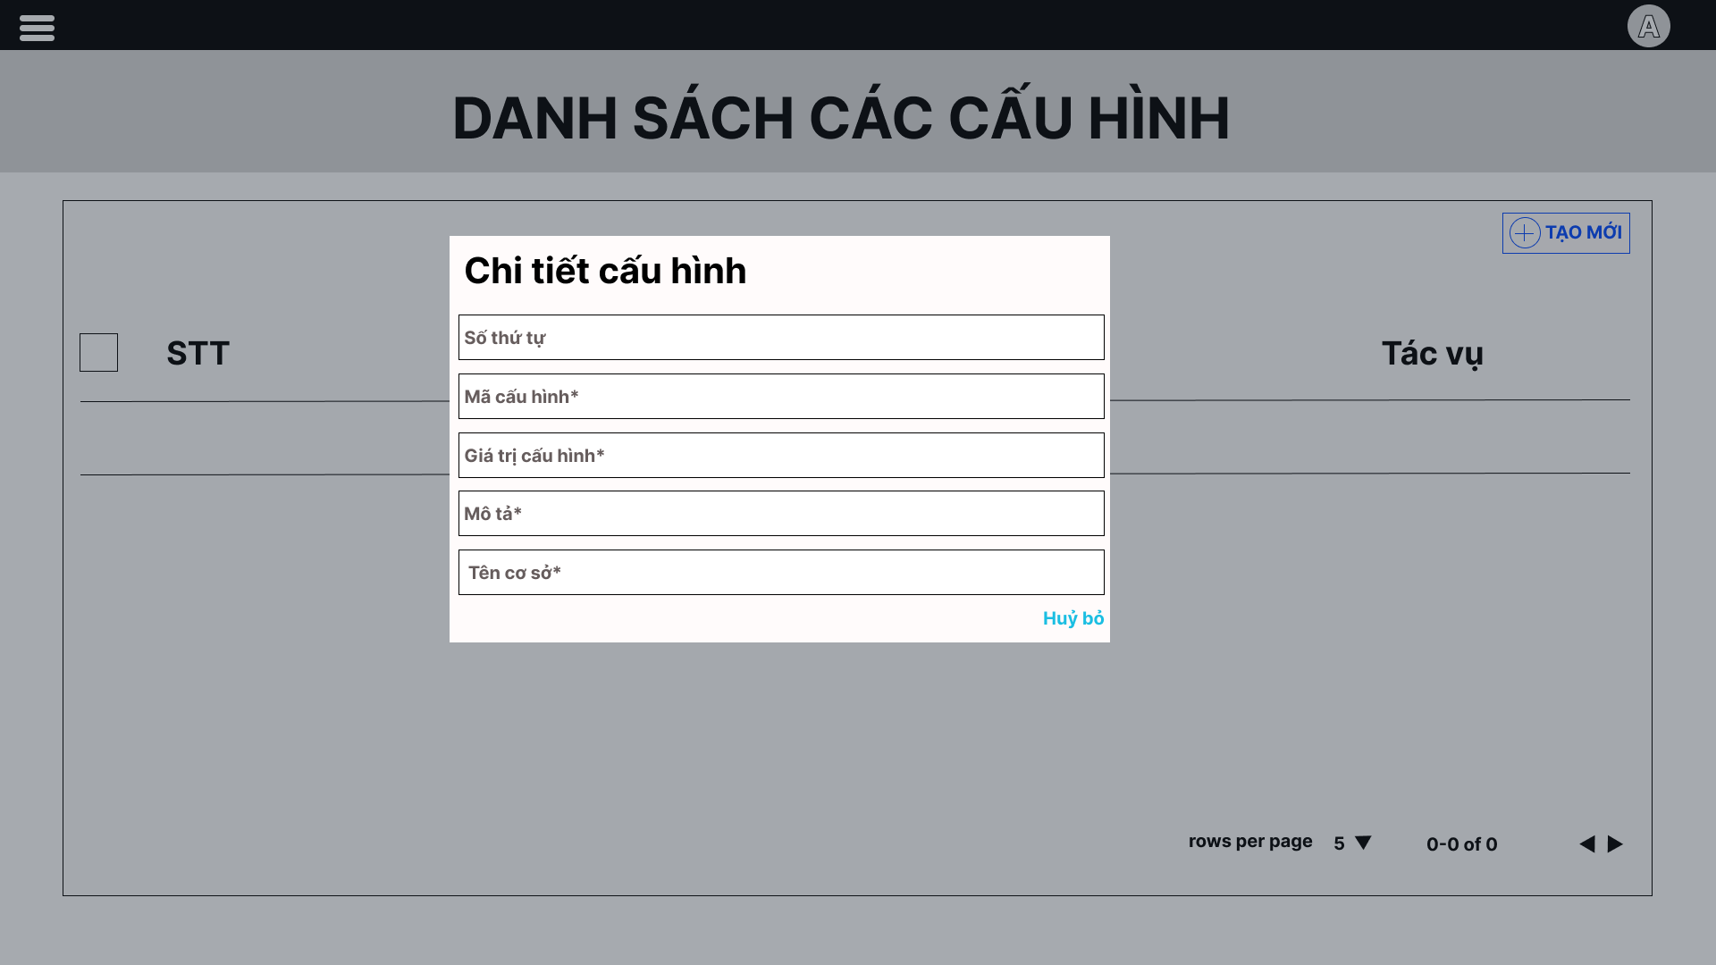

## 4. Non-Functional Requirements

### 4.1 External Interfaces

#### 4.1.1 User Interfaces

UI-1: The application has a friendly user interface and is easy to use.

UI-2: The page layout of the screen is streamlined, clearly, easy to operate, and implement for the user.

UI-3: Have a responsive layout for Desktop, Mobile screen.

UI-4: Buttons have distinctive features and colors, based on the standard of UI layout.

UI-5: Active button or link direction when user is on a screen or function, sync with the interface.

UI-6: Notifications displayed based on events the user has done on the screen have a banner outlining the content for the user.

UI-7: Use icons to provide visual insights to users.

#### 4.1.2 Software Interfaces

Web User Interface: Require Web Browsers.

SI-1:   Require Web Browsers that have HTML5 / CSS3 / Javascript supported

|  |  |
| --- | --- |
| **Web / Mobile Browser** | **Infrastructure Classic Console and Applications Console** |
| Microsoft Internet Explorer | 11 or later |
| Mozilla Firefox | 52 or later |
| Google Chrome | 63 or later |
| Apple Safari | 10 or later |
| Microsoft Edge | 35 or later |
| Safari, Chrome, Firefox on iOS (iPad and iPhone) | Latest |
| Chrome, Firefox on Android (Phone and Tablet) | Latest |

#### 4.1.3 Hardware Interfaces

HI-1: To use an application, a smart device such as a phone, computer, laptop, or tablet is required.

HI-2: Because the application runs on the Internet, the device must connect to the Internet.

#### 4.1.4 Communications Interfaces

CI-1: The communication architecture must follow the client-server model.

### 4.2 Quality Attributes

#### 4.2.1 Usability

* Main languages: Vietnamese
* User interfaces are friendly, easy to use and should be elegant.
* All the titles or names of features, function should be easy to understand and reflect the purpose of the function.
* Error messages should be clearly and detailed.
* Direction or links are easily recognizable and can be clickable.
* Buttons, checkboxes, dropdowns, etc are easily clickable.
* The Front-end web application should support almost all Web Browsers.

#### 4.2.2 Reliability

* Availability:
* MTBF (Mean Time Between Failures): 1 month
  + **MTBF = # of operational hours ÷ # of failures**
* MTTR (Mean Time To Repair): 30 minutes (It includes both the repair time and any testing time)
* Accuracy:
* Maximum Bugs: 10% (No fatal, user interfaces or server error, only automatically recoverable)
* Bugs Rate or Defect Rate:
  + Minor: Error in back-end that rarely happen and automatically recoverable
  + Significant: Error that usually happen but automatically recoverable
  + Critical: Error that leads to data loss, system down.

#### 4.2.3 Performance

* Response time for a transaction:
  + **Average**: 3s
  + **Maximum**: 5s
* The number of customers visiting the system can accommodate: 200 users.
* The application’s action should feel snappy, responsive and needs to be light-weighted and not use much memory or resources.

## 5. Requirement Appendix

### 5.1 Application Messages List

|  |  |  |  |  |
| --- | --- | --- | --- | --- |
| **#** | **Message code** | **Message Type** | **Context** | **Content** |
| 1 | MSG01 | Toast message | Input wrong username or password while login | *Tên tài khoản hoặc Mật khẩu của bạn không đúng, vui lòng thử lại* |
| 2 | MSG02 | Toast message | Input wrong username, password, phone number, customer’s name while register | *Tên đăng nhập, Mật khẩu, Số điện thoại, Họ tên không hợp lệ. Vui lòng kiểm tra lại* |
| 3 | MSG03 | In red, under the text box | Confirm password is not same password | *Không trùng khớp với mật khẩu! Vui lòng kiểm tra lại* |
| 4 | MSG04 | Toast message | Do not agree with terms and services | *Bạn cần phải đồng ý với các điểu khoản & dịch vụ của chúng tôi* |
| 5 | MSG05 | Toast message | Send form successfully | *Cảm ơn đã điền khảo sát.* |
| 6 | MSG06 | Inline | Do not answer a required question | *Câu hỏi này không thể bỏ trống!* |
| 7 | MSG07 | Inline | Do not answer all required questions | *Khách hàng vui lòng không để trống các câu hỏi bắt buộc đánh dấu \** |
| 8 | MSG08 | Inline | Booking successfully | *Đặt lịch thành công! Nhân viên spa sẽ sớm liên hệ với bạn để xác nhận thông tin lịch hẹn. Cảm ơn bạn đã lựa chọn sử dụng dịch vụ của chúng tôi* |
| 9 | MSG09 | Toast message | Do not input information at all steps while booking | *Có lỗi xảy ra, vui lòng thử lại sau!* |
| 10 | MSG10 | In red, under the text box | Do not input in required field | *Trường này không được để trống* |
| 11 | MSG11 | In red, under the text box | Do not input right format in required field | *Trường này không được để trống và chỉ được nhập số* |
| 12 | MSG12 | Toast message | Do not input all required field while adding form | *Vui lòng cung cấp đầy đủ các trường thông tin.* |
| 13 | MSG13 | In red, under the text box | Incorrect name while adding appointment | *Tên khách hàng không hợp lệ* |
| 14 | MSG14 | In red, under the text box | Incorrect phone number while adding appointment | *Số điện thoại không hợp lệ* |
| 15 | MSG15 | In red, under the text box | Do not select service while adding appointment | *Vui lòng chọn ít nhất 1 dịch vụ* |
| 16 | MSG16 | In red, under the text box | Do not select time while adding appointment | *Vui lòng chọn thời gian* |
| 17 | MSG17 | Inline | Customer do not send image | *Khách hàng không gửi ảnh* |
| 18 | MSG18 | Toast message | Do not input image while check-out booking | *Vui lòng chọn phương thức thanh toán và tải lên biên lai để hoàn tất thanh toán* |

# IV. Software Design Description

## 1. System Design

### 1.1 System Architecture

#### 1.1.1 Diagram

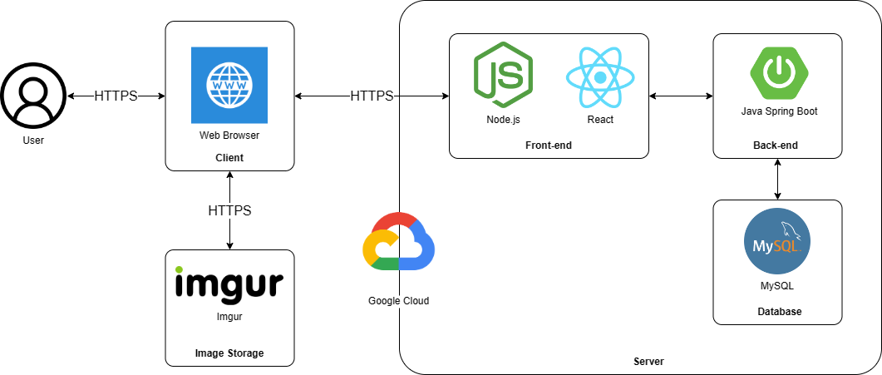

*Figure 4.1: System Architecture Diagram*

#### 1.1.2 Component Explanation

##### 1.1.2.1 Spring Boot



*Figure 4.2: Spring boot Framework*

In the project, the team uses Spring Boot libraries to implement the backend system for this project. The project uses the startup libraries provided by Spring Boot and uses the Spring Security library to generate JWT Tokens to authenticate and authorize requests sent to the system.

##### 1.1.2.2 ReactJS



*Figure 4.3: ReactJS Framework*

ReactJS is a JavaScript library used to create reusable person interface factors. The definition of React is as follows: React is a library for creating composable person interfaces. It promotes the development of reusable UI additives that show constantly changing statistics.

React takes away the DOM from you, resulting in a greater honest programming fashion and stepped forward velocity. React can also energy local apps with React local and also render at the server the use of Node. React makes use of one-manner reactive records flow, that's less boilerplate and easier to apprehend than traditional records binding.

##### 1.1.2.3 Node.js



*Figure 4.4: Node.js Cross-platform*

Node.js is a [cross-platform](https://en.wikipedia.org/wiki/Cross-platform), [open-source](https://en.wikipedia.org/wiki/Open-source_software) server environment that can run on [Windows](https://en.wikipedia.org/wiki/Microsoft_Windows), [Linux](https://en.wikipedia.org/wiki/Linux), [Unix](https://en.wikipedia.org/wiki/Unix), [macOS](https://en.wikipedia.org/wiki/MacOS), and more. Node.js is a [back-end](https://en.wikipedia.org/wiki/Frontend_and_backend) [JavaScript](https://en.wikipedia.org/wiki/JavaScript) [runtime environment](https://en.wikipedia.org/wiki/Runtime_system), runs on the [V8](https://en.wikipedia.org/wiki/V8_(JavaScript_engine)) [JavaScript Engine](https://en.wikipedia.org/wiki/JavaScript_Engine), and executes JavaScript code outside a [web browser](https://en.wikipedia.org/wiki/Web_browser).

Node.js lets developers use JavaScript to write command line tools and for [server-side scripting](https://en.wikipedia.org/wiki/Server-side_scripting). The functionality of running scripts server-side produces [dynamic web page](https://en.wikipedia.org/wiki/Dynamic_web_page) content before the page is sent to the user's web browser. Consequently, Node.js represents a "JavaScript everywhere" paradigm, unifying [web-application](https://en.wikipedia.org/wiki/Web_application) development around a single programming language, rather than different languages for server-side and client-side scripts.

##### 1.1.2.4 MySQL

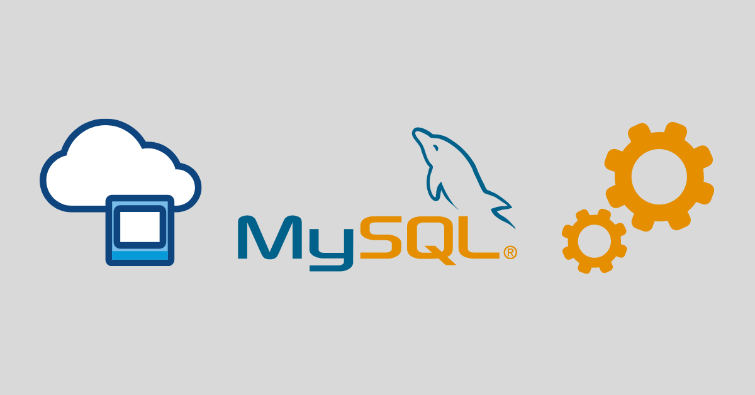

*Figure 4.5: MySQL Database*

My team is final student and we are looking for a free or low-cost database management system, several are available from which to choose: MySQL, PostgreSQL, SQLite, one of the free-but-unsupported engines from commercial vendors, and so forth. When we compare MySQL with other database systems, think about what's most important to us. Performance, support, features (such as SQL conformance or extensions), licensing conditions and restrictions, and price all are factors to take into account. Given these considerations, MySQL has many attractive features to offer:

* **Speed**: MySQL is fast. Its developers contend that MySQL is about the fastest database system can get.
* **Ease of use:** MySQL is a high-performance but relatively simple database system and is much less complex to set up and administer than larger systems.
* **Query language support:** MySQL understands SQL, the standard language of choice for all modern database systems.
* **Capability:** The MySQL server is multi-threaded, so many clients can connect to it at the same time. Each client can use multiple databases simultaneously.

##### 1.1.2.5 Google Cloud Platform



*Figure 4.6: Google Cloud Platform*

In the project, the team uses many typical Google Cloud platform services such as the Google Map API service to use for locating the hostel and giving directions to the hostel right on the interface of the website. In addition, the team also deploys the project on a virtual machine of Google Cloud with Ubuntu operating system and running Nginx server.

##### 1.1.2.6 Goong Maps API



*Figure 4.7: Goong Platform*

Goong Maps is a Web-based service that provides detailed information about geographical regions and sites around the world. In addition to conventional road maps, Goong Maps offers aerial and satellite views of many places. In some cities, Goong Maps offers street views compromising photographs taken from vehicles. It offers satellite imagery, aerial photography, street maps, 360° interactive panoramic views of streets (Street View), real-time traffic conditions

### 1.2 Package Diagram

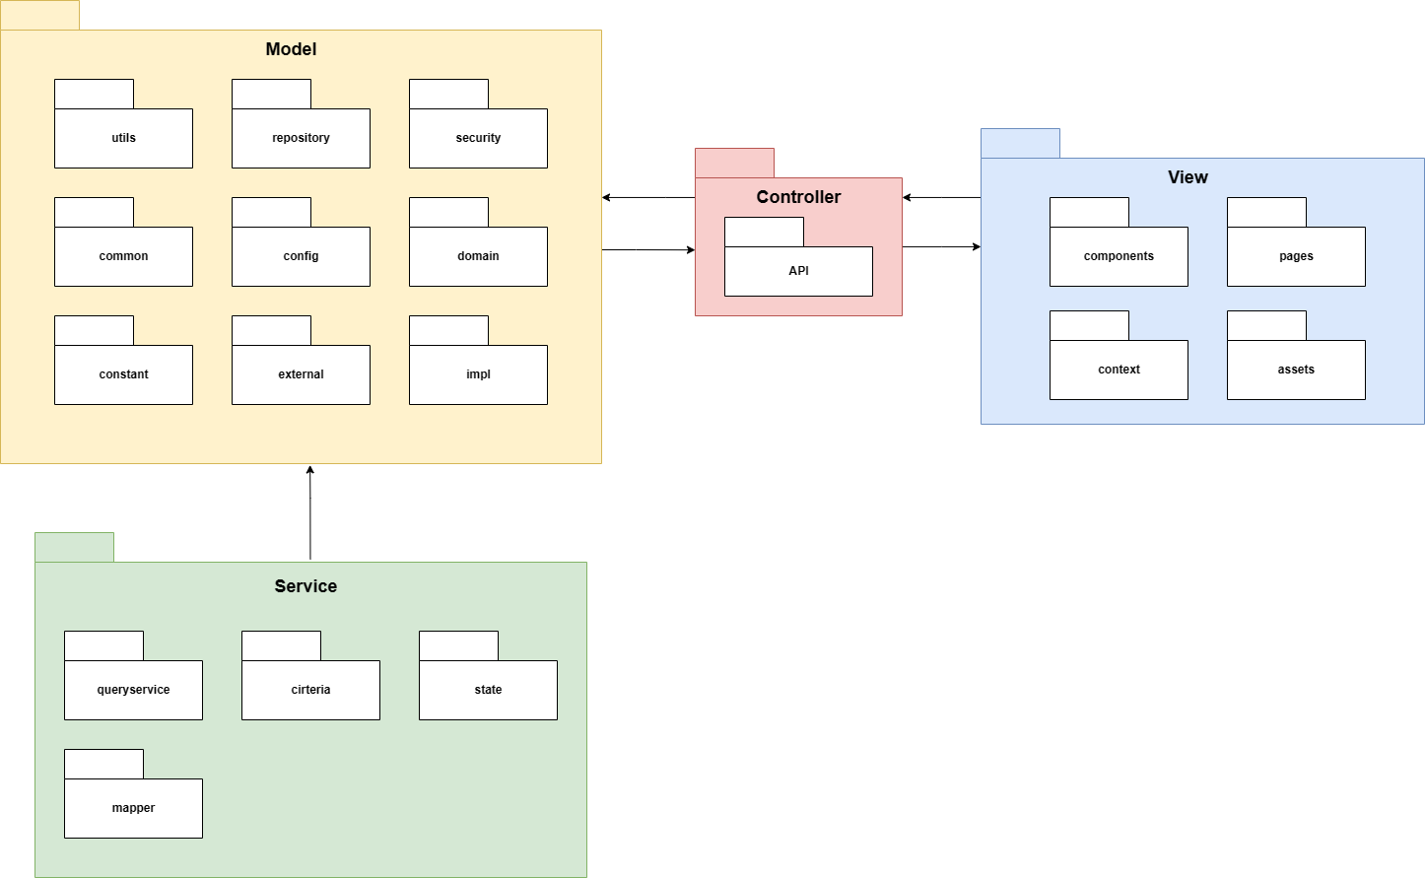

*Figure 4.8: Package Diagram*

***Package Descriptions***

|  |  |  |
| --- | --- | --- |
| **No** | **Package** | **Description** |
| 01 | Model | Carries data between processes |
| 02 | Service | Contains classes for handle logic, modify, convert from model to controller |
| 03 | Controller | Communicate between Backend and Frontend |
| 04 | View | Contains the UI and UX of the website |

## 2. Database Design

### 2.1 Database Diagram

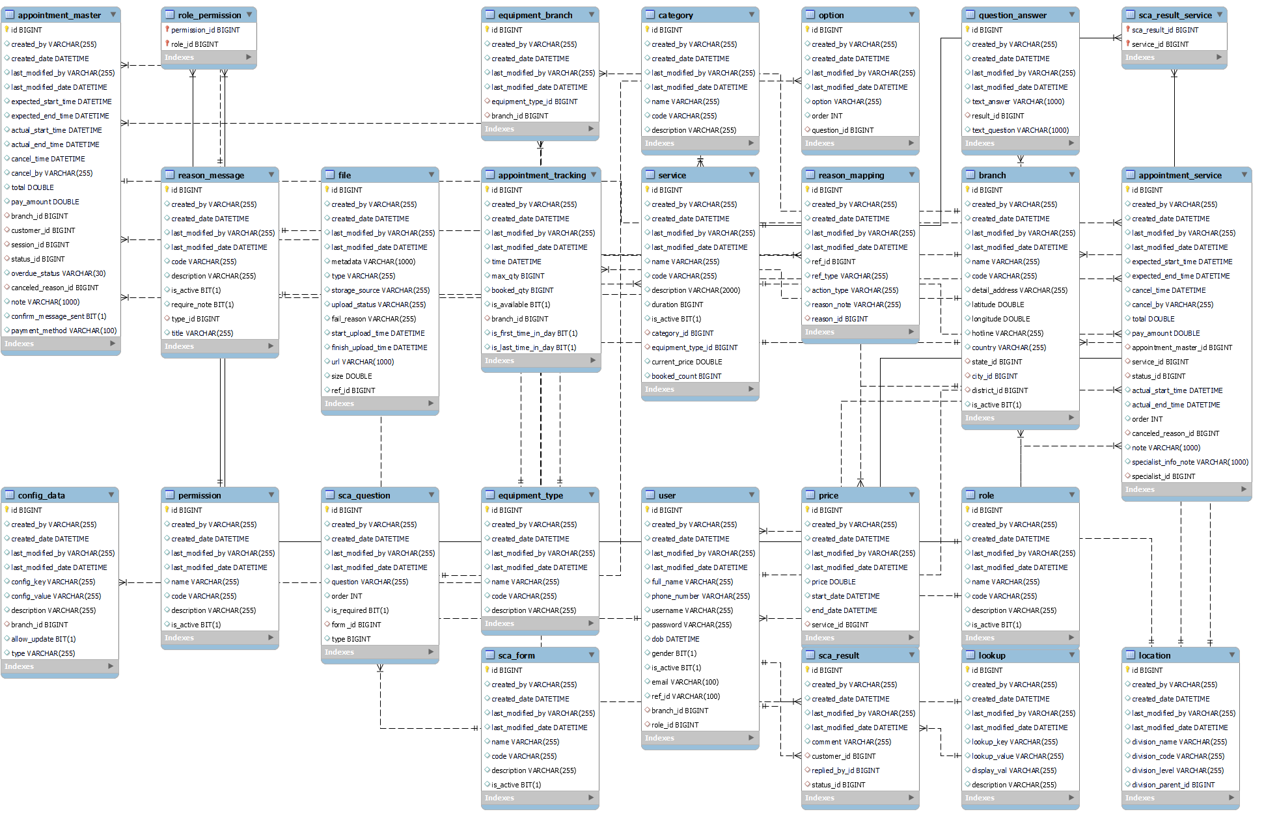

*Figure 4.9: Database Diagram*

### 2.2 Table Descriptions

#### 2.2.1 Sca_form

|  |  |  |  |  |  |
| --- | --- | --- | --- | --- | --- |
| **No** | **Field name** | **Type** | **PK/FK** | **Not null** | **Notes** |
| 01 | id | bigint | PK | x | This is an id of the form |
| 02 | code | varchar(30) |  |  | This is a code of the form |
| 03 | name | varchar(50) |  |  | This is a name of the form |
| 04 | description | varchar(255) |  |  | This is a description of the form |
| 05 | last_modified_by | varchar(30) |  |  | Last modified editor |
| 06 | last_modified_date | datetime |  |  | Last modified datetime |
| 07 | created_by | varchar(30) |  |  | The creator of the form |
| 08 | created_date | datetime |  |  | Created datetime |

#### 2.2.2 Sca_question

|  |  |  |  |  |  |
| --- | --- | --- | --- | --- | --- |
| **No** | **Field name** | **Type** | **PK/FK** | **Not null** | **Notes** |
| 01 | id | bigint | PK | x | This is an id of the question |
| 02 | question | varchar(150) |  |  | This is a content of the question |
| 03 | order | int |  |  | This is an order of the question |
| 04 | is_required | bit(1) |  |  | Required or optional question |
| 05 | last_modified_by | varchar(30) |  |  | Last modified editor |
| 06 | last_modified_date | datetime |  |  | Last modified datetime |
| 07 | created_by | varchar(30) |  |  | The creator of the question |
| 08 | created_date | datetime |  |  | Created datetime |
| 09 | form_id | int | FK |  | This is a form id which the question belongs to |

#### 2.2.3 Option

|  |  |  |  |  |  |
| --- | --- | --- | --- | --- | --- |
| **No** | **Field name** | **Type** | **PK/FK** | **Not null** | **Notes** |
| 01 | id | bigint | PK | x | This is an id of the option |
| 02 | question_id | int | FK |  | This is a question id which the option belongs to |
| 03 | option | varchar(150) |  |  | This is a content of the option |
| 04 | order | int |  |  | This is an order of the option |
| 05 | last_modified_by | varchar(30) |  |  | Last modified editor |
| 06 | last_modified_date | datetime |  |  | Last modified datetime |
| 07 | created_by | varchar(30) |  |  | The creator of the option |
| 08 | created_date | datetime |  |  | Created datetime |

#### 2.2.4 Question_answer

|  |  |  |  |  |  |
| --- | --- | --- | --- | --- | --- |
| **No** | **Field name** | **Type** | **PK/FK** | **Not null** | **Notes** |
| 01 | id | bigint | PK | x | This is an id of the answer |
| 02 | text_answer | varchar(500) |  |  | This is content of the answer |
| 03 | text_question | varchar(500) |  |  | This is content of the question |
| 04 | last_modified_by | varchar(30) |  |  | Last modified editor |
| 05 | last_modified_date | datetime |  |  | Last modified datetime |
| 06 | created_by | varchar(30) |  |  | The creator of the answer |
| 07 | created_date | datetime |  |  | Created datetime |
| 08 | result_id | bigint |  |  | This is a result id |

#### 2.2.5 Sca_result

|  |  |  |  |  |  |
| --- | --- | --- | --- | --- | --- |
| **No** | **Field name** | **Type** | **PK/FK** | **Not null** | **Notes** |
| 01 | id | int | PK | x | This is an id of the result |
| 02 | customer_id | bigint | FK |  | This is an id of the customer |
| 03 | replied_by_id | bigint | FK |  | This is an id of the manager who reply to customer |
| 04 | status_id | bigint | FK |  | This is an id of the status |
| 05 | comment | varchar(255) |  |  | This is a comment for customer |
| 06 | last_modified_by | varchar(30) |  |  | Last modified editor |
| 07 | last_modified_date | datetime |  |  | Last modified datetime |
| 08 | created_by | varchar(30) |  |  | The creator of the result |
| 09 | created_date | datetime |  |  | Created datetime |

#### 2.2.6 Sca_result_service

|  |  |  |  |  |  |
| --- | --- | --- | --- | --- | --- |
| **No** | **Field name** | **Type** | **PK/FK** | **Not null** | **Notes** |
| 01 | id | int | PK | x | This is an id of the set include result and service |
| 02 | result_id | int | FK |  | This is an id of the result |
| 03 | service_id | int | FK |  | This is an id of the service |

#### 2.2.7 Lookup

|  |  |  |  |  |  |
| --- | --- | --- | --- | --- | --- |
| **No** | **Field name** | **Type** | **PK/FK** | **Not null** | **Notes** |
| 01 | id | bigint | PK | x | This is an id of the lookup |
| 02 | lookup_key | varchar(50) |  |  | This is a code of the lookup |
| 03 | lookup_val | varchar(50) |  |  | This is a value of the lookup |
| 04 | display_val | varchar(70) |  |  | This is a content of the lookup |
| 05 | description | varchar(255) |  |  | This is a description of the lookup |
| 06 | last_modified_by | varchar(30) |  |  | Last modified editor |
| 07 | last_modified_date | datetime |  |  | Last modified datetime |
| 08 | created_by | varchar(30) |  |  | The creator of the lookup |
| 09 | created_date | datetime |  |  | Created datetime |

#### 2.2.8 Branch

|  |  |  |  |  |  |
| --- | --- | --- | --- | --- | --- |
| **No** | **Field name** | **Type** | **PK/FK** | **Not null** | **Notes** |
| 01 | id | bigint | PK | x | This is an id of the branch |
| 02 | status_id | bigint | FK |  | This is an id of the status |
| 03 | city_id | bigint | FK |  | This is an id of the city |
| 04 | district_id | bigint | FK |  | This is an id of the district |
| 05 | name | varchar(50) |  |  | This is a name of the branch |
| 06 | code | varchar(30) |  |  | This is a code of the branch |
| 07 | detail_address | varchar(100) |  |  | This is a detail address of the branch |
| 08 | hotline | varchar(20) |  | x | This is a phone number of the branch |
| 09 | latitude | double |  | x | This is a latitude of the branch |
| 10 | longitude | double |  | x | This is a longitude of the branch |
| 11 | country | varchar(30) |  |  | This is a country which the branch belongs to |
| 12 | last_modified_by | varchar(30) |  |  | Last modified editor |
| 13 | last_modified_date | datetime |  |  | Last modified datetime |
| 14 | created_by | varchar(30) |  |  | The creator of the branch |
| 15 | created_date | datetime |  |  | Created datetime |

#### 2.2.9 Config_data

|  |  |  |  |  |  |
| --- | --- | --- | --- | --- | --- |
| **No** | **Field name** | **Type** | **PK/FK** | **Not null** | **Notes** |
| 01 | id | bigint | PK | x | This is an id of the data config |
| 02 | branch_id | int | FK |  | This is an id of the branch |
| 03 | config_key | varchar(70) |  |  | This is a code of the data config |
| 04 | config_value | varchar(50) |  |  | This is a value of the data config |
| 05 | description | varchar(255) |  |  | This is a description of the data config |
| 06 | last_modified_by | varchar(30) |  |  | Last modified editor |
| 07 | last_modified_date | datetime |  |  | Last modified datetime |
| 08 | created_by | varchar(30) |  |  | The creator of the data config |
| 09 | created_date | datetime |  |  | Created datetime |
| 10 | allow_update | bit(1) |  |  | Update or not update |
| 11 | type | varchar(20) |  |  | This is a type of the data config |

#### 2.2.10 Service

|  |  |  |  |  |  |
| --- | --- | --- | --- | --- | --- |
| **No** | **Field name** | **Type** | **PK/FK** | **Not null** | **Notes** |
| 01 | id | bigint | PK | x | This is an id of the service |
| 02 | category_id | int | FK |  | This is an id of the category |
| 03 | equipment_id | int | FK |  | This is an id of the equipment |
| 04 | name | varchar(50) |  |  | This is a name of the service |
| 05 | code | varchar(30) |  |  | This is a code of the service |
| 06 | description | varchar(255) |  |  | This is a description of the service |
| 07 | duration | int |  |  | This is a duration of the service |
| 08 | is_active | boolean |  |  | Active or inactive |
| 09 | last_modified_by | varchar(30) |  |  | Last modified editor |
| 10 | last_modified_date | datetime |  |  | Last modified datetime |
| 11 | created_by | varchar(30) |  |  | The creator of the service |
| 12 | created_date | datetime |  |  | Created datetime |

#### 2.2.11 Price

|  |  |  |  |  |  |
| --- | --- | --- | --- | --- | --- |
| **No** | **Field name** | **Type** | **PK/FK** | **Not null** | **Notes** |
| 01 | id | bigint | PK | x | This is an id of the price |
| 02 | service_id | int | FK |  | This is an id of the service |
| 03 | price | double |  |  | This is a value of the price |
| 04 | start_date | datetime |  |  | This is a start time of the service |
| 05 | end_date | datetime |  |  | This is an end time of the service |
| 06 | last_modified_by | varchar(30) |  |  | Last modified editor |
| 07 | last_modified_date | datetime |  |  | Last modified datetime |
| 08 | created_by | varchar(30) |  |  | The creator of the price |
| 09 | created_date | datetime |  |  | Created datetime |

#### 2.2.12 Category

|  |  |  |  |  |  |
| --- | --- | --- | --- | --- | --- |
| **No** | **Field name** | **Type** | **PK/FK** | **Not null** | **Notes** |
| 01 | id | int | PK | x | This is an id of the category |
| 02 | name | varchar(50) |  |  | This is a name of the category |
| 03 | code | varchar(50) |  |  | This is a code of the category |
| 04 | description | varchar(255) |  |  | This is a description of the category |
| 06 | last_modified_by | varchar(30) |  |  | Last modified editor |
| 07 | last_modified_date | datetime |  |  | Last modified datetime |
| 08 | created_by | varchar(30) |  |  | The creator of the category |
| 09 | created_date | datetime |  |  | Created datetime |

#### 2.2.13 Equipment_type

|  |  |  |  |  |  |
| --- | --- | --- | --- | --- | --- |
| **No** | **Field name** | **Type** | **PK/FK** | **Not null** | **Notes** |
| 01 | id | int | PK | x | This is an id of the equipment |
| 02 | name | varchar(50) |  |  | This is a name of the equipment |
| 03 | code | varchar(50) |  |  | This is a code of the equipment |
| 04 | description | varchar(255) |  |  | This is a description of the equipment |
| 05 | last_modified_by | varchar(30) |  |  | Last modified editor |
| 06 | last_modified_date | datetime |  |  | Last modified datetime |
| 07 | created_by | varchar(30) |  |  | The creator of the equipment |
| 08 | created_date | datetime |  |  | Created datetime |

#### 2.2.14 Equipment_branch

|  |  |  |  |  |  |
| --- | --- | --- | --- | --- | --- |
| **No** | **Field name** | **Type** | **PK/FK** | **Not null** | **Notes** |
| 01 | id | int | PK | x | This is an id of the set include equipment and branch |
| 02 | equipment_code | varchar(50) | FK |  | This is a code of the equipment |
| 03 | branch_id | int | FK |  | This is an id of the branch |
| 04 | quantity | int |  |  | This is quantity of the equipment |
| 05 | last_modified_by | varchar(30) |  |  | Last modified editor |
| 06 | last_modified_date | datetime |  |  | Last modified datetime |
| 07 | created_by | varchar(30) |  |  | The creator of the set include equipment and branch |
| 08 | created_date | datetime |  |  | Created datetime |

#### 2.2.15 Role

|  |  |  |  |  |  |
| --- | --- | --- | --- | --- | --- |
| **No** | **Field name** | **Type** | **PK/FK** | **Not null** | **Notes** |
| 01 | id | bigint | PK | x | This is an id of the role |
| 02 | name | varchar(50) |  |  | This is a name of the role |
| 03 | code | varchar(30) |  |  | This is a code of the role |
| 04 | description | varchar(255) |  |  | This is a description of the role |
| 05 | is_active | boolean |  |  | Active or inactive |
| 06 | last_modified_by | varchar(30) |  |  | Last modified editor |
| 07 | last_modified_date | datetime |  |  | Last modified datetime |
| 08 | created_by | varchar(30) |  |  | The creator of the role |
| 09 | created_date | datetime |  |  | Created datetime |

#### 2.2.16 Permission_role

|  |  |  |  |  |  |
| --- | --- | --- | --- | --- | --- |
| **No** | **Field name** | **Type** | **PK/FK** | **Not null** | **Notes** |
| 01 | id | bigint | PK | x | This is an id of the set include role and permission |
| 02 | role_id | bigint | FK |  | This is an id of the role |
| 03 | permission_id | bigint | FK |  | This is an id of the permission |

#### 2.2.17 Permission

|  |  |  |  |  |  |
| --- | --- | --- | --- | --- | --- |
| **No** | **Field name** | **Type** | **PK/FK** | **Not null** | **Notes** |
| 01 | id | bigint | PK | x | This is an id of the permission |
| 02 | name | varchar(50) |  |  | This is a name of the permission |
| 03 | code | varchar(30) |  |  | This is a code of the permission |
| 04 | description | varchar(255) |  |  | This is a description of the permission |
| 05 | is_active | bit(1) |  |  | Active or inactive |
| 06 | last_modified_by | varchar(30) |  |  | Last modified editor |
| 07 | last_modified_date | datetime |  |  | Last modified datetime |
| 08 | created_by | varchar(30) |  |  | The creator of the permission |
| 09 | created_date | datetime |  |  | Created datetime |

#### 2.2.18 User

|  |  |  |  |  |  |  |
| --- | --- | --- | --- | --- | --- | --- |
| **No** | **Field name** | **Type** | **PK/FK** | **Not null** | **UNIQUE** | **Notes** |
| 01 | id | bigint | PK | x |  | This is an id of the user |
| 02 | full_name | varchar(50) |  |  |  | This is a name of the user |
| 03 | phone_number | varchar(15) |  | x | x | This is a phone number of the user |
| 04 | email | varchar(50) |  |  |  | This is an email of the user |
| 05 | username | varchar(30) |  | x | x | This is a username of the user |
| 06 | dob | datetime |  |  |  | This is a date of birth of the user |
| 07 | gender | boolean |  |  |  | This is a gender of the user |
| 08 | password | varchar(50) |  |  |  | This is a password of the user |
| 09 | is_active | bit(1) |  |  |  | Active or inactive |
| 10 | last_modified_by | varchar(30) |  |  |  | Last modified editor |
| 11 | last_modified_date | datetime |  |  |  | Last modified datetime |
| 12 | created_by | varchar(30) |  |  |  | The creator of the user |
| 13 | created_date | datetime |  |  |  | Created datetime |

#### 2.2.19 Appointment_master

|  |  |  |  |  |  |
| --- | --- | --- | --- | --- | --- |
| **No** | **Field name** | **Type** | **PK/FK** | **Not null** | **Notes** |
| 01 | id | bigint | PK | x | This is an id of the appointment master |
| 02 | customer_id | bigint | FK |  | This is an id of the customer |
| 03 | branch_id | bigint | FK |  | This is an id of the branch |
| 04 | status_id | bigint | FK |  | This is an id of the status |
| 05 | canceled_reason_id | bigint | FK |  | This is an id of the canceled reason |
| 06 | expected_start_time | datetime |  |  | This is an expected start time |
| 07 | expected_end_time | datetime |  |  | This is an expected end time |
| 08 | actual_start_time | datetime |  |  | This is an actual start time |
| 09 | actual_end_time | datetime |  |  | This is an actual start time |
| 10 | cancel_time | datetime |  |  | This is a cancel time |
| 11 | canceled_by | varchar(20) |  |  | A person who canceled an appointment |
| 12 | total | double |  |  | Expected price of the appointment |
| 13 | pay_amount | double |  |  | Actual price of the appointment |
| 14 | overdue_status | varchar(30) |  |  | Overdue status |
| 15 | note | varchar(255) |  |  | This is a note of the appointment |
| 16 | last_modified_by | varchar(30) |  |  | Last modified editor |
| 17 | last_modified_date | datetime |  |  | Last modified datetime |
| 18 | created_by | varchar(30) |  |  | The creator of the appointment |
| 19 | created_date | datetime |  |  | Created datetime |

#### 2.2.20 Apointment_service

|  |  |  |  |  |  |
| --- | --- | --- | --- | --- | --- |
| **No** | **Field name** | **Type** | **PK/FK** | **Not null** | **Notes** |
| 01 | id | bigint | PK | x | This is an id of the appointment service |
| 02 | appointment_master_id | bigint | FK |  | This is an id of the appointment master |
| 03 | service_id | bigint | FK |  | This is an id of the service |
| 04 | status_id | bigint | FK |  | This is an id of the status |  |
| 05 | canceled_reason_id | bigint | FK |  | This is an id of the canceled reason |  |
| 06 | expected_start_time | datetime |  |  | This is an expected start time |  |
| 07 | expected_end_time | datetime |  |  | This is an expected end time |  |
| 08 | total | float |  |  | This is an expected price of the appointment |  |
| 09 | pay_amount | float |  |  | This is an actual price of the appointment |  |
| 10 | cancel_time | datetime |  |  | This is a cancel time |  |
| 11 | cancelled_by | varchar(30) |  |  | A person who canceled an appointment |  |
| 12 | last_modified_by | varchar(30) |  |  | Last modified editor |  |
| 13 | last_modified_date | datetime |  |  | Last modified datetime |  |
| 14 | created_by | varchar(30) |  |  | The creator of the appointment |  |
| 15 | created_date | datetime |  |  | Created datetime |  |
| 16 | actual_start_time | datetime |  |  | This is an actual start time |  |
| 17 | actual_end_time | datetime |  |  | This is an actual end time |  |
| 18 | order | int |  |  | This is an order of the appointment |  |
| 19 | note | varchar(255) |  |  | This is a note of the appointment |  |

#### 2.2.21 Reason_mapping

|  |  |  |  |  |  |
| --- | --- | --- | --- | --- | --- |
| **No** | **Field name** | **Type** | **PK/FK** | **Not null** | **Notes** |
| 01 | id | bigint | PK | x | This is an id of the reason mapping |
| 02 | reason_id | int | FK |  | This is an id of the reason |
| 03 | ref_id | int |  |  | This is an id of the reference |
| 04 | ref_type | varchar(50) |  |  | This is a reference type |
| 05 | action_type | varchar(30) |  |  | This is an action type |
| 06 | reason_note | varchar(100) |  |  | This is a note |
| 07 | last_modified_by | varchar(30) |  |  | Last modified editor |
| 08 | last_modified_date | datetime |  |  | Last modified datetime |
| 09 | created_by | varchar(30) |  |  | The creator of the reason mapping |
| 10 | created_date | datetime |  |  | Created datetime |

#### 2.2.22 Reason_message

|  |  |  |  |  |  |
| --- | --- | --- | --- | --- | --- |
| **No** | **Field name** | **Type** | **PK/FK** | **Not null** | **Notes** |
| 01 | id | bigint | PK | x | This is an id of the reason message |
| 02 | type_id | bigint | FK |  | This is an id of the type |
| 03 | code | varchar(30) |  |  | This is a code of the reason message |
| 04 | title | varchar(50) |  |  | This is a title of the reason message |
| 05 | description | varchar(255) |  |  | This is a description of the reason message |
| 06 | is_active | bit(1) |  |  | Active or inactive |
| 07 | required_note | bit(1) |  |  | Require or not require |
| 08 | last_modified_by | varchar(30) |  |  | Last modified editor |
| 09 | last_modified_date | datetime |  |  | Last modified datetime |
| 10 | created_by | varchar(30) |  |  | The creator of the reason message |
| 11 | created_date | datetime |  |  | Created datetime |

#### 2.2.23 File

|  |  |  |  |  |  |
| --- | --- | --- | --- | --- | --- |
| **No** | **Field name** | **Type** | **PK/FK** | **Not null** | **Notes** |
| 01 | id | int | PK | x | This is an id of the file |
| 02 | metadata | varchar(50) |  |  | This is a metadata |
| 03 | type | varchar(30) |  |  | This is a type of the file |
| 04 | storage_source | varchar(30) |  |  | This is a source storage of the file |
| 05 | upload_status | varchar(10) |  |  | This is an upload status |
| 06 | fail_reason | varchar(30) |  |  | This is a failure reason |
| 07 | start_upload_time | datetime |  |  | This is a started upload time |
| 08 | finish_upload_time | datetime |  |  | This is a finished upload time |
| 09 | url | varchar(255) |  |  | This is a url of the file |
| 10 | last_modified_by | varchar(30) |  |  | Last modified editor |
| 11 | last_modified_date | datetime |  |  | Last modified datetime |
| 12 | created_by | varchar(30) |  |  | The creator of the file |
| 13 | created_date | datetime |  |  | Created datetime |
| 14 | size | double |  |  | This is a size of the file |
| 15 | ref_id | bigint |  |  | This is a reference id of the file |

#### 2.2.24 Apointment_tracking

|  |  |  |  |  |  |
| --- | --- | --- | --- | --- | --- |
| **No** | **Field name** | **Type** | **PK/FK** | **Not null** | **Notes** |
| 01 | id | bigint | PK | x | This is an id of the appointment tracking |
| 02 | branch_id | bigint | FK |  | This is an id of the branch |
| 03 | is_first_time_in_day | bit(1) |  |  | This is first time in day |
| 04 | is_last_time_in_day | bit(1) |  |  | This is last time in day |
| 05 | time | datetime |  |  | This is a realtime |
| 06 | max_qty | int |  |  | This is max quantity |
| 07 | booked_qty | int |  |  | This is booked quantity |
| 08 | is_available | bit(1) |  |  | Available or unavailable |
| 09 | last_modified_by | varchar(30) |  |  | Last modified editor |
| 10 | last_modified_date | datetime |  |  | Last modified datetime |
| 11 | created_by | varchar(30) |  |  | The creator of the appointment tracking |
| 12 | created_date | datetime |  |  | Created datetime |

#### 2.2.25 Location

|  |  |  |  |  |  |
| --- | --- | --- | --- | --- | --- |
| **No** | **Field name** | **Type** | **PK/FK** | **Not null** | **Notes** |
| 01 | id | bigint | PK | x | This is an id of the location |
| 02 | division_name | varchar(50) |  |  | This is a name of the location |
| 03 | division_code | varchar(50) |  |  | This is a code of the location |
| 04 | division_level | varchar(50) |  |  | This is a level of the location |
| 05 | division_parent_id | datetime |  |  | This is a parent id of the location |
| 06 | last_modified_by | varchar(30) |  |  | Last modified editor |
| 07 | last_modified_date | datetime |  |  | Last modified datetime |
| 08 | created_by | varchar(30) |  |  | The creator of the location |
| 09 | created_date | datetime |  |  | Created datetime |

## 3. Detailed Design

### 3.1 Manage Category

##### 3.1.1 Class Diagram

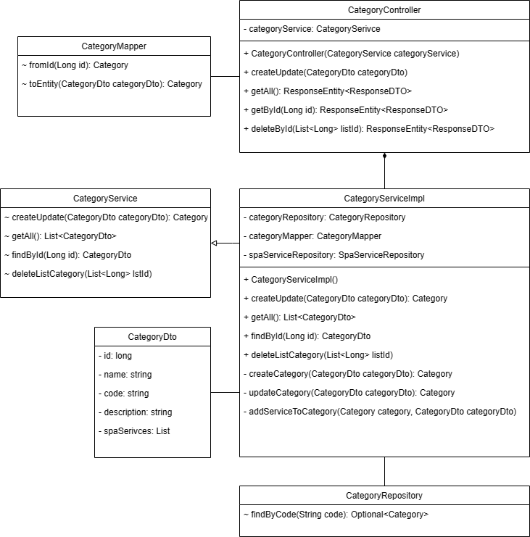

*Figure 4.10: Category Class Diagram*

##### 3.1.2 Sequence Diagram

- View category list

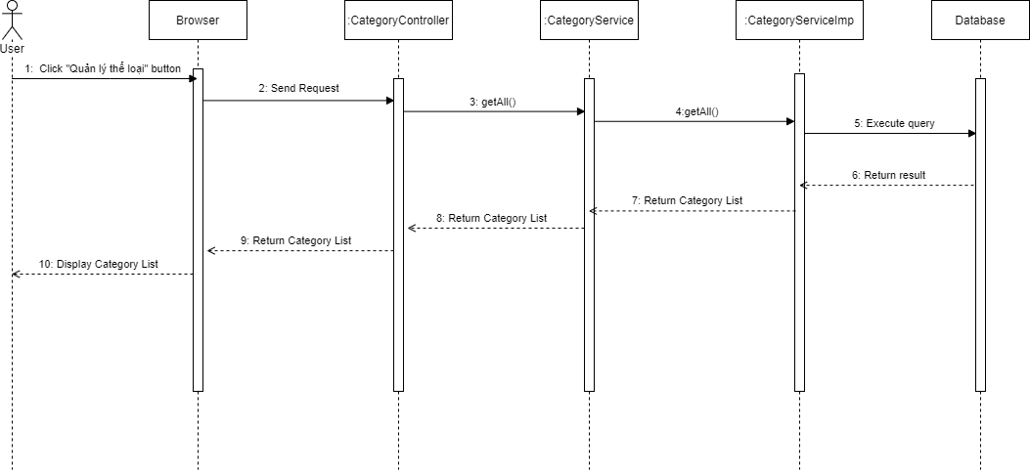

*Figure 4.11: View category list Sequence Diagram*

- View category detail

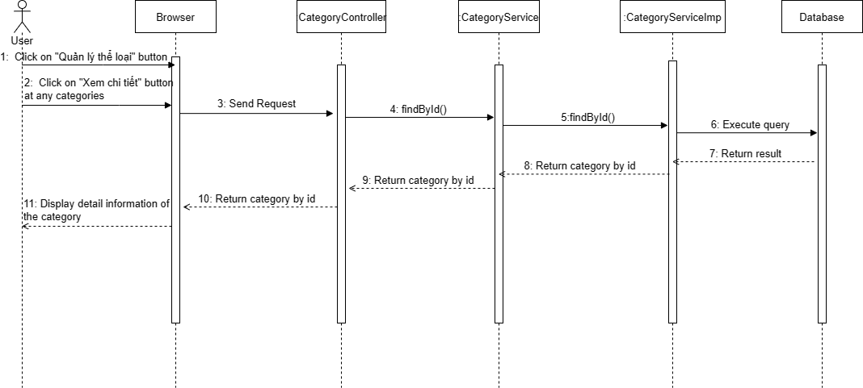

*Figure 4.12: View category detail Sequence Diagram*

- Create category

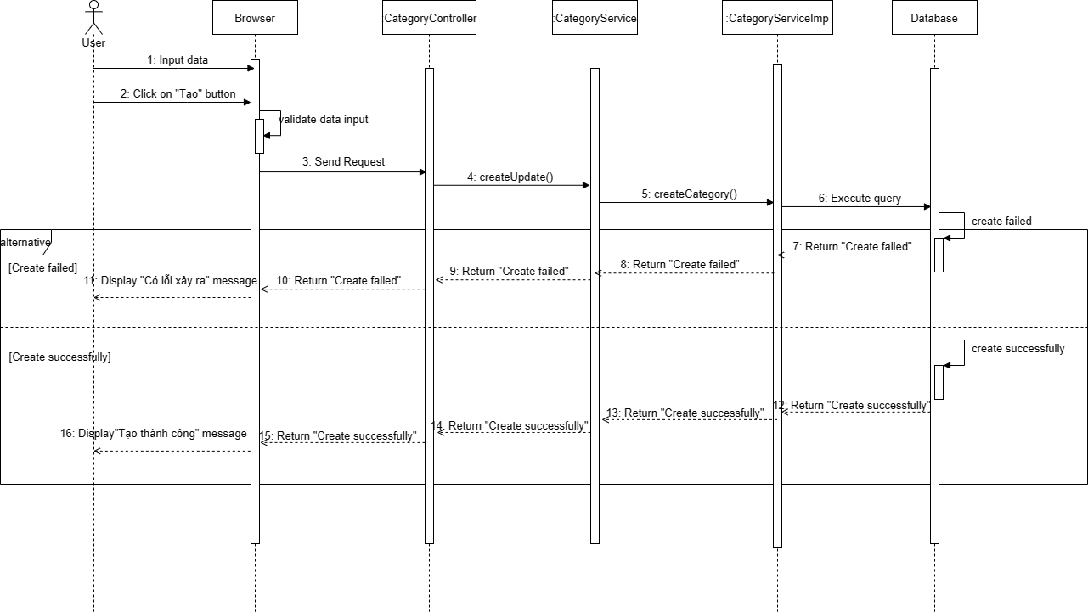

*Figure 4.13: Create category Sequence Diagram*

- Update category

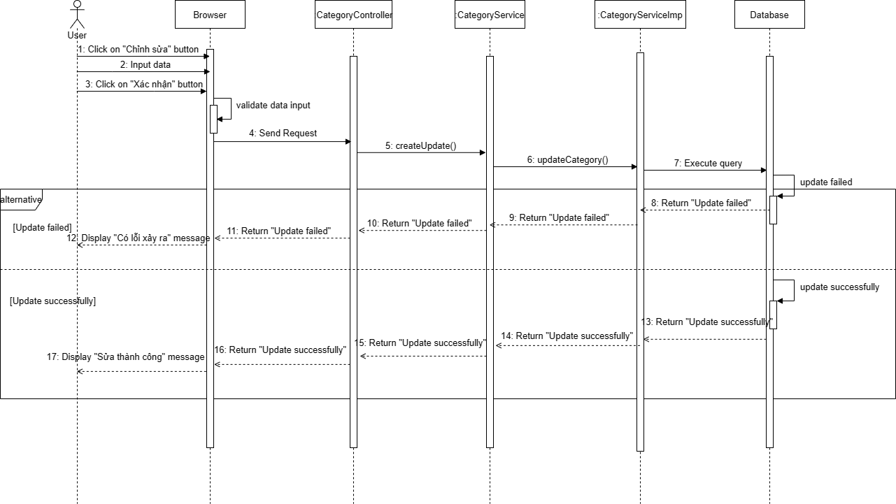

*Figure 4.14: Update category Sequence Diagram*

- Delete category

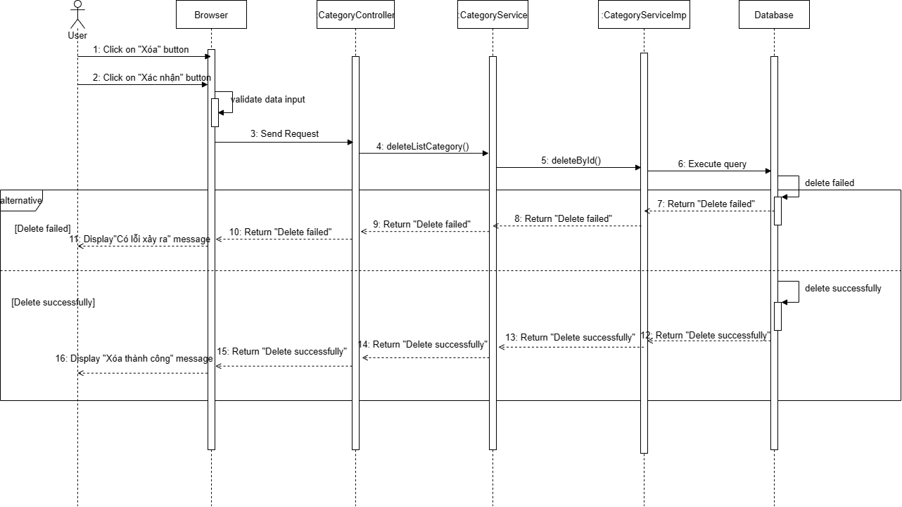

*Figure 4.15: Delete category Sequence Diagram*

### 3.2 Manage Service

##### 3.2.1 Class Diagram

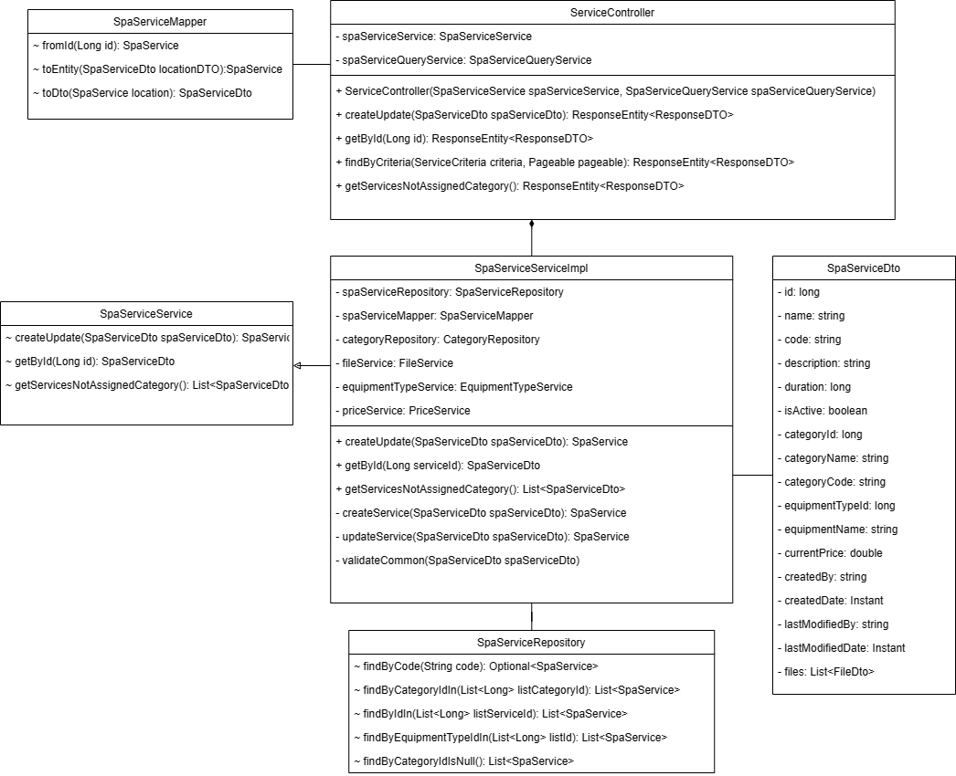

*Figure 4.16: Service Class Diagram*

##### 3.2.2 Sequence Diagram

- View service list

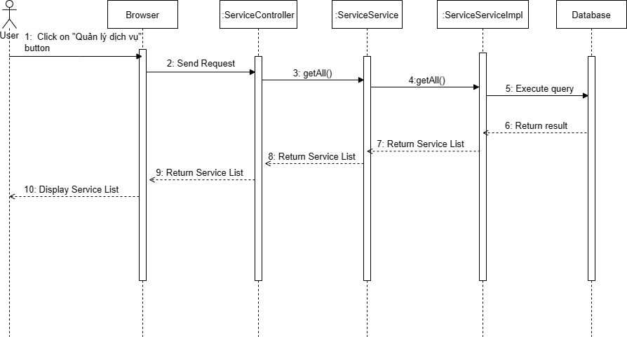

*Figure 4.17: View service list Sequence Diagram*

- View service detail

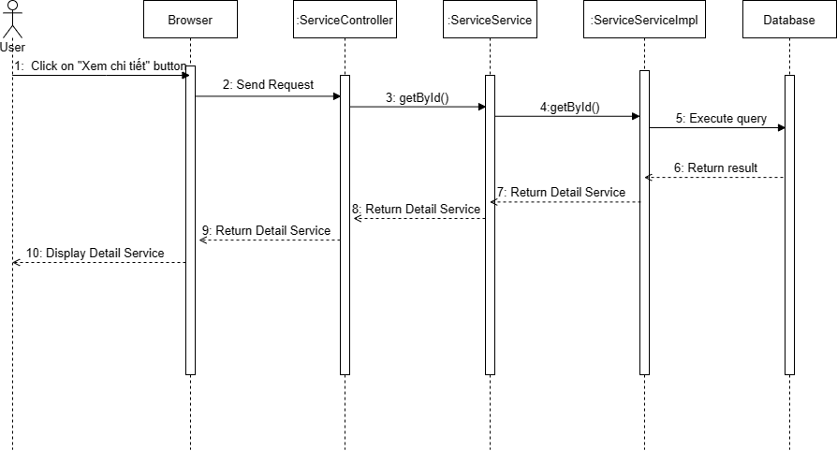

*Figure 4.18: View service detail Sequence Diagram*

- Create service

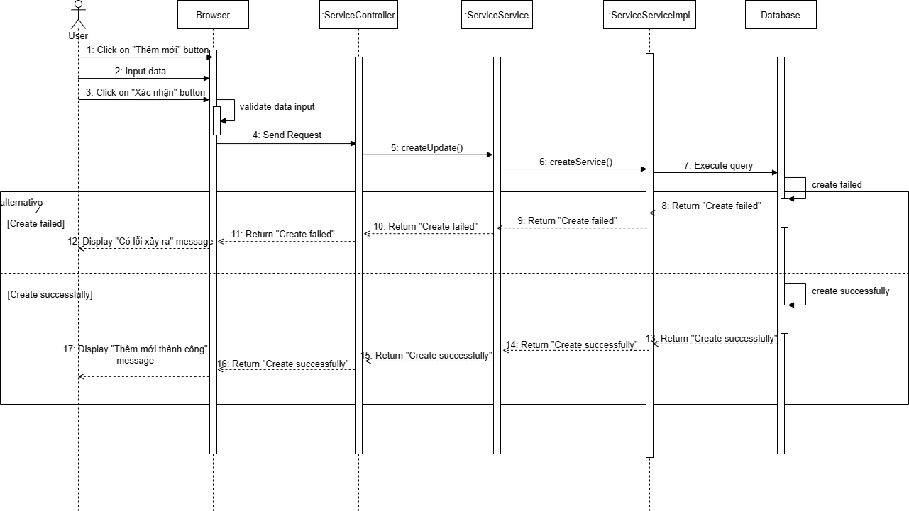

*Figure 4.19: Create service Sequence Diagram*

- Update service

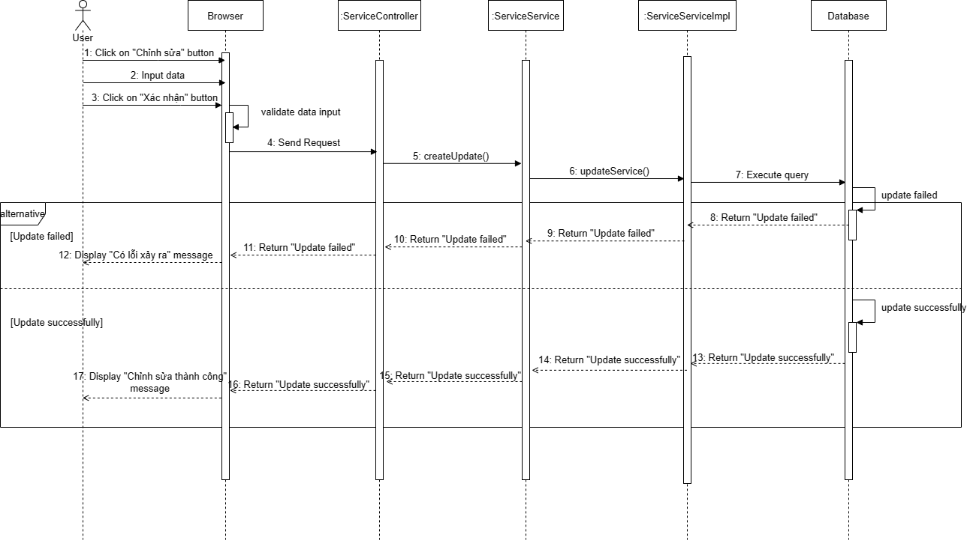

*Figure 4.20: Update service Sequence Diagram*

- Search service

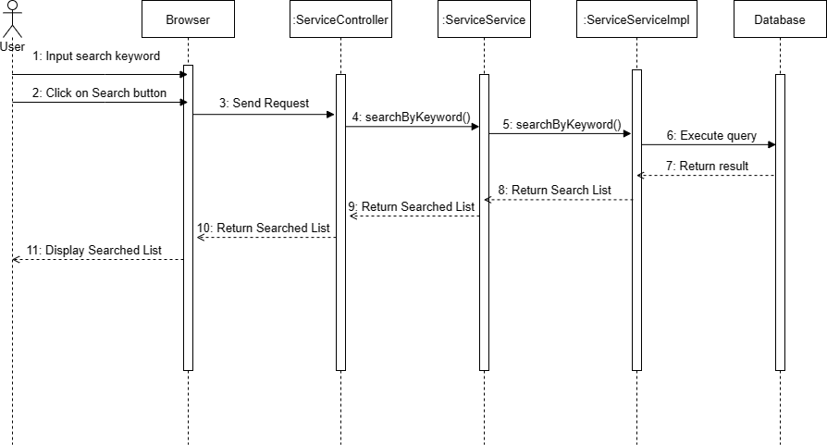

*Figure 4.21: Search service Sequence Diagram*

### 3.3 Manage Branch

##### 3.3.1 Class Diagram

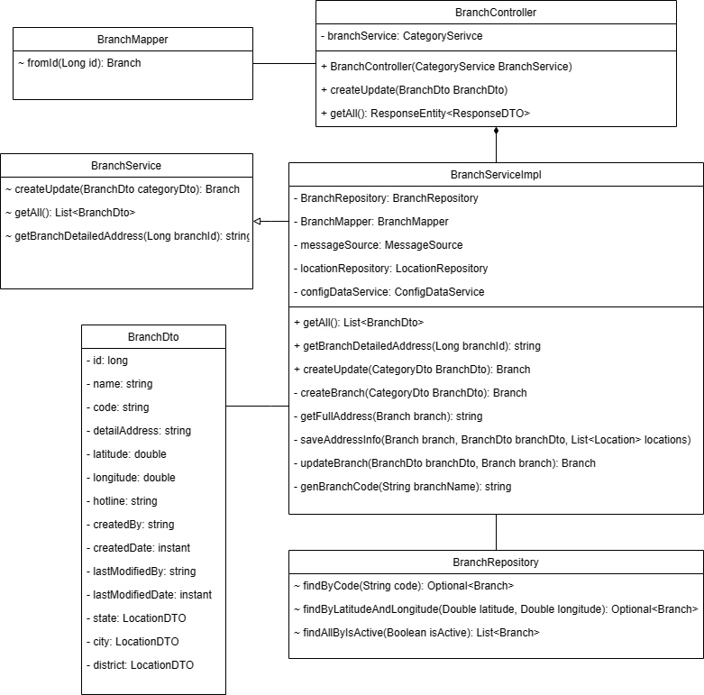

*Figure 4.22: Branch Class Diagram*

##### 3.3.2 Sequence Diagram

- View branch list

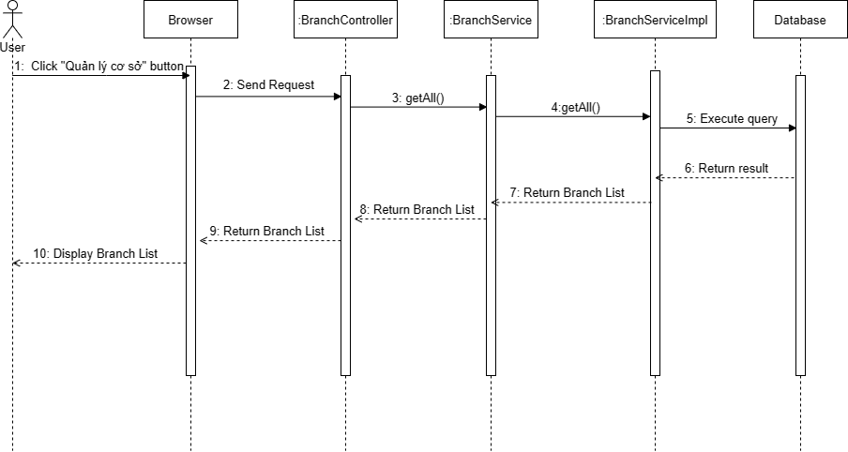

*Figure 4.23: View branch list Sequence Diagram*

- View branch detail

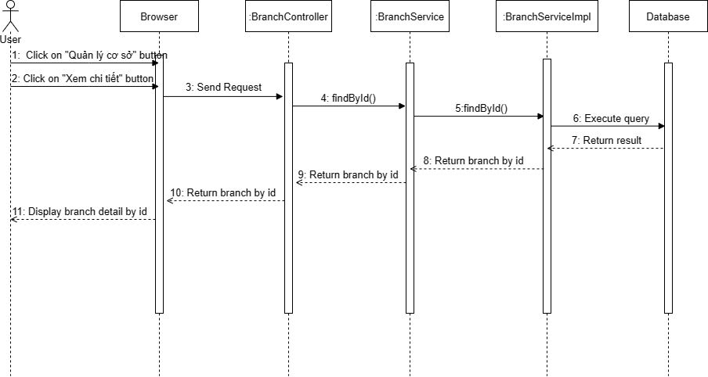

*Figure 4.24: View branch detail Sequence Diagram*

- Create branch

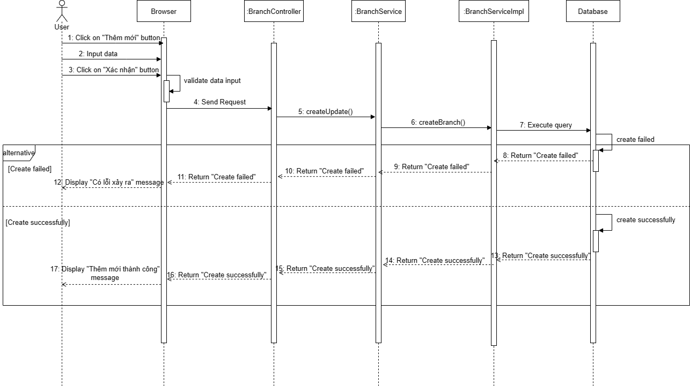

*Figure 4.25: Create branch Sequence Diagram*

- Update branch

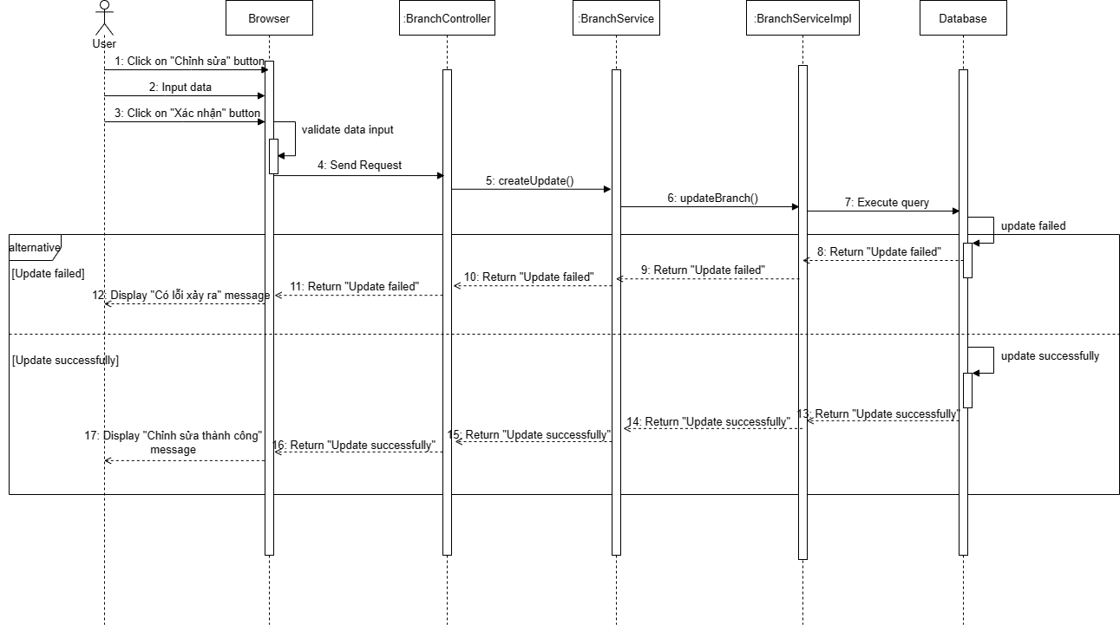

*Figure 4.26: Update branch Sequence Diagram*

### 3.4 Manage Data Config

##### 3.4.1 Class Diagram

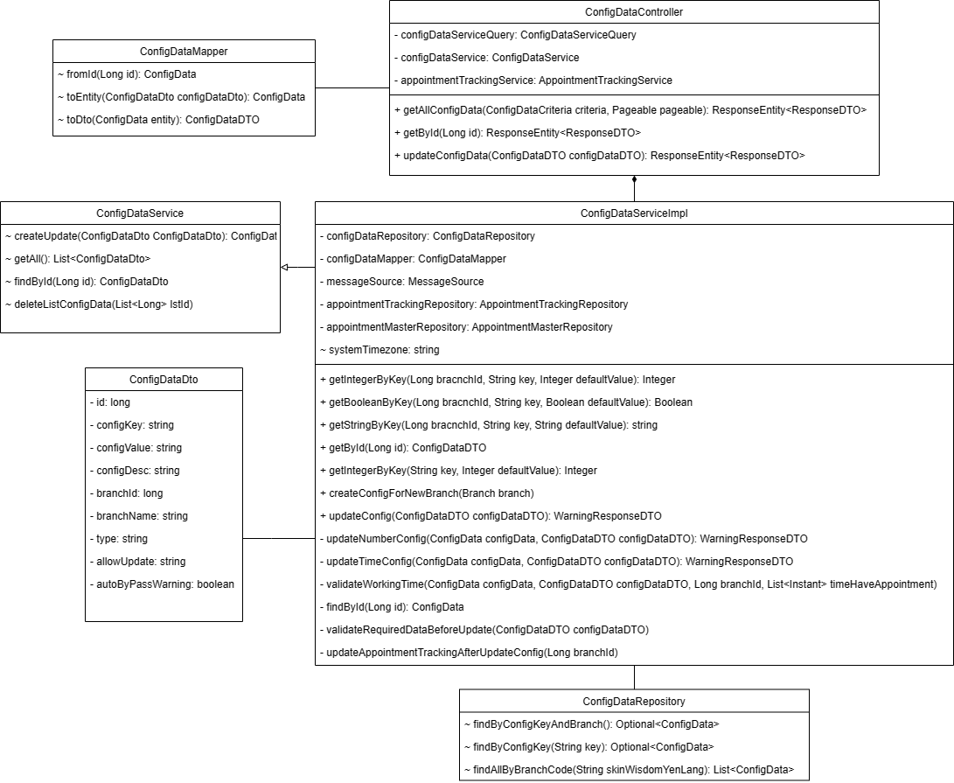

*Figure 4.27: Data config Class Diagram*

##### 3.4.2 Sequence Diagram

- View data config list

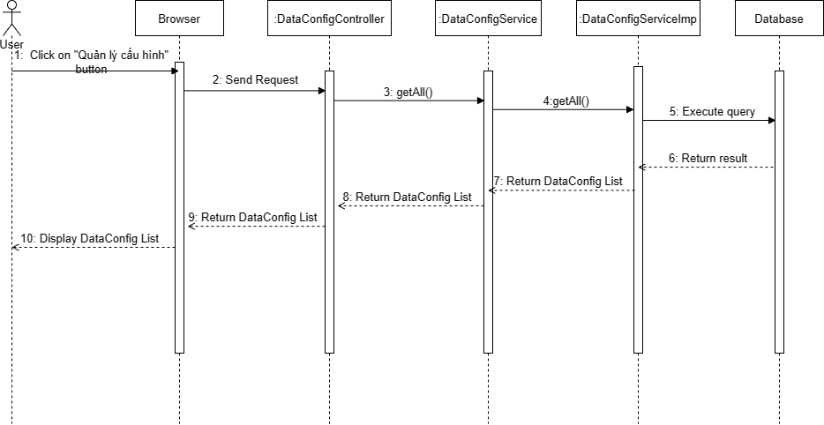

*Figure 4.28: View data config list Sequence Diagram*

- View data config detail

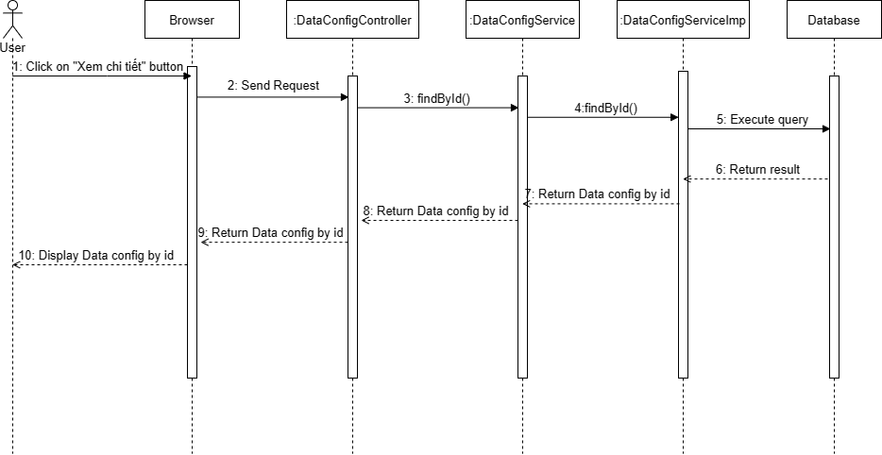

*Figure 4.29: View data config detail Sequence Diagram*

- Update data config

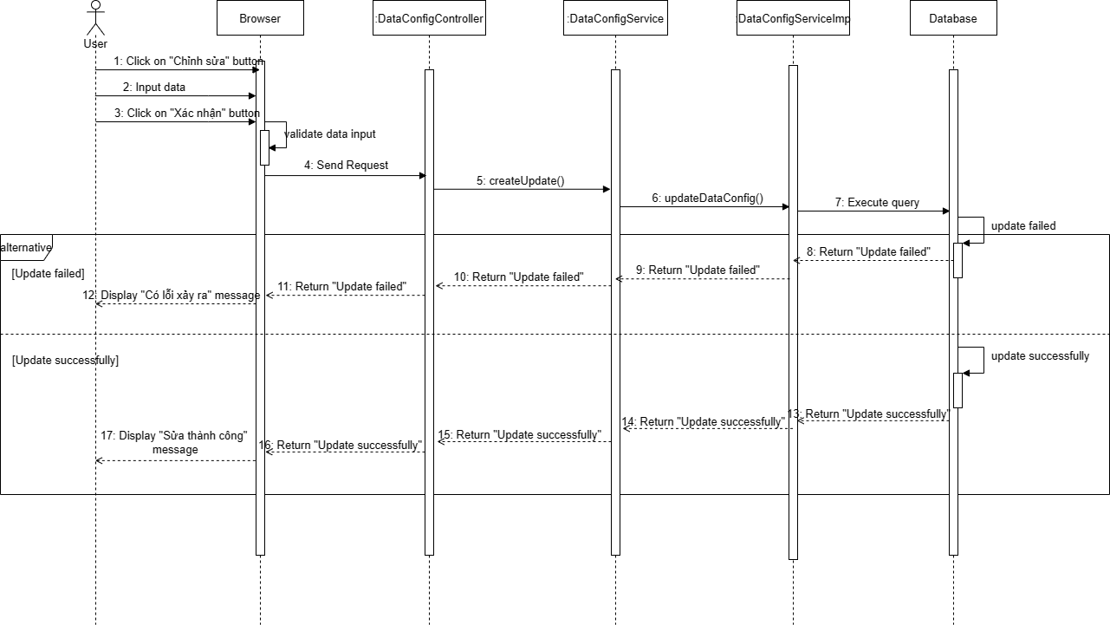

*Figure 4.30: Update data config Sequence Diagram*

### 3.5 Manage Equipment

##### 3.5.1 Class Diagram

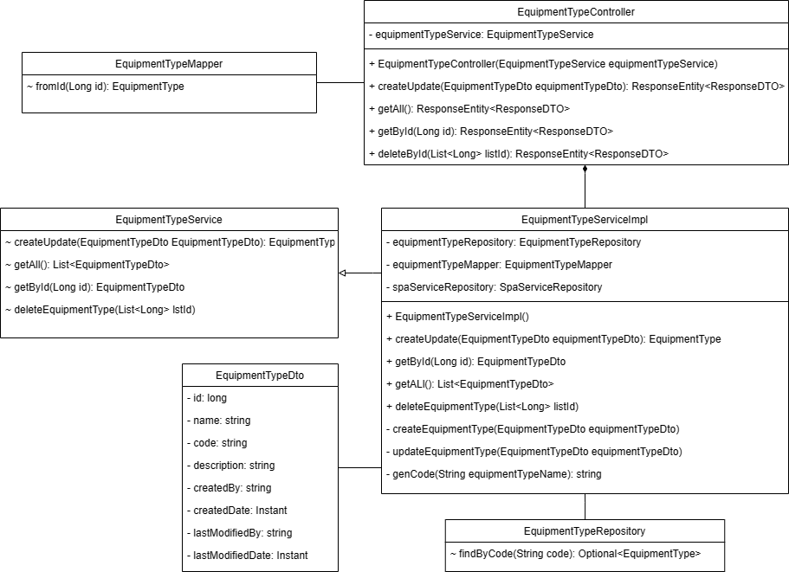

*Figure 4.31: Equipment Class Diagram*

##### 3.5.2 Sequence Diagram

- View equipment list

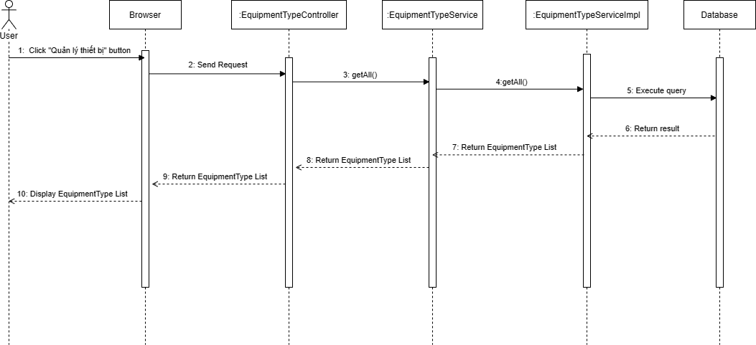

*Figure 4.32: View equipment list Sequence Diagram*

- View equipment detail

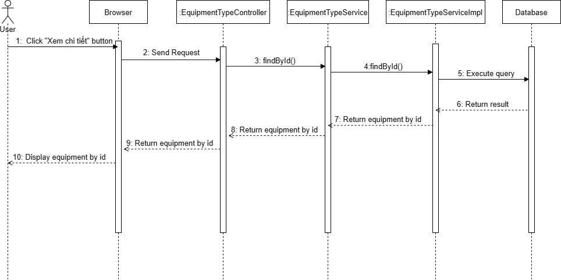

*Figure 4.33: View equipment detail Sequence Diagram*

- Create equipment

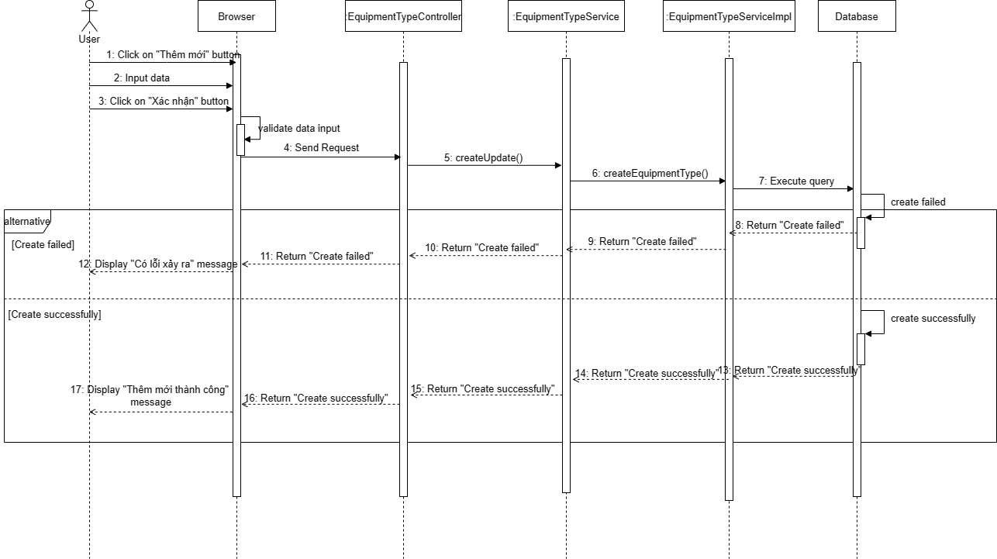

*Figure 4.34: Create equipment Sequence Diagram*

- Update equipment

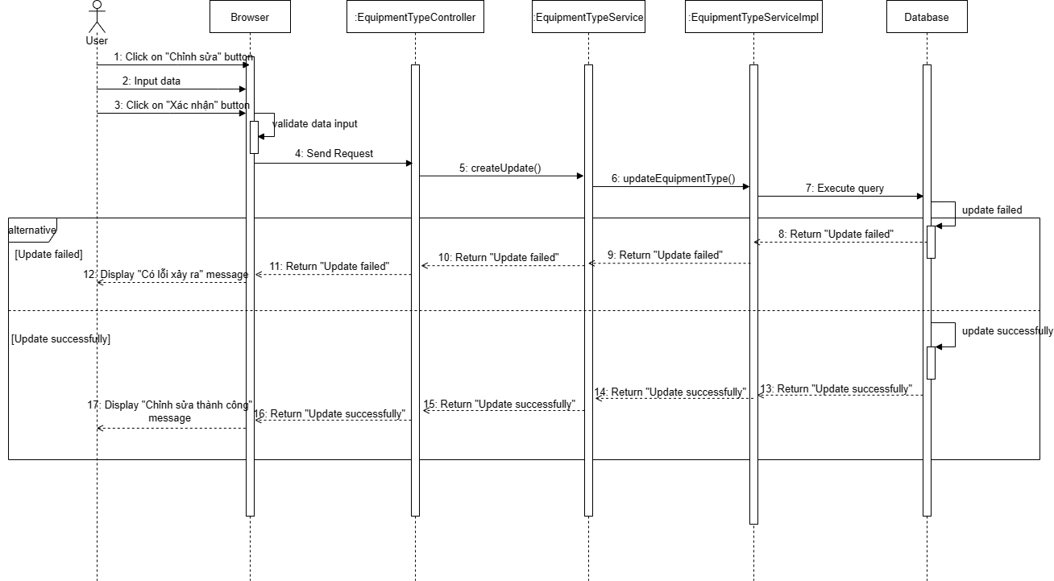

*Figure 4.35: Update equipment Sequence Diagram*

- Delete Equipment

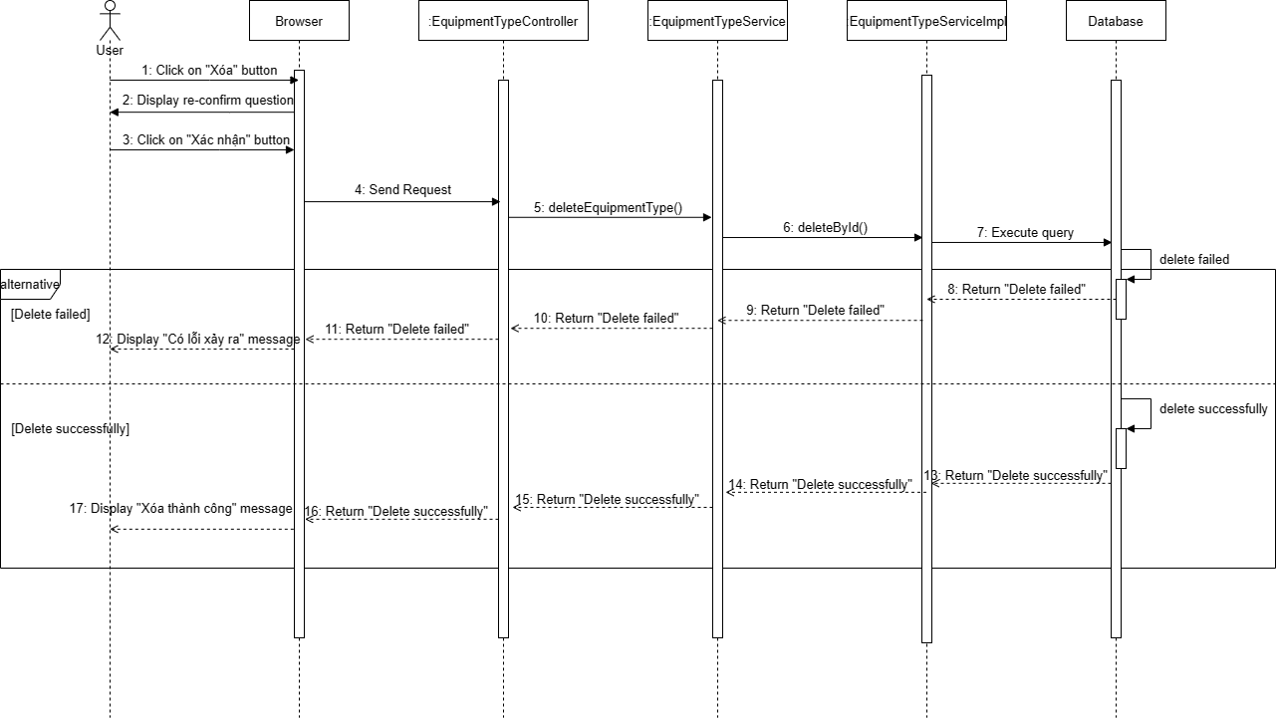

*Figure 4.36: Delete Equipment Sequence Diagram*

### 3.6 Manage Appointment

##### 3.6.1 Class Diagram

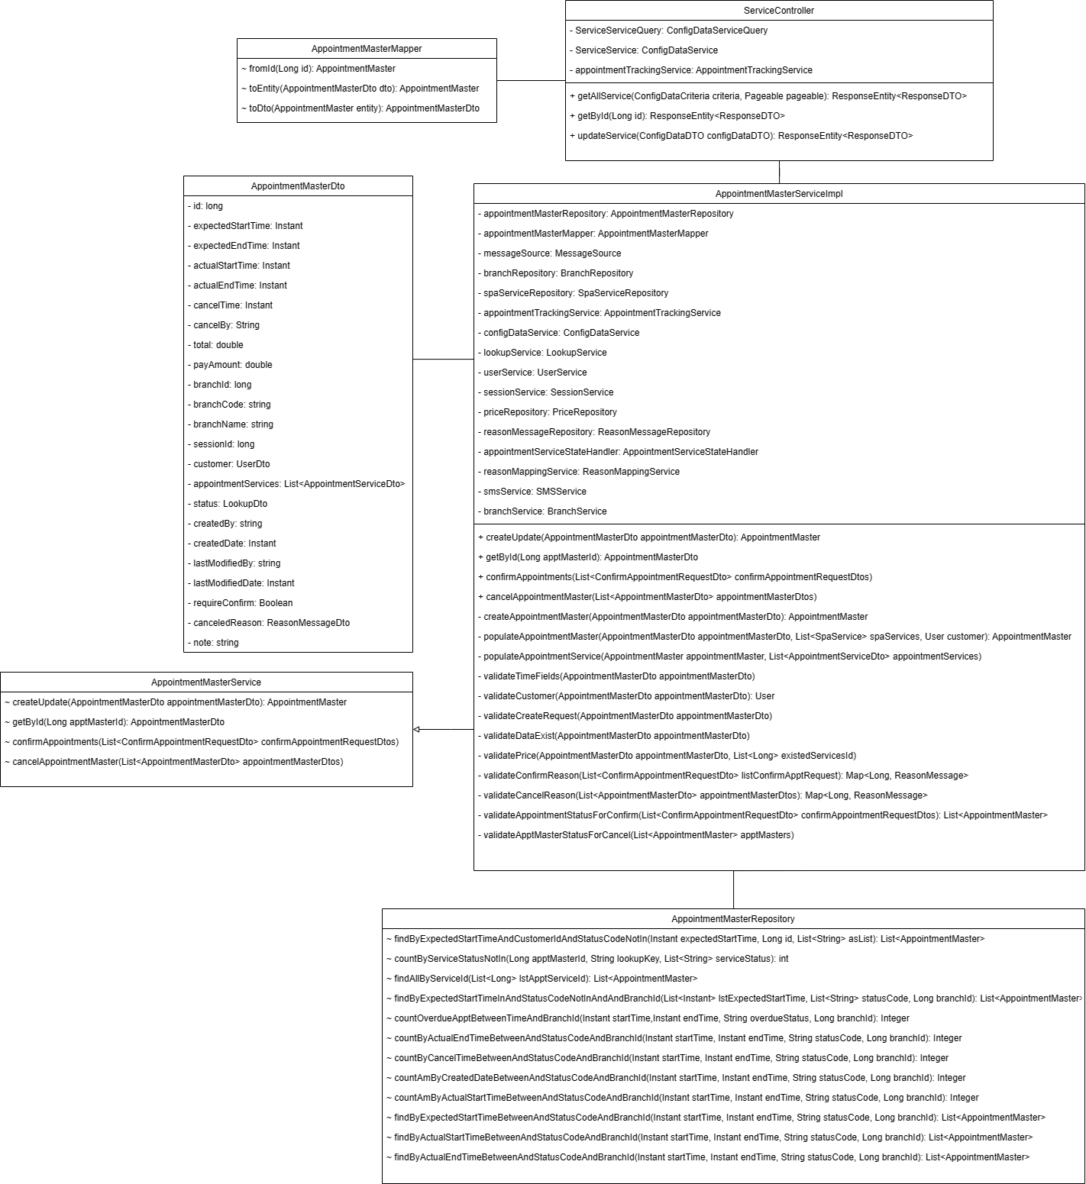

*Figure 4.37: Appointment Class Diagram*

##### 3.6.2 Sequence Diagram

- View appointment list

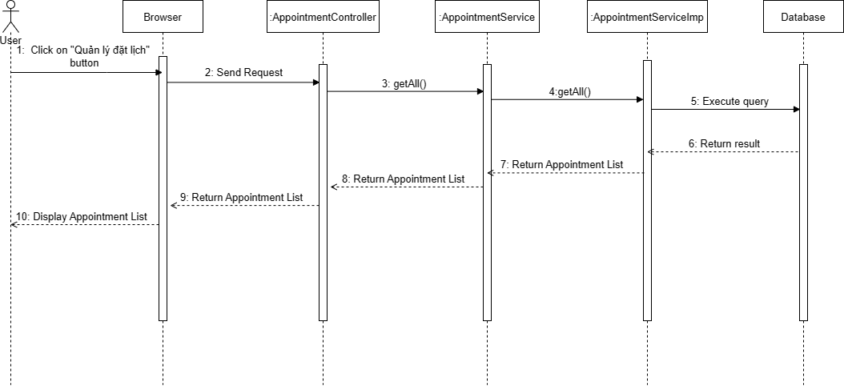

*Figure 4.38: View appointment list Sequence Diagram*

- View appointment detail

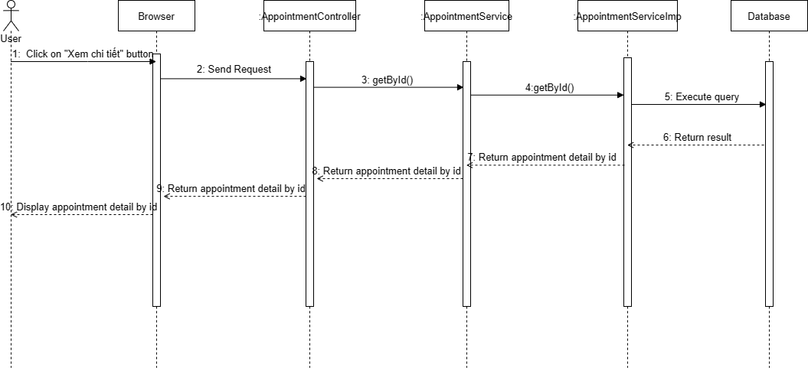

*Figure 4.39: View appointment detail Sequence Diagram*

- Create appointment

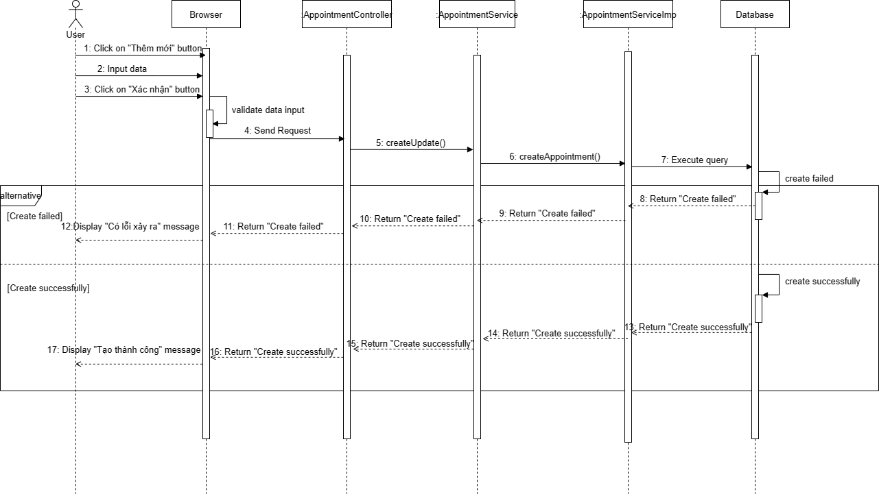

*Figure 4.40: Create appointment Sequence Diagram*

- Book appointment

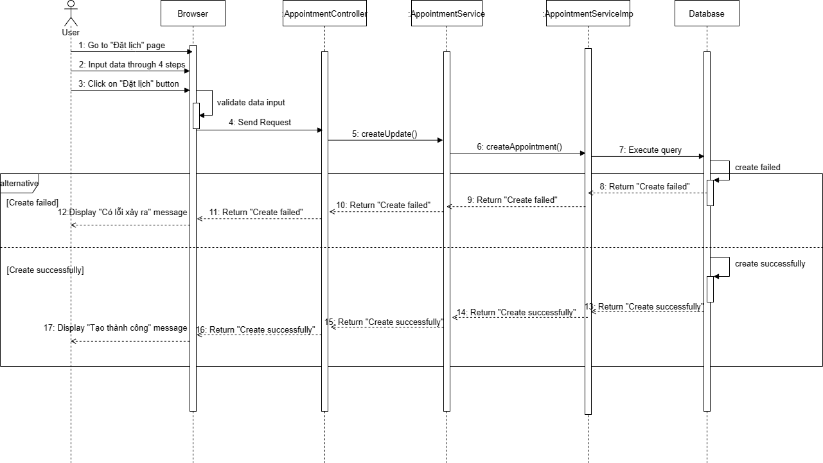

*Figure 4.41: Book appointment Sequence Diagram*

- Confirm appointment

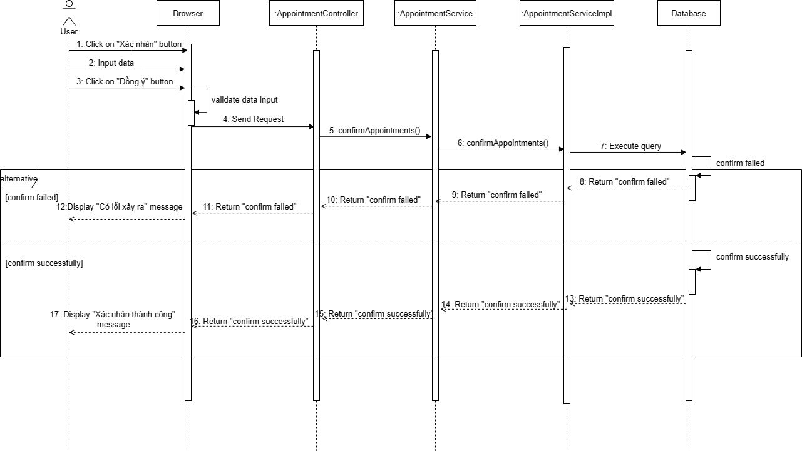

*Figure 4.42: Confirm appointment Sequence Diagram*

- Check-in

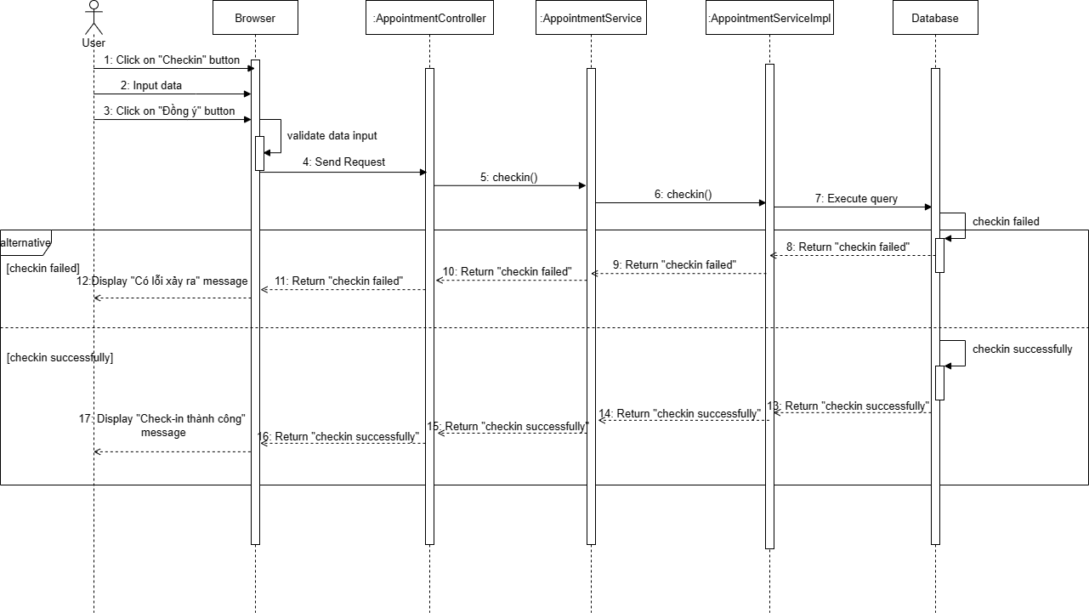

*Figure 4.43: Check-in Sequence Diagram*

- Check-out

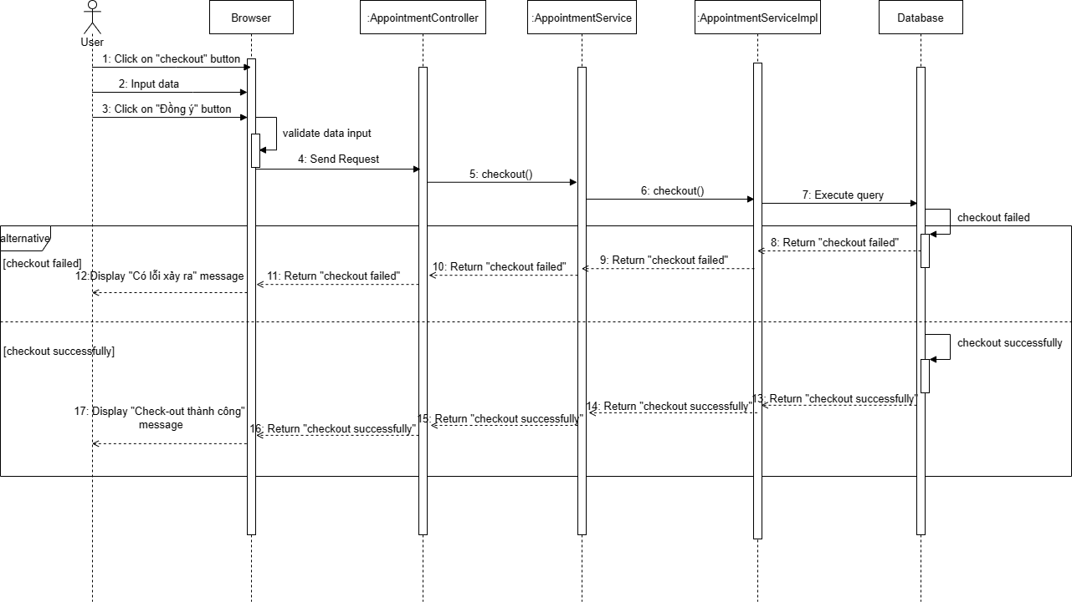

*Figure 4.44: Check-out Sequence Diagram*

- Cancel appointment

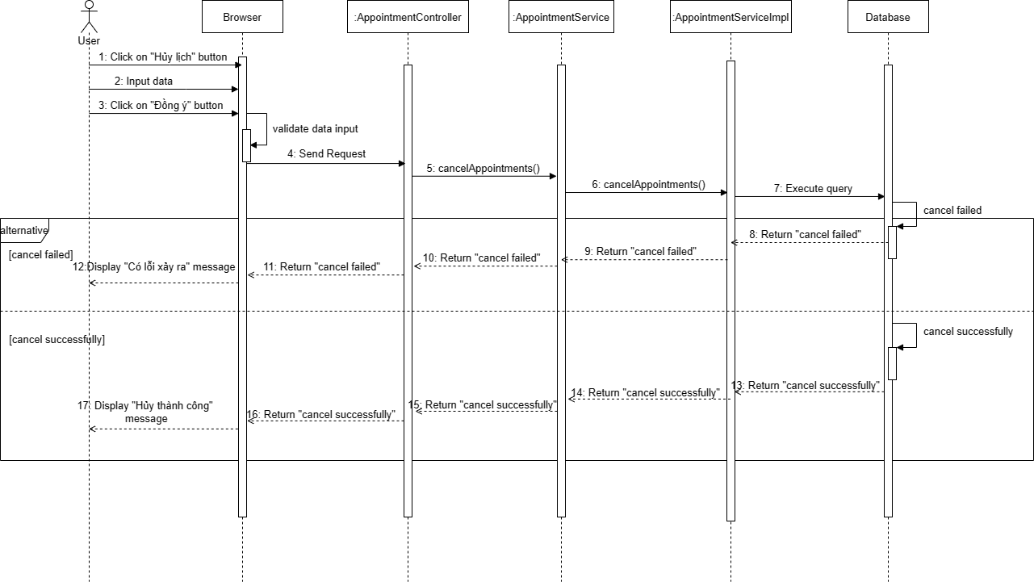

*Figure 4.45: Cancel appointment Sequence Diagram*

### 3.7 Manage SCA Form

##### 3.7.1 Class Diagram

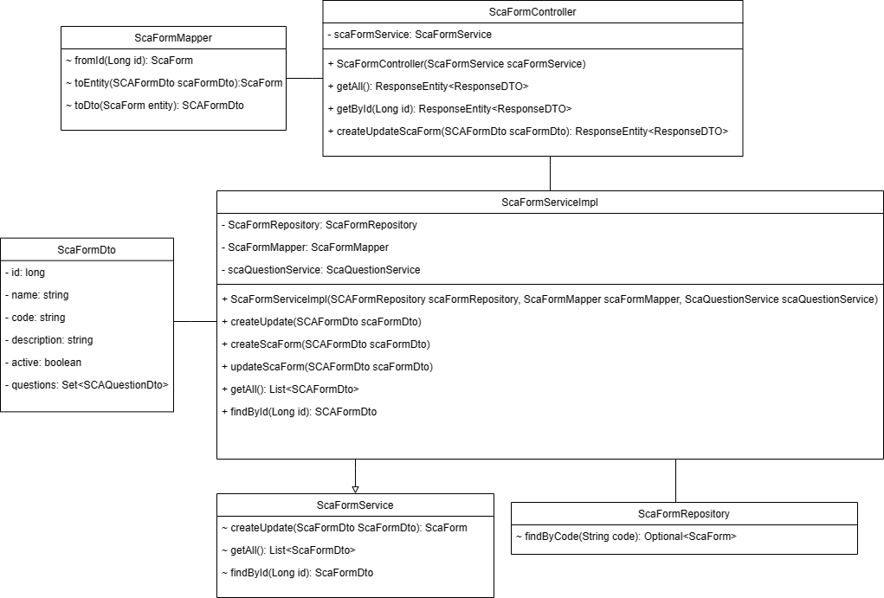

*Figure 4.46: SCA Form Class Diagram*

##### 3.7.2 Sequence Diagram

- View form list

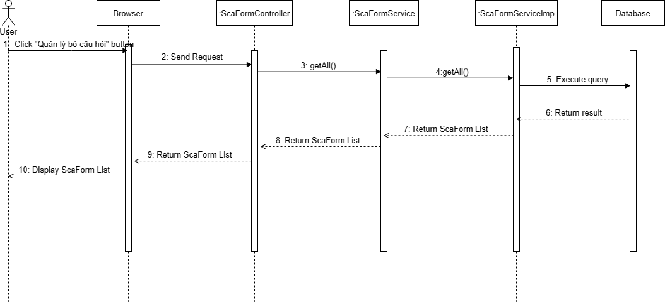

*Figure 4.47: View form list Sequence Diagram*

- View form detail

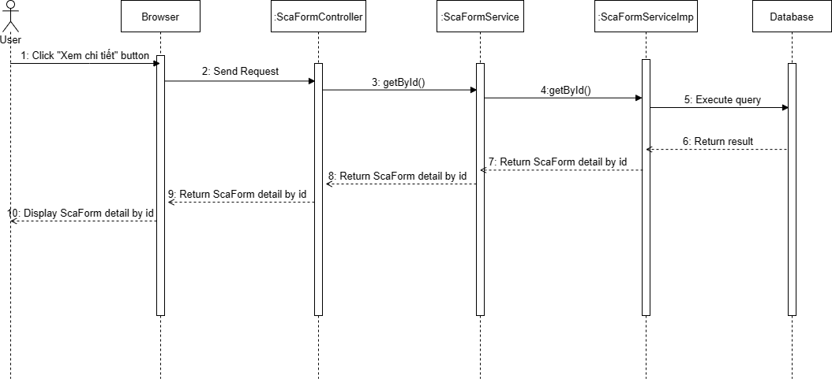

*Figure 4.47: View form detail Sequence Diagram*

- Create form

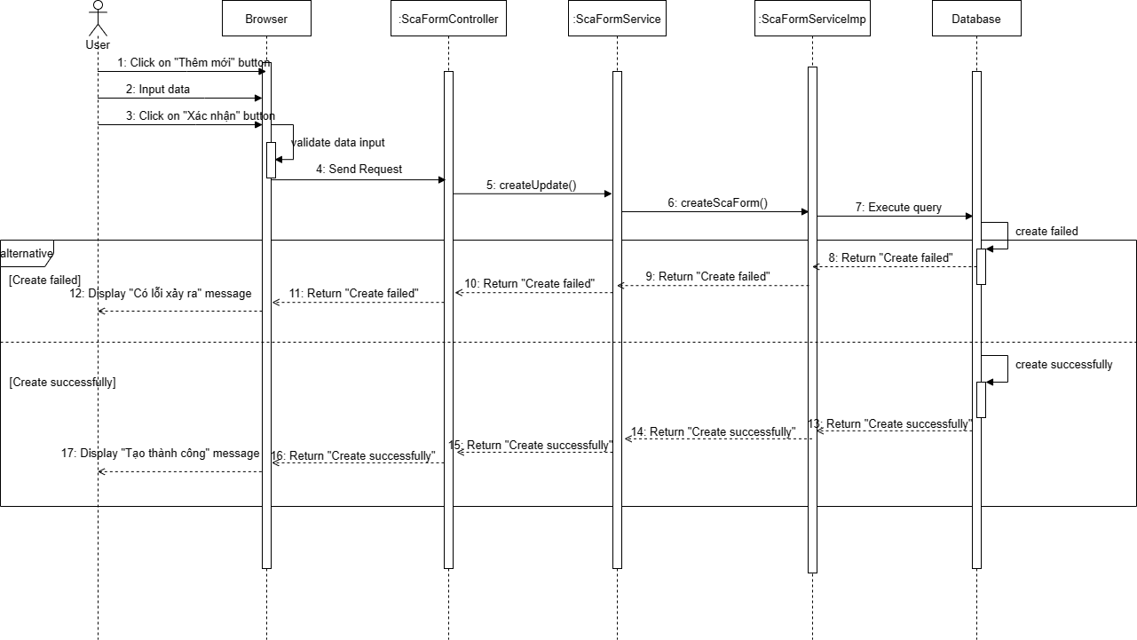

*Figure 4.49: Create form Sequence Diagram*

- Update form

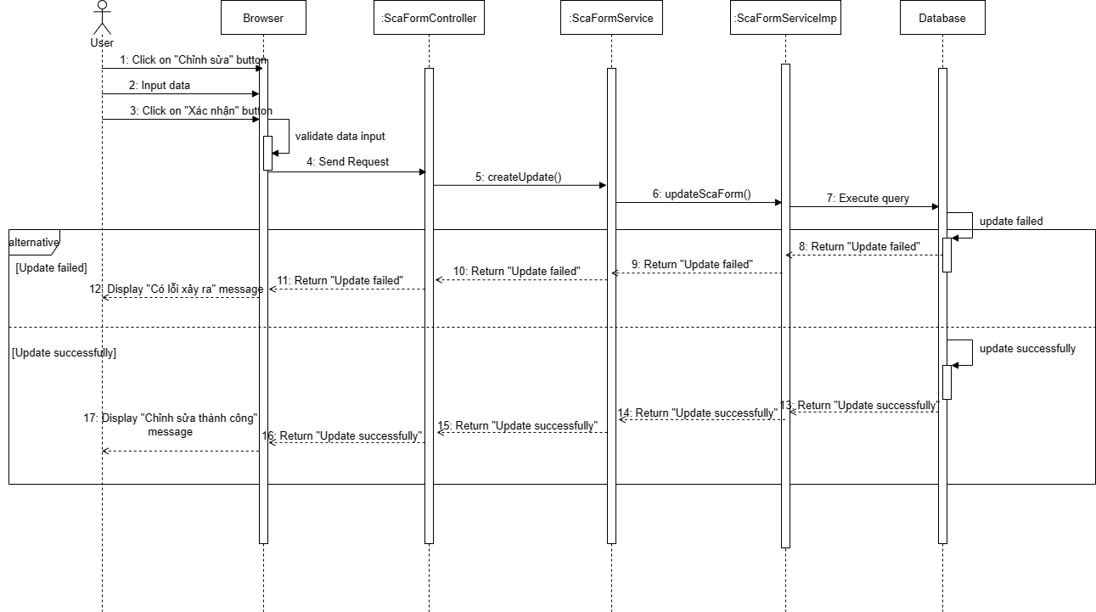

*Figure 4.50: Update form Sequence Diagram*

- Deactivate form

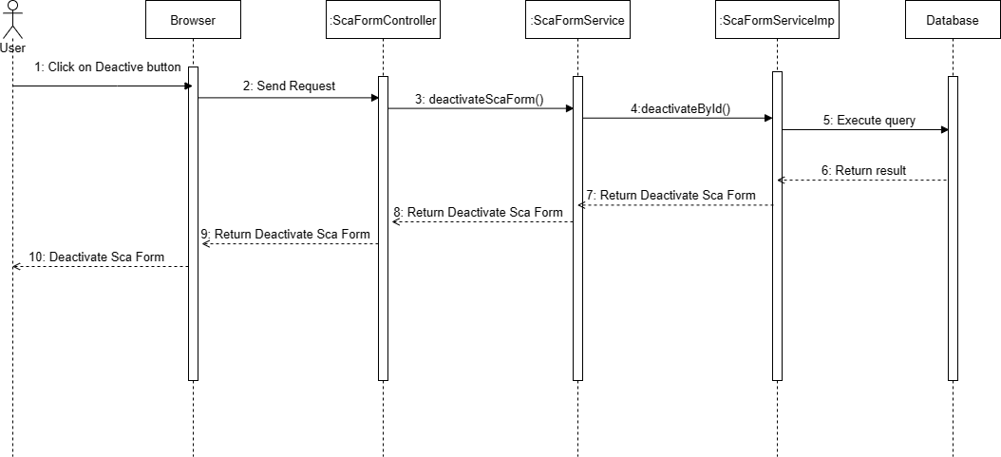

*Figure 4.51: Deactivate form Sequence Diagram*

- Answer form

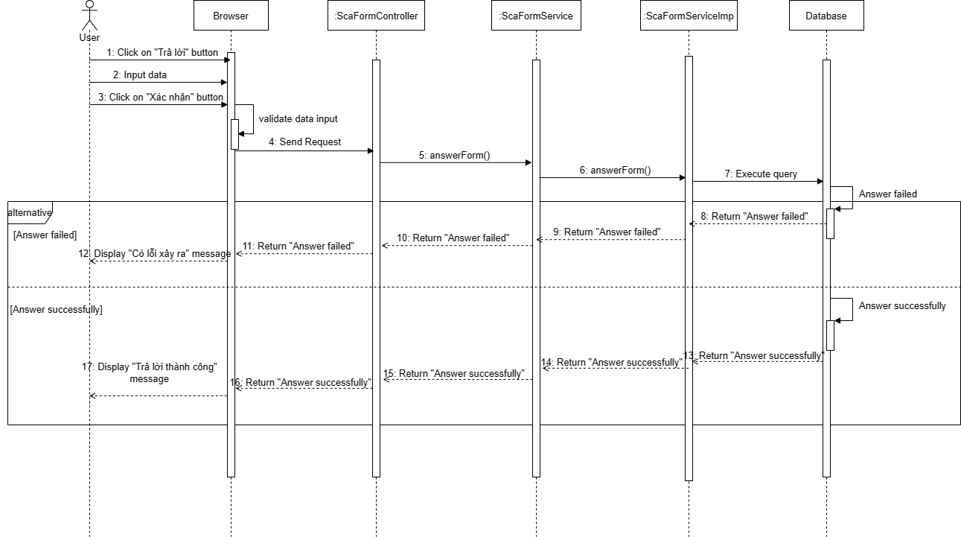

*Figure 4.52: Answer form Sequence Diagram*

- Consult customer

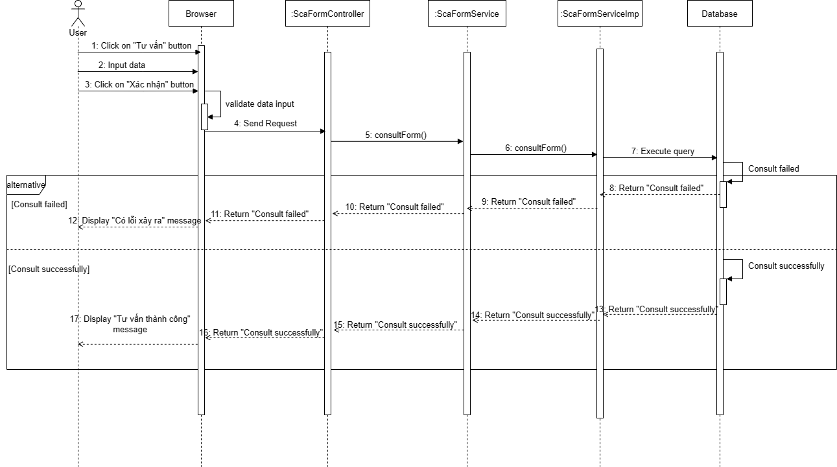

*Figure 4.53: Consult customer Sequence Diagram*

### 3.8 Manage User

##### 3.8.1 Class Diagram

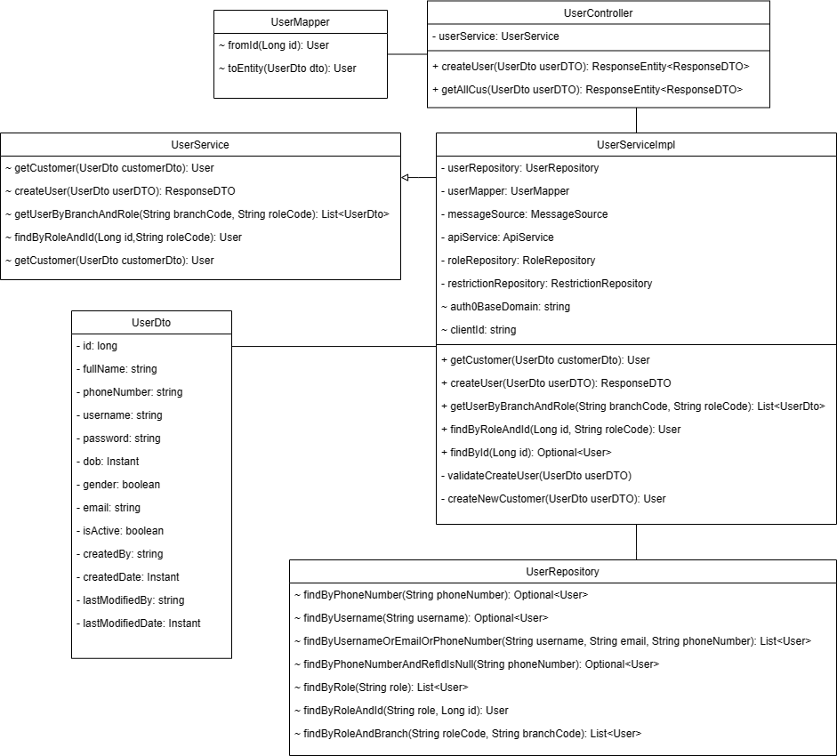

*Figure 4.54: User Class Diagram*

##### 3.8.2 Sequence Diagram

- View user list

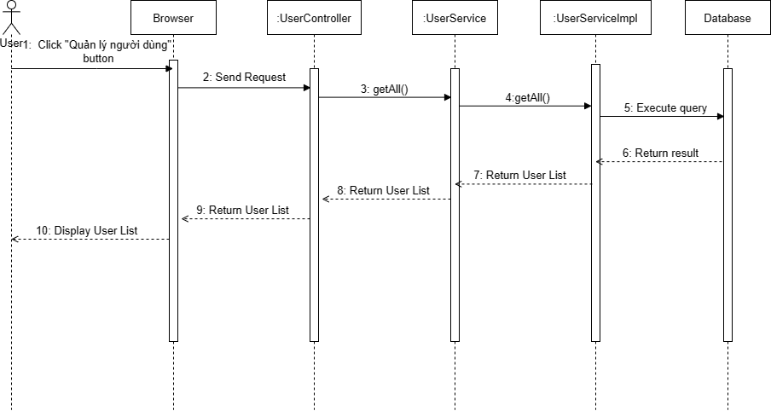

*Figure 4.55: View user list Sequence Diagram*

- Create user

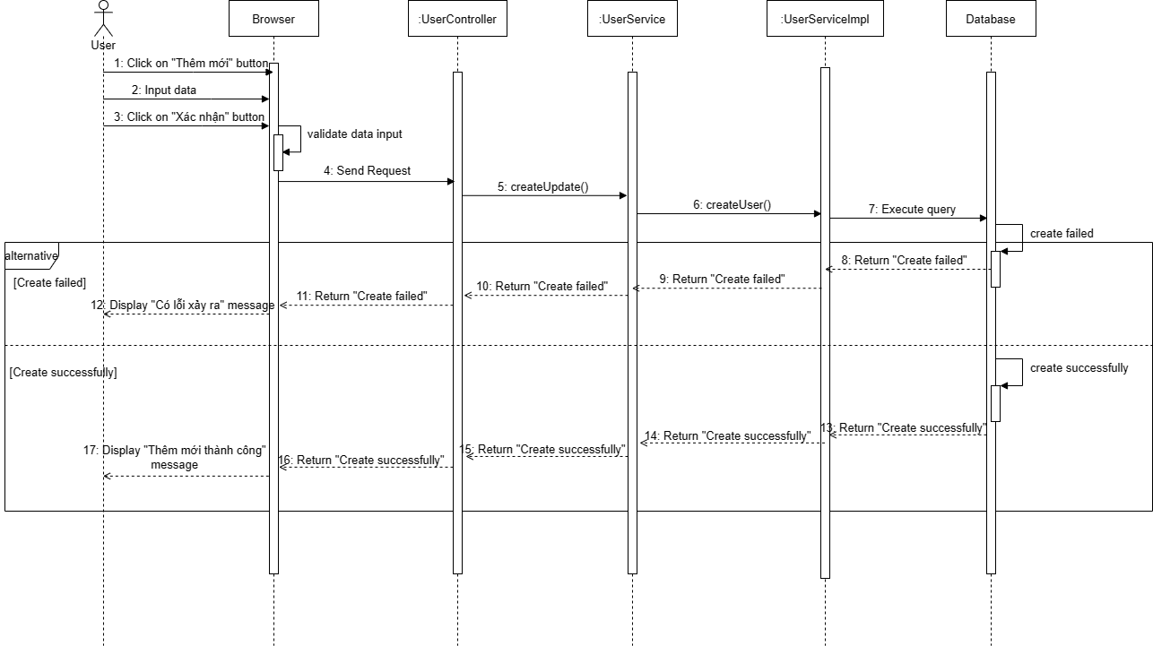

*Figure 4.56: Create user Sequence Diagram*

- View profile

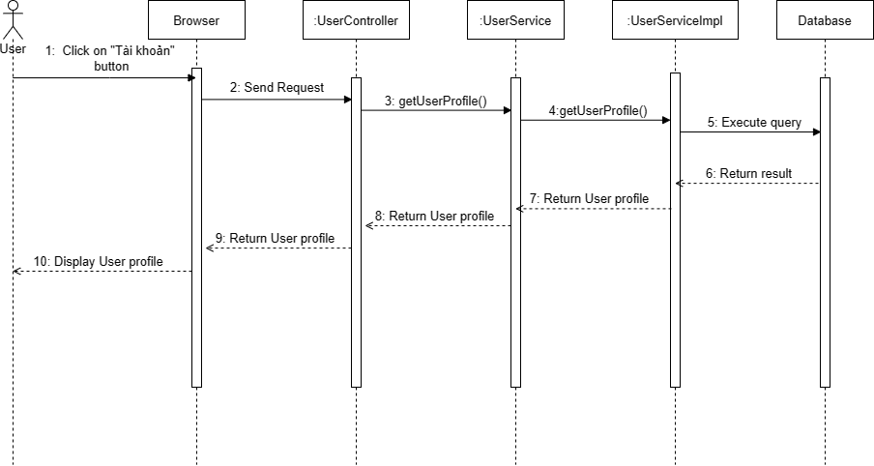

*Figure 4.57: View profile Sequence Diagram*

- Update profile

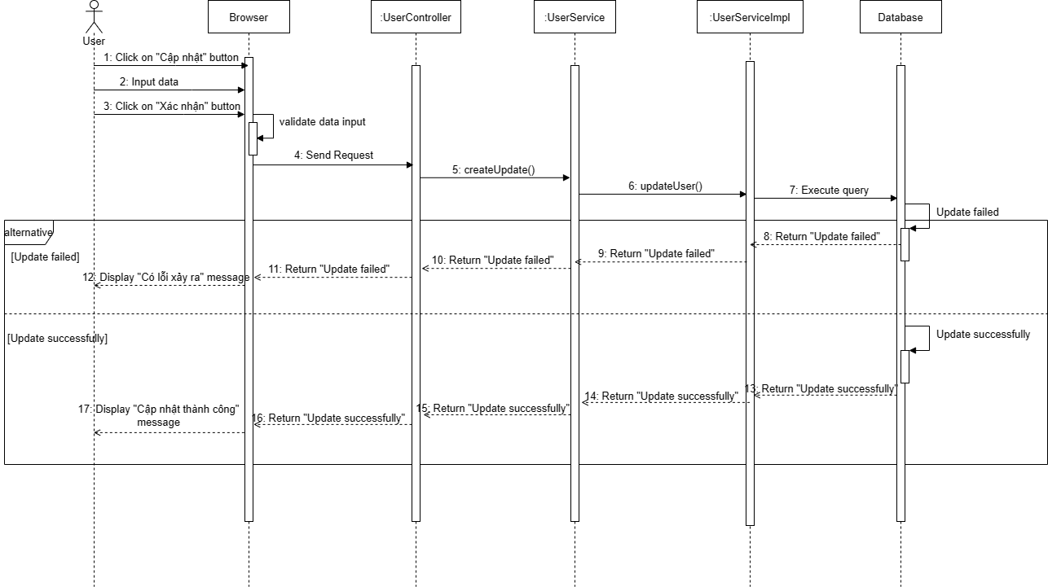

*Figure 4.56: Update profile Sequence Diagram*

- Change password

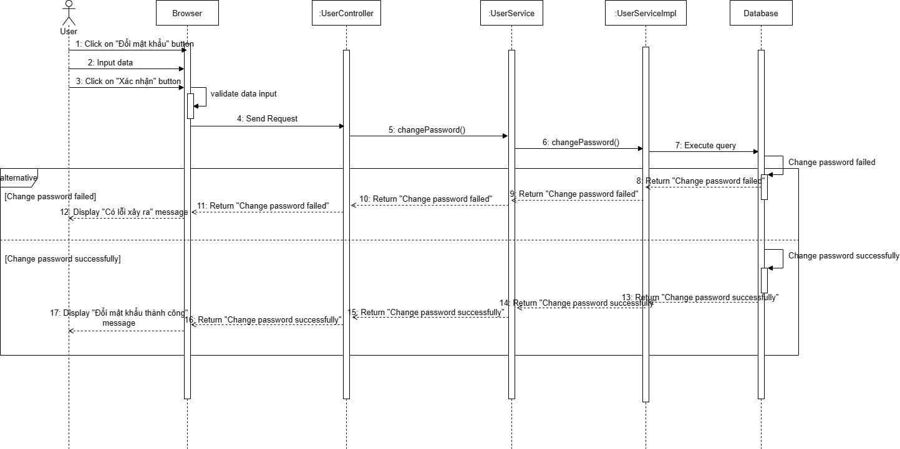

*Figure 4.58: Change password Sequence Diagram*

### 3.9 Administrator

##### 3.9.1 Class Diagram

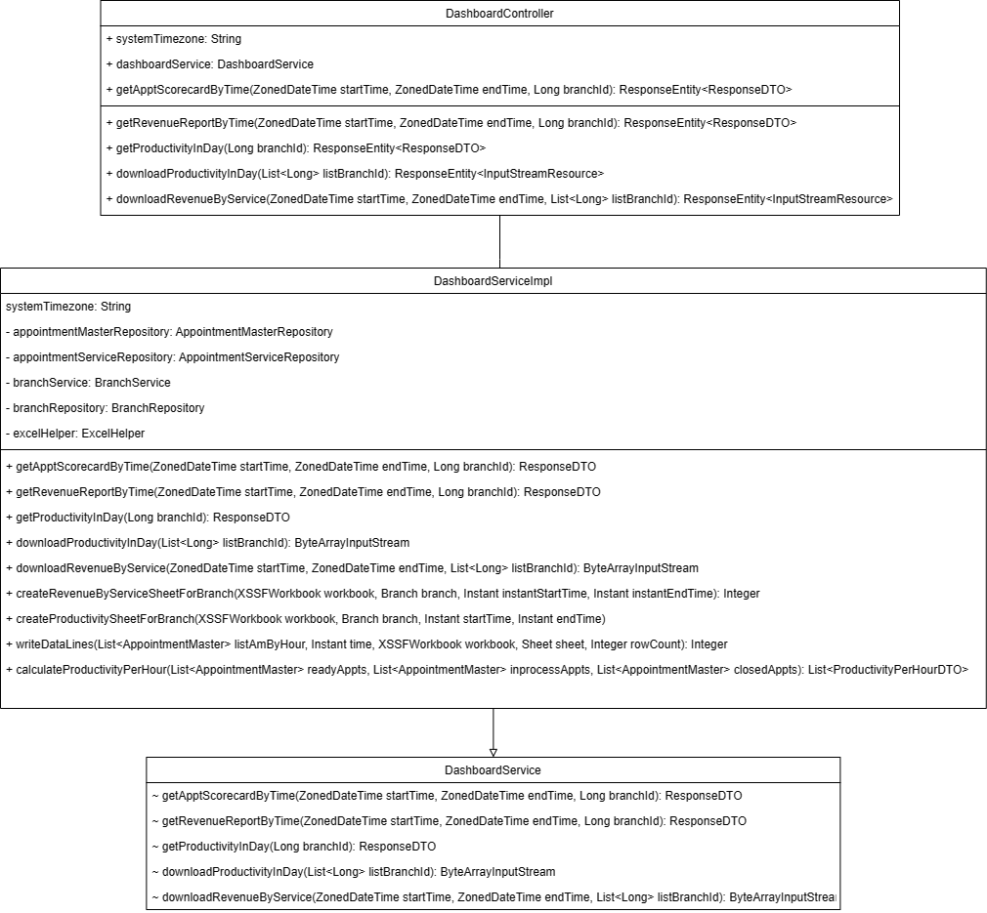

*Figure 4.59: Dashboard Class Diagram*

##### 3.9.2 Sequence Diagram

- View dashboard

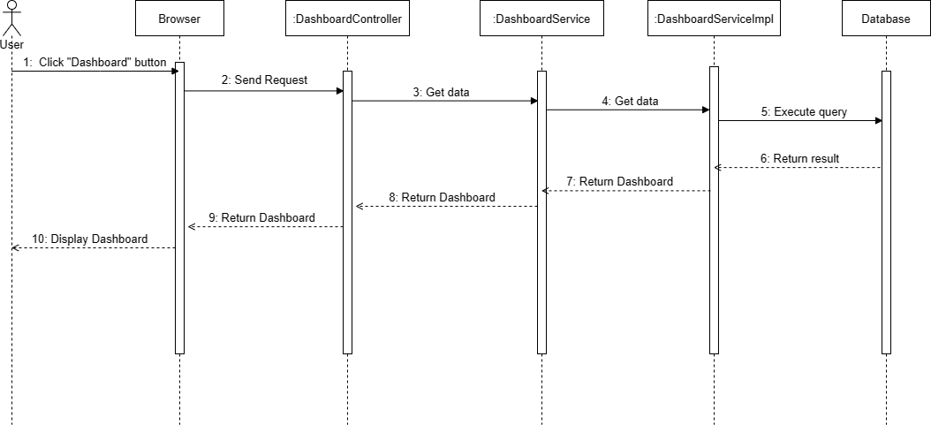

*Figure 4.60: View dashboard Sequence Diagram*

- Export report

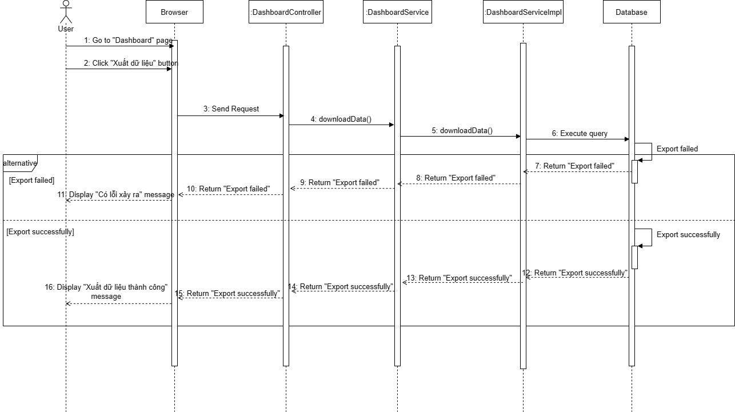

*Figure 4.61: Export report Sequence Diagram*

- Search data

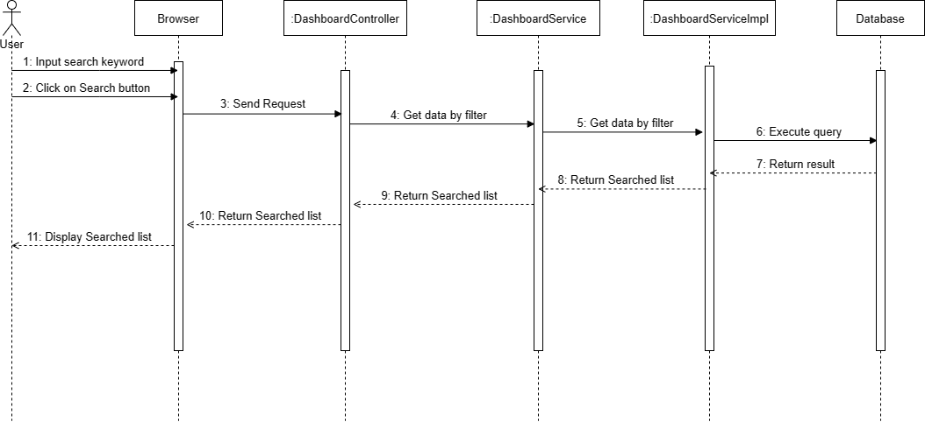

*Figure 4.62: Search data Sequence Diagram*

- Import file

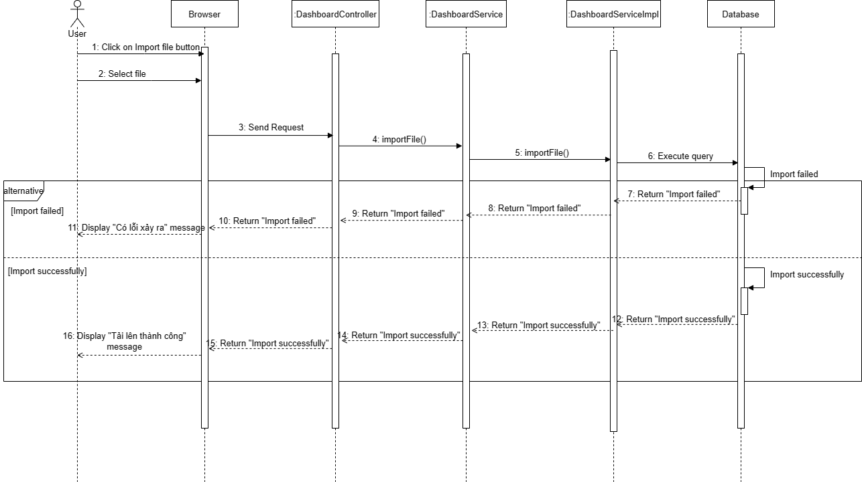

*Figure 4.63: Import file Sequence Diagram*

### 3.10 Authentication

##### 3.10.1 Sequence Diagram

- Register

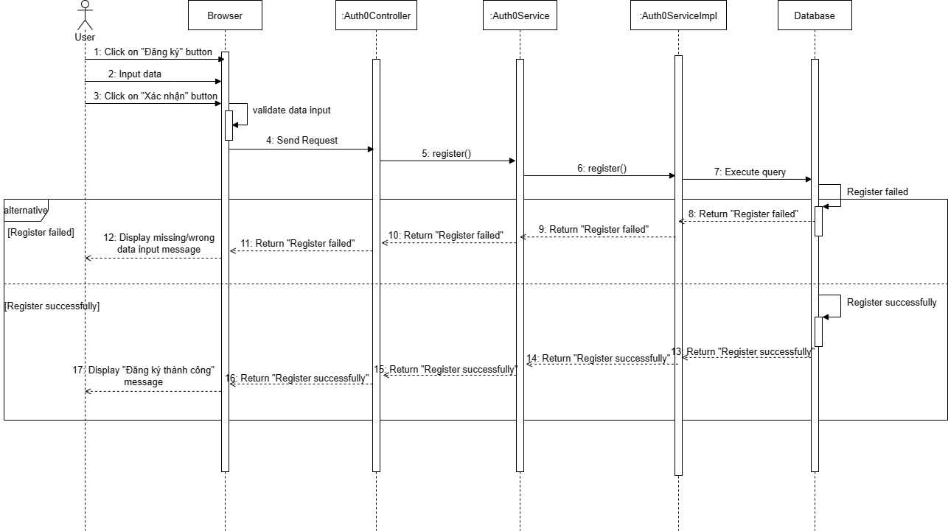

*Figure 4.64: Register Sequence Diagram*

- Login

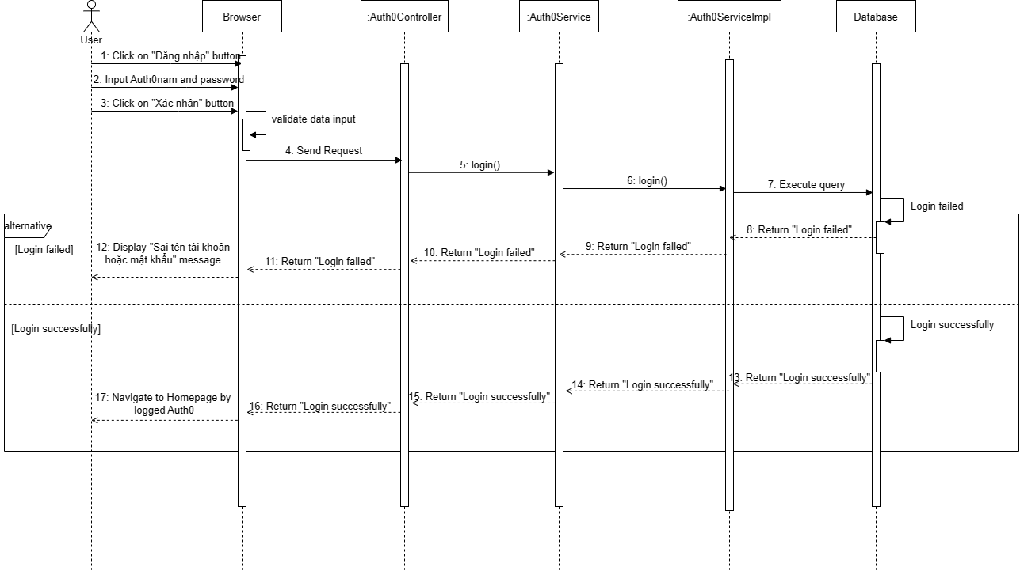

*Figure 4.65: Login Sequence Diagram*

- Forgot password

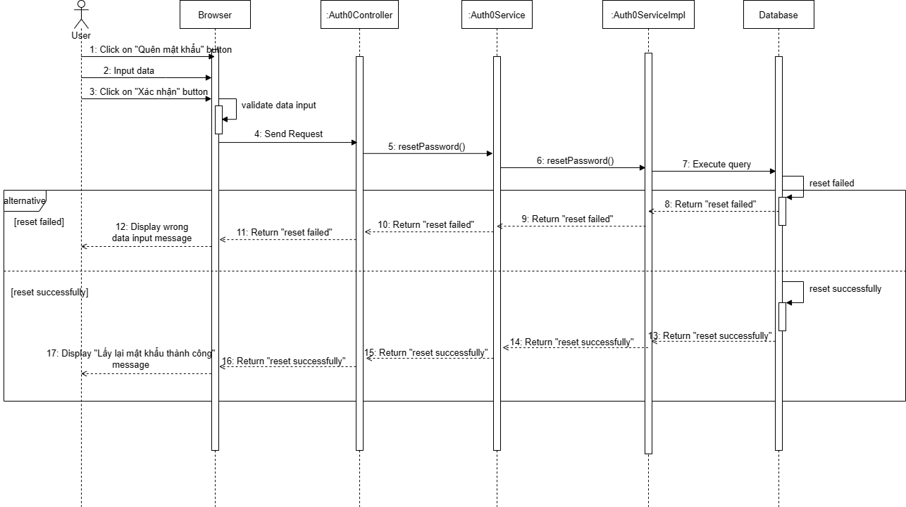

*Figure 4.66: Forgot password Sequence Diagram*

- Logout

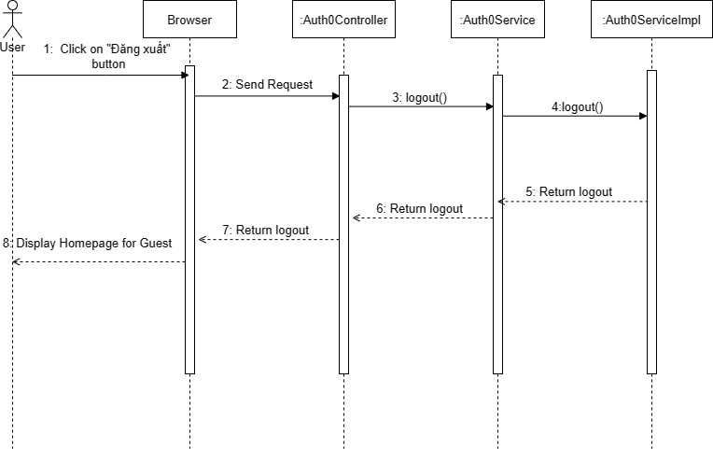

*Figure 4.67 Logout Sequence Diagram*

# V. Software Testing Documentation

## 1. Scope of Testing

-Team members focus on the functions of the actor to be tested and executed.

-In this testing phase, there are 4 stages in the testing process that members of the team are focusing on: Unit Test, Integration Test, System Test.

|  |  |  |
| --- | --- | --- |
| **Testing Stage** | **Purpose** | **Description** |
| Unit Test | Checking all specifications and potential scenarios to see if a function can accommodate them. | It is used to test the functions in the back-end code. Usually, this test stage is performed by the developer by creating a small function in source code. |
| Integration Test | Revealing issues with how integrated modules interact or have interfaces. | It is performed by grouping all the individual modules together to test the interaction between these modules and components in a fully integrated system. It is created by tester and designed during the software design stages. |
| System Test | Testing the overall system and verifying the data. | It is used to test the completed integrated system. It is created and performed by testers during the system analysing stages. |

## 2. Test Strategy

Spa Service Providing System follows the V-Model for testing.

The V-Model is a model used to describe testing activities as part of the software development process. It can be interpreted as an extension of the Waterfall development model, which describes the testing activities as one of the last steps in a sequential development process.

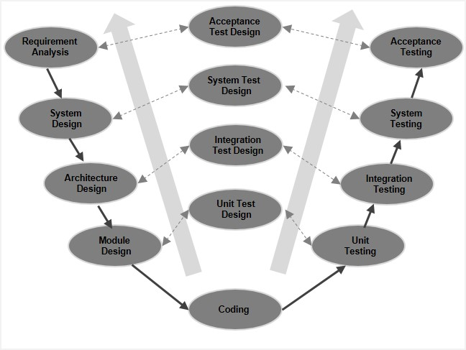

*Figure 5.1: V-model Testing Process*

We choose this test model because:

* Simple and easy to use.
* Testing activities like planning, test designing happens well before coding. This saves a lot of time.
* Proactive defect tracking –that is defects are found at an early stage. Most of the defects and bugs are found in the beginning of the project development. So, less chances of defect or bug to occur at final testing phase.
* Avoids the downward flow of the defects

### 2.1 Testing Types

|  |  |
| --- | --- |
| **Testing Type** | **Description** |
| Functional Testing | Testing by executing some basic function in the system to check if the function is correct or not. |
| GUI Testing | Testing the user interface of the website includes these features like background, component, grammars, and resolution of the screen. |
| Regression Testing | This test is performed to confirm that the bugs in the system are fixed by the developer. |

### 2.2 Test Levels

| **Type of Tests** | **Test Level** | | |
| --- | --- | --- | --- |
| **Unit** | **Integration** | **System** |
| Functional Testing | x | x | x |
| GUI Testing |  | x | x |
| Regression Testing |  | x | x |

### 2.3 Supporting Tools

|  |  |  |  |
| --- | --- | --- | --- |
| **Purpose** | **Tool** | **Provider** | **Version** |
| Test API | Postman | Postman Inc | Latest |
| Manage the test case | Microsoft Excel | Microsoft | Version 2016 |
| Test function | Visual studio code | Microsoft | Version 2019 |

## 3. Test Plan

### 3.1 Human Resources

|  |  |  |
| --- | --- | --- |
| **Worker/Doer** | **Role** | **Specific Responsibilities/Comments** |
| Trần Nam Long | Test leader | * Create a test plan. * Create a test process, test cases. * Create a report. * Fix bugs. * Log bug. |
| Phạm Kiều Trinh | Test member | * Create a test process, test cases. * Create a report. * Fix bugs. * Log bug. |
| Nguyên Như Chương | Test member | * Execute test case. * Fix bugs. * Log bug. |
| Nguyễn Trung Dũng | Test member | * Fix bugs. * Log bug. |
| Hoàng Mạnh Hà | Test member, Document | * Log bug. |

### 3.2 Test Environment

|  |  |  |  |
| --- | --- | --- | --- |
| **Purpose** | **Tool** | **Provider** | **Version** |
| Website GUI test | Microsoft Edge, Chrome | Microsoft | Latest |
| Debug Front-end | Visual Studio Code | Microsoft | 1.74.2 |
| Terminal |  | 2.12 |
| Test API | Postman | Google | 10.6 |

### 3.3 Test Milestones

|  |  |  |
| --- | --- | --- |
| **Milestones Task** | **Start Date** | **End Date** |
| Create test plan | 04/01/2022 | 06/01/2022 |
| Execute unit test | 06/01/2022 | 22/01/2022 |
| Execute integration test | 09/01/2022 | 27/01/2023 |
| Execute system test | 27/01/2023 | 28/01/2023 |
| Create testing report | 28/01/2023 | 28/01/2023 |

## 4. Test Cases

### 4.1 Unit Test

Unit testing will be done by developers. The development team implements this procedure to achieve the following benefits:

* Ensure that features would work correctly as defined in the documentation, including source code design, business logic, result accuracy, etc.
* Detects and classifies coding bugs as soon as possible, providing debugging information and solutions for bug fixing.

We only create test scripts of the important test cases.

### 4.2 Integration Test

Integration tests include GUI Test and API Test. Integration tests are done manually by a tester right after each system feature is completed, where test cases are created on a use case basis. If it detects bugs, the tester is responsible for reporting to the developer and testing again when the developer has finished fixing it.

### 4.3 System Test

System testing is done manually by the tester at the last iteration. In which test cases are created based on the combination of use cases. This combination creates the streams that the user will affect the system. From there, the correctness of the system can be validated according to system requirements

## 5. Test Reports

### 5.1 Unit Test

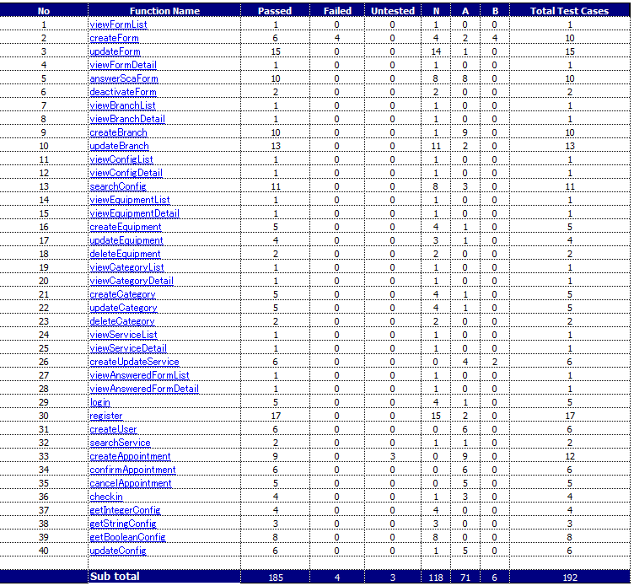

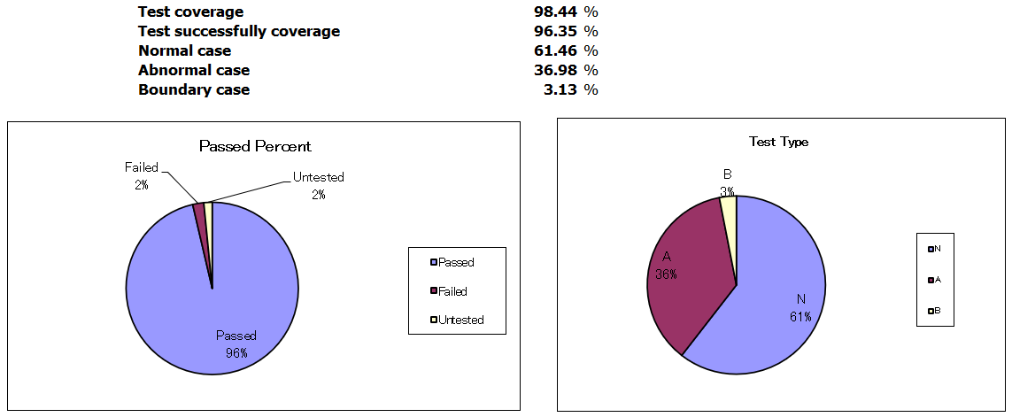

*Figure 5.2: Unit Test Report*

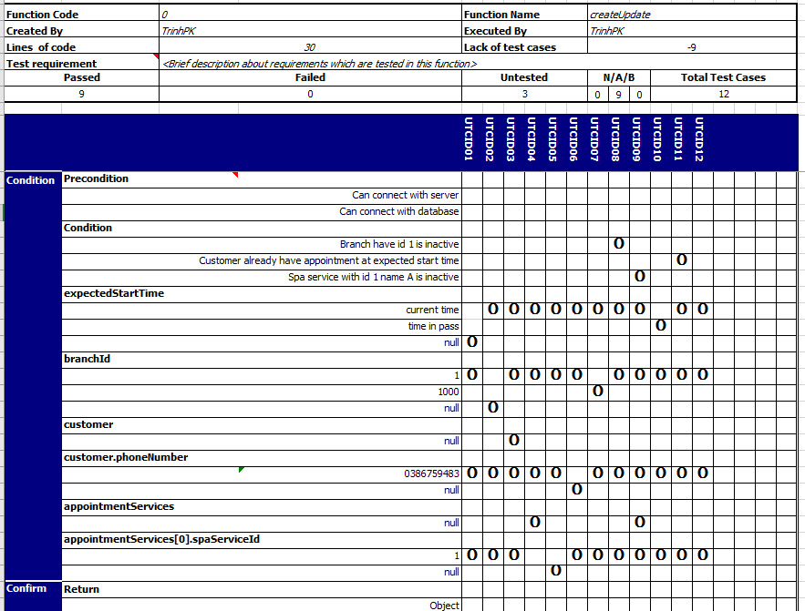

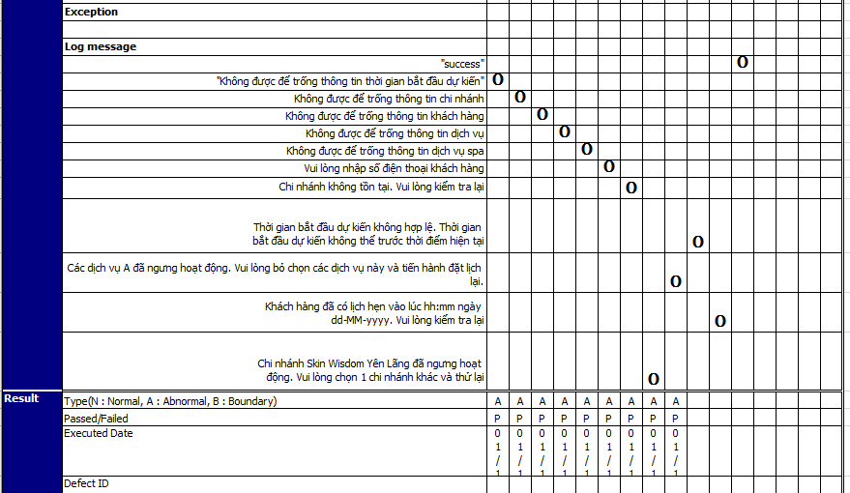

*Figure 5.3: Unit Test Example*

### 5.2 Integration Test

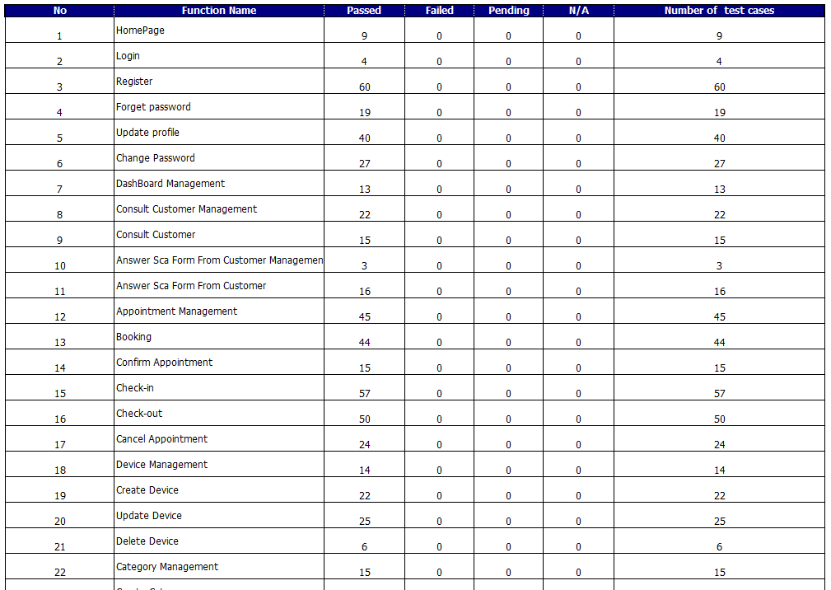

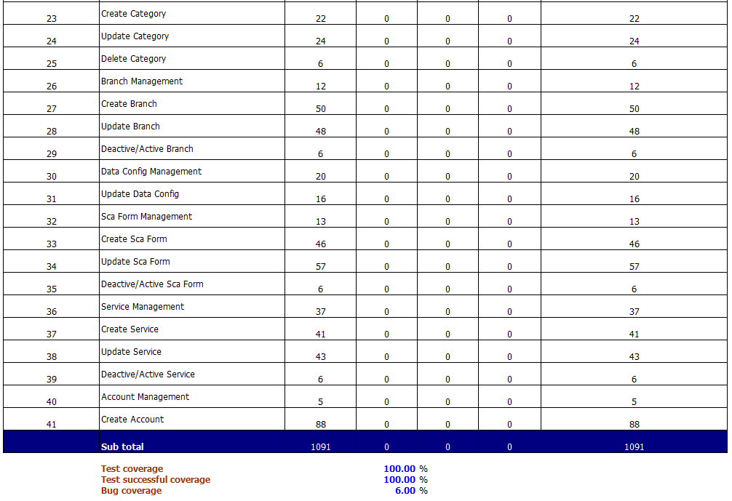

*Figure 5.4: Integration Test Report*

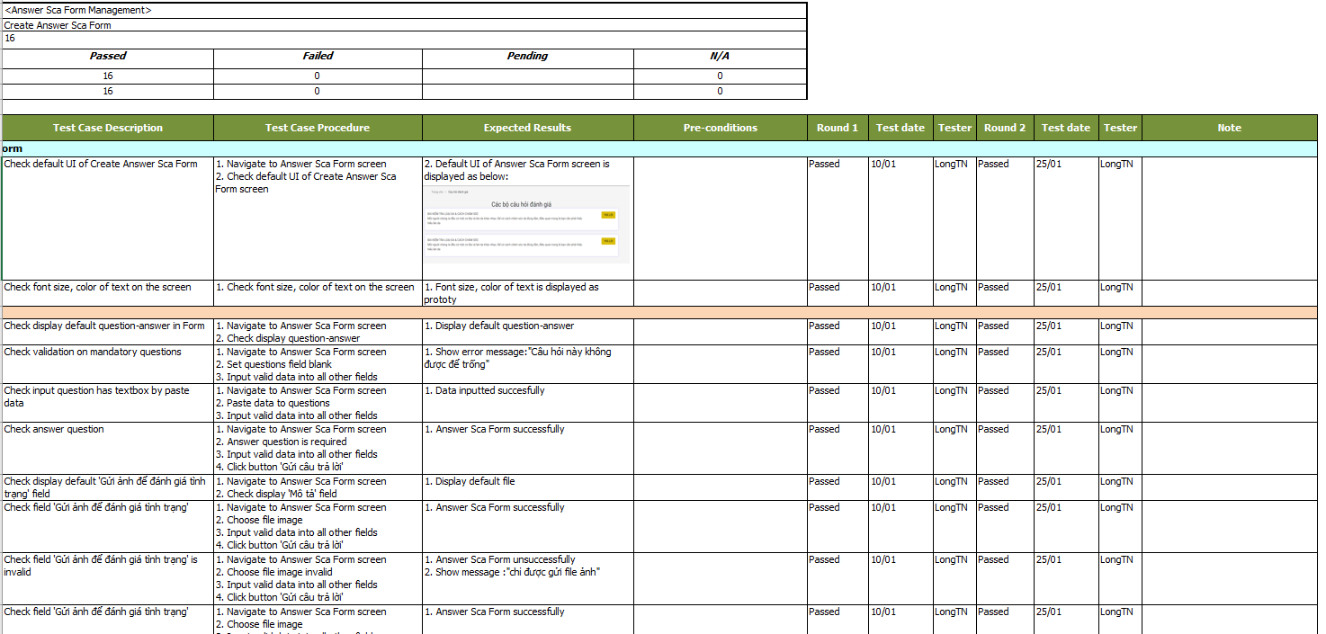

*Figure 5.5: Integration Test Example*

### 5.3 System Test

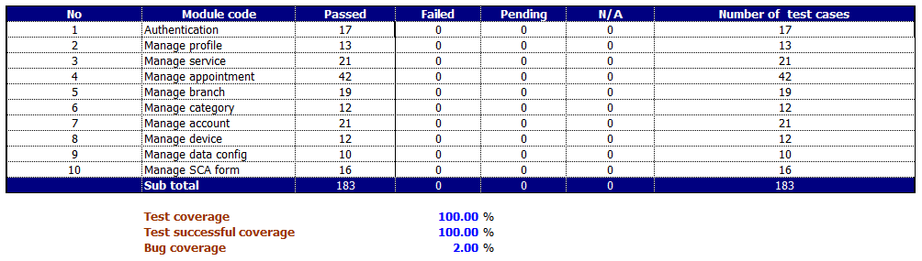

*Figure 5.6: System Test Report*

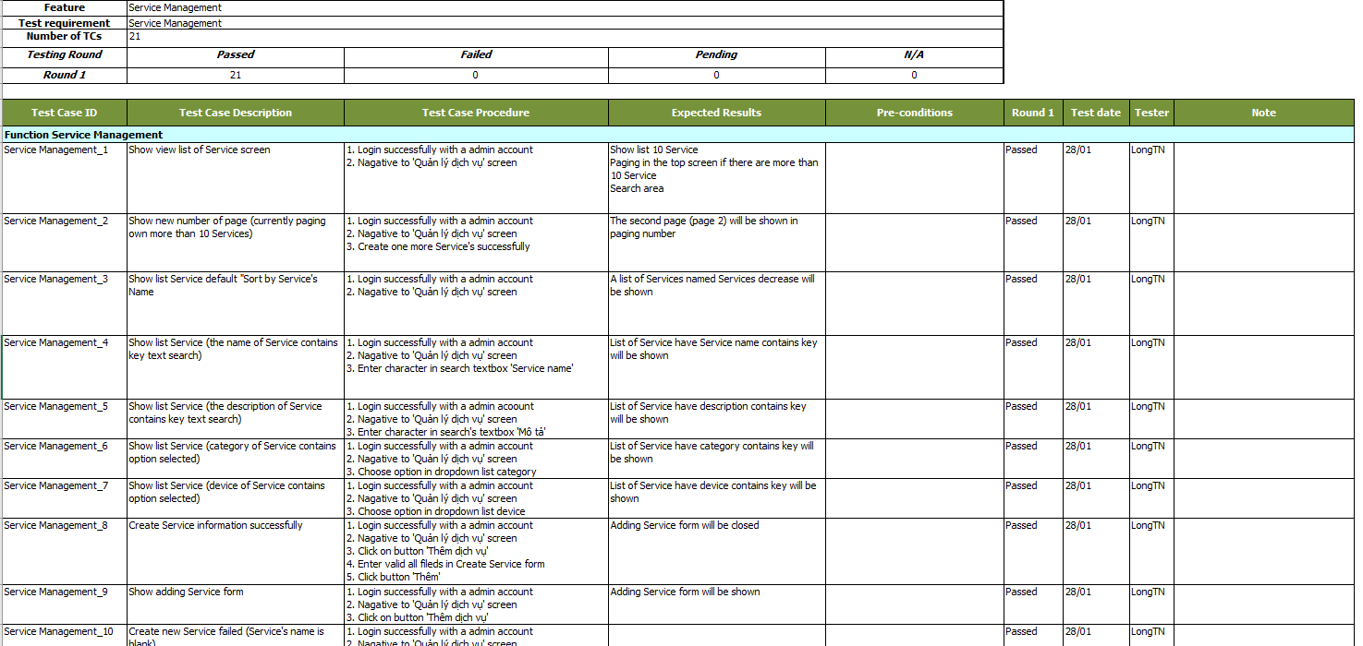

*Figure 5.7: System Test Example*

# VI. Release Package & User Guides

## 1. Deliverable Package

|  |  |  |  |  |
| --- | --- | --- | --- | --- |
| **No.** | **Items** | **Sub-items** | **Type** | **Version** |
| **Code Package** | | | | |
| 1 | Source-code | Spa Service Providing System.zip | zip | 1.0 |
| **Database** | | | | |
| 2 | Tables | Spa Service Providing System.sql | zip | 1.0 |
| **Documents** | | | | |
| 3 | Final Report | Spa Service Providing System.pdf | pdf | 1.0 |
| 4 | Slide Presentation | Spa Service Providing System.pdf | pdf | 1.0 |
| 5 | Unit Test | SSDS_Unit Test.xls | xls | 1.0 |
| 6 | Integration Test | SSDS_Integration Test.xlsx | xlsx | 1.0 |
| 7 | System Test | SSDS_System Test.xlsx | xlsx | 1.0 |

## 2. Installation Guides

### 2.1 System Requirements

- Require Internet connection.

- Require browsers on PC and Laptop: Google Chrome, Mozilla FireFox, Microsoft Edge and other browsers.

## 3. User Manual

### 3.1 Overview

- This user guide will provide detailed instructions for user features according to each role (Guest, Customer, Receptionist, Manager) when accessing our system.

- For Guest/Customer: <https://widen.dev>

- For Receptionist/Manager: https://manager.widen.dev

### 3.2 Guest/Customer

#### 3.2.1 Homepage

- Step 1: Open website “https://widen.dev”.

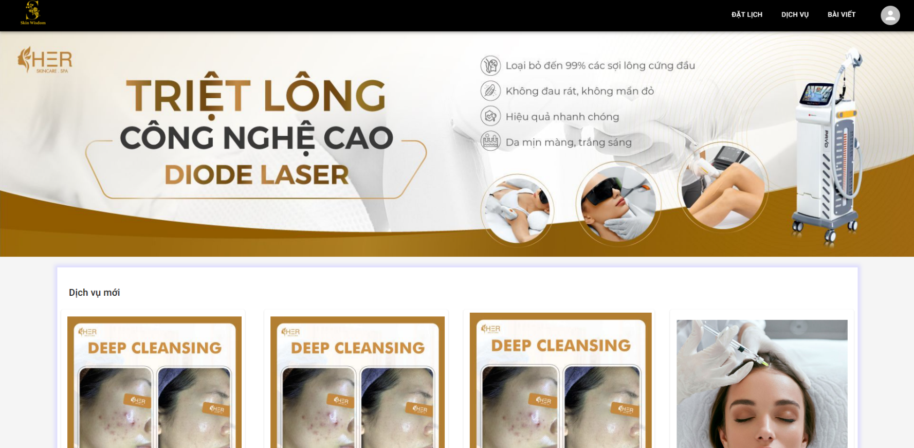

#### 3.2.2 Login

- Step 1: Click on Avatar in Header bar of the Homepage.

- Step 2: Click on “Đăng nhập” button.

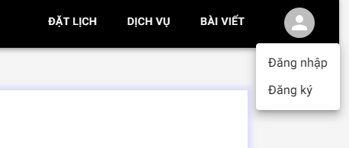

- Step 3: Fill in username, password.

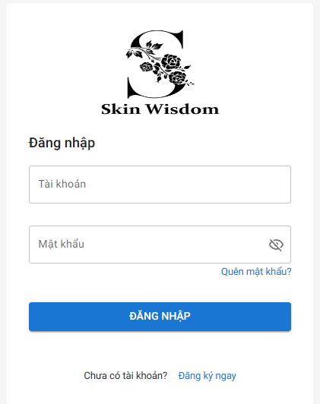

- Step 4: Click on “Đăng nhập” button.

- Step 5: Navigate to Homepage with logged user and display user’s avatar.

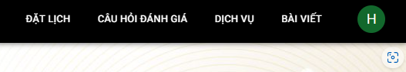

*\*Note: Currently, the system still does not allow login with social network accounts, this function will be added in the next version.*

#### 3.2.3 Register

- Step 1: Click on Avatar in Header bar of the Homepage.

- Step 2: Click on “Đăng ký” button.



- Step 3: Fill in real name, username, password, re-password, phone number, email address.

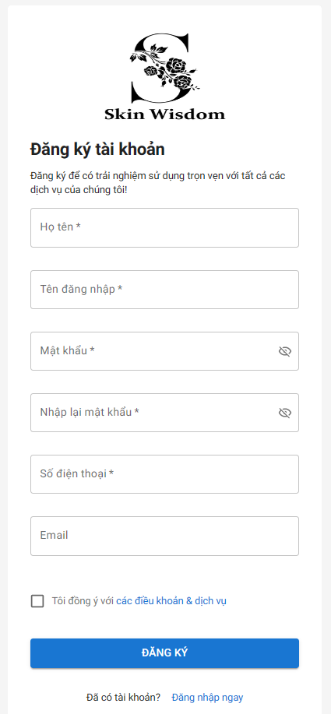

- Step 4: Click on checkbox “Tôi đồng ý với các điều khoản & dịch vụ”.

- Step 5: Click on “Đăng ký” button.

- Step 6: Display register successfully message.

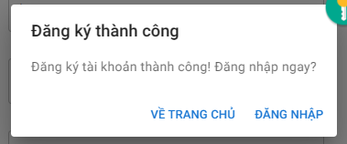

#### 3.2.4 View service list

- Step 1: Open Homepage

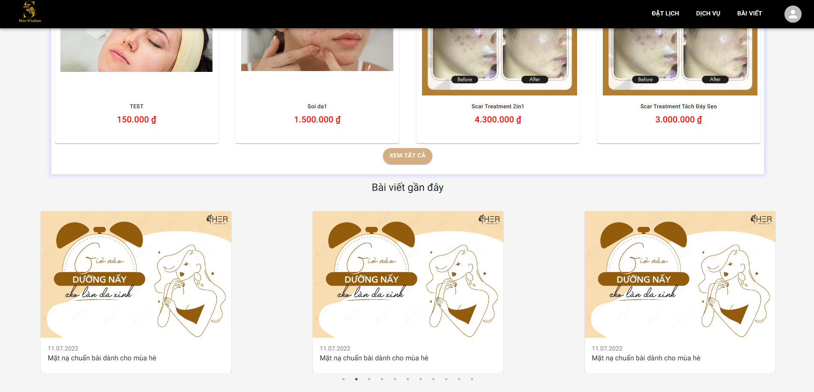

- Step 2: Click on “Xem tất cả” button or click on “Dịch vụ” button in Header bar of Homepage.

- Step 3: Navigate to service list page.

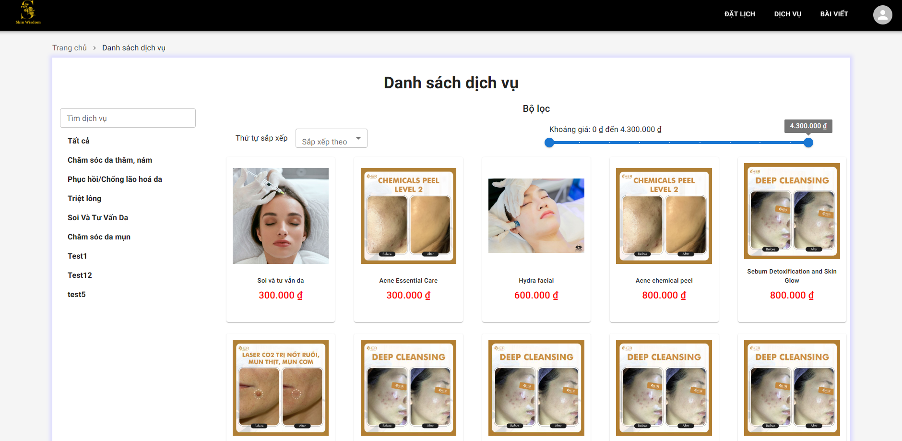

- User clicks on category button in category list on the left to filter all service linked to that category.

- User can select Sort order by clicks on “Sắp xếp theo” button.

- User can select Price range by price bar.

#### 3.2.5 View service details

- Step 1: Click on any services on Homepage/Service page.

- Step 2: Navigate to that service details page.

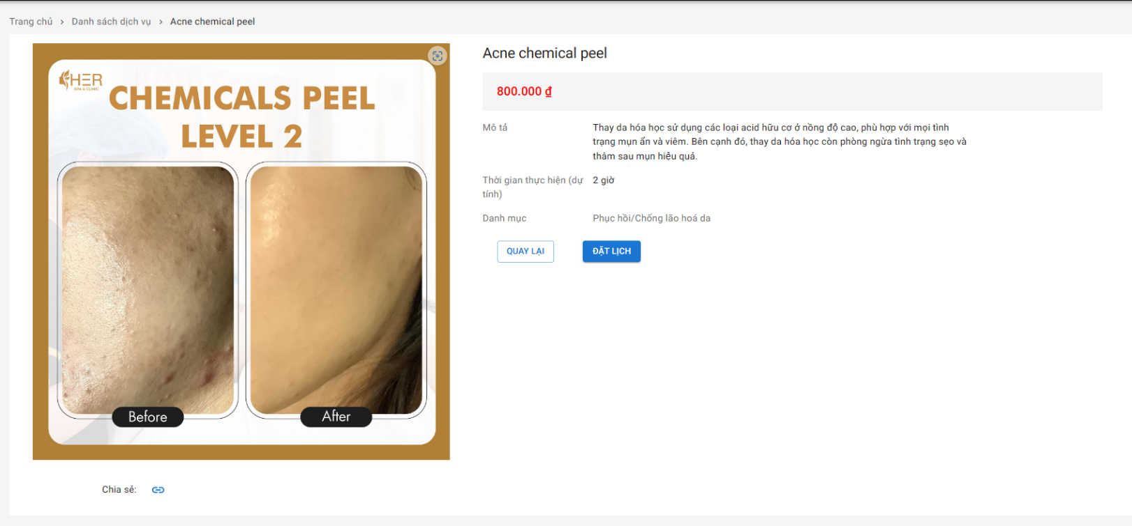

- User clicks on “Quay lại” button to back to Homepage/Service page.

- User clicks on “Đặt lịch” button to move on Booking page.

#### 3.2.6 Answer SCA form (for Customer)

- Step 1: Click on “Câu hỏi đánh giá” on Header bar of the Homepage.



- Step 2: Select form to answer.

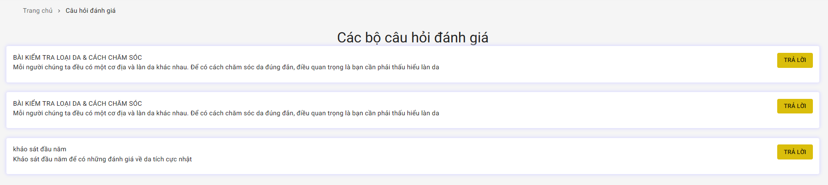

- Step 3: Click on “Trả lời” button.

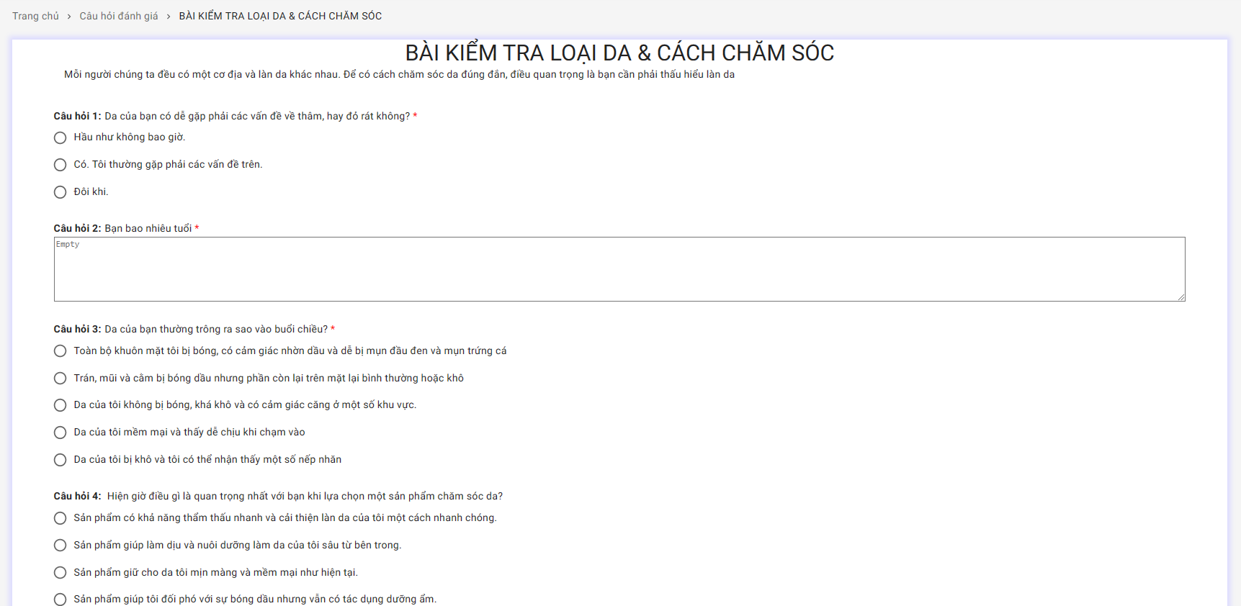

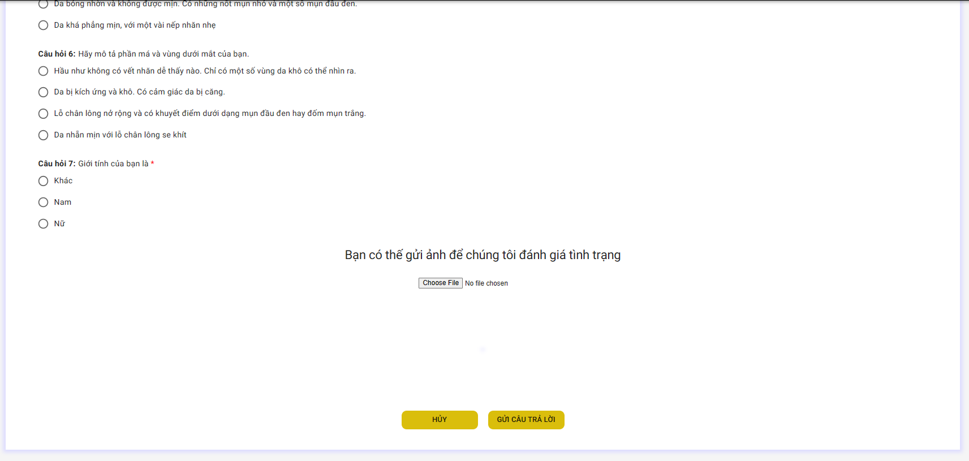

- Step 4: Answer all the questions in form (the question with * is require question)

- Step 5: Click on “Choose file” button to upload image.

- Step 6: Click on “Gửi câu trả lời” button to send form.

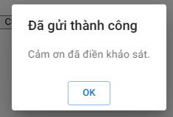

- User can click on “Hủy” to back to SCA Form list page.

#### 3.2.7 View answered SCA form (for Customer)

- Step 1: Click on Avatar in Header bar of the Homepage.

- Step 2: Click on “Các bộ câu hỏi đã trả lời” button.

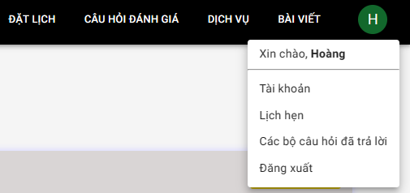

- Step 3: Click on “Xem chi tiết” button.

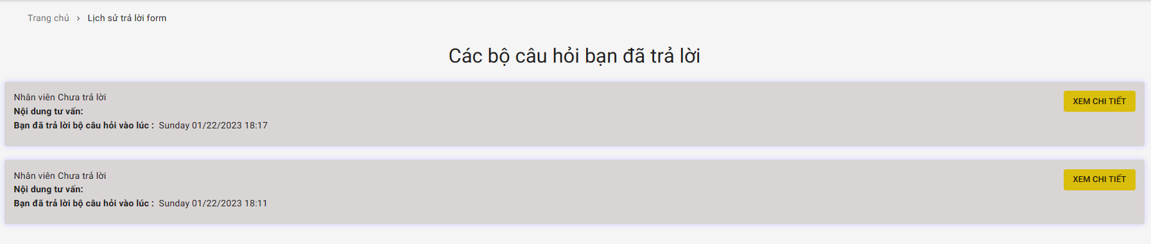

- Step 4: Navigate to form details page.

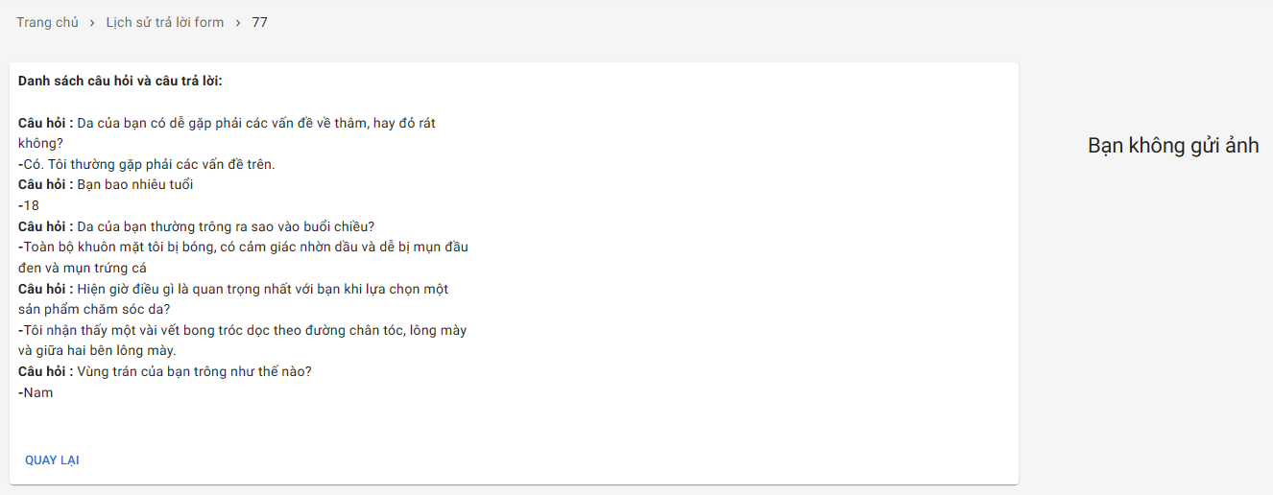

- User clicks on “Quay lại” button to back to answered SCA form list page.

#### 3.2.8 Booking

- Step 1: Click on “Đặt lịch” button on Header bar of the Homepage.



- Step 2: Fill in name, phone number, email and click on “Bước kế tiếp” button (Customer can skip this step).

- User can click on “Về trang chủ” button to back to Homepage.

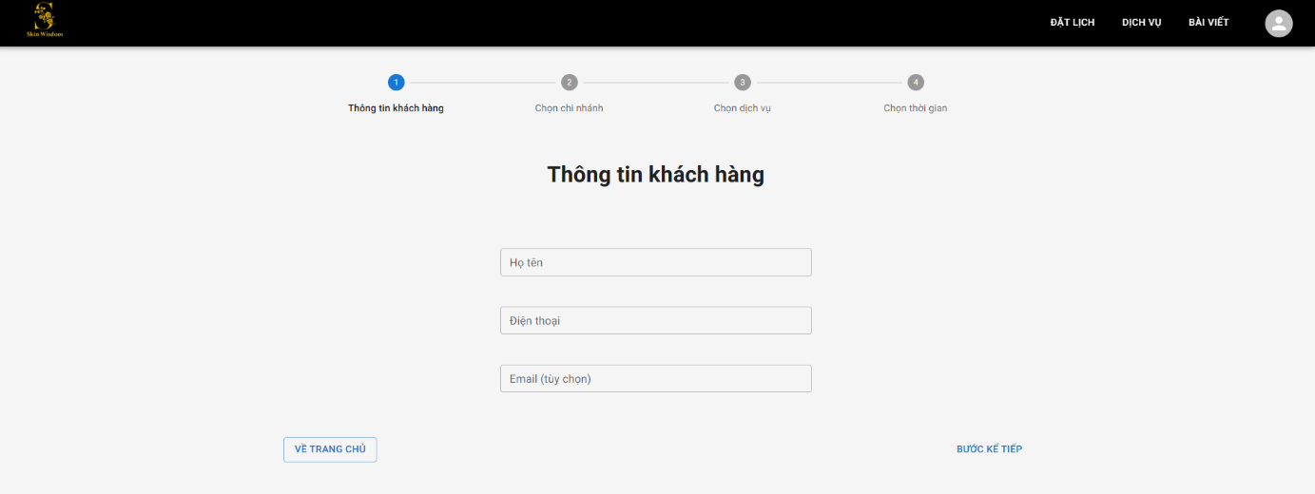

- Step 3: Select branch and click on “Bước kế tiếp” button

- User can click on “Tìm spa gần nhất” button to locate the nearest branch.

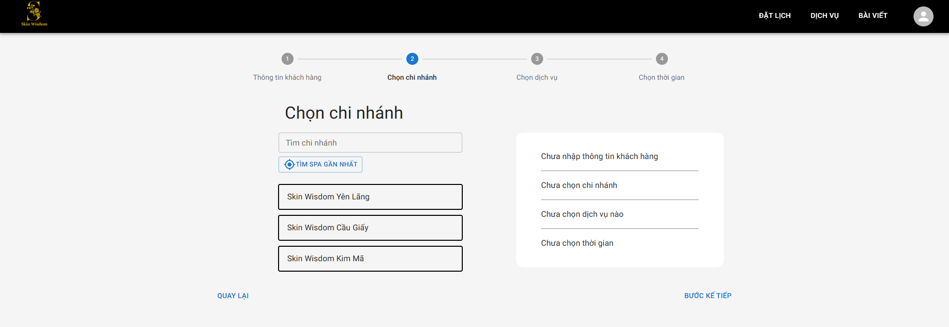

- Step 4: Select services and click on “Bước kế tiếp” button.

- User can select many services.

- User can remove selection by clicking on “X” button on the right of the page.

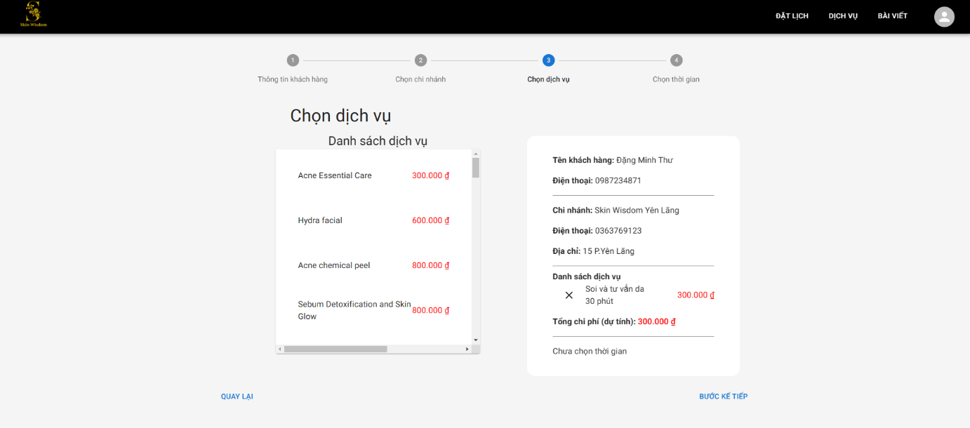

- Step 5: Select date and time and click on “Đặt lịch” button to finish.

- User can click on “Quay lại” button to back to the previous step of the booking session.

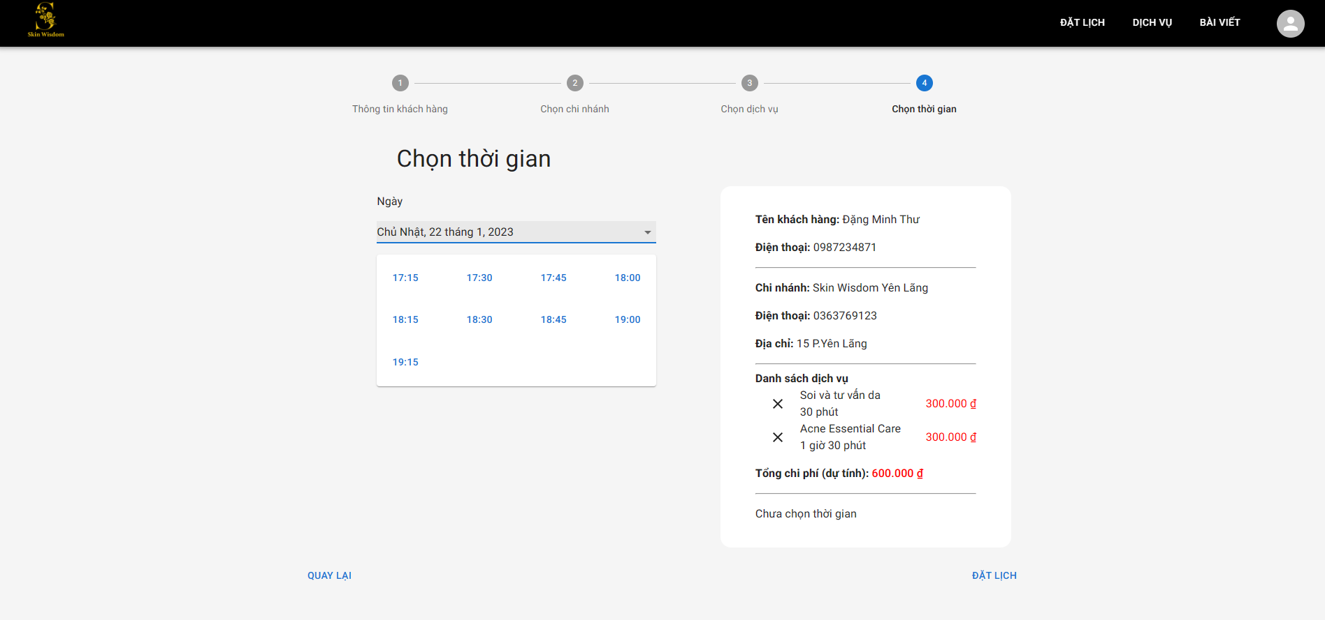

- Step 6: Navigate to re-confirm page with full information.

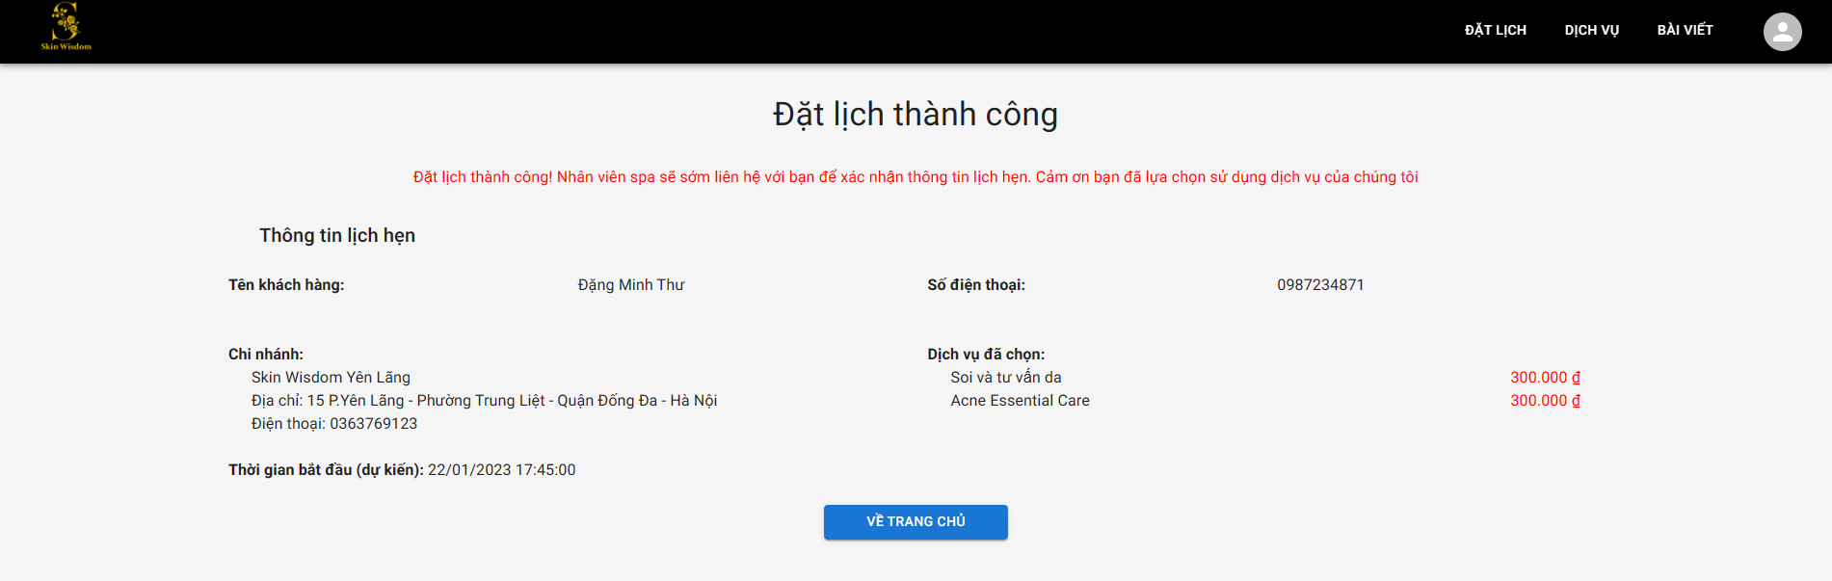

#### 3.2.9 View booked appointment and cancel appointment (for Customer)

- Step 1: Click on Avatar in Header bar of the Homepage.

- Step 2: Click on “Lịch hẹn” button.



- Step 3: Click on “Xem chi tiết” button.



- Step 4: Navigate to form details page.

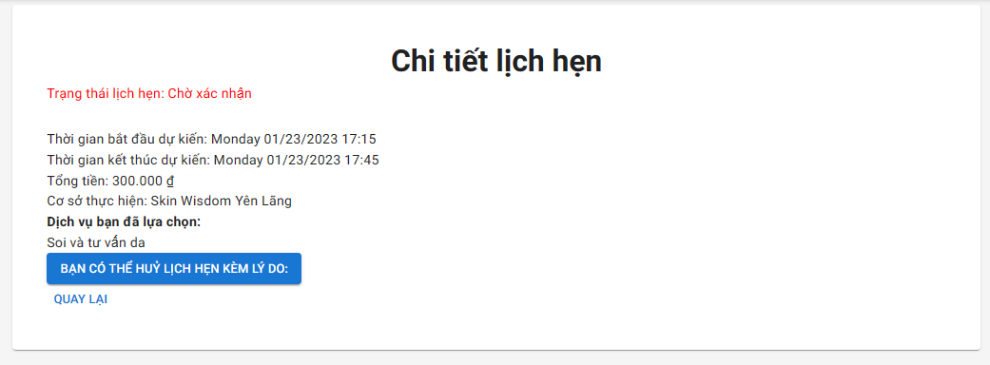

- Step 5: Click on “Bạn có thể hủy lịch hẹn kèm lý do” button.

- User can click on “Quay lại” button to back to the booked appointment list page.

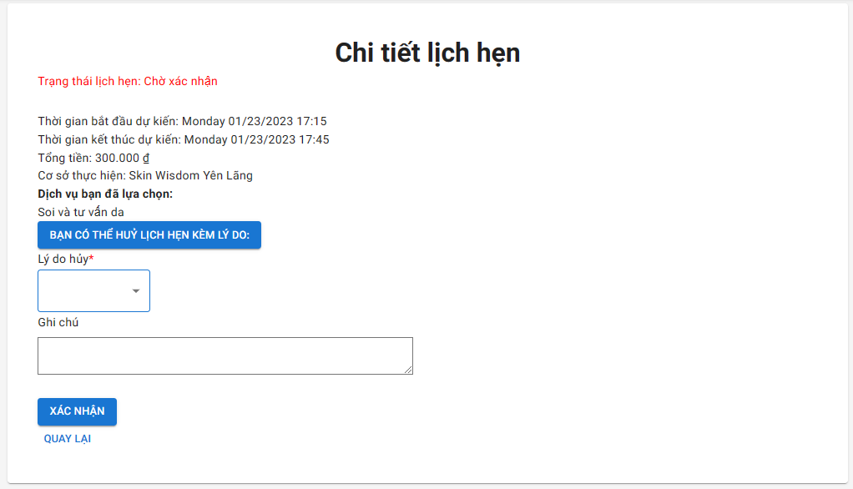

- Step 6: Click on “Lý do hủy” and select reason, user can write on the note.

- Step 7: Click on “Xác nhận” button.

*\*Note: User can only cancel an appointment if the status of it is “Chờ xác nhận”.*

#### 3.2.10 View profile (for Customer)

- Step 1: Click on Avatar in Header bar of the Homepage.

- Step 2: Click on “Tài khoản” button.



- Step 3: Navigate to Profile page.

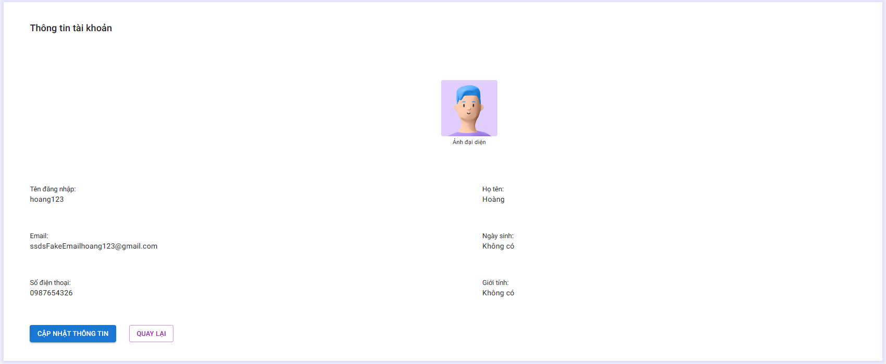

#### 3.2.11 Logout

- Step 1: Click on Avatar in Header bar of the Homepage.

- Step 2: Click on “Đăng xuất” button.



- Step 3: Navigate to Login page.

### 3.3 Receptionist/Manager

#### 3.3.1 Login

- Step 1: Go to “https://manager.widen.dev”.

- Step 2: Fill in username, password and click on “Đăng nhập” button.

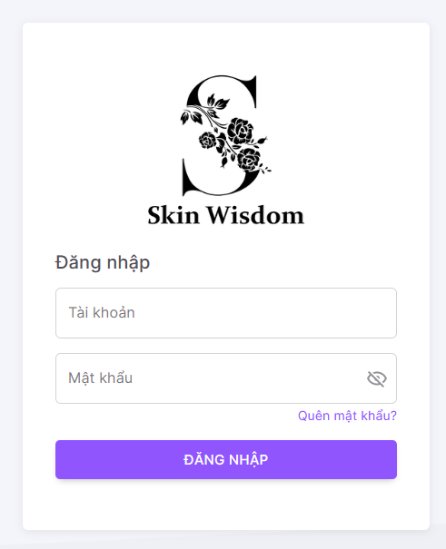

- Step 3: Navigate to Dashboard page.

#### 3.3.2 Dashboard

- User clicks on “Chọn thời gian” button to select time range for the dashboard.

- Manager clicks on “Chi nhánh” button to select branch for the dashboard. Receptionist is assigned only one branch.

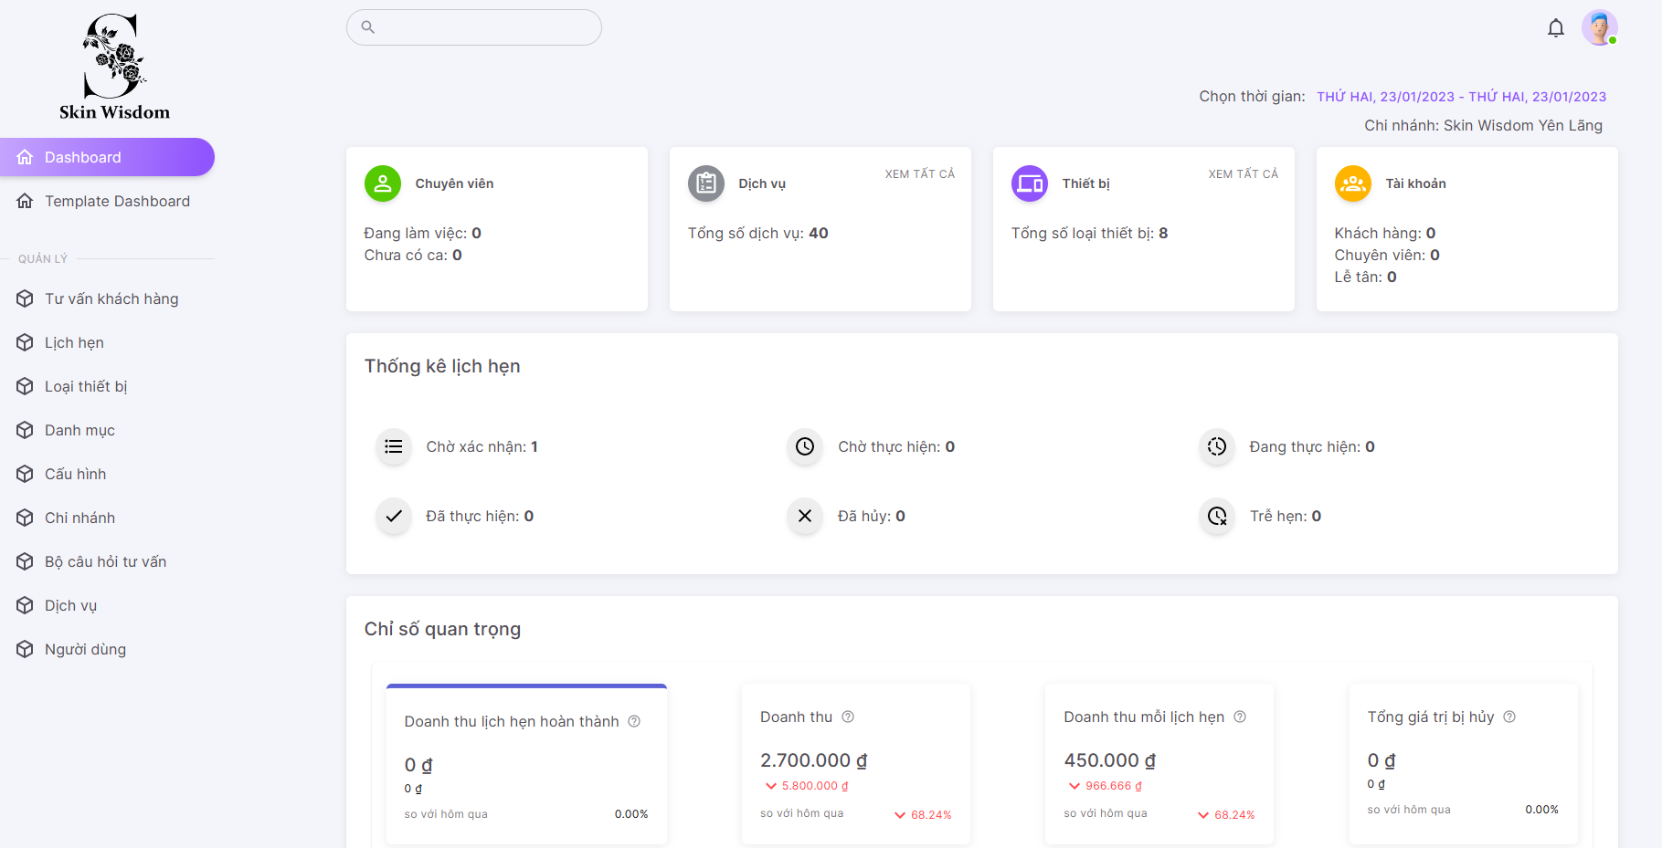

- User can select 1 or many indexs to display statistic on the dashboard.

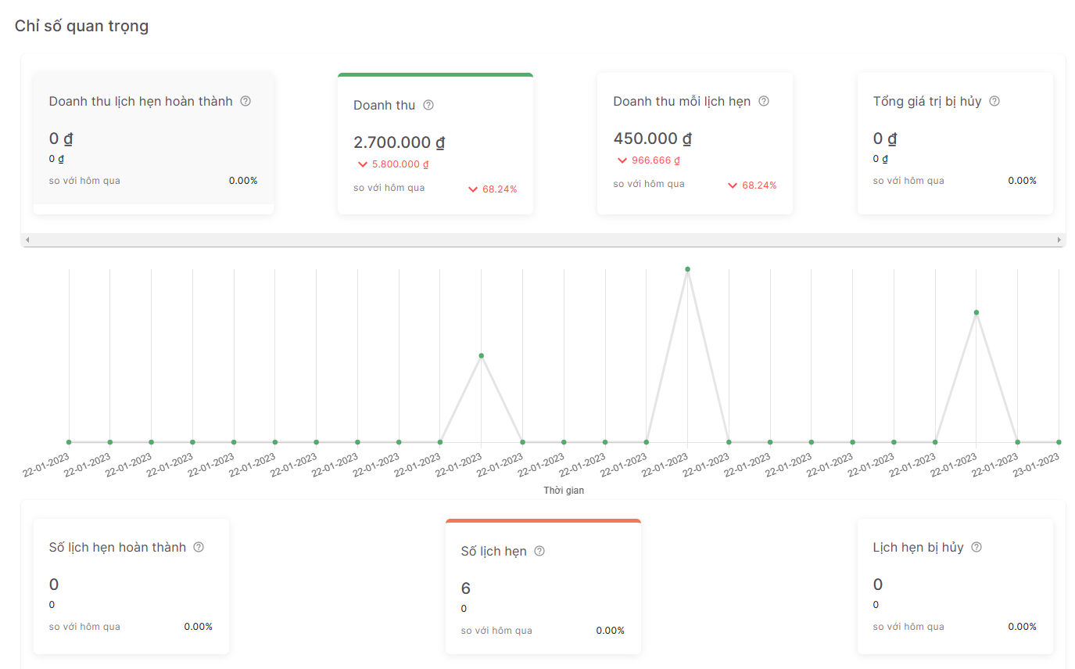

#### 3.3.3 Manage equipment (for Manager)

- User clicks on “Loại thiết bị” button in the menu bar on the left side of the management page.

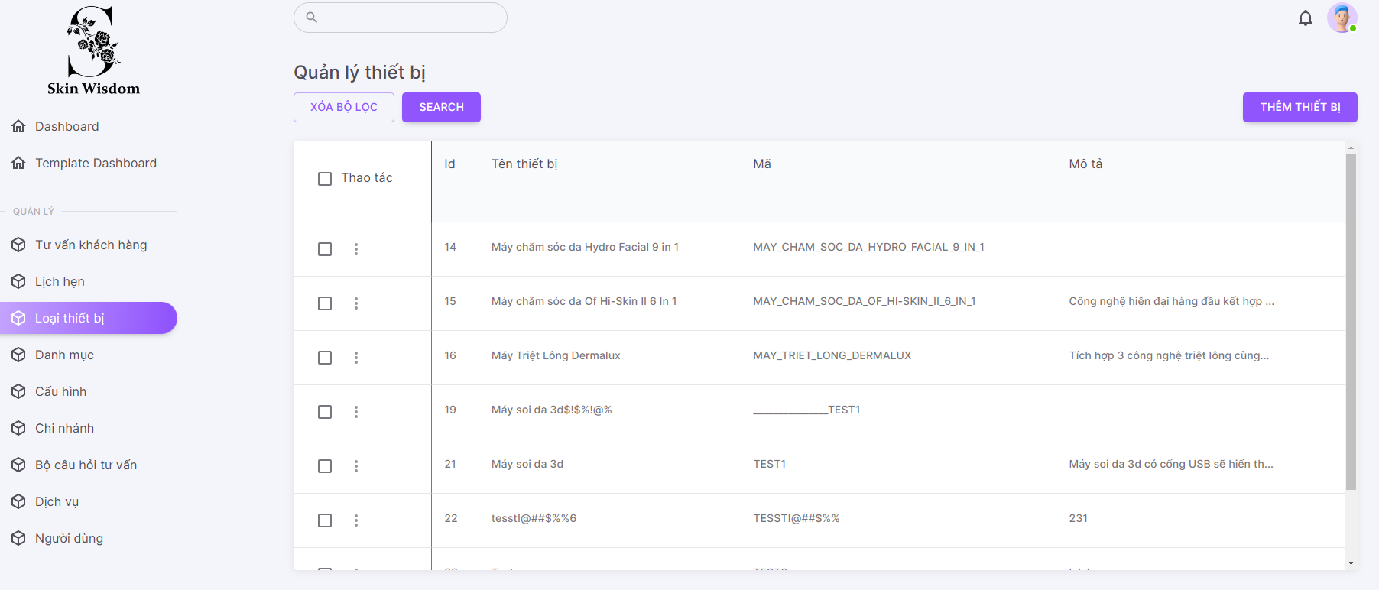

##### 3.3.3.1 Create equipment

- Step 1: Click on “Thêm thiết bị” button.

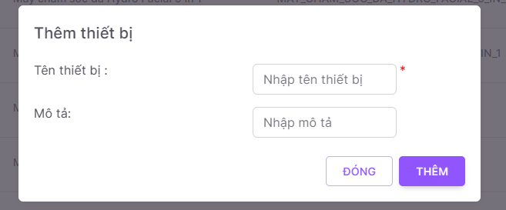

- Step 2: Fill in name, description and click on “Thêm” button.

- User can click on “Đóng” button to cancel.

##### 3.3.3.2 View equipment details (also for Receptionist)

- Step 1: Click on 3 dots icon on “Thao tác” column.

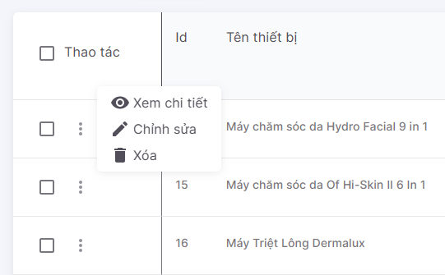

- Step 2: Click on “Xem chi tiết” button.

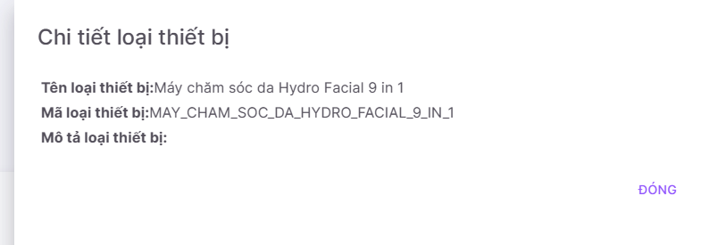

##### 3.3.3.3 Update equipment

- Step 1: Click on “Chỉnh sửa” button.



- Step 2: Edit information of the equipment.

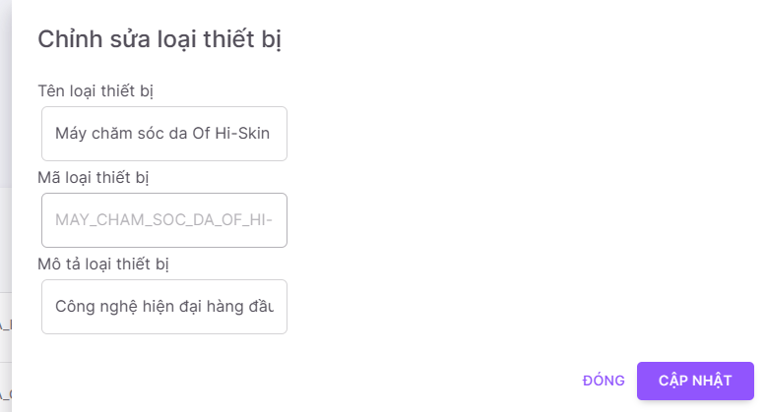

- Step 3: Click on “Cập nhật” button to update.

##### 3.3.3.4 Delete equipment

- Step 1: Click on “Xóa” button.



- User can select 1 or many equipments to delete.

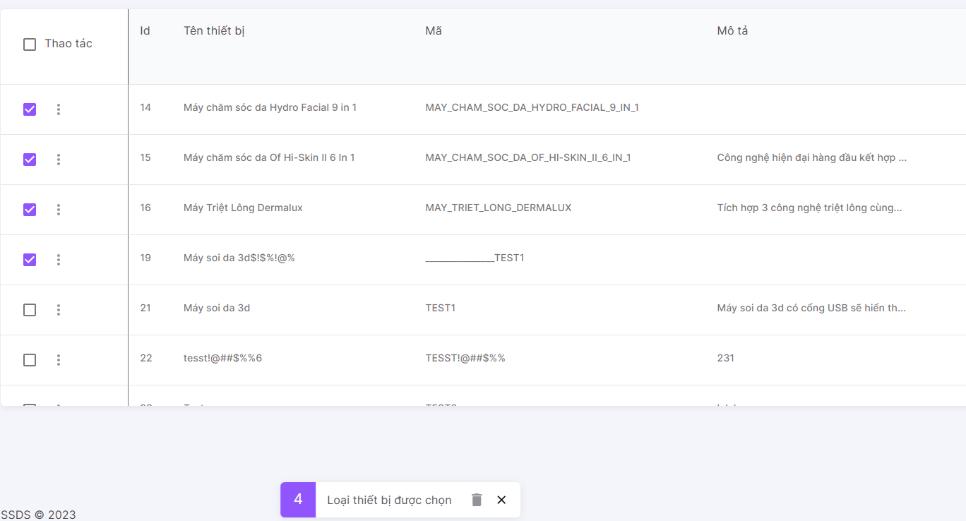

- User checks on checkbox button and clicks on Garbage icon to multiple deletes.

- User can click on “X” button to cancel.

#### 3.3.4 Manage category (for Manager)

- User clicks on “Danh mục” button in the menu bar on the left side of the management page.

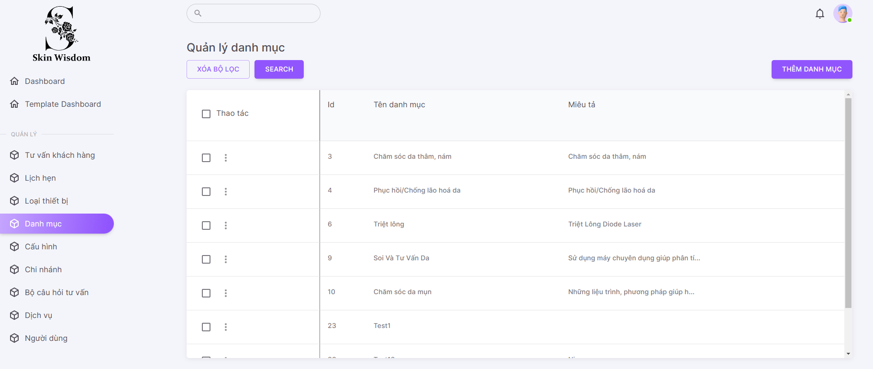

##### 3.3.4.1 Create category

- Step 1: Click on “Thêm danh mục” button.

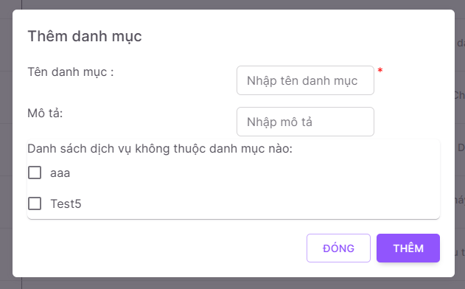

- Step 2: Fill in name, description and select services are belong to new category.

- Step 3: Click on “Thêm” button.

##### 3.3.4.2 View category details (also for Receptionist)

- Step 1: Click on 3 dots icon on “Thao tác” column.

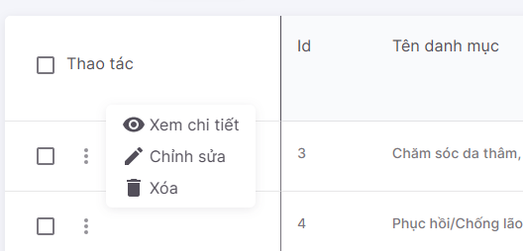

- Step 2: Click on “Xem chi tiết” button.

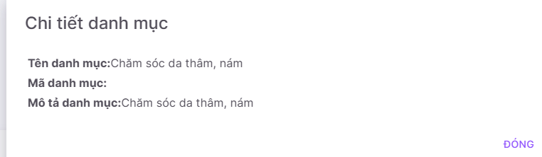

##### 3.3.4.3 Update category

- Step 1: Click on “Chỉnh sửa” button.



- Step 2: Edit information of the category.

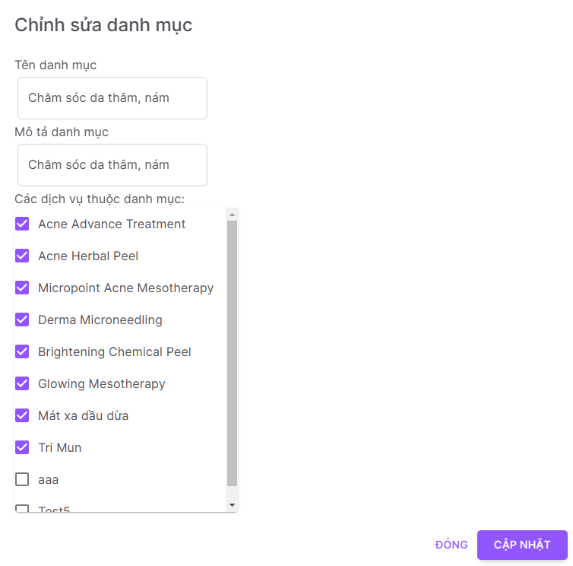

- Step 3: Click on “Cập nhật” button to update.

##### 3.3.3.4 Delete category

- Step 1: Click on “Xóa” button.



- User can select 1 or many categories to delete.

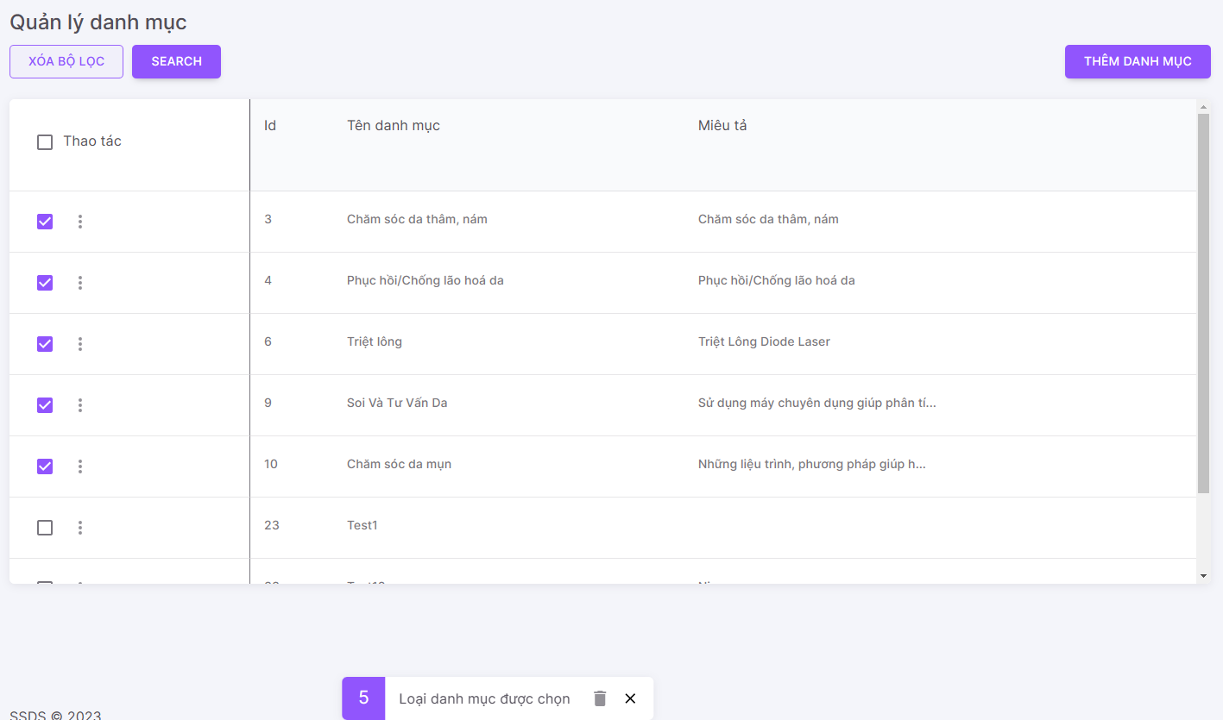

- User checks on checkbox button and clicks on Garbage icon to multiple deletes.

- User can click on “X” button to cancel.

#### 3.3.5 Manage data config (for Manager)

- User clicks on “Cấu hình” button in the menu bar on the left side of the management page.

*\*Note: Data configurations is automatically generated when user create a new branch.*

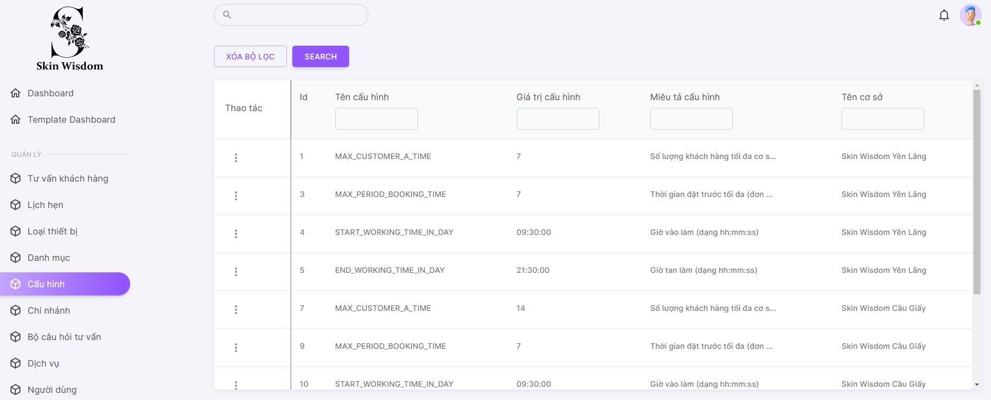

##### 3.3.5.1 View data config details (also for Receptionist)

- Step 1: Click on 3 dots icon on “Thao tác” column.

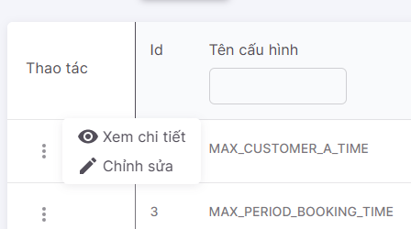

- Step 2: Click on “Xem chi tiết” button.

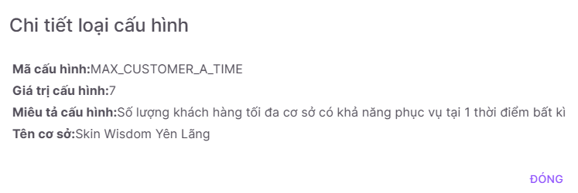

##### 3.3.5.2 Update data config

- Step 1: Click on “Chỉnh sửa” button.



- Step 2: Edit information of the data config.

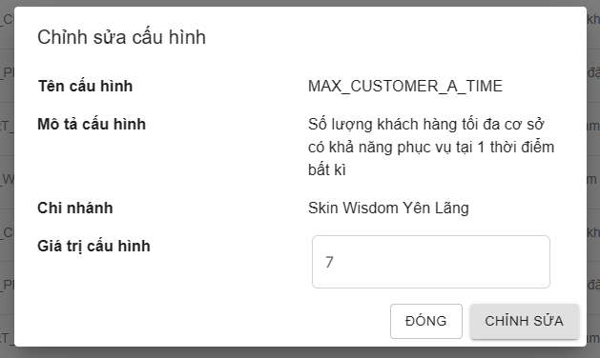

- Step 3: Click on “Chỉnh sửa” button to update.

#### 3.3.6 Manage branch (for Manager)

- User clicks on “Chi nhánh” button in the menu bar on the left side of the management page.

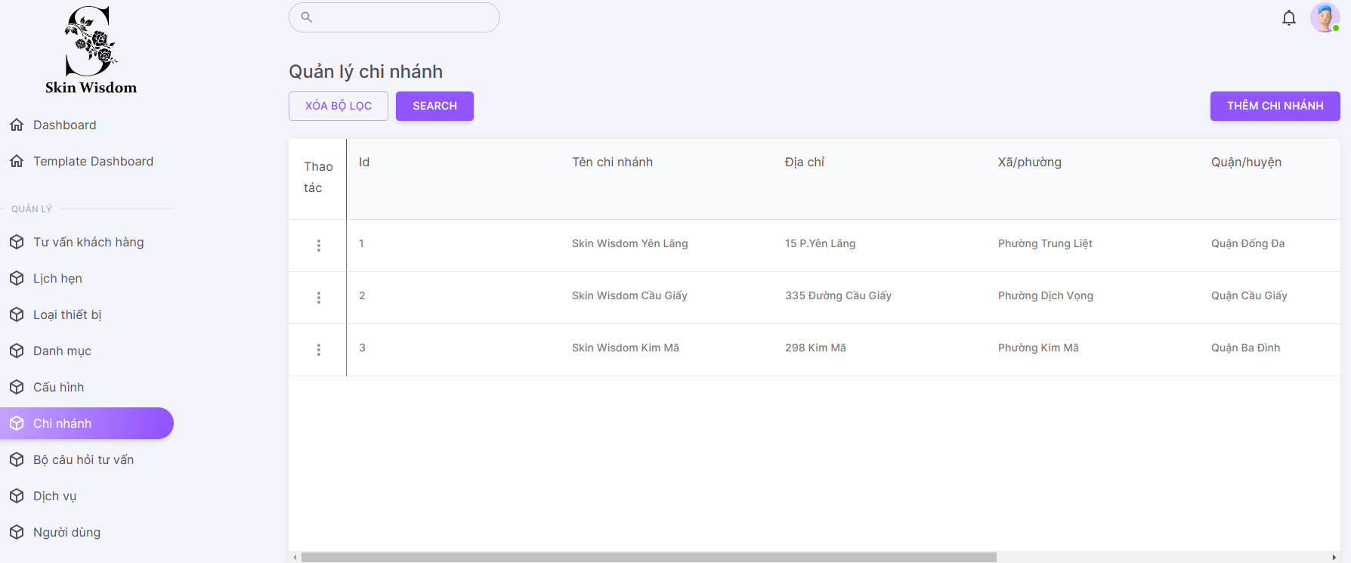

##### 3.3.6.1 Create branch

- Step 1: Click on “Thêm chi nhánh” button.

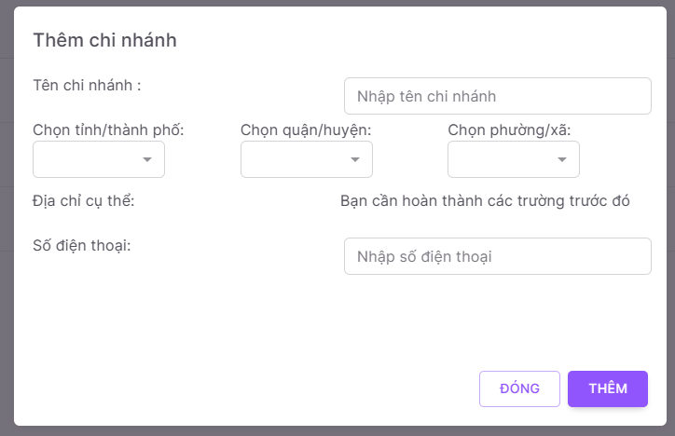

- Step 2: Fill in name, city, district, ward, detail address, phone number and click on “Thêm” button.

- User can click on “Đóng” button to cancel.

##### 3.3.6.2 View branch details (also for Receptionist)

- Step 1: Click on 3 dots icon on “Thao tác” column.

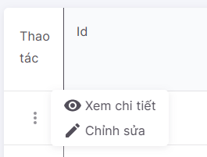

- Step 2: Click on “Xem chi tiết” button.

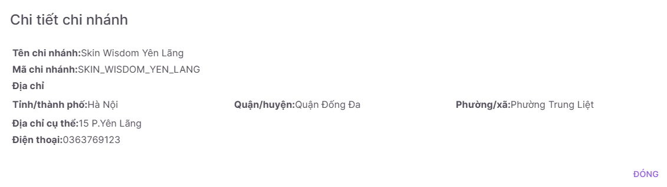

##### 3.3.6.3 Update branch

- Step 1: Click on “Chỉnh sửa” button.



- Step 2: Edit information of the branch.

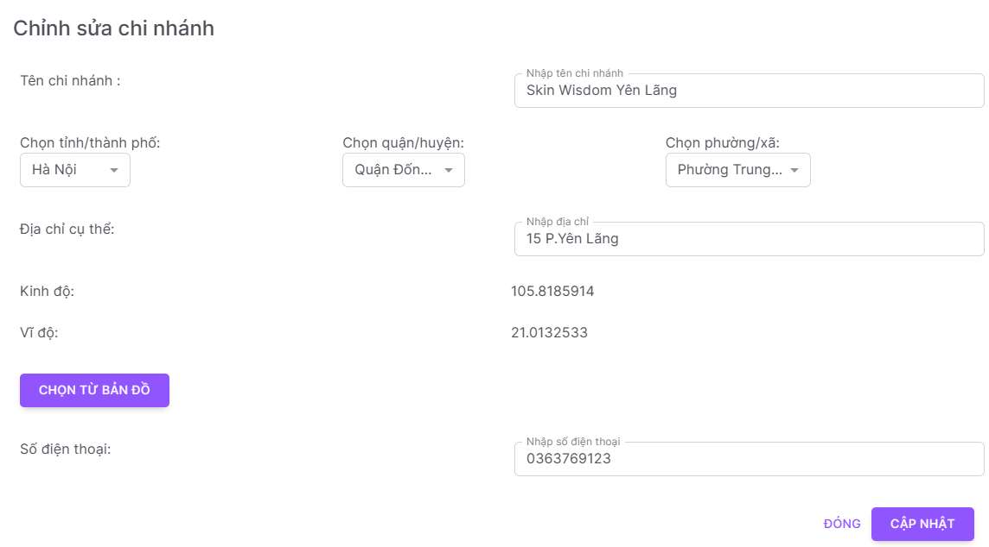

- Step 3: Click on “Cập nhật” button to update.

#### 3.3.7 Manage SCA form (for Manager)

- User clicks on “Bộ câu hỏi tư vấn” button in the menu bar on the left side of the management page.

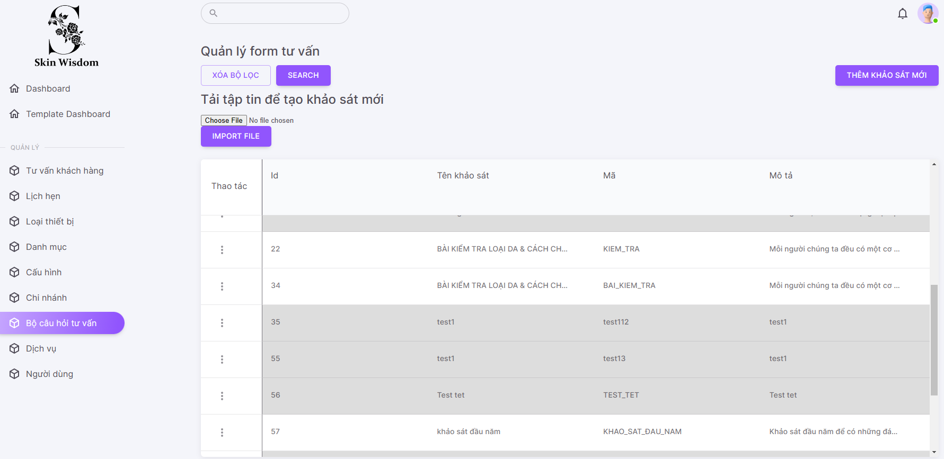

##### 3.3.7.1 Create form

- Step 1: Click on “Thêm khảo sát mới” button.

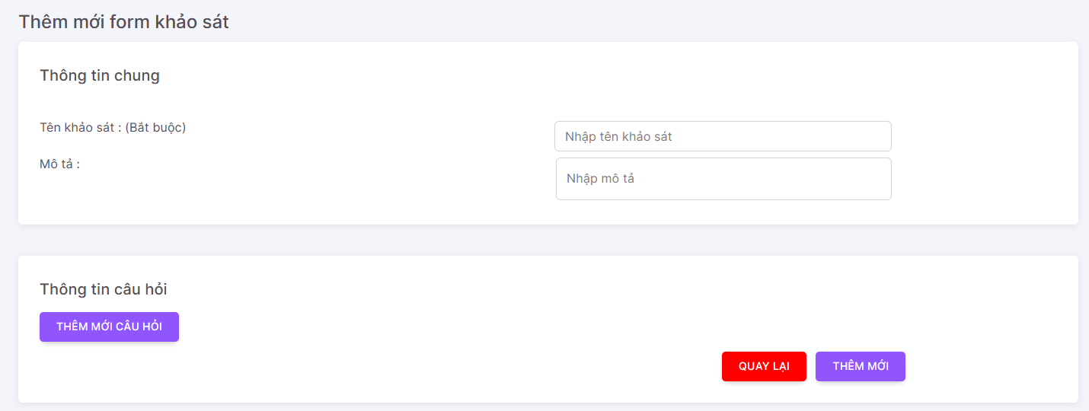

- Step 2: Fill in name, description.

- Step 3: Click on “Thêm mới câu hỏi” button.

- Step 4: Click on “Loại” button and select type of the question.

+ The “Tự luận” question is only had a question.

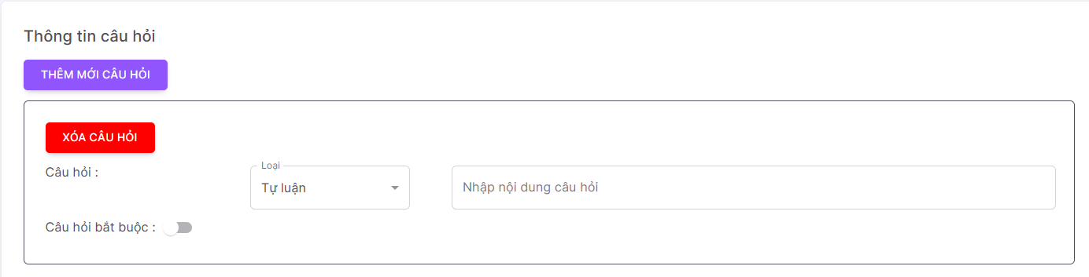

+ The “Trắc nghiệm” question is contained a question and many answers.

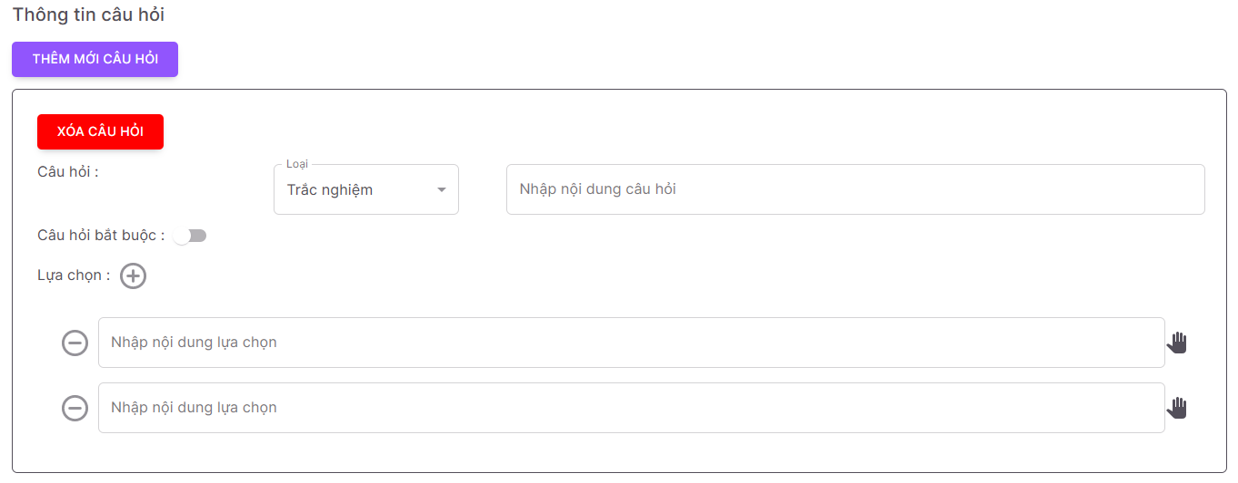

* Click on “+” button to add answer.
* Click on “-” button to remove answer.
* Hold and drag Hand icon to change the order of the answer.

+ User can make require question or not by clicking on Switch button(gray is off, yellow is on) at “Câu hỏi bắt buộc”.

+ User clicks on “Xóa câu hỏi” button to remove question.

- Step 5: Click on “Thêm mới” button.

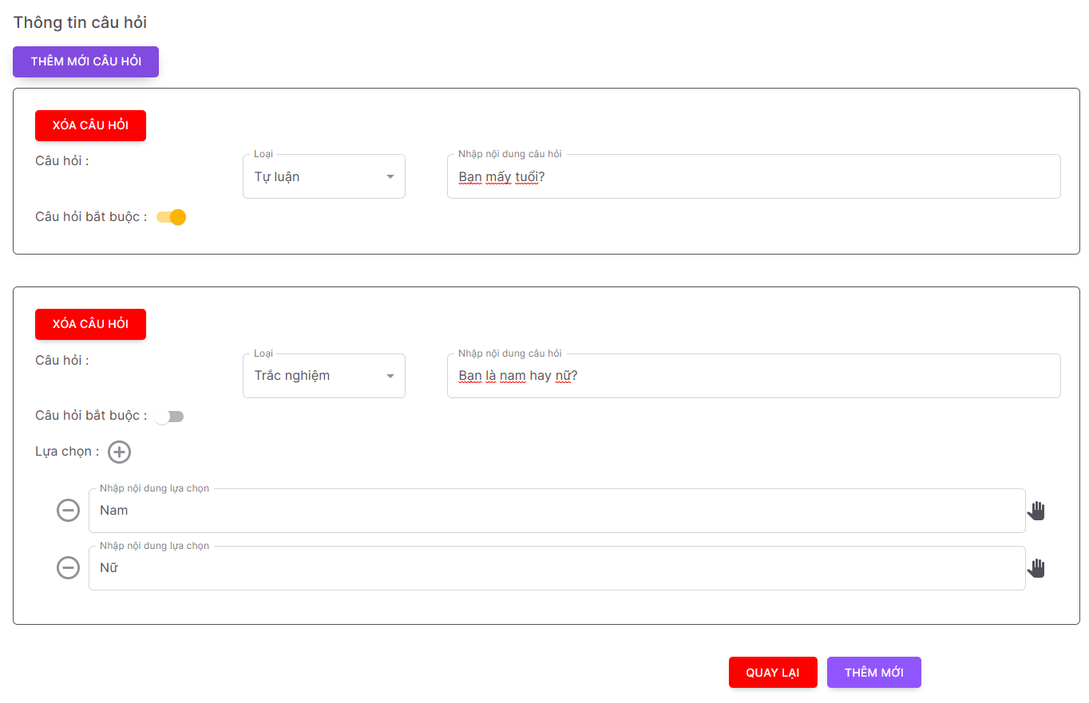

- User clicks on “Quay lại” button to cancel.

##### 3.3.7.2 View form details (also for Receptionist)

- Step 1: Click on 3 dots icon on “Thao tác” column.

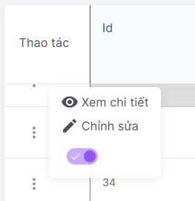

- Step 2: Click on “Xem chi tiết” button.

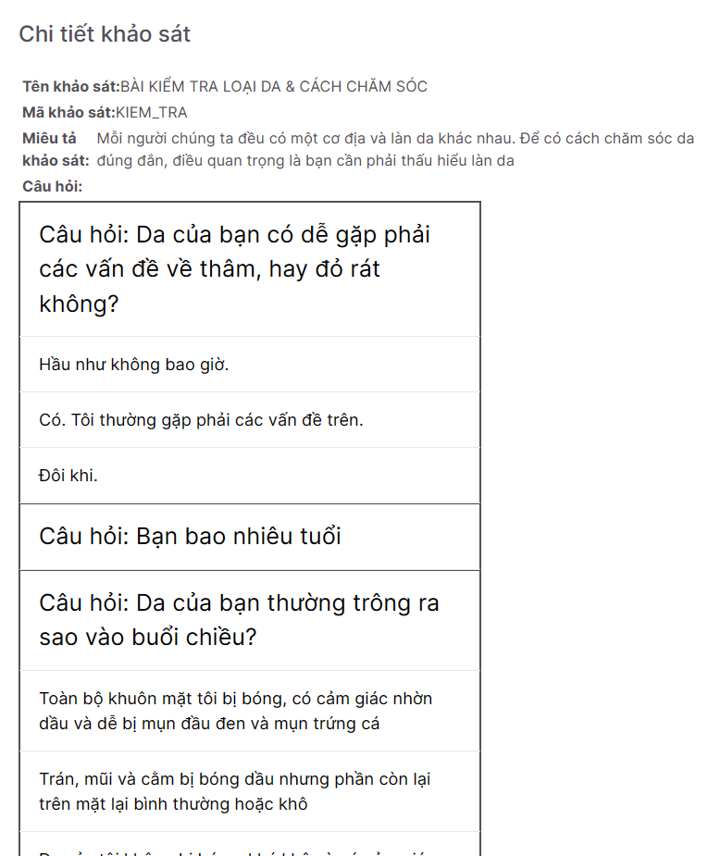

##### 3.3.7.3 Update form

- Step 1: Click on “Chỉnh sửa” button.



- Step 2: Edit information of the form.

+ Click on Garbage icon to remove a question/answer.

+ Input content in “Thêm câu trả lời” field and press Enter to add a new answer.

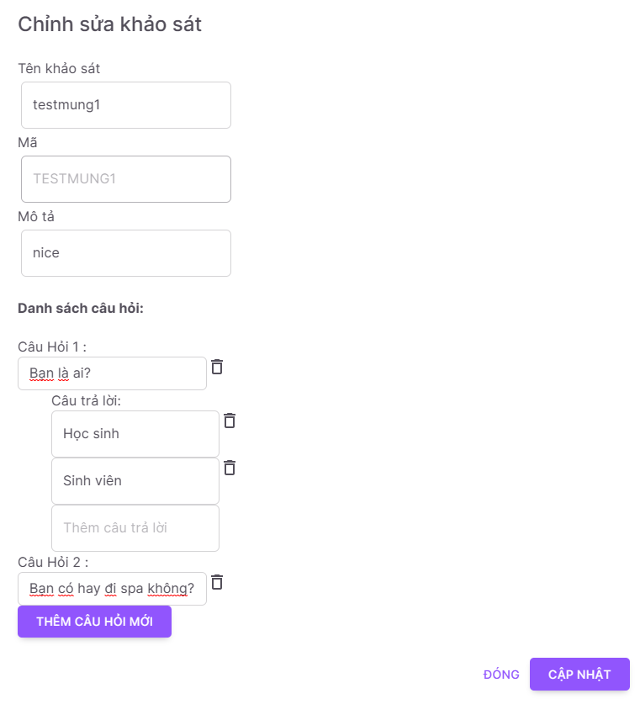

- Step 3: Click on “Thêm câu hỏi mới” button to add a new question.

*\*Note: When user adds a new question, the system will disable the form until user clicks on “Sửa khảo sát” button.*

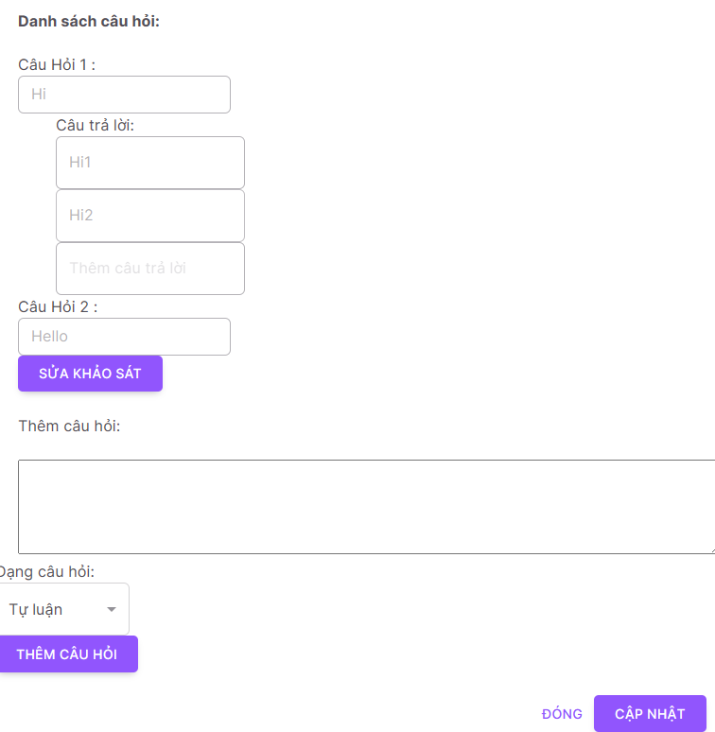

- Step 4: Input information for a new question and click on “Thêm câu hỏi” button.

- Step 5: Click on “Cập nhật” button to update.

- User clicks on “Đóng” button to cancel.

##### 3.3.7.4 Deactivate form

- Click on Switch button (grey is deactivate, purple is activated) to activate/deactivate the form.

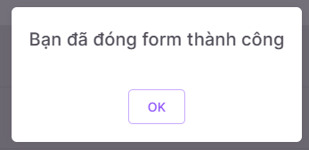

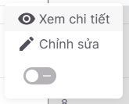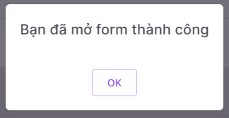

##### 3.3.7.5 Import file to add a form

- Step 1: Click on “Choose file” button.

- Step 2: Select file to import.

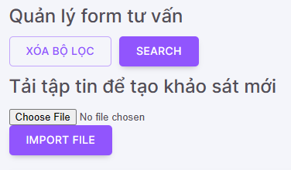

- Step 3: Click on “Import file” button.

#### 3.3.8 Manage service (for Manager)

- User clicks on “Dịch vụ” button in the menu bar on the left side of the management page.

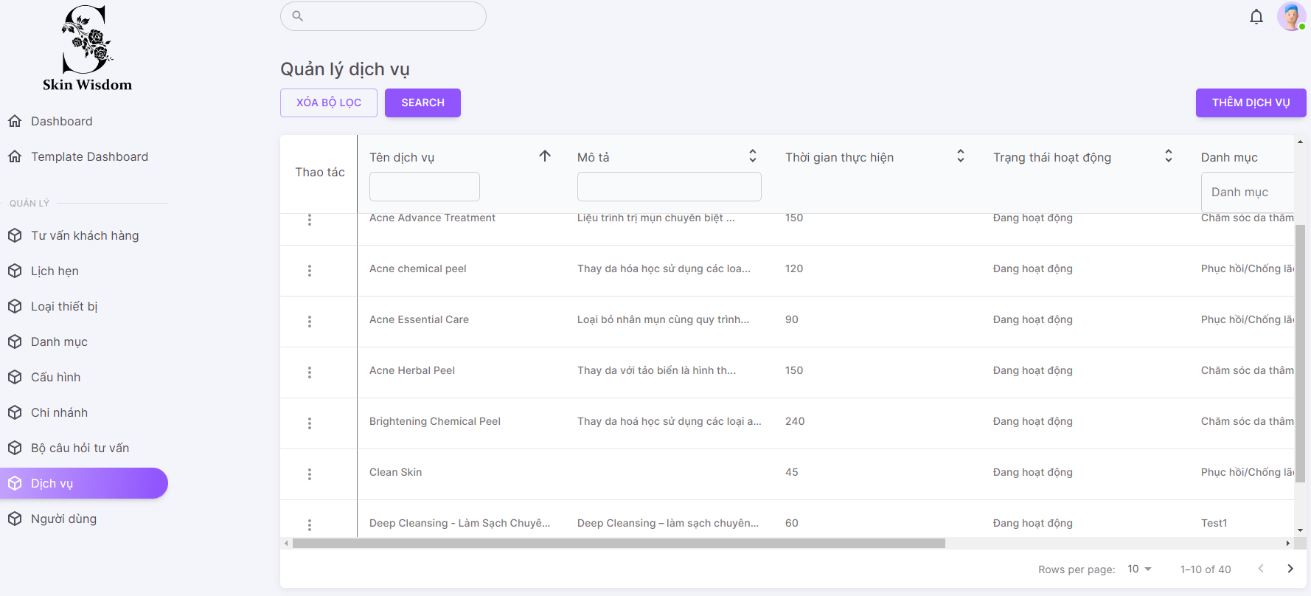

##### 3.3.8.1 Create service

- Step 1: Click on “Thêm dịch vụ” button.

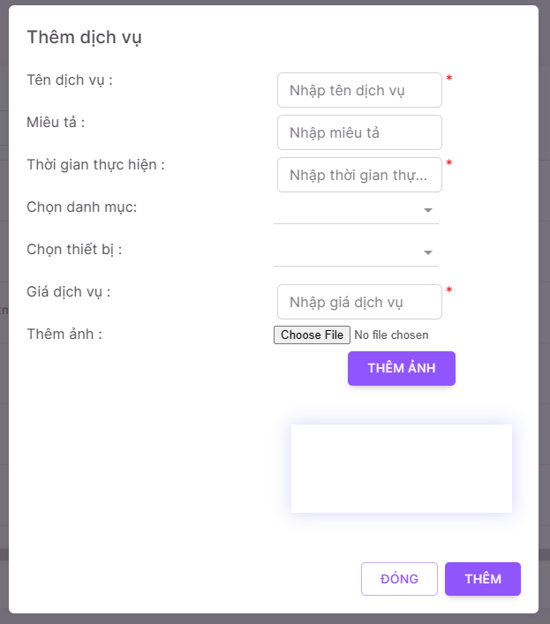

- Step 2: Fill in name, description, time, category, equipment, price, image and click on “Thêm” button.

- User can click on “Đóng” button to cancel.

##### 3.3.8.2 View service details (also for Receptionist)

- Step 1: Click on 3 dots icon on “Thao tác” column.



- Step 2: Click on “Xem chi tiết” button.

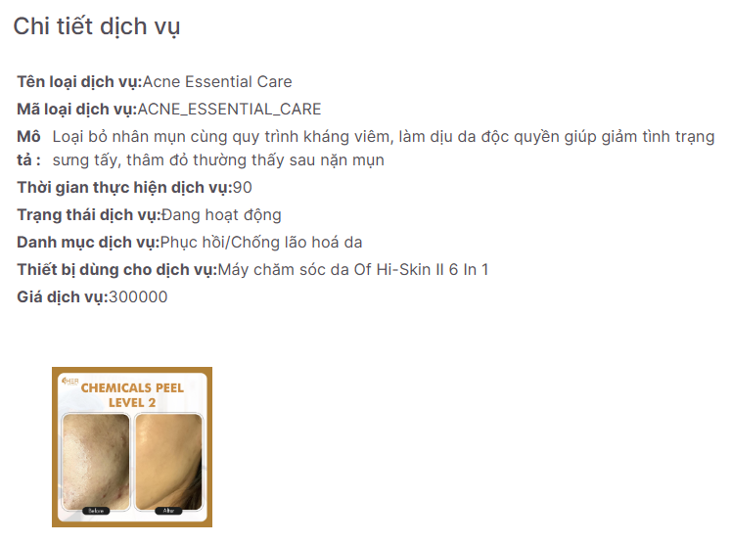

##### 3.3.8.3 Update service

- Step 1: Click on “Chỉnh sửa” button.



- Step 2: Edit information of the equipment.

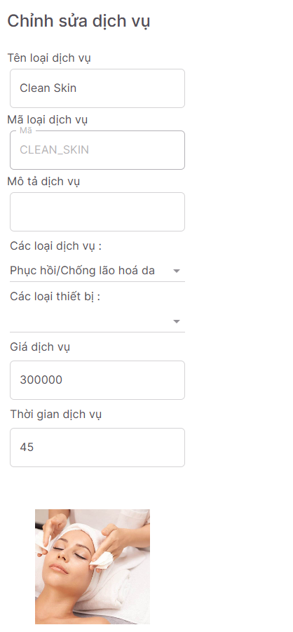

- Step 3: Click on “Cập nhật” button to update.

##### 3.3.8.4 Deactivate service

- Click on Switch button (grey is deactivate, purple is activated) to activate/deactivate the service.



#### 3.3.9 Manage user

- User clicks on “Người dùng” button in the menu bar on the left side of the management page.

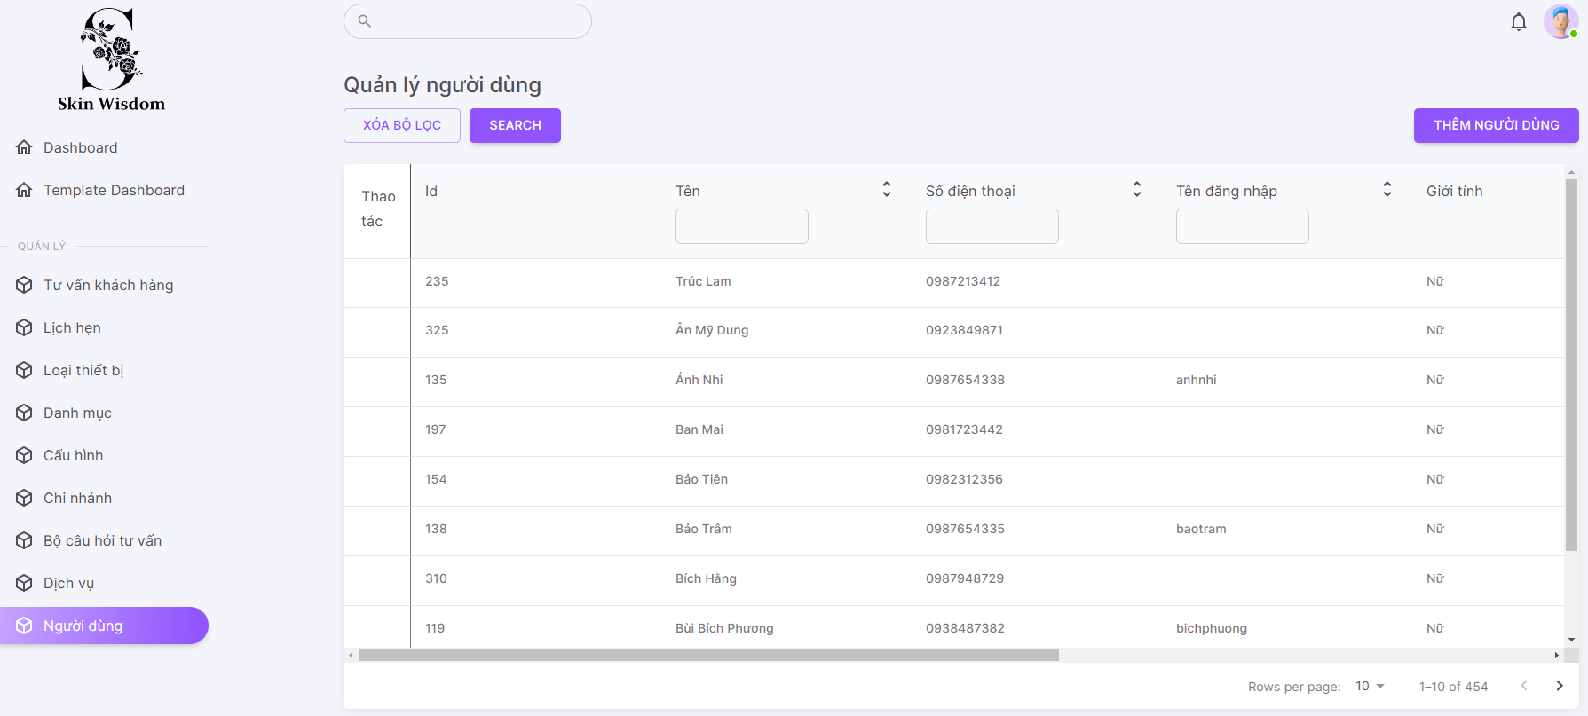

##### 3.3.9.1 Create user

- Step 1: Click on “Thêm người dùng” button.

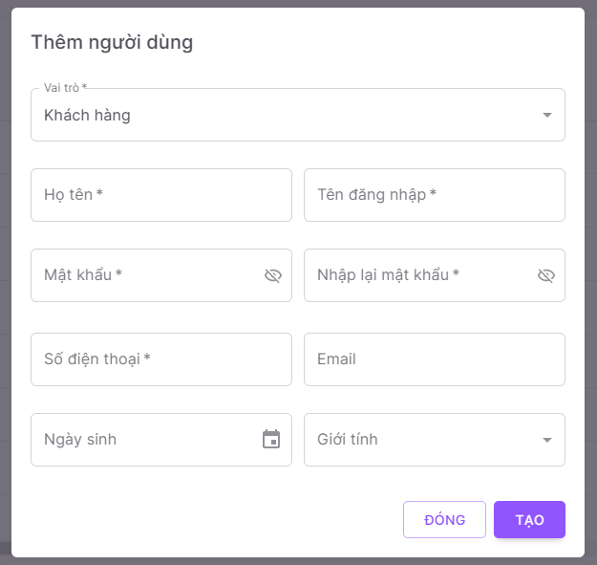

- Step 2: Fill in name, username, password, re-password, phone number, email, date of birth, gender, select role and click on “Thêm” button.

- User can click on “Đóng” button to cancel.

#### 3.3.10 Consult customer

- User clicks on “Tư vấn khách hàng” button in the menu bar on the left side of the management page.

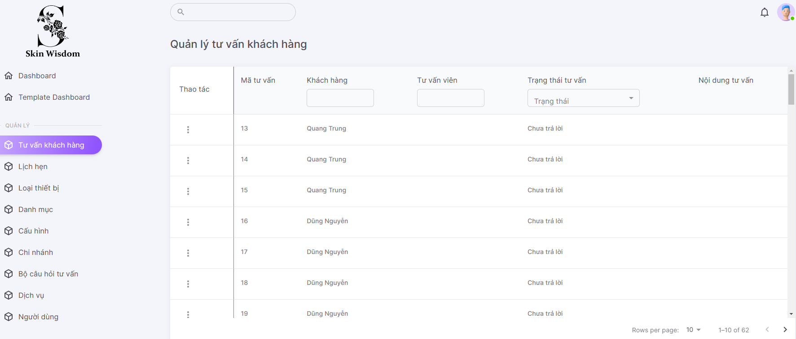

- Step 2: Click on 3 dots icon on “Thao tác” column.

- Step 3: Click on “Tư vấn” button.

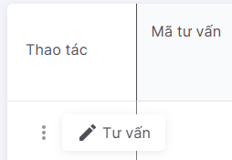

- Step 4: Fill in comment and recommend service for customer.

+ User can recommend multiple services.

+ User clicks on “X” button to remove recommendation.

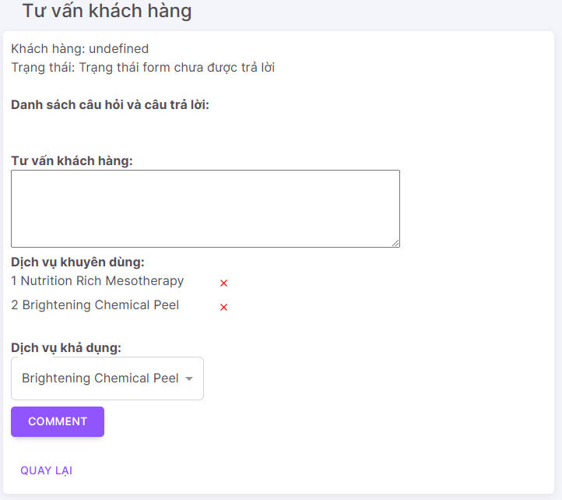

- Step 5: Click on “Comment” button to send.

- User can click on “Quay lại” button to cancel.

#### 3.3.11 Manage appointment (for Receptionist)

- User clicks on “Lịch hẹn” button in the menu bar on the left side of the management page.

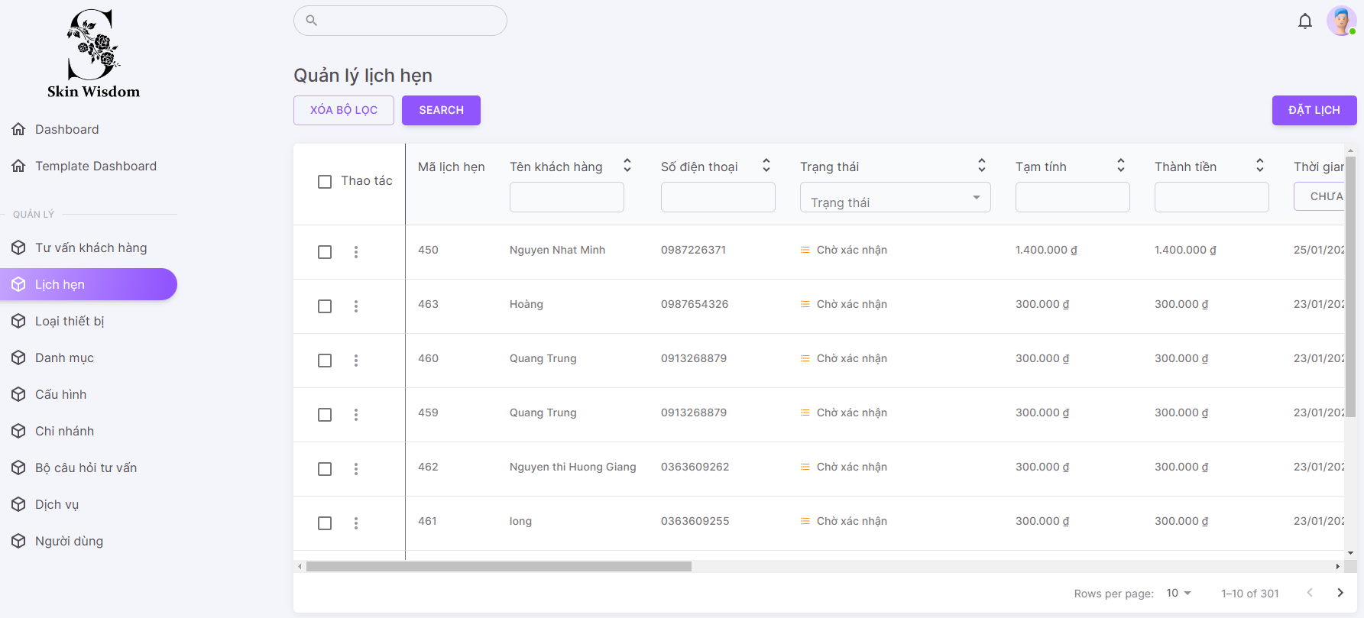

- Status of the appointment:

+ Chờ xác nhận: Customer make a booking on the system and have no confirm.

+ Chờ thực hiện: Receptionist contact customer and confirm.

+ Đang thực hiện: Customer come to the spa and check-in.

+ Hoàn tất thanh toán: Customer complete spa activities, check-out and do a payment.

+ Đã hủy: Customer cancel the appointment or don’t come to the spa.

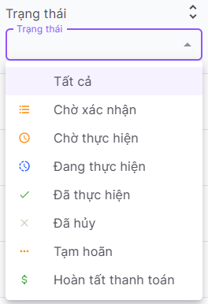

##### 3.3.11.1 Create appointment

- Step 1: Click on “Đặt lịch” button.

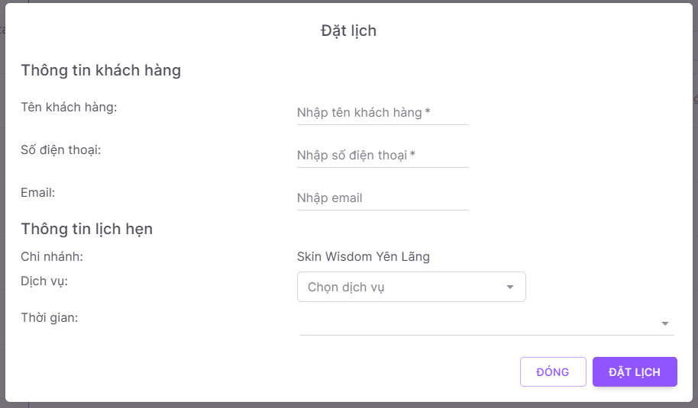

- Step 2: Fill in customer’s name, phone number, email, select services and time, then click on “Đặt lịch” button.

- User can click on “Đóng” to cancel.

##### 3.3.11.2 View appointment details (also for Manager)

- Step 1: Click on 3 dots icon on “Thao tác” column.

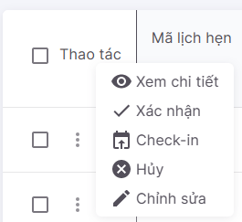

- Step 2: Click on “Xem chi tiết” button.

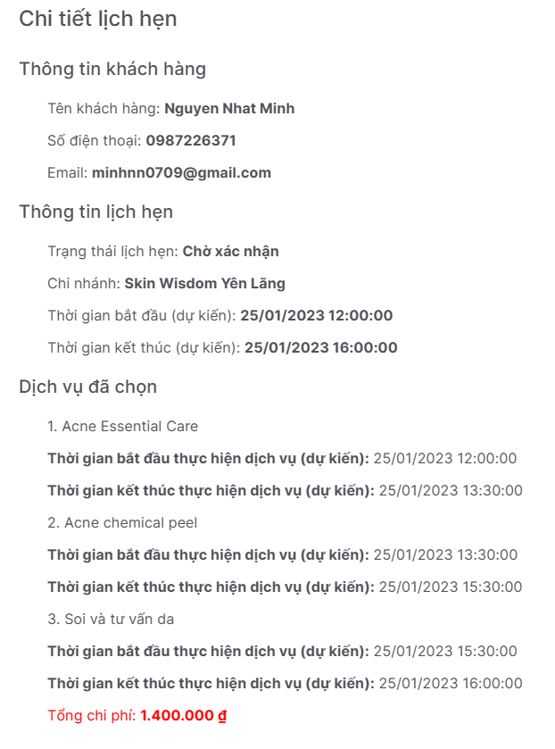

##### 3.3.11.3 Confirm or cancel appointment

*\*Note: In this activity, user must contact customer to confirm before updating in the system.*

- Step 1: Click on “Xác nhận” button.



- Step 2: Select action and reason (if cancel)

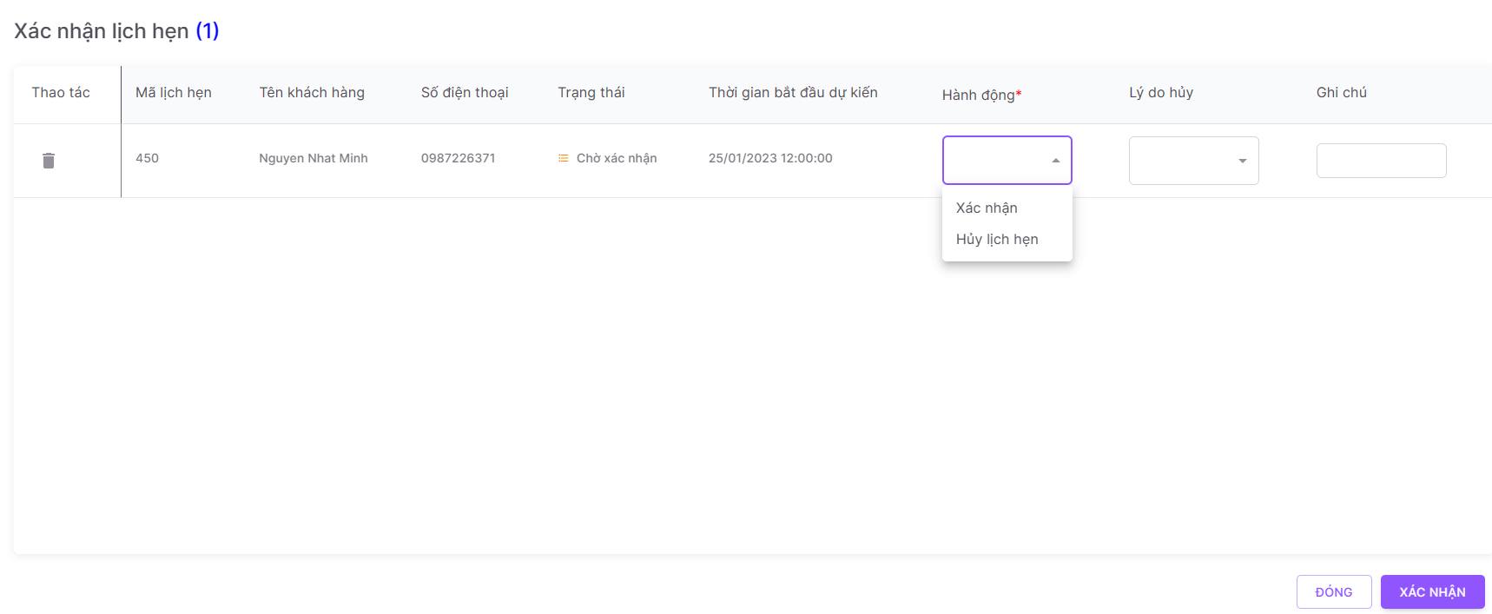

+ Select “Xác nhận” for confirm appointment.

+ Select “Hủy lịch hẹn” for cancel appointment, select “Lý do hủy” to choose reason (not required). User also can cancel by clicking on “Hủy” button at step 1.

- Step 3: Click on “Xác nhận” button.

- User can click on “Đóng” button to cancel.

- User can select multiple appointments to confirm.

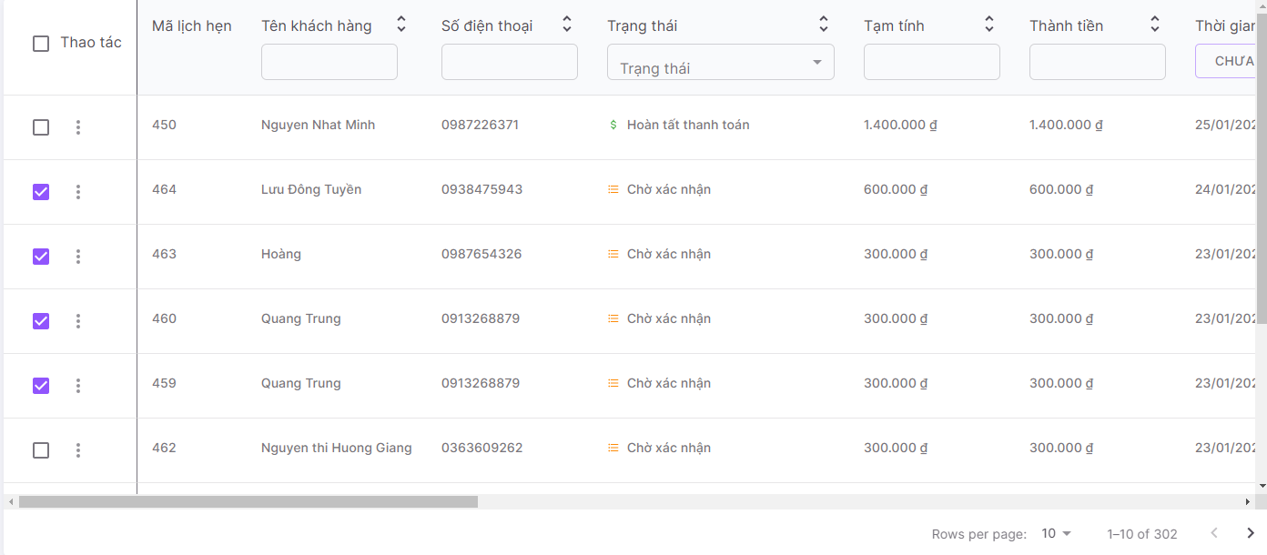

- Step 1: Click on checkbox on the “Thao tác” column and select appointment.

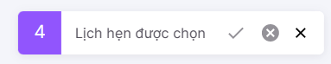

- Step 2: Click on Check icon to confirm, Circle X icon to cancel, “X” button to close.

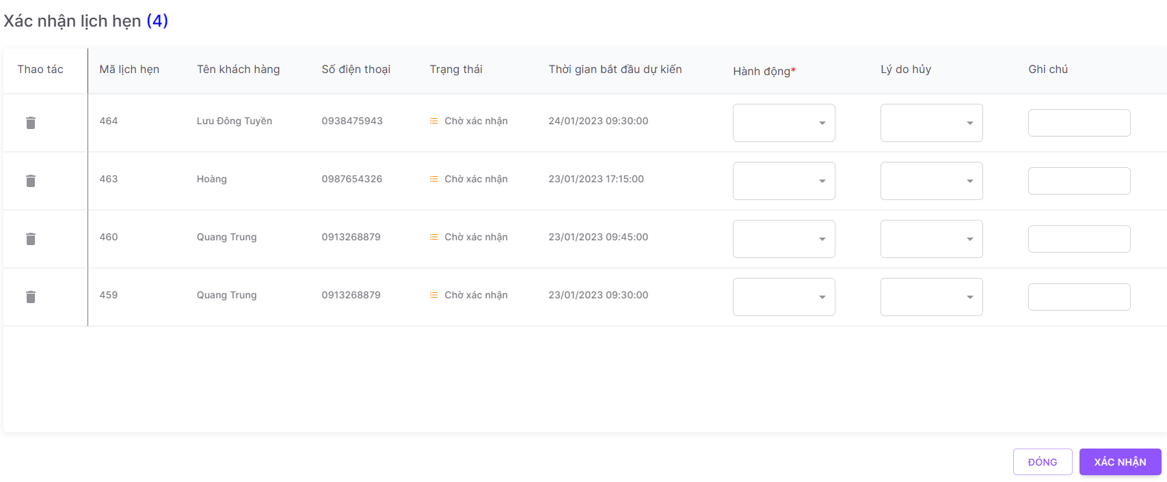

- Step 3: Do the same as single confirm.

##### 3.3.11.4 Check-in

*\*Note: This activity is done when customer come to the spa.*

- Step 1: Click on “Check-in” button.



- Step 2: Select actual start time, first service to do.

- Step 3: Select spa specialist for each service.

+ If there is no specialist to select, so that means in that time the spa is full.

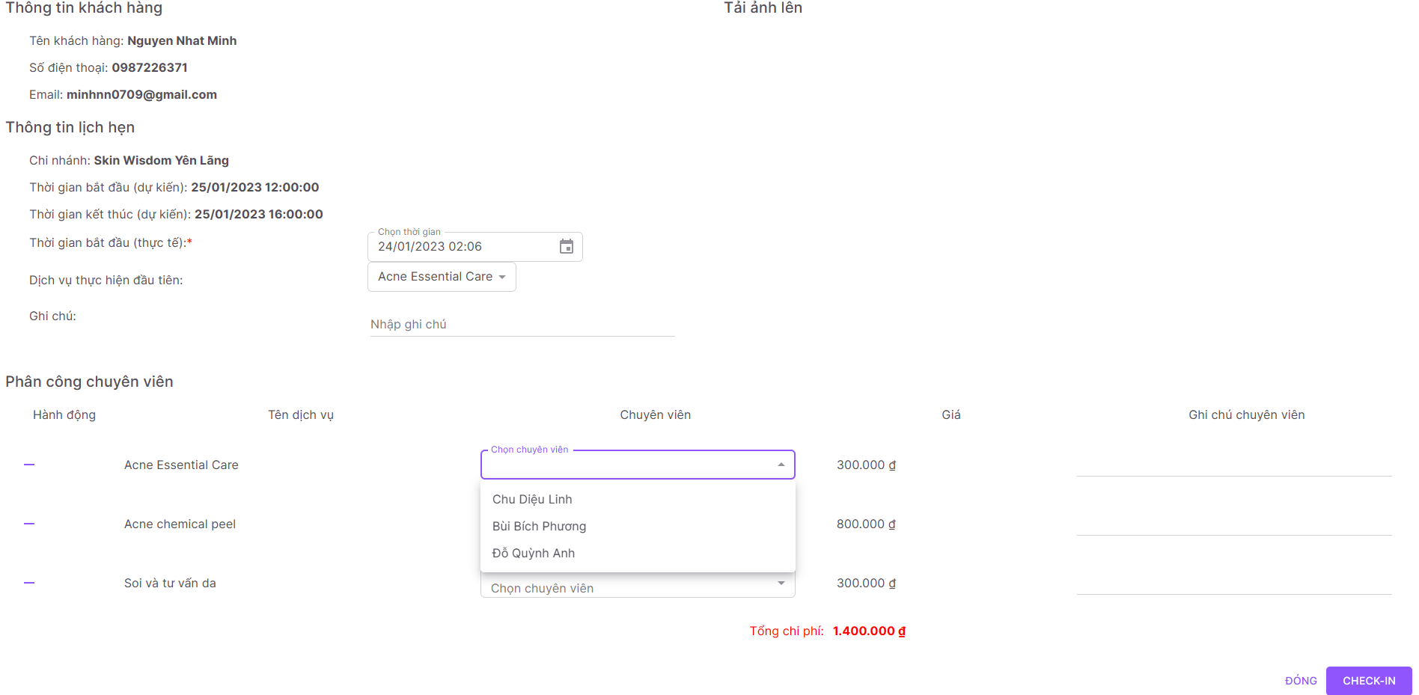

- Step 4: Click on “-” button to remove service (if full)

+ Select cancel reason and click on “Hủy dịch vụ” button.

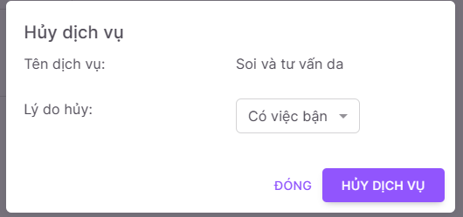

- Step 5: Click on “Check-in” button to check-in.

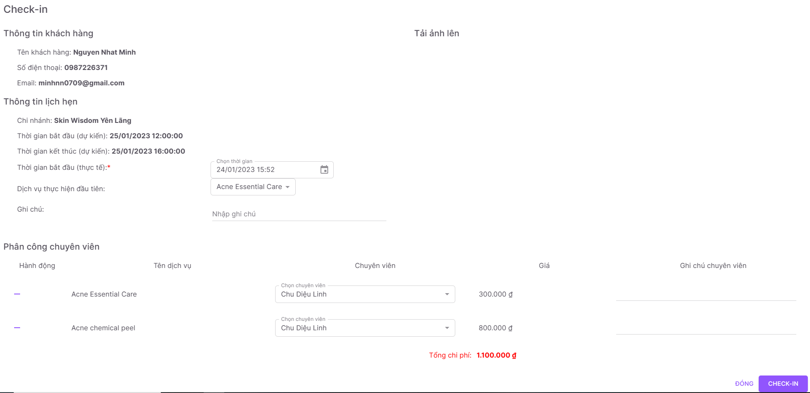

##### 3.3.11.5 Check-out

*\*Note: In this activity, user can only check-out an appointment if it is checked in before.*

- Step 1: Click on “Check-out” button.

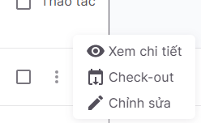

- Step 2: Select payment method.

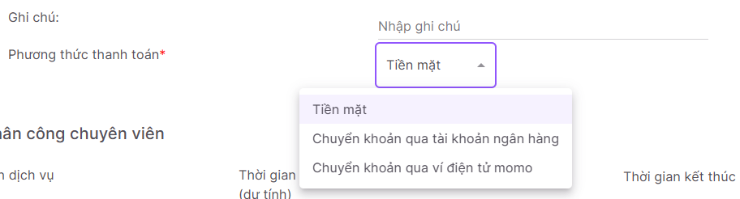

- Step 3: Click on “Xem hóa đơn” button to check bill.

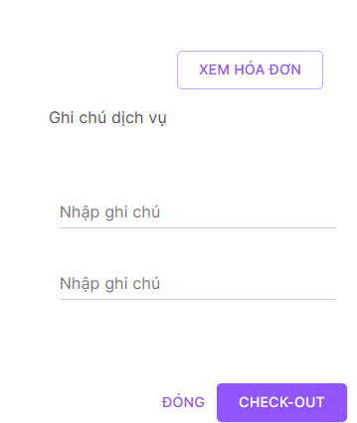

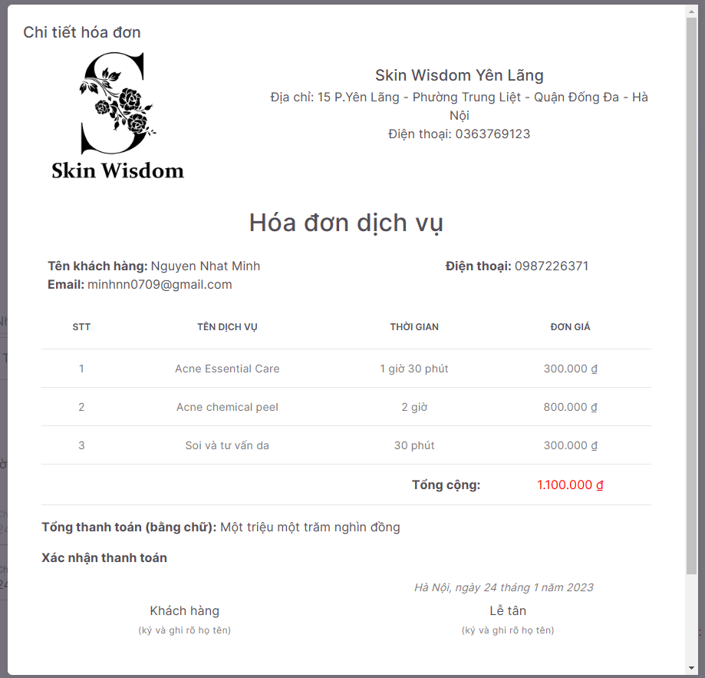



- Step 4: Click on “In hóa đơn” button to print.

- Step 5: Add bill by clicking on “Choose file” button then click on “Thêm ảnh”.

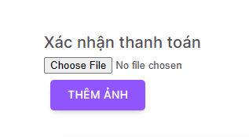

- Step 6: Select actual start time, actual end time of each service by clicking on Calendar button (if needed).

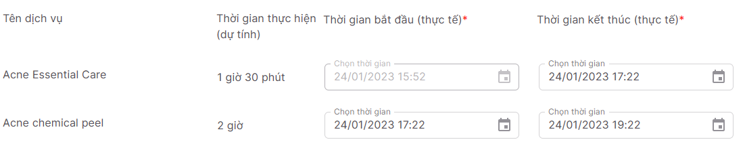

- Step 7: Click on “Check-out” button to check-out.

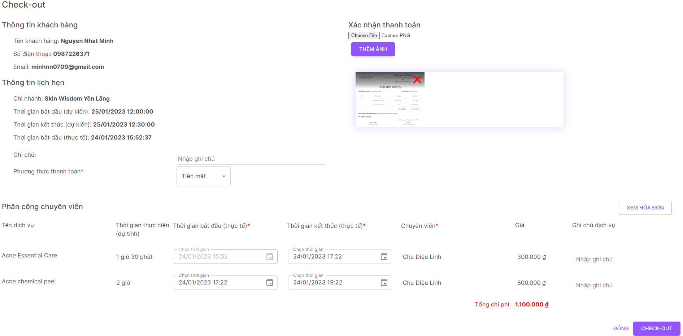

#### 3.3.12 Search data

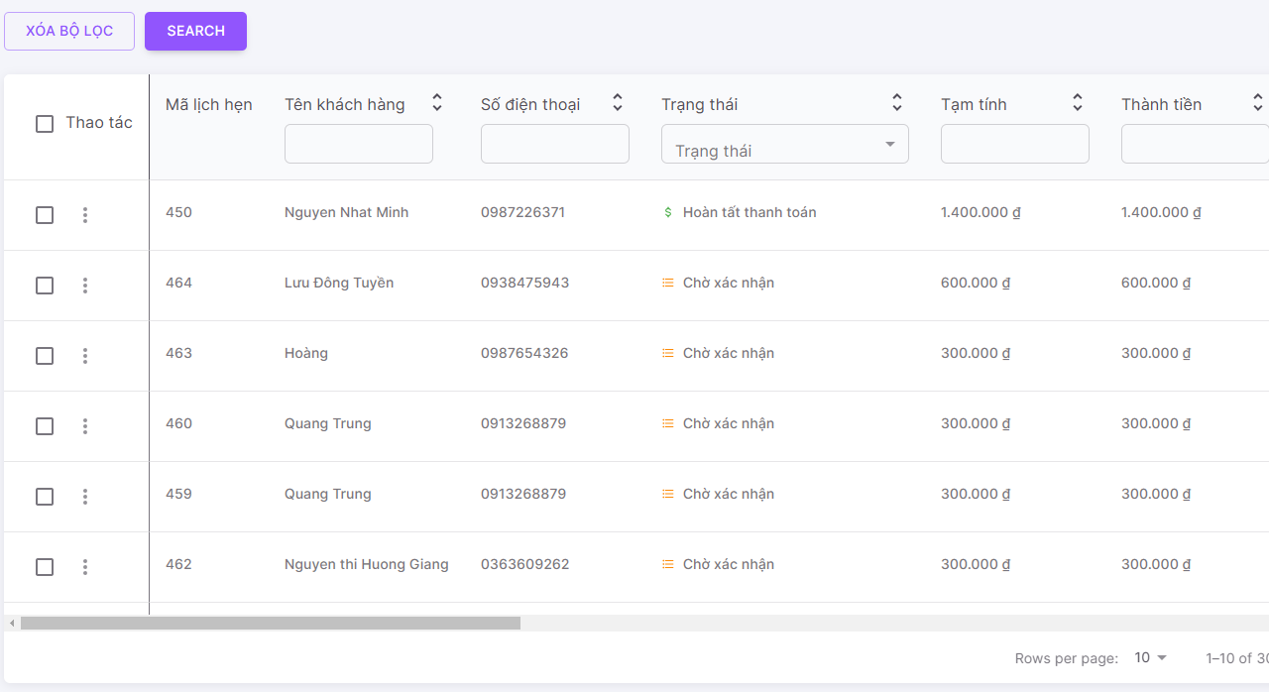

- Step 1: Fill in search keyword on the search bar.

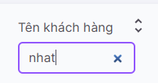

- Step 2: Click on “Search” button or press Enter.

- User can fill in many searched fields to make detail searching.

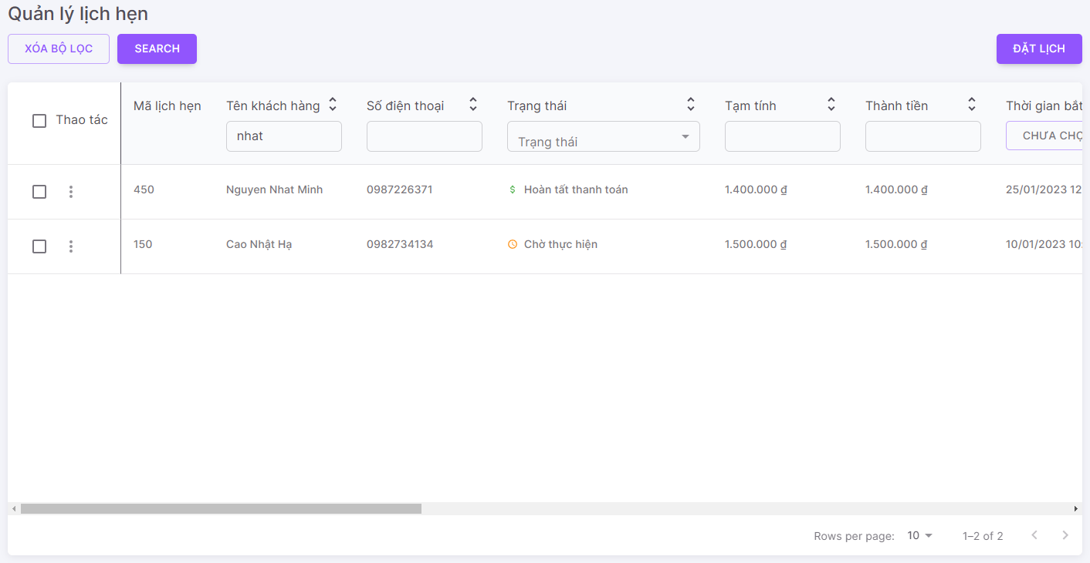

- Step 3: Click on “Xóa bộ lọc” button to refresh.

## 4. Exception

- Because of many reasons, Post function is not completed.

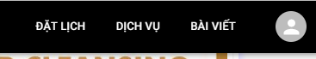

- User can’t interact with any posts.

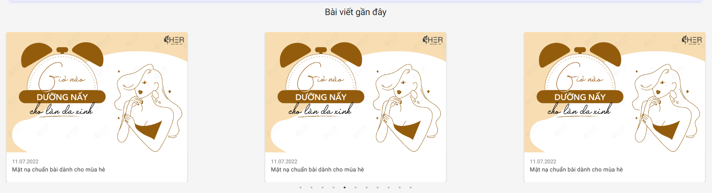

- We will bring this feature on the next version.